FLAT 10, CLEVELAND COURT
GROSVENOR PLACE
EXETER
EX1 2JP

£126,000 LEASEHOLD
A well proportioned ground floor apartment in an attractive period building forming part of this popular retirement development close to local amenities and Exeter city centre. Spacious lounge/dining room. Kitchen. Shower/wet room. Large double bedroom (previously two bedrooms which could easily be converted back if required). Beautifully well kept communal gardens and grounds. No onward chain. Viewing highly recommended.

ACCOMMODATION IN DETAIL COMPRISES (All dimensions approximate)

Communal front door, accessed via telephone intercom, to:

COMMUNAL HALL
With 5 stairs leading to private door of:

FLAT 10
RECEPTION HALL
Telephone point. Intercom. Night storage heater. Smoke alarm. Cloak hanging space. Electric consumer unit. Deep airing cupboard, with fitted shelving, housing lagged hot water cylinder. Glass panelled door leads to:

LOUNGE/DINING ROOM
17’6” (5.33m) maximum into bay x 14’2” (4.32m) maximum dining room end reducing to 10’2” (3.10m). A spacious room with feature high ceiling. Television aerial point. Night storage heater. Two wall light points. Range of storage cupboards into bay window. Large full height arched sash windows to front aspect with pleasant outlook over communal gardens.

From reception hall, door to:

KITCHEN
7’10” (2.39m) x 7’0” (2.13m). Fitted with a range of base, drawer and eye level cupboards. Wood effect roll edge work surfaces with tiled splashbacks. Single drainer sink unit. Fitted electric oven. Four ring electric hob with filter/extractor hood over. Integrated fridge. Plumbing and space for washing machine. Upright storage cupboard. Electric wall heater. Feature high ceiling. Large arched sash window to side aspect. Additional sash window to side aspect.

From reception hall, door leads to:

BEDROOM
14’10” (4.52m) x 9’10” (3.0m) (This room was previously two bedrooms and can easily be converted back with the installation of a partition wall). Night storage heater. Deep built in wardrobe. Additional door to reception hall. uPVC double glazed window to rear aspect with outlook over communal garden. Sash window to side aspect.

From reception hall, door to:

SHOWER ROOM/WET ROOM
7’6” (2.29m) x 5’10” (1.78m). Fitted electric shower unit with shower enclosure. Wash hand basin. Low level WC. Three eye level cupboards. Light/shaver point. Part tiled walls. Electric wall heater. Extractor fan.

OUTSIDE
The property benefits from the use of the beautifully kept and well maintained communal gardens and grounds, resident’s car park, resident’s lounge and also availability to book a guest flat for visitors.

TENURE
LEASEHOLD. We have been advised the property in question was granted a lease term of 99 years from 1988. We have also been advised a purchase of the share of the freehold is available

MAINTENANCE/SERVICE CHARGE
The current service charge is set at £200 per month to include general maintenance, upkeep of the building, warden’s salary, communal electricity, gardening, external window cleaning, insurances etc.

GROUND RENT
£50 per annum

DIRECTIONS
From the roundabout at the top of Sidwell Street take the first exit left into Western Way. Take the first turning left into Belmont Road and continue along taking the second turning left into Grosvenor Place. Continue along and turn right into Cleveland Court

VIEWING
Strictly by appointment with the Vendors Agents.

AGENTS NOTE
The information given in these particulars is intended to help you decide whether you wish to view this property and to avoid wasting your time in viewing unsuitable properties. We have tried to make sure that these particulars are accurate, but to a large extent we have to rely on what the seller tells us about the property.

We do not check every single piece of information ourselves as the cost of doing so would be prohibitive and we do not wish to unnecessarily add to the cost of moving house.

Once you find the property you want to buy, you will need to carry out more investigations into the property than it is practical or reasonable for an estate agent to do when preparing sales particulars. For example, we have not carried out any kind of survey of the property to look for structural defects and would advise any homebuyer to obtain a surveyor’s report before exchanging contracts. If you do not have your own surveyor, we would be pleased to recommend one. We have not checked whether any equipment in the property (such as central heating) is in working order and would advise homebuyers to check this.

You should also instruct a solicitor to investigate all legal matters relating to the property (e.g. title, planning permission, etc.) as these are specialist matters in which estate agents are not qualified. Your solicitor will also agree with the seller what items (e.g. carpets, curtains, etc.) will be included in the sale.

Please be aware that all measurements within these particulars are recorded with a sonic tape, and whilst every effort has been taken to ensure their accuracy potential purchasers are recommended to satisfy themselves before entering a contract to purchase.

AGENTS NOTE MONEY LAUNDERING POLICY
Samuels Estate Agents are committed to ensuring that it has adequate controls to counter money laundering activities and terrorist financing activities, in line with the Money Laundering Regulations 2007. Any prospective purchaser will be required to show proof of funds and identification. We ask for your cooperation on this matter in order that there will be no delay in the transaction

REFERENCE
CDER/1122/8312/AV

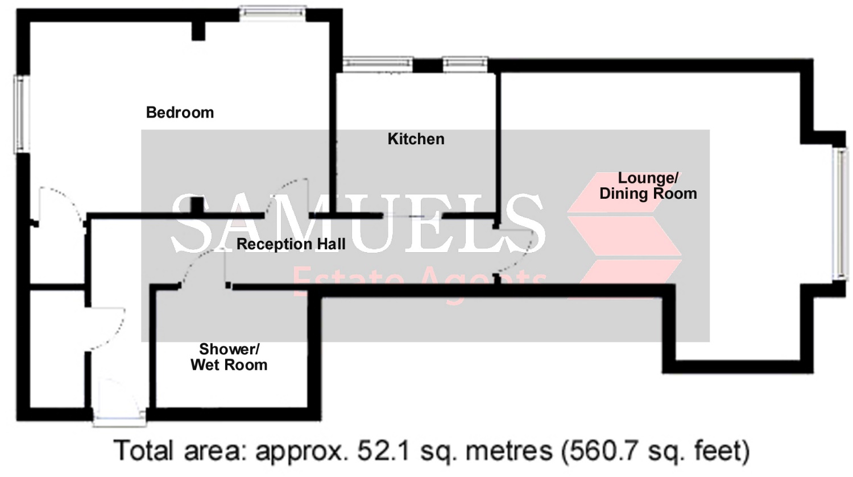
Floor plan for illustration purposes only – not to scale

www.samuelsagents.co.uk

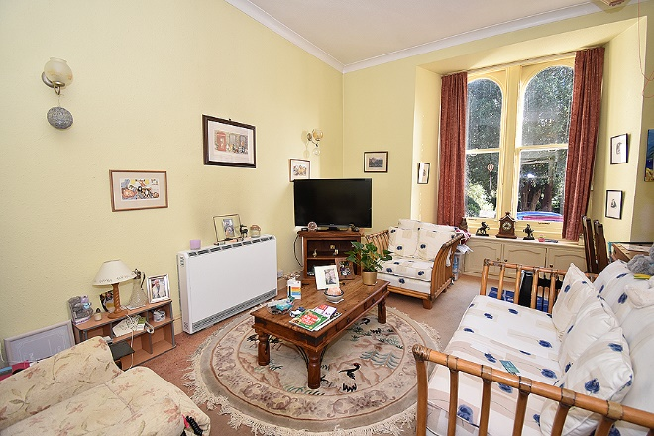 |  | 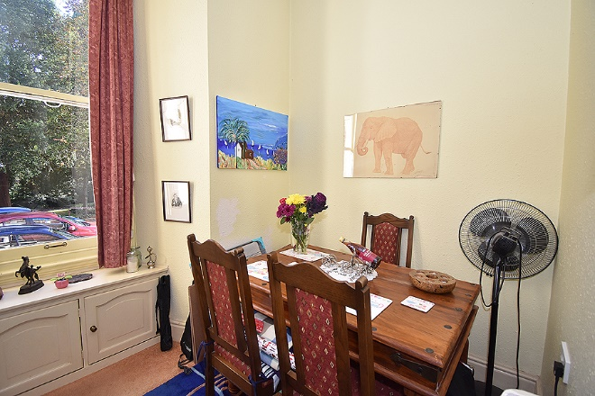
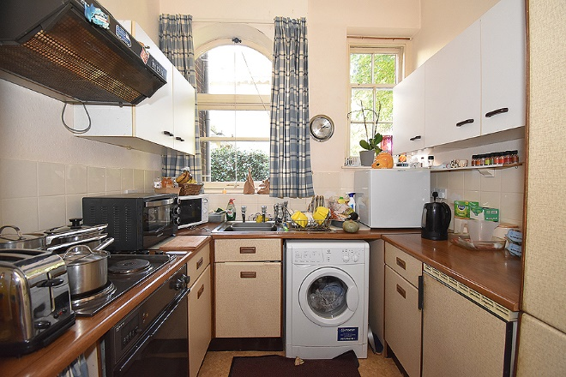 |  | 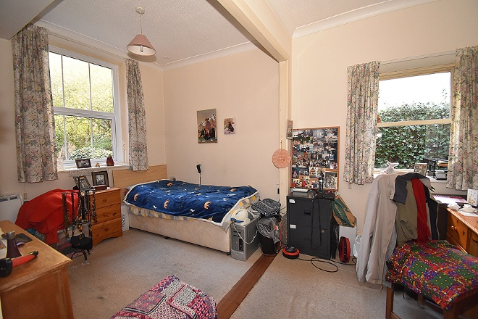
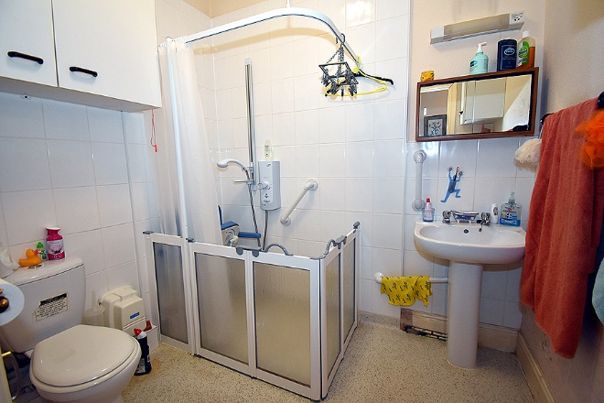 |  | 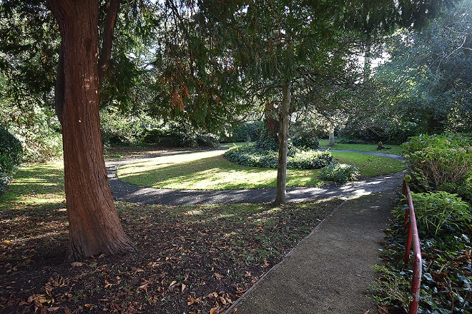
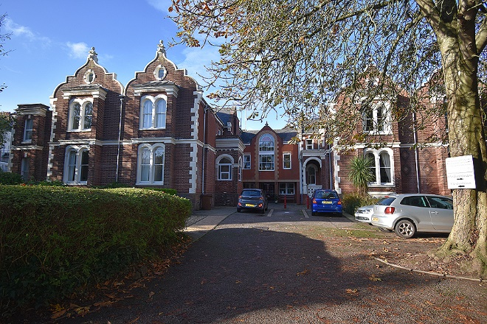 |  | 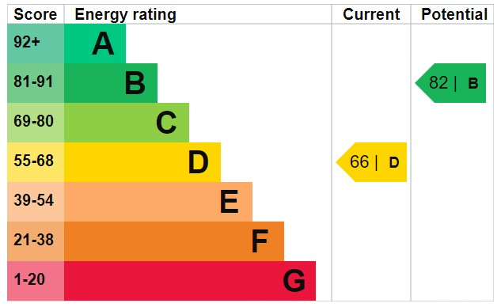

www.samuelsagents.co.uk

