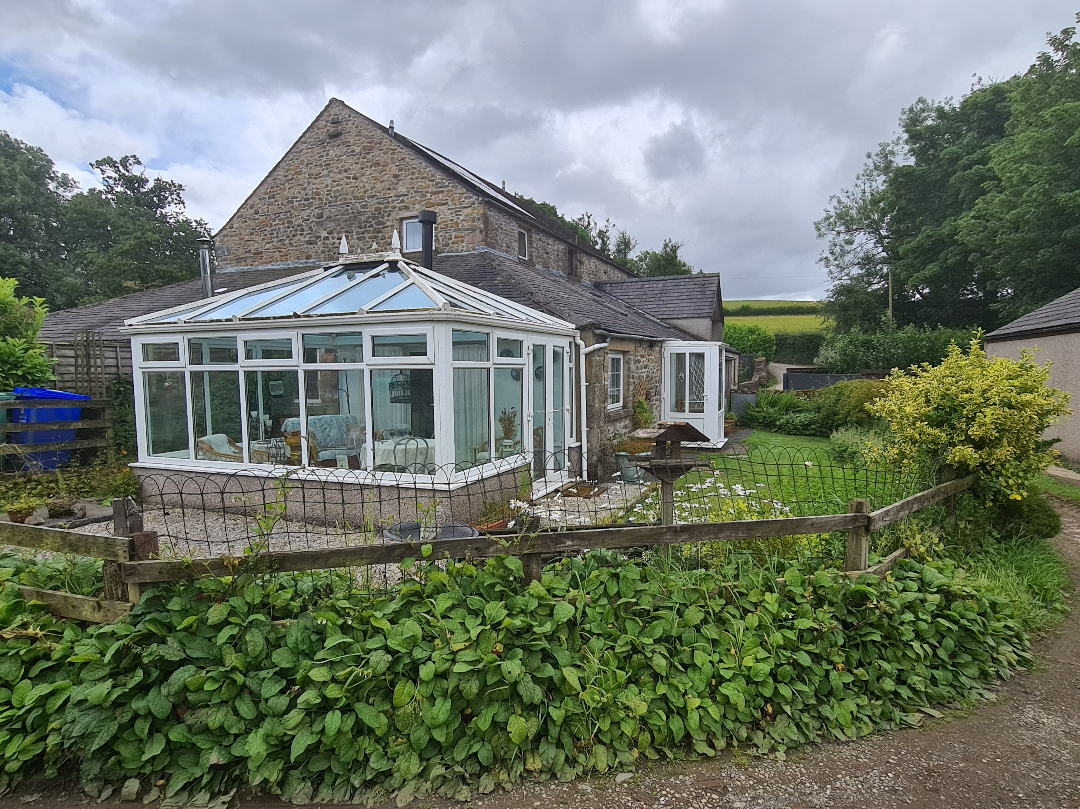

* Tenure **Freehold**
* Council Tax Band **D**
* EPC Rating **D**
* Formally Two Cottages, Made Into A Single Dwelling
* Located In A Quiet Small Hamlet
* Two Gardens
* Land Extending To Approx. 0.76 Acres
* Off Road Parking
* Garage
* Viewing Essential To Fully Appreciate The Property

CHAIN FREE

|  |  |  |  |  |  |
| --- | --- | --- | --- | --- | --- |
|  | 3 |  | 3 |  | 2 |

£450,000 Region

6 NOOKDALE COTTAGES, DUMB TOMS LANE, INGLETON, LA6 3DS

BROOKHOUSE, LA2 9PH

|  |  |
| --- | --- |
| RTS | Richard Turner & Son  AUCTIONEERS, VALUERS & ESTATE AGENTS Est 1803 |
|  |  |