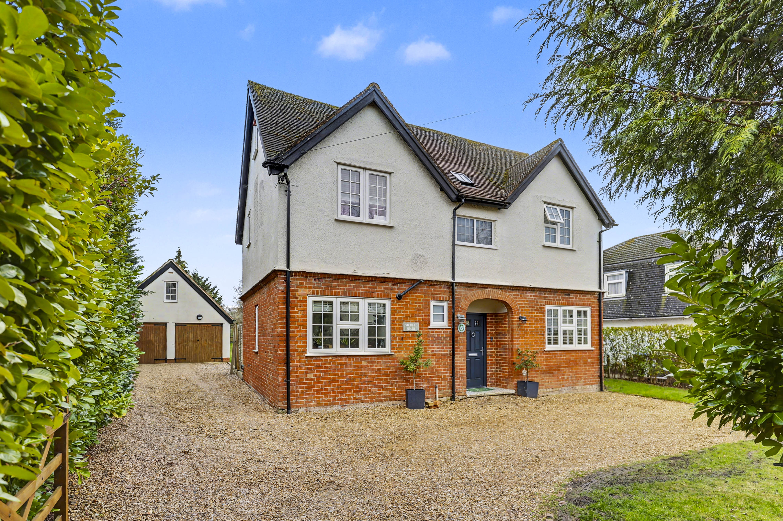
203 Baldock Road, Letchworth Garden City, SG6 2EJ
£750,000 Freehold

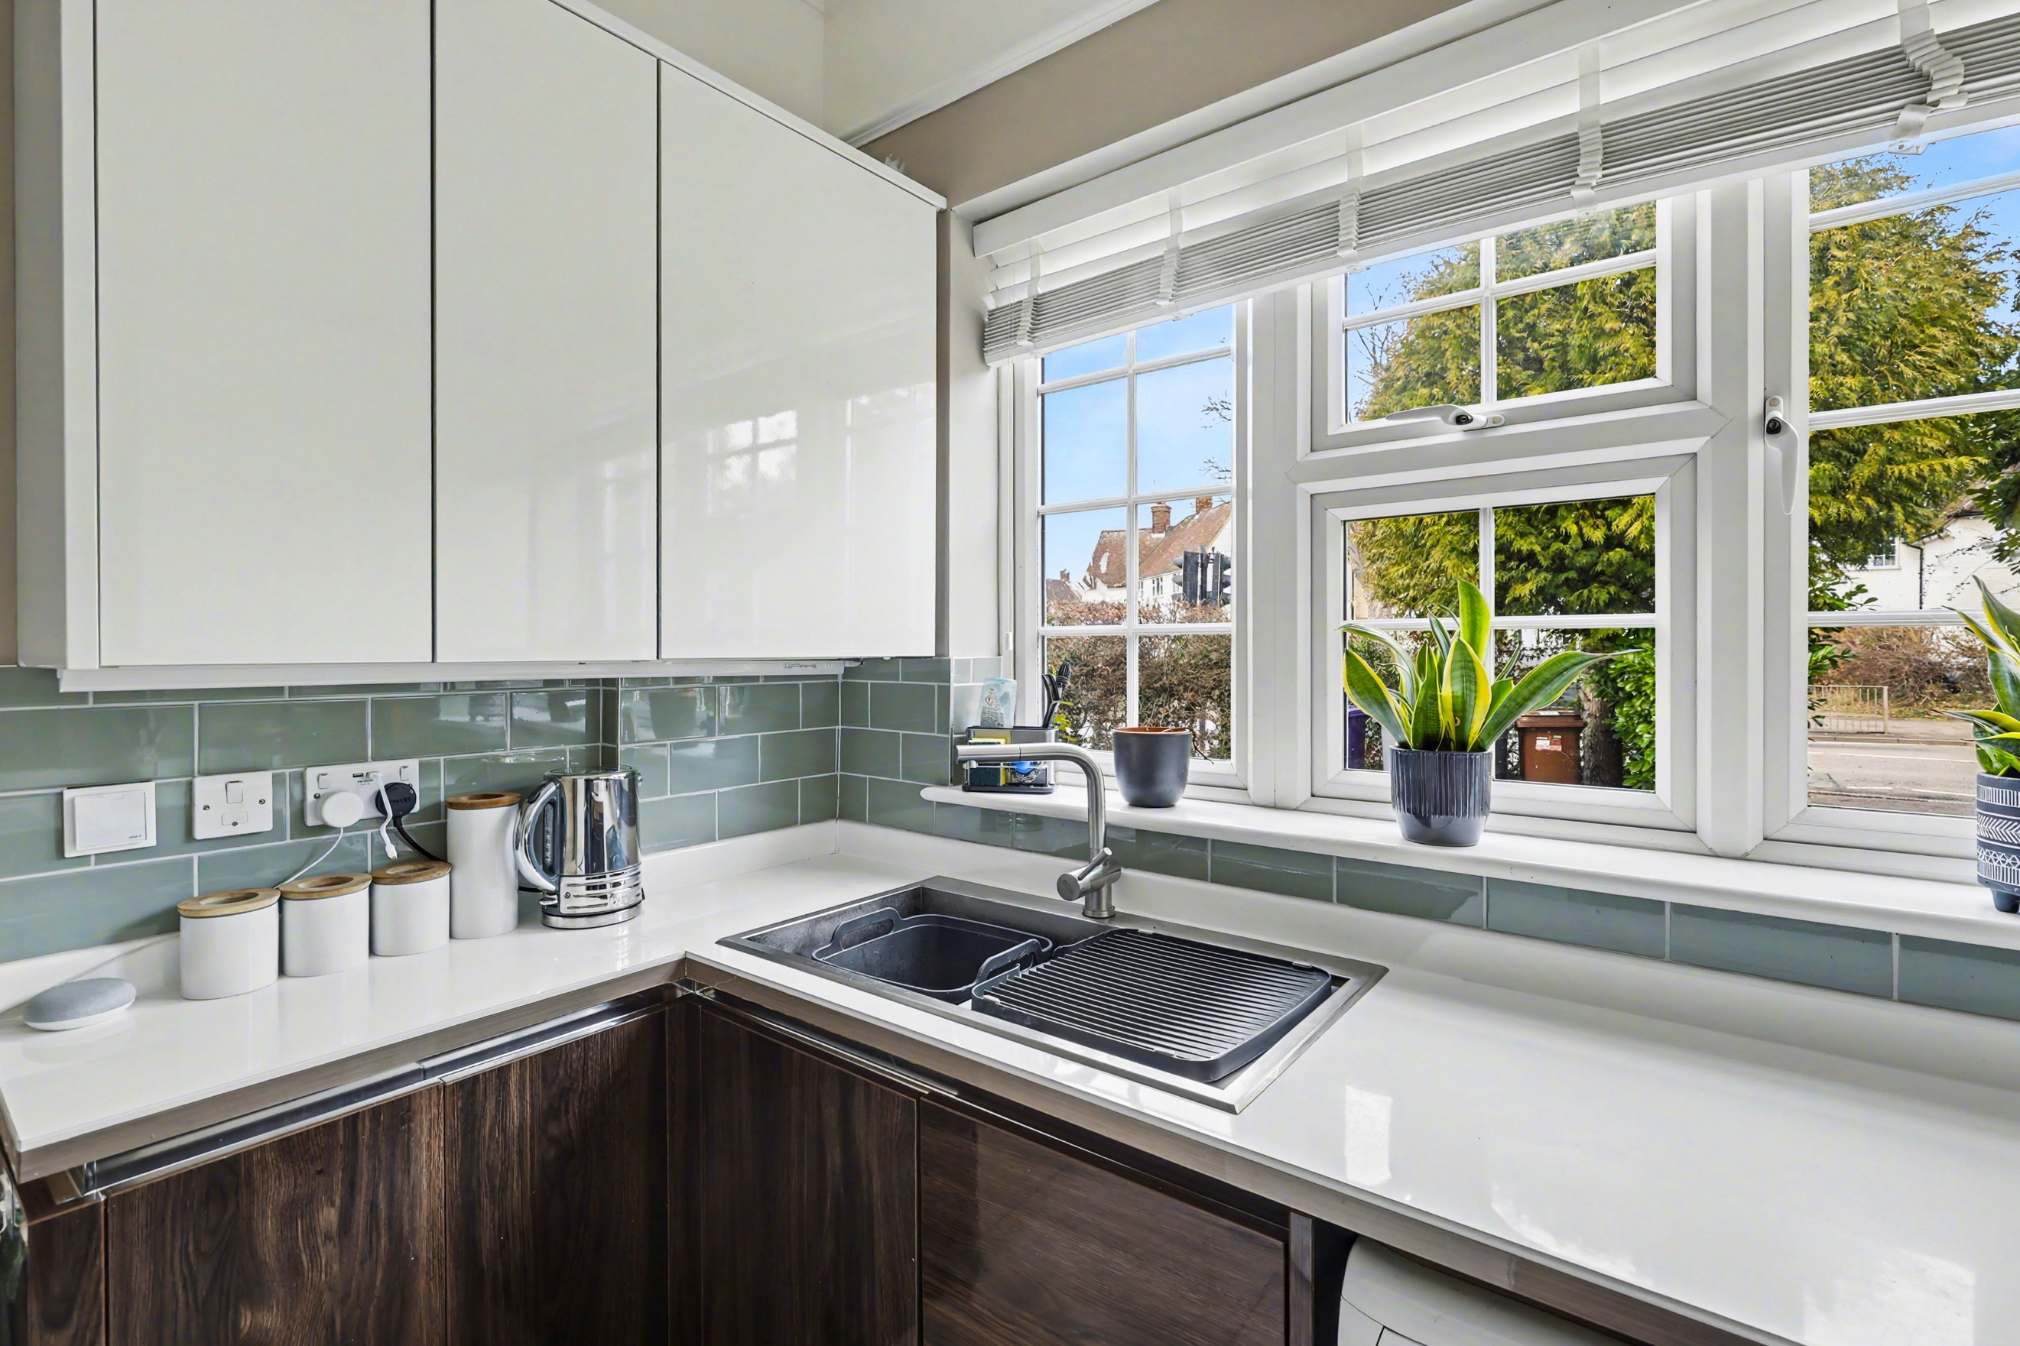
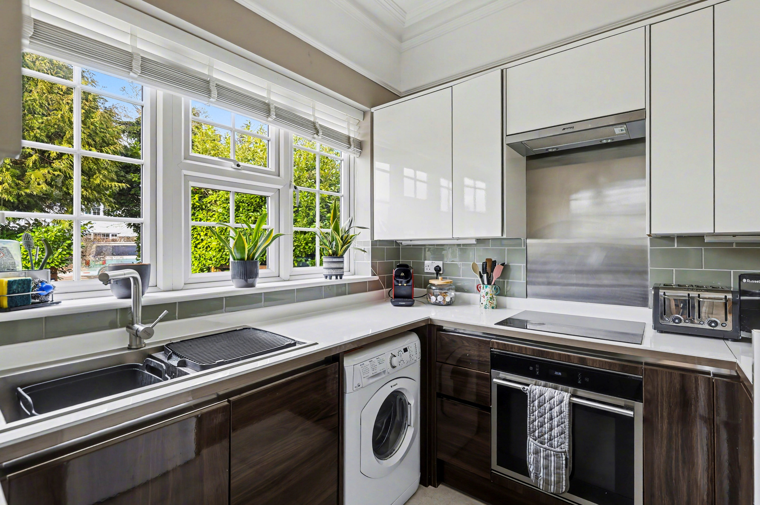
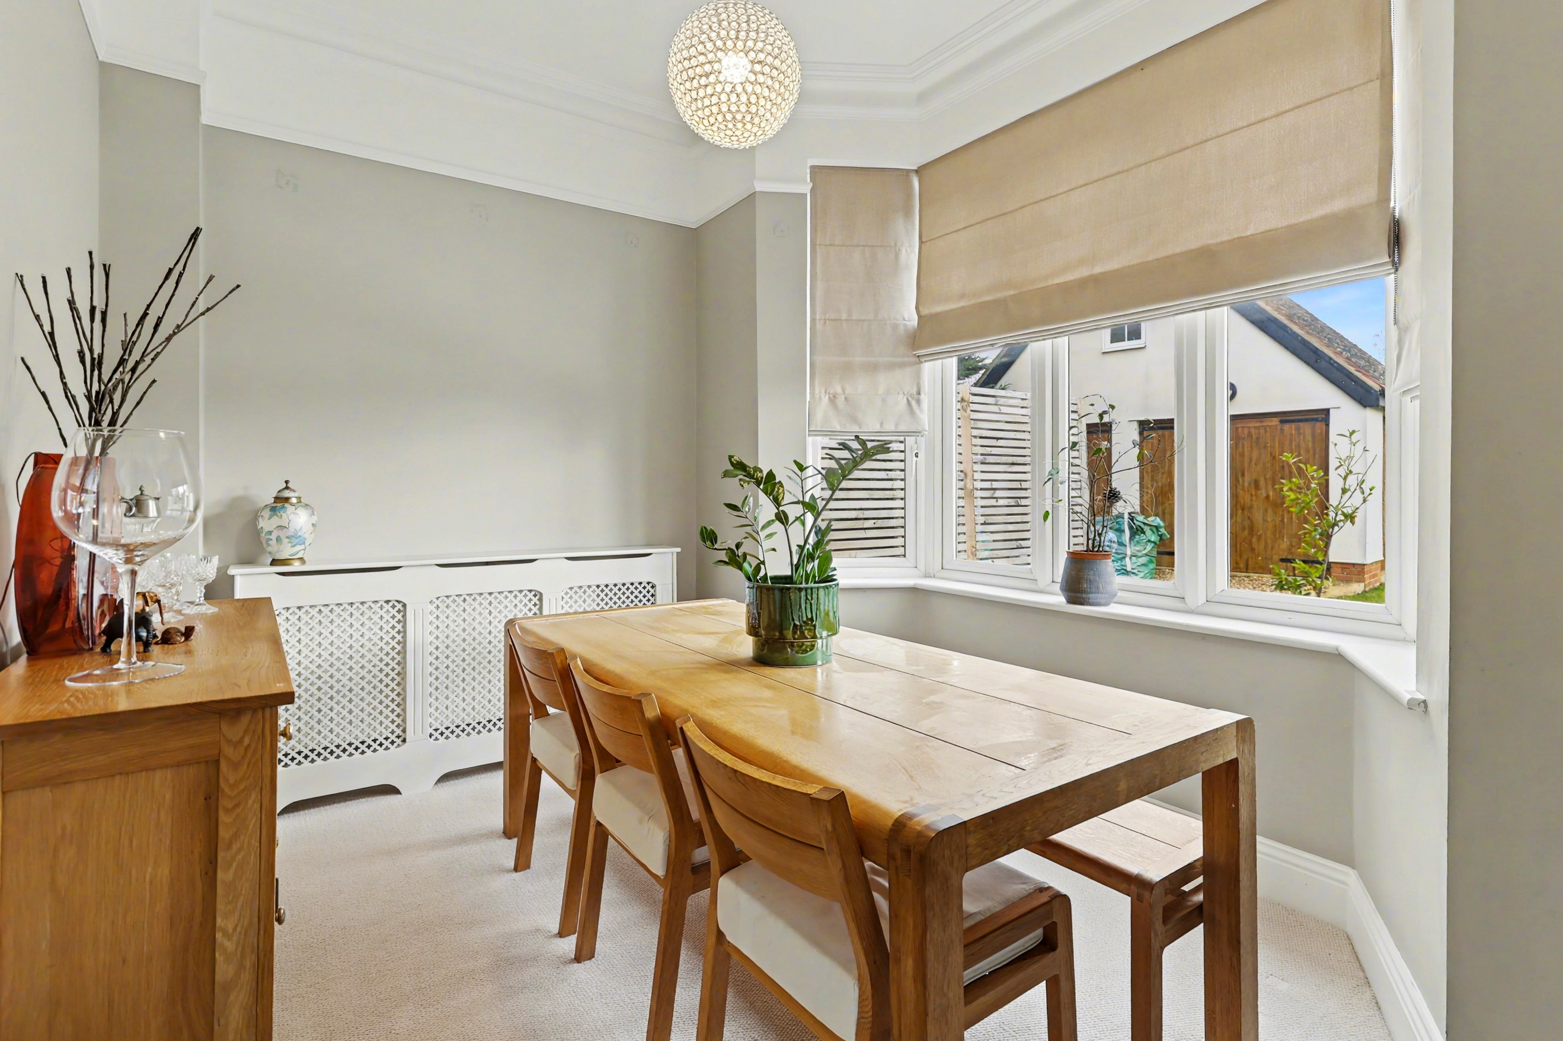
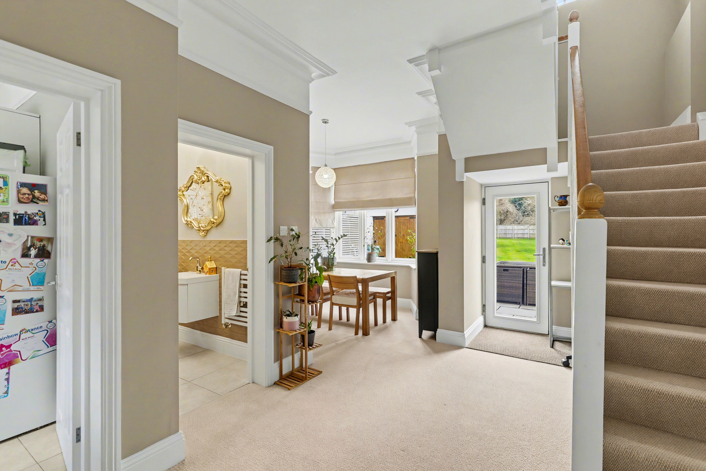
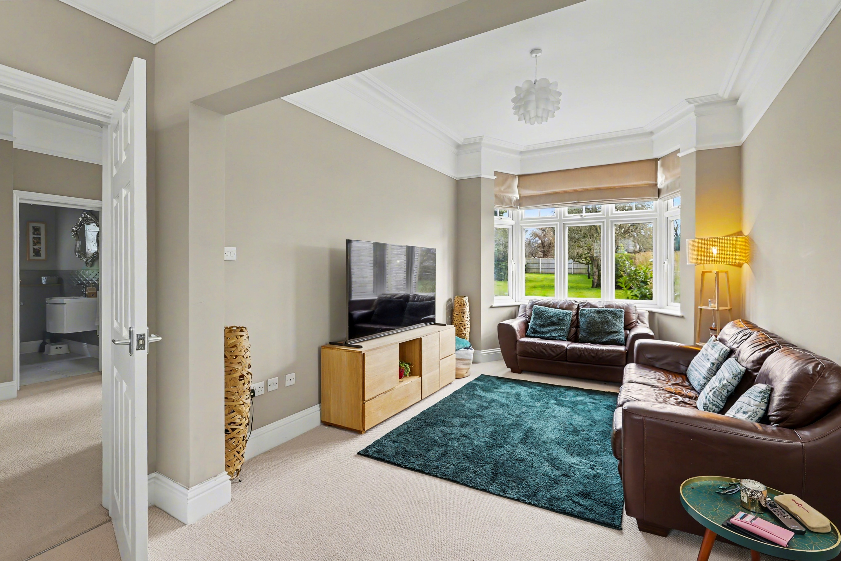
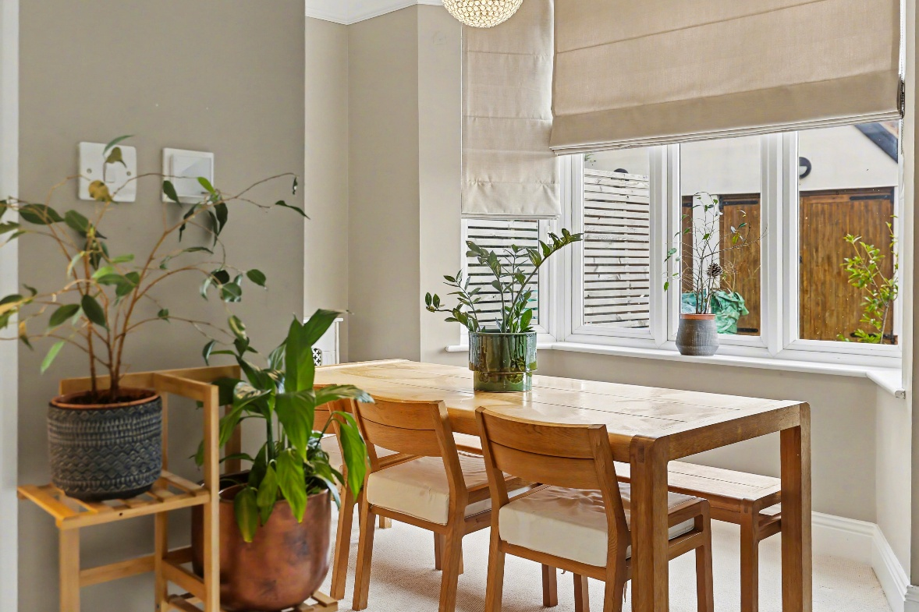
Letchworth Garden City, established in 1903 as the world's first garden city, offers an excellent blend of heritage charm and modern convenience. The town benefits from outstanding transport links, with the railway station providing fast services to London King's Cross in approximately 30 minutes and direct connections to Cambridge, whilst road links via the nearby A1(M) offer easy access to the wider region. The town centre provides a good range of shopping facilities, with the picturesque Broadway Gardens at its heart offering a beautiful civic space, alongside Howard Park which features a popular children's splash park. Letchworth is particularly well-served for families, with a strong selection of primary schools including Lordship Farm Primary, Hillshott Infant School and Nursery as well as secondary provision at Highfield School, Fearnhill School as well as St. Christopher and St. Francis . The town's extensive green spaces and leisure facilities, combined with its excellent commuter links and comprehensive amenities, make Letchworth Garden City an increasingly popular choice for families and professionals alike.
Stepping inside this beautifully presented modern detached home and you'll immediately appreciate the quality and care that has been invested throughout. The open entrance hall, sets the tone for the impressive accommodation that follows. To your left, a well-appointed kitchen features sleek cabinetry with complementary worktops, integrated appliances including an oven hob, extractor and dishwasher. The modern design continues with attractive tiled flooring and plenty of storage, whilst a useful separate store room in the hall provides additional practical space.
The heart of the home is the magnificent sitting room, an exceptionally spacious reception room measuring over 20 feet in length that truly showcases the property's contemporary appeal. Flooded with natural light from dual-aspect windows, including an attractive bay window to the rear, this room offers a wonderful sense of space. The neutral décor, quality carpeting, and thoughtful lighting create an inviting atmosphere perfect for both relaxation and entertaining. Adjacent to this and flowing into the entrance hall, a separate dining room provides flexible living space, ideal for formal dining with an ideal additional home office space by the stairs, with bay window adding character and charm as well as a back door to the garden.
Ascending the staircase to the first floor, you'll find four well-proportioned bedrooms arranged around a spacious landing. The principal bedroom is particularly impressive, measuring over 12 feet in length and offering generous accommodation with fitted wardrobes and a modern finish throughout. Bedrooms two, three and four provide comfortable double accommodation. Serving the first floor is a contemporary family bathroom finished to a high standard with integrated fixtures, panelled bath with shower over, low-level WC, and wash hand basin with vanity, complemented by stylish tiled walls and quality flooring.
About Letchworth

Step Inside

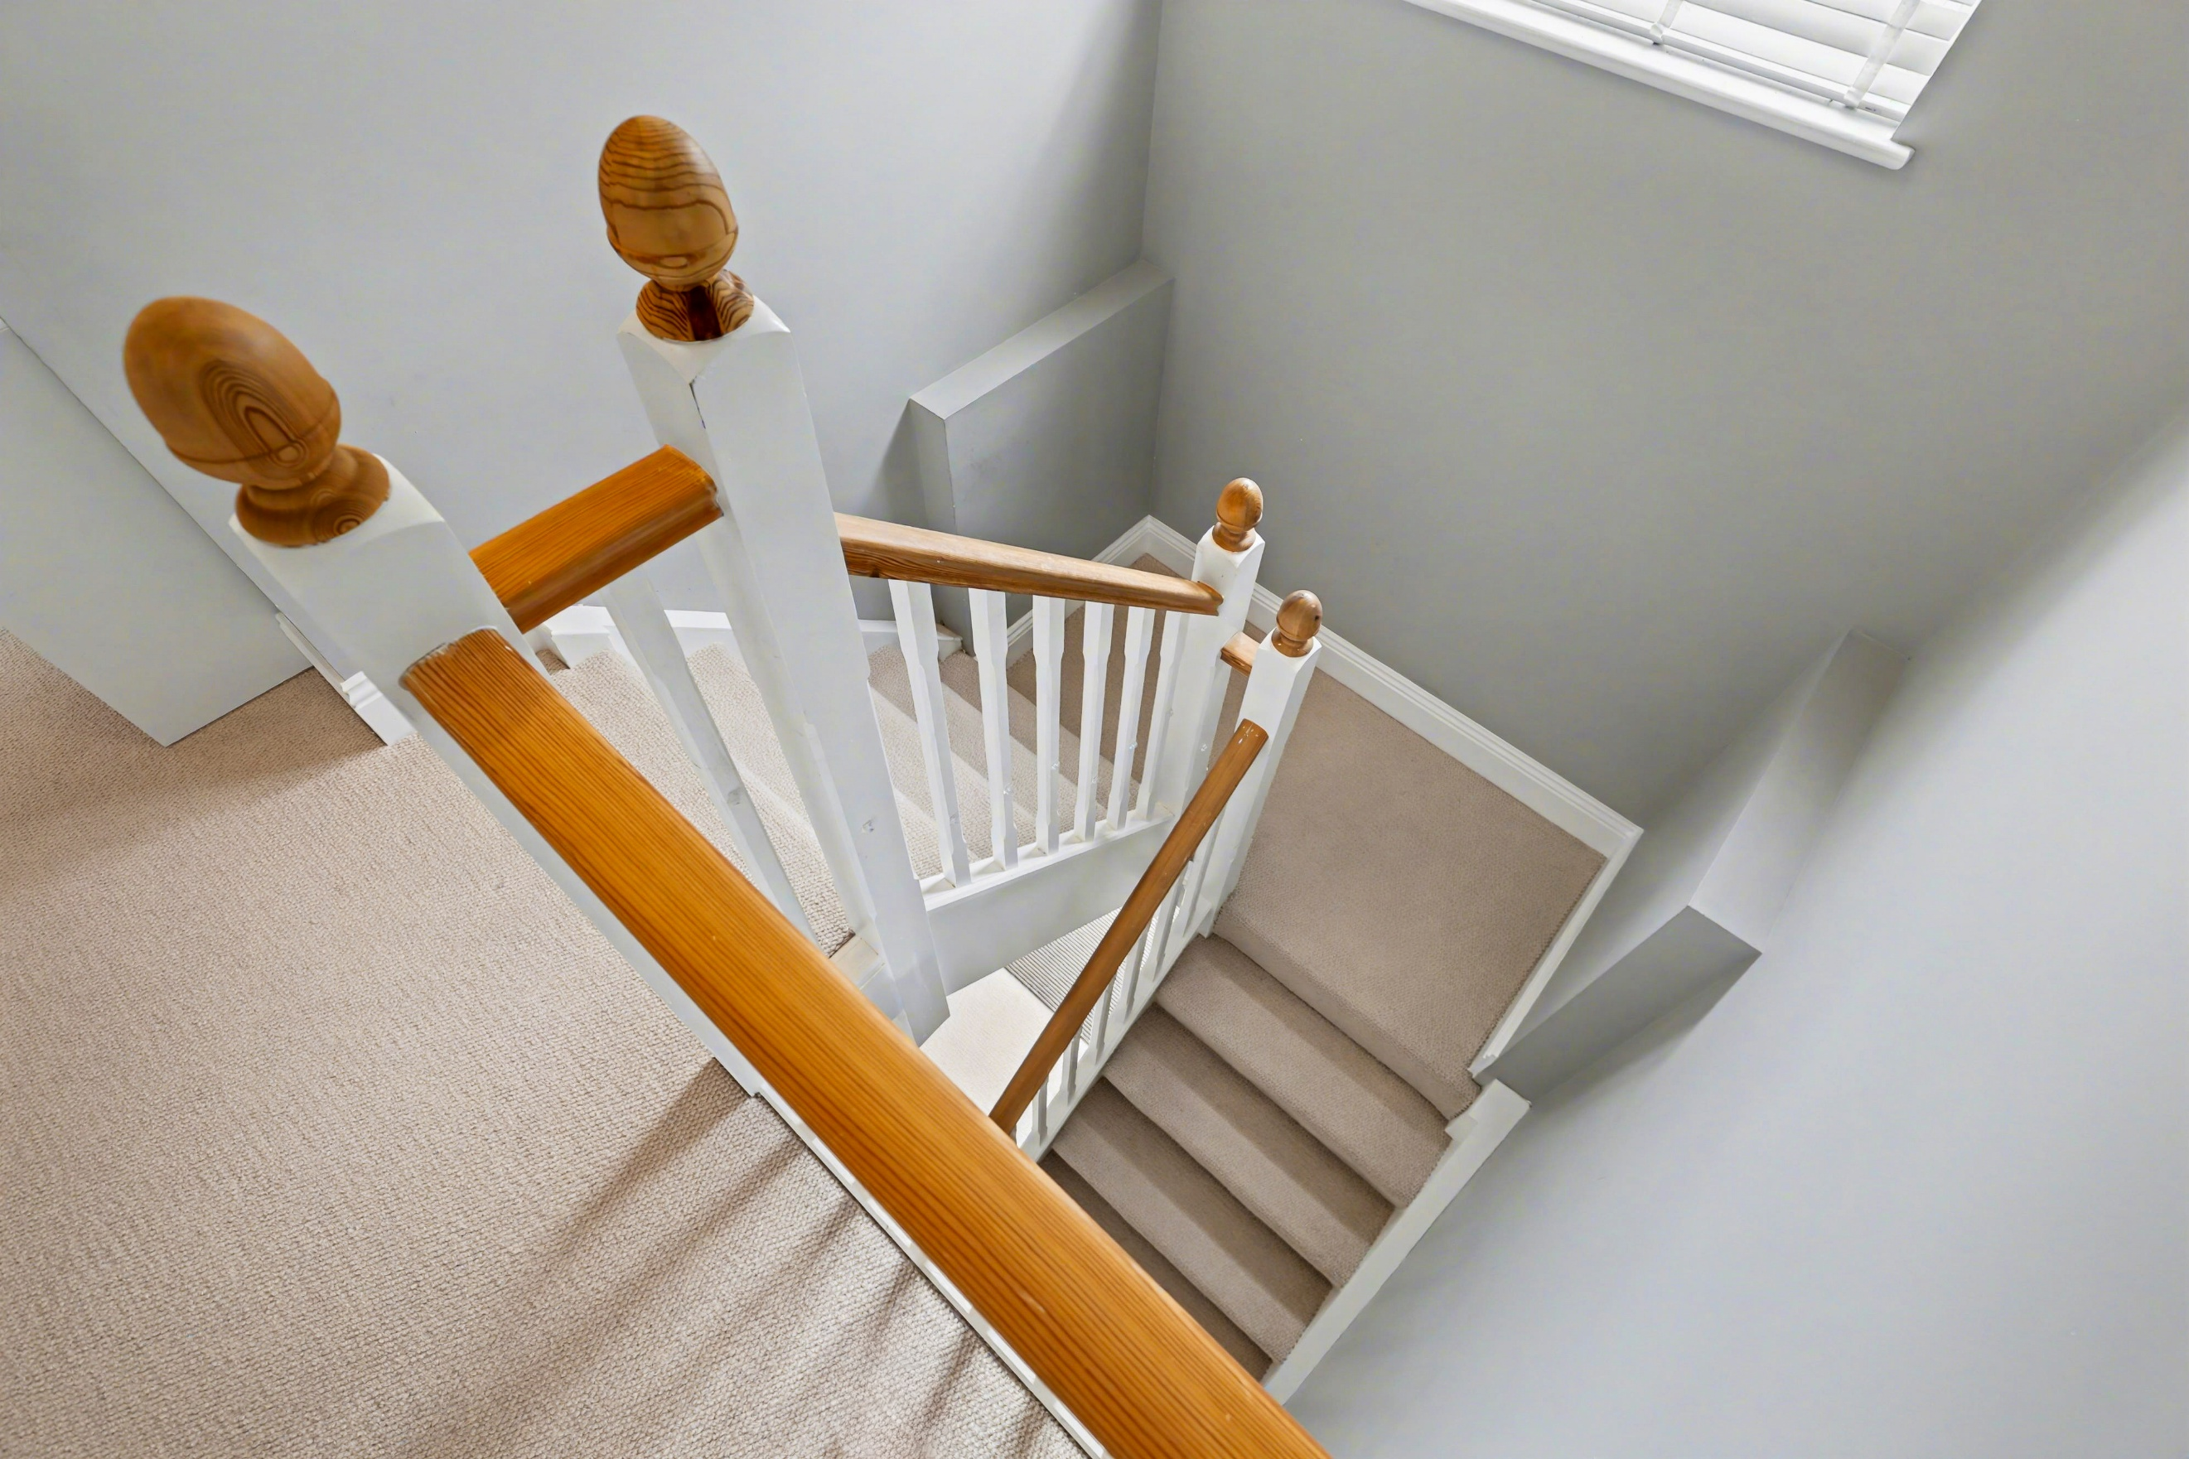
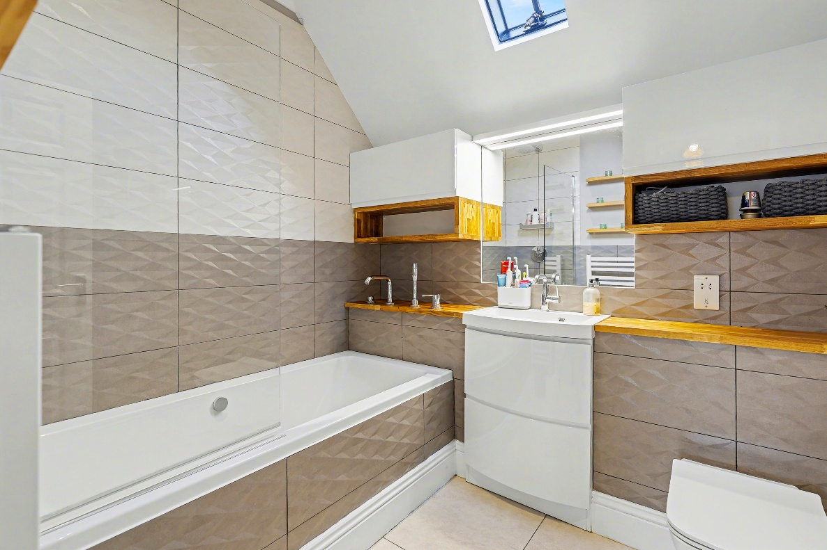
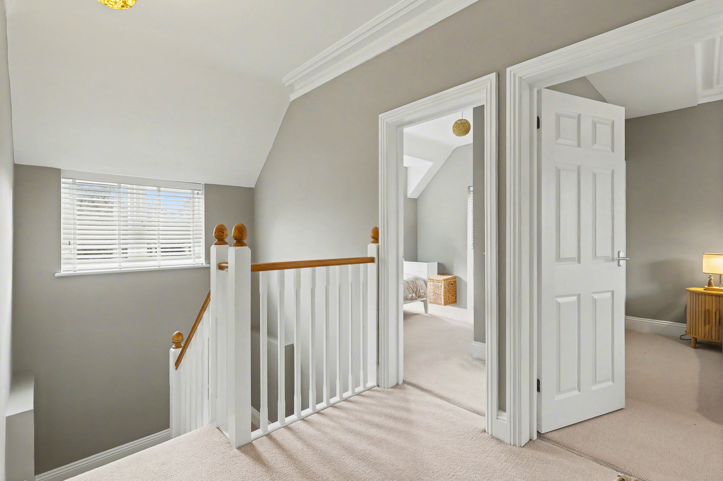
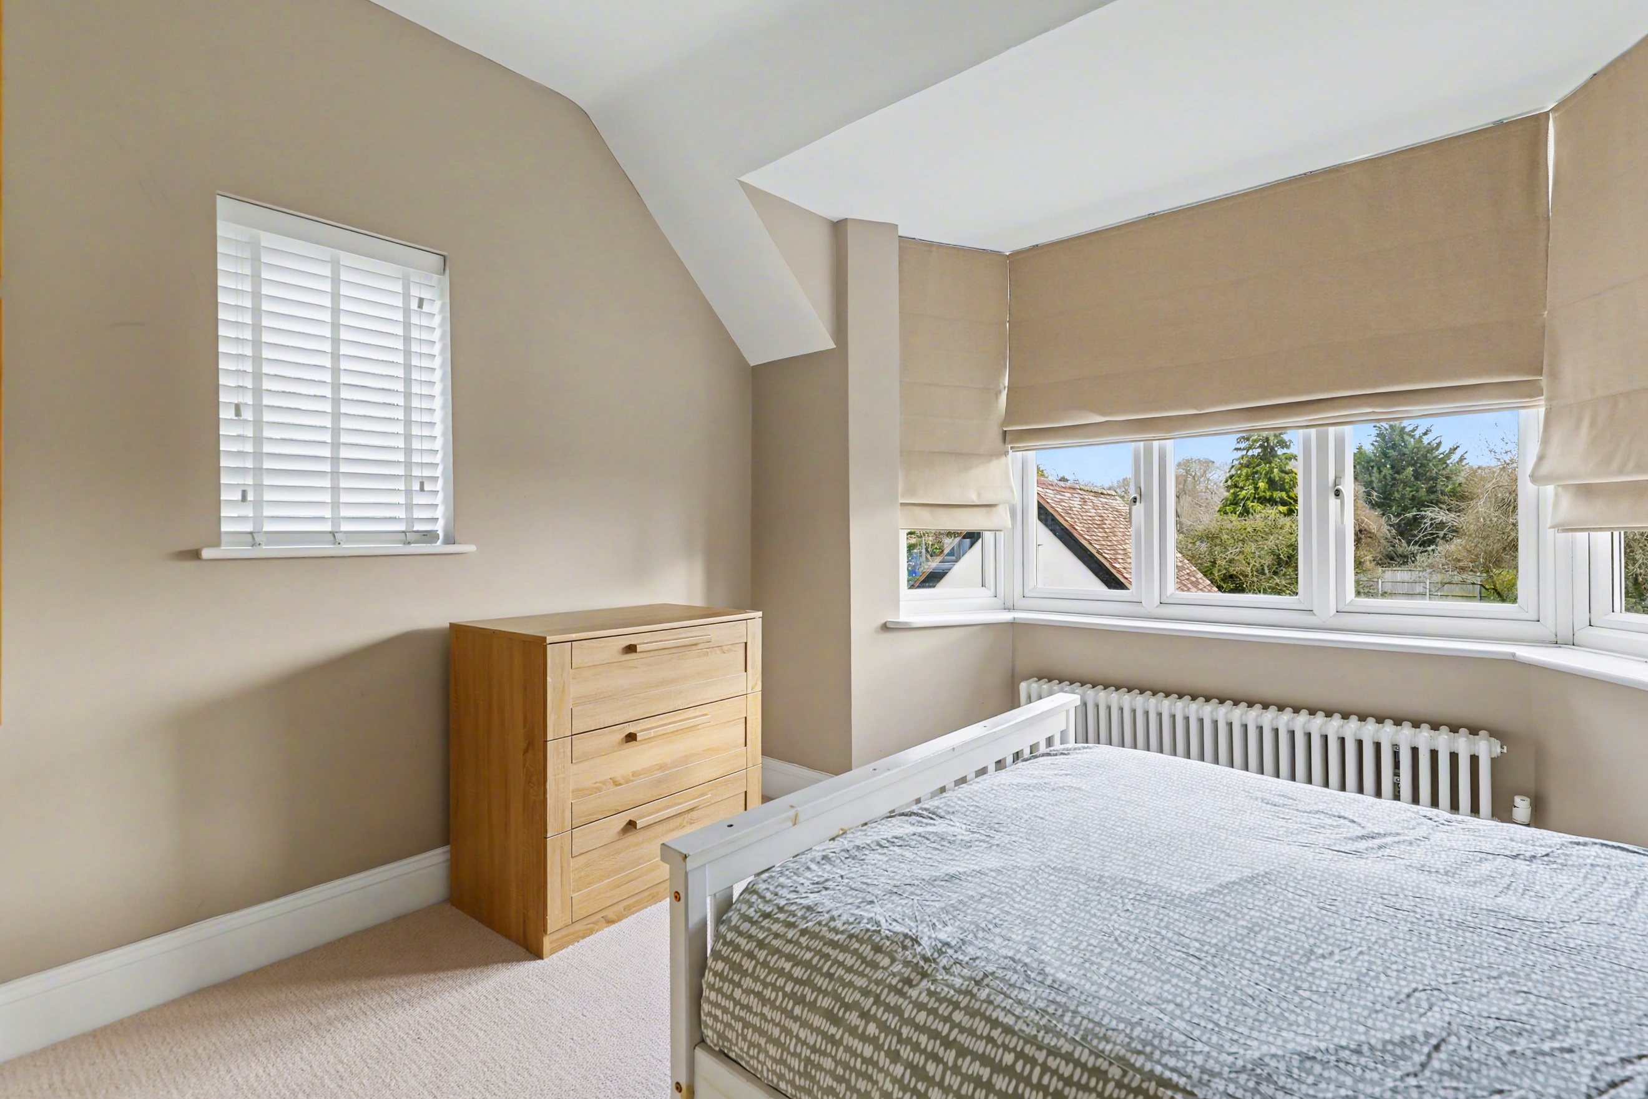
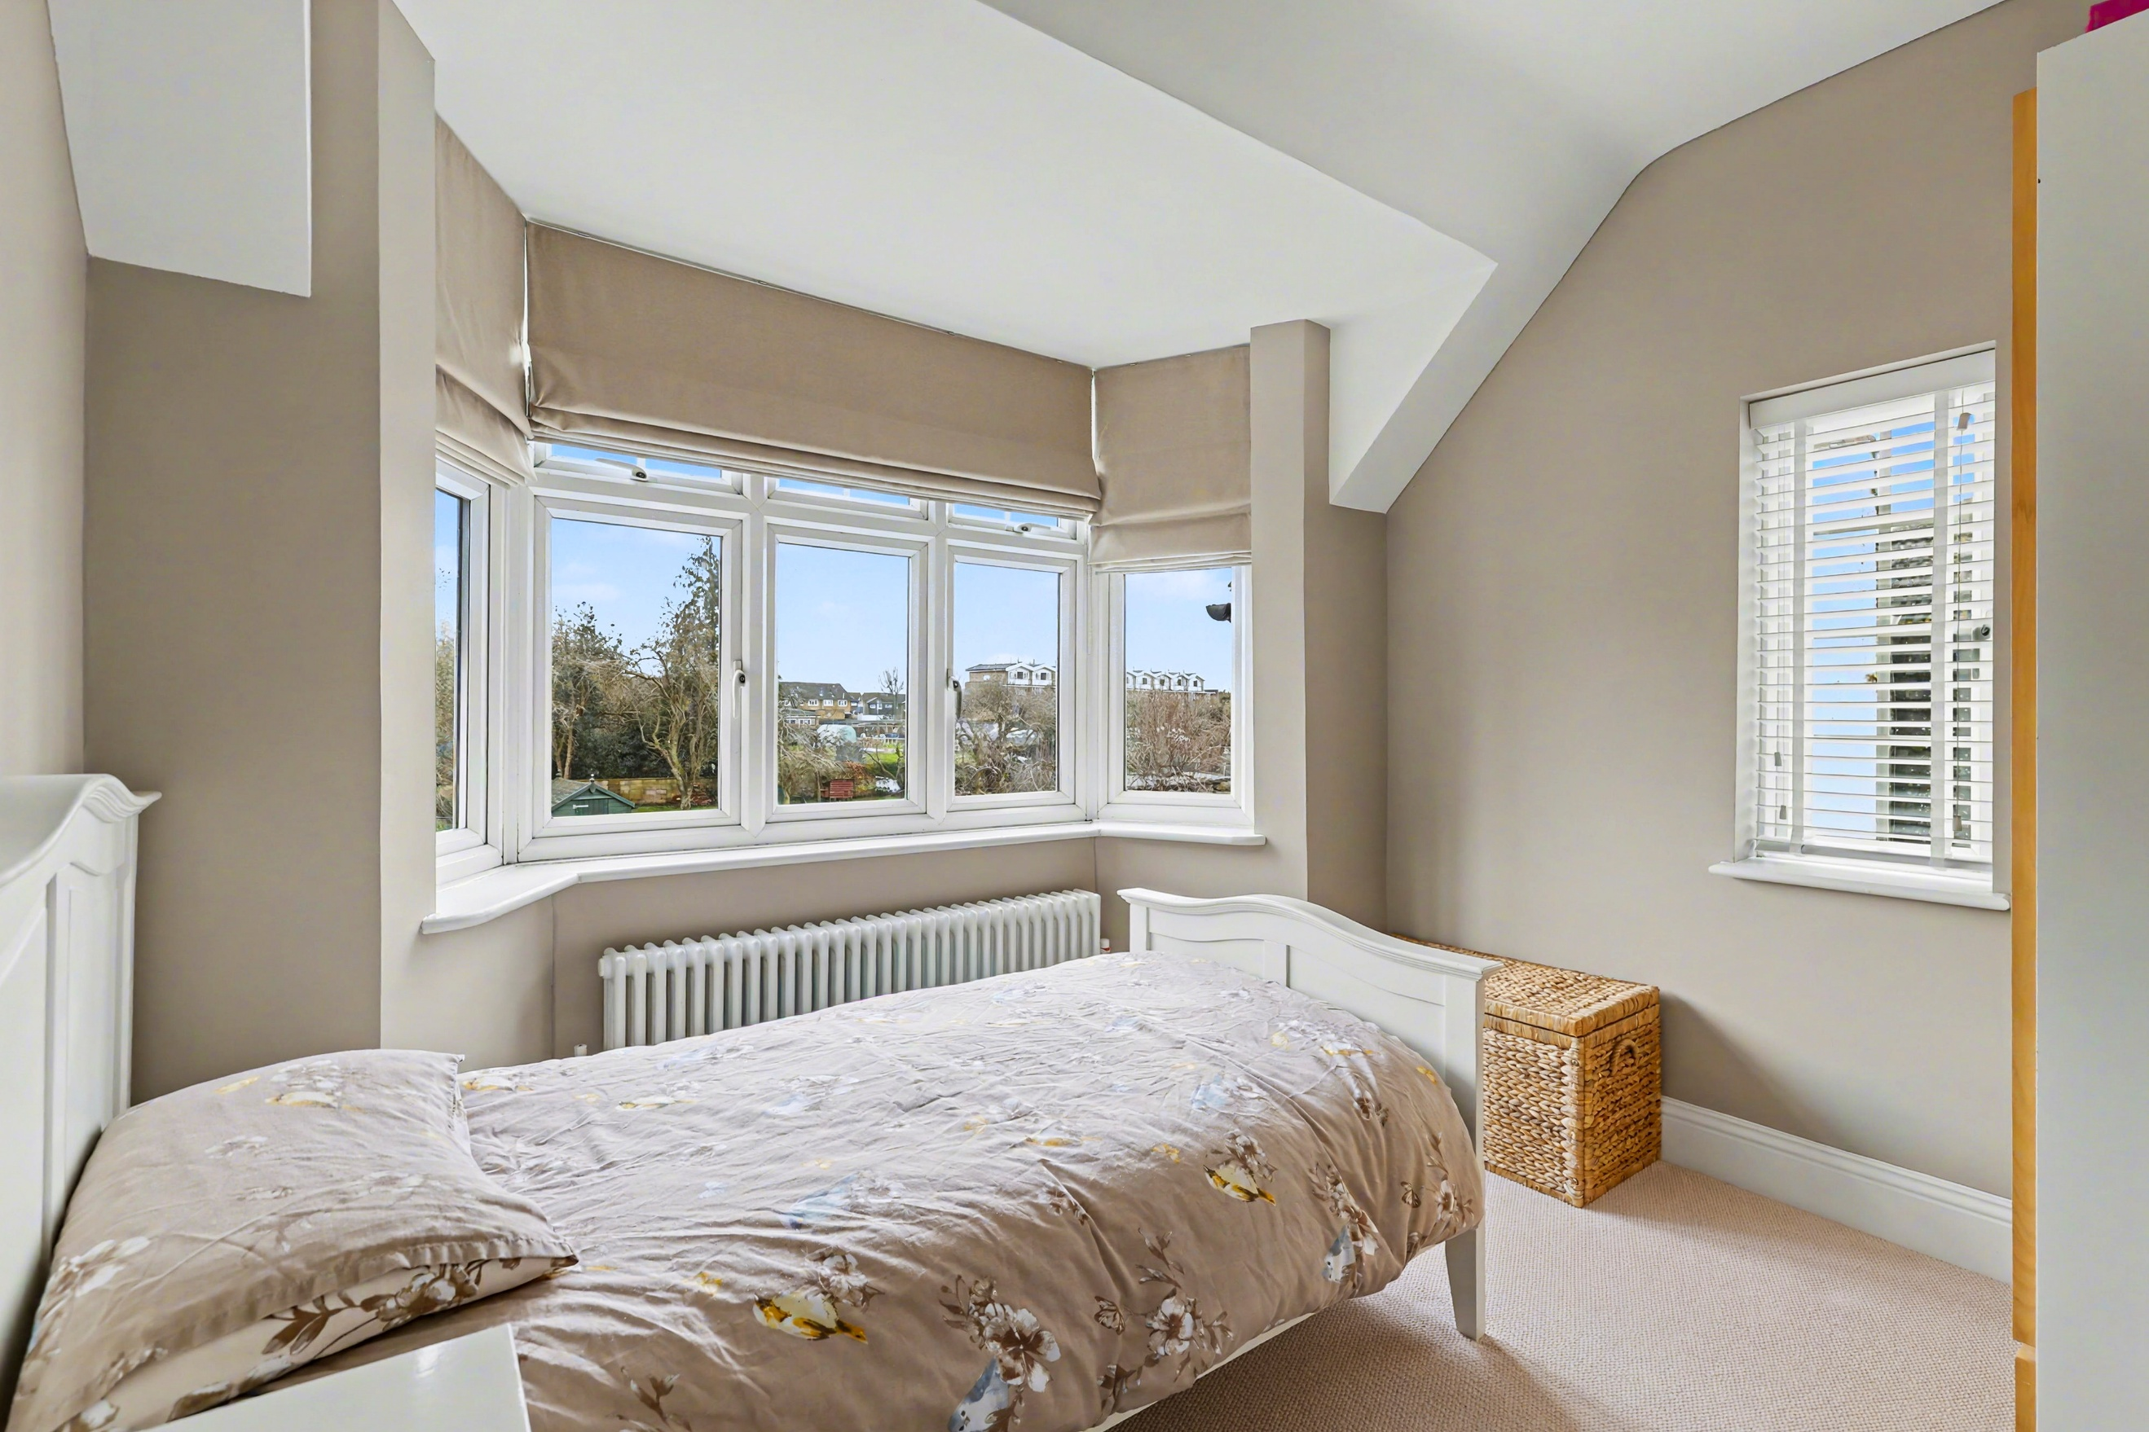
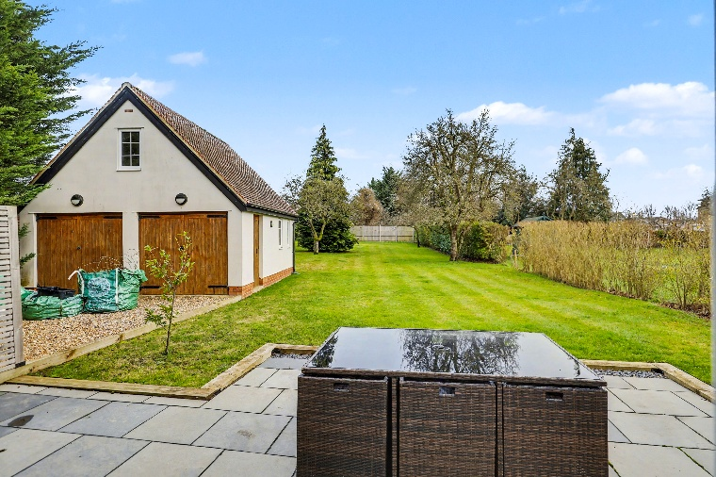
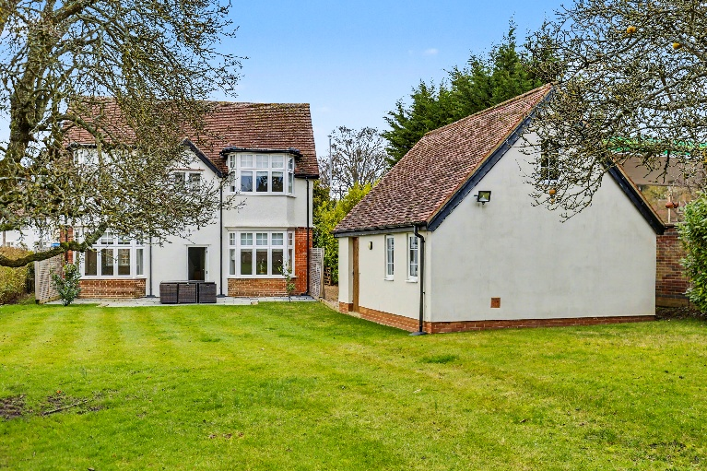
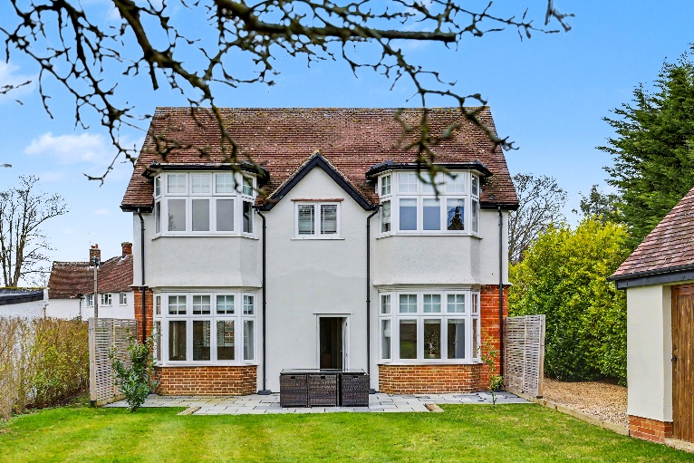
The property is approached via a generous gravel driveway providing ample off-road parking and leading to a detached double garage with attractive wooden doors. The front entrance is particularly inviting, featuring a handsome grey composite door set beneath a characterful red brick archway with contrasting white uPVC windows to either side.
The real jewel of this property is the exceptional rear garden – a truly expansive plot predominantly laid to lawn and offering a genuine sense of space and privacy. The beautifully maintained garden is bordered by mature trees and established hedging, creating a peaceful, semi-rural atmosphere whilst remaining close to local amenities.
A recently detached outbuilding provides excellent additional versatility, finished with rendered elevations beneath a tiled roof and featuring timber double doors, windows, and potential for use as a home office, studio, or hobby room. The paved patio area immediately adjoins the rear of the property, offering an ideal spot for outdoor entertaining and family gatherings.
The garden is thoughtfully landscaped with mature trees providing natural screening and interest throughout the seasons. The entire plot represents a rare opportunity to acquire such generous outside space, perfect for families, keen gardeners, or those seeking room for children and pets to play in safety. The property also offers fantastic scope to extend subject to planning which has previously been granted for a two-story extension.

Step Outside

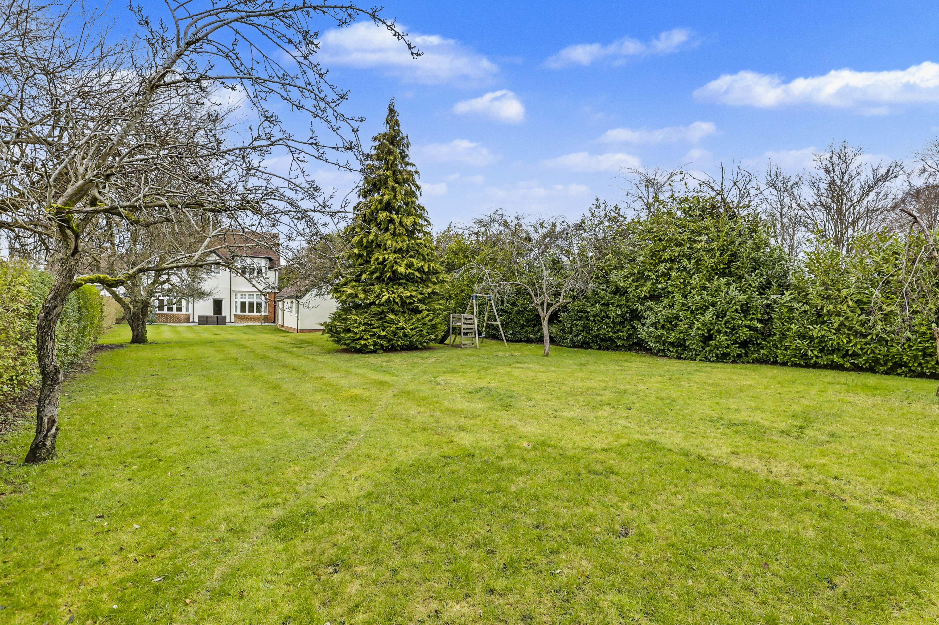

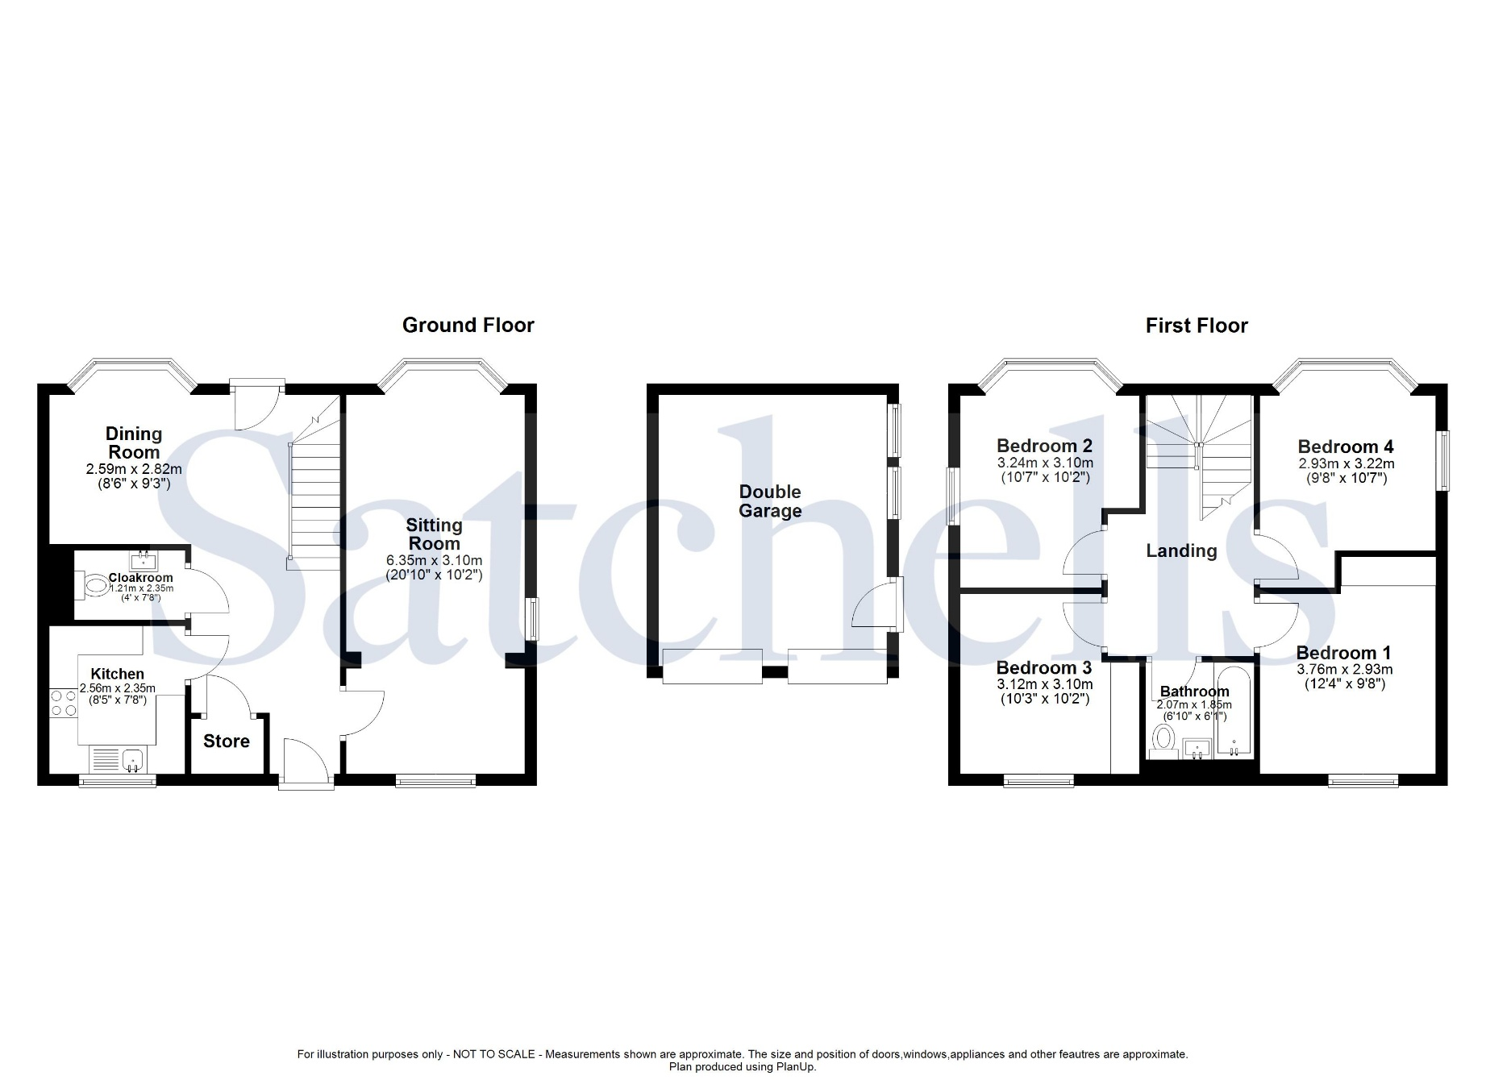

These particulars are a guide only and do not constitute an offer or a contract. The floorplan is for identification purposes only and not to scale. All measurements are approximate and should not be relied upon if ordering furniture, white goods and flooring etc. We have presented the property as we feel fairly describes it but before arranging a viewing or deciding to buy, should there be anything specific you would like to know about the property please enquire. Satchells have not tested any of the appliances or carried out any form of survey and advise you to carry out your own investigations on the state, condition, structure, services, title, tenure, and council tax band of the property. Some images may have been enhanced and the contents shown may not be included in the sale. Satchells routinely refer to 3rd party services for which we receive an income from their fee. If you would like us to refer you to one of these services, please ask one of our staff who will pass your details on. We advise you check the availability of the property on the day of your viewing.



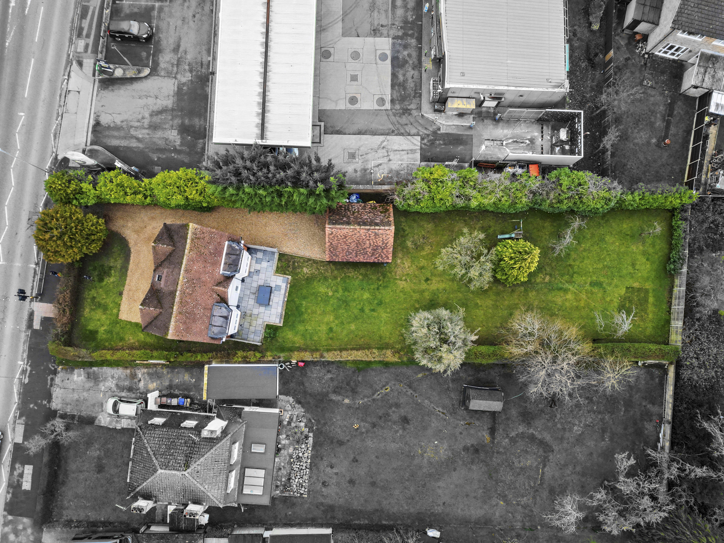
Station Place, Letchworth Garden City, Hertfordshire, SG6 3AQ.
01462 480077
letchworth@satchells.co.uk
www.satchells.com

