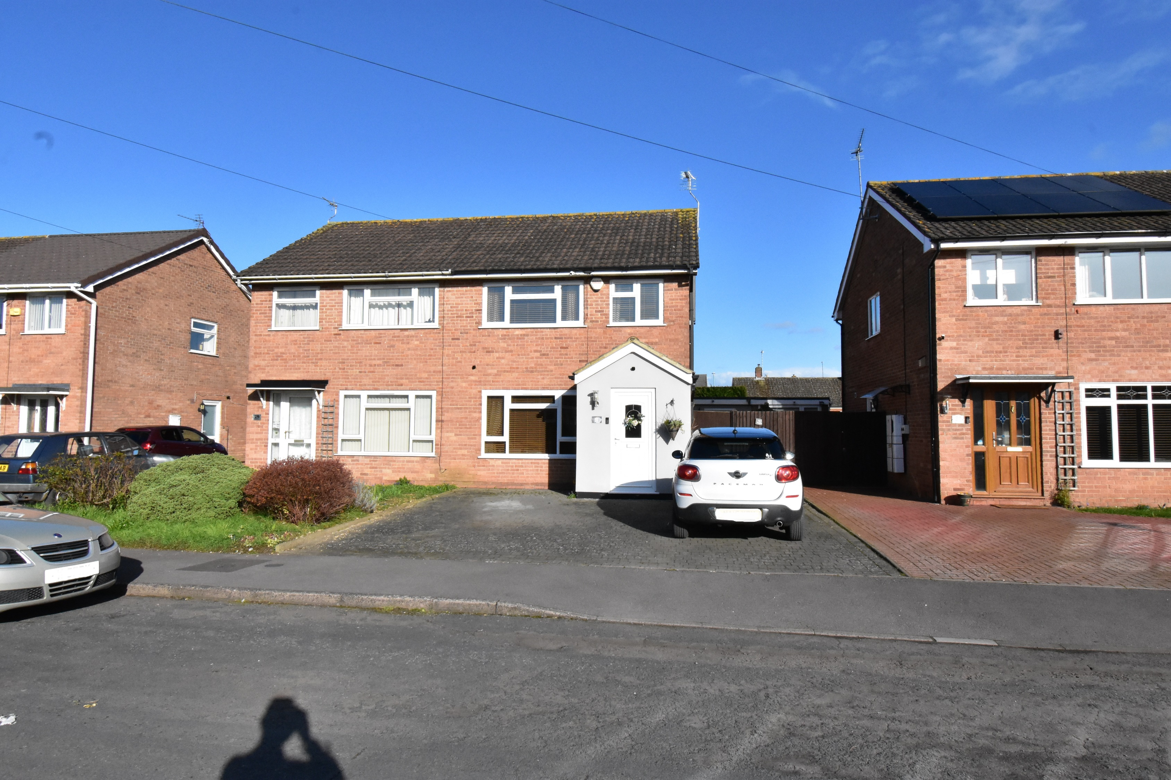



**01684 293246**



**Newtown**

**30 Knights Way, Newtown, Tewkesbury, GL20 8DY**

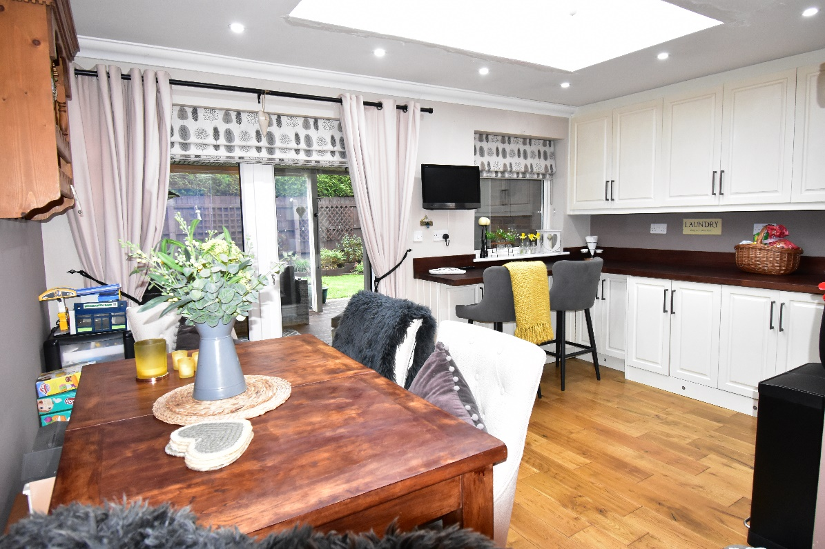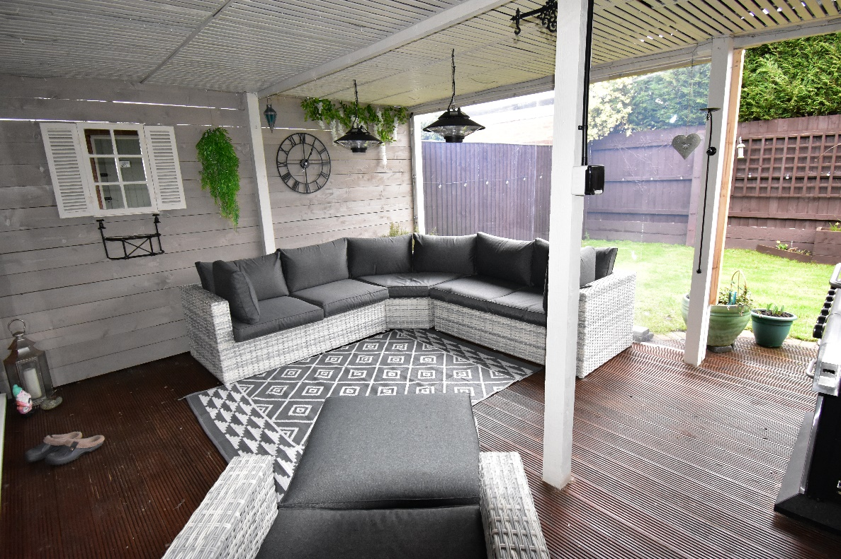

This is a beautifully presented semi detached home with the advantage of gated side access leading through to parking and access to the single garage.

A welcoming entrance porch leads into the property and to the dual aspect lounge on the left.

An extension across the rear of the property creates a lovely kitchen/dining room with a snug/sitting area.

Completing the accommodation on the ground floor is a guest wc.

On the first floor there are three bedrooms and a bathroom. The contemporary styled bathroom comprises of a p shaped bath with shower over, vanity unit with inset wash basin and low level wc.

Outside there is a great covered, decked veranda creating the perfect garden room. The rear garden is laid to lawn with decked patio area and gated access to the front of the property. At the front there is a blocked paved drive creating additional off road parking spaces.

Throughout the property has the benefit of upvc double glazing, under floor heating on the ground floor and a gas fired boiler.

To the side of the property is the original garage which the current vendors have turned into a store room and workshop, benefitting from power and light.

Newtown is a sought after area of the town being with easy access to the centre, bus routes and the motorway and rail networks.

Locally it has a convenience store, primary and senior school, and parks and walks with open countryside within minutes of the front door.

Tewkesbury is centrally located on J9 M5 motorway, between Cheltenham, Worcester and Gloucester.

Centrally situated between Cheltenham (10 miles), Worcester (18 miles), Gloucester (11 miles) M5 J9 (1.5 miles) Ashchurch Station (2 miles) it is an excellent commuting base.

**Ground Floor**

Lounge 13’4”x9’11”

Open Plan Living room

Kitchen 11’11”x6’11”

Dining 14’6”x8’11”

Snug 10’11”x8’4”

Guest wc

**First Floor**

Bedroom 1 13’8”x9’3”

Bedroom 2 11’x9’10”

Bedroom 3 6’9”x6’7”

Bathroom 8’x5’10”

**Outside**

Covered Veranda

Single Garage

**Tewkesbury Borough Council Tax Band C**

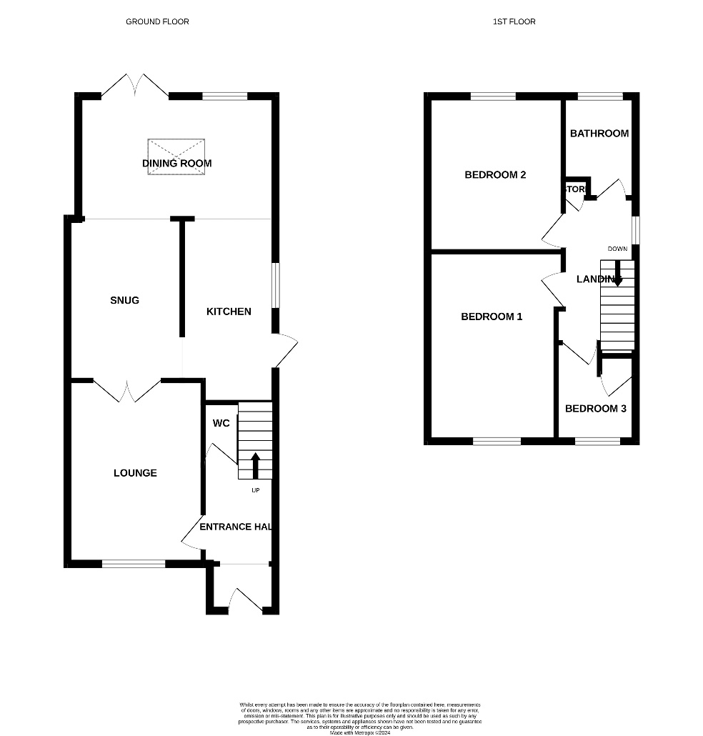

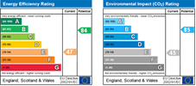

**Guide Price £340,000 Freehold**

**01684 293 246**

**www.engallcastle.com**



**Viewing strictly by arrangement with Engall Castle Ltd**  
155 High Street Tewkesbury Gloucestershire GL20 5JP

Office hours: Mon – Fri 9am to 6pm, Sat 9am to 4pm

**email: sales@engallcastle.com**

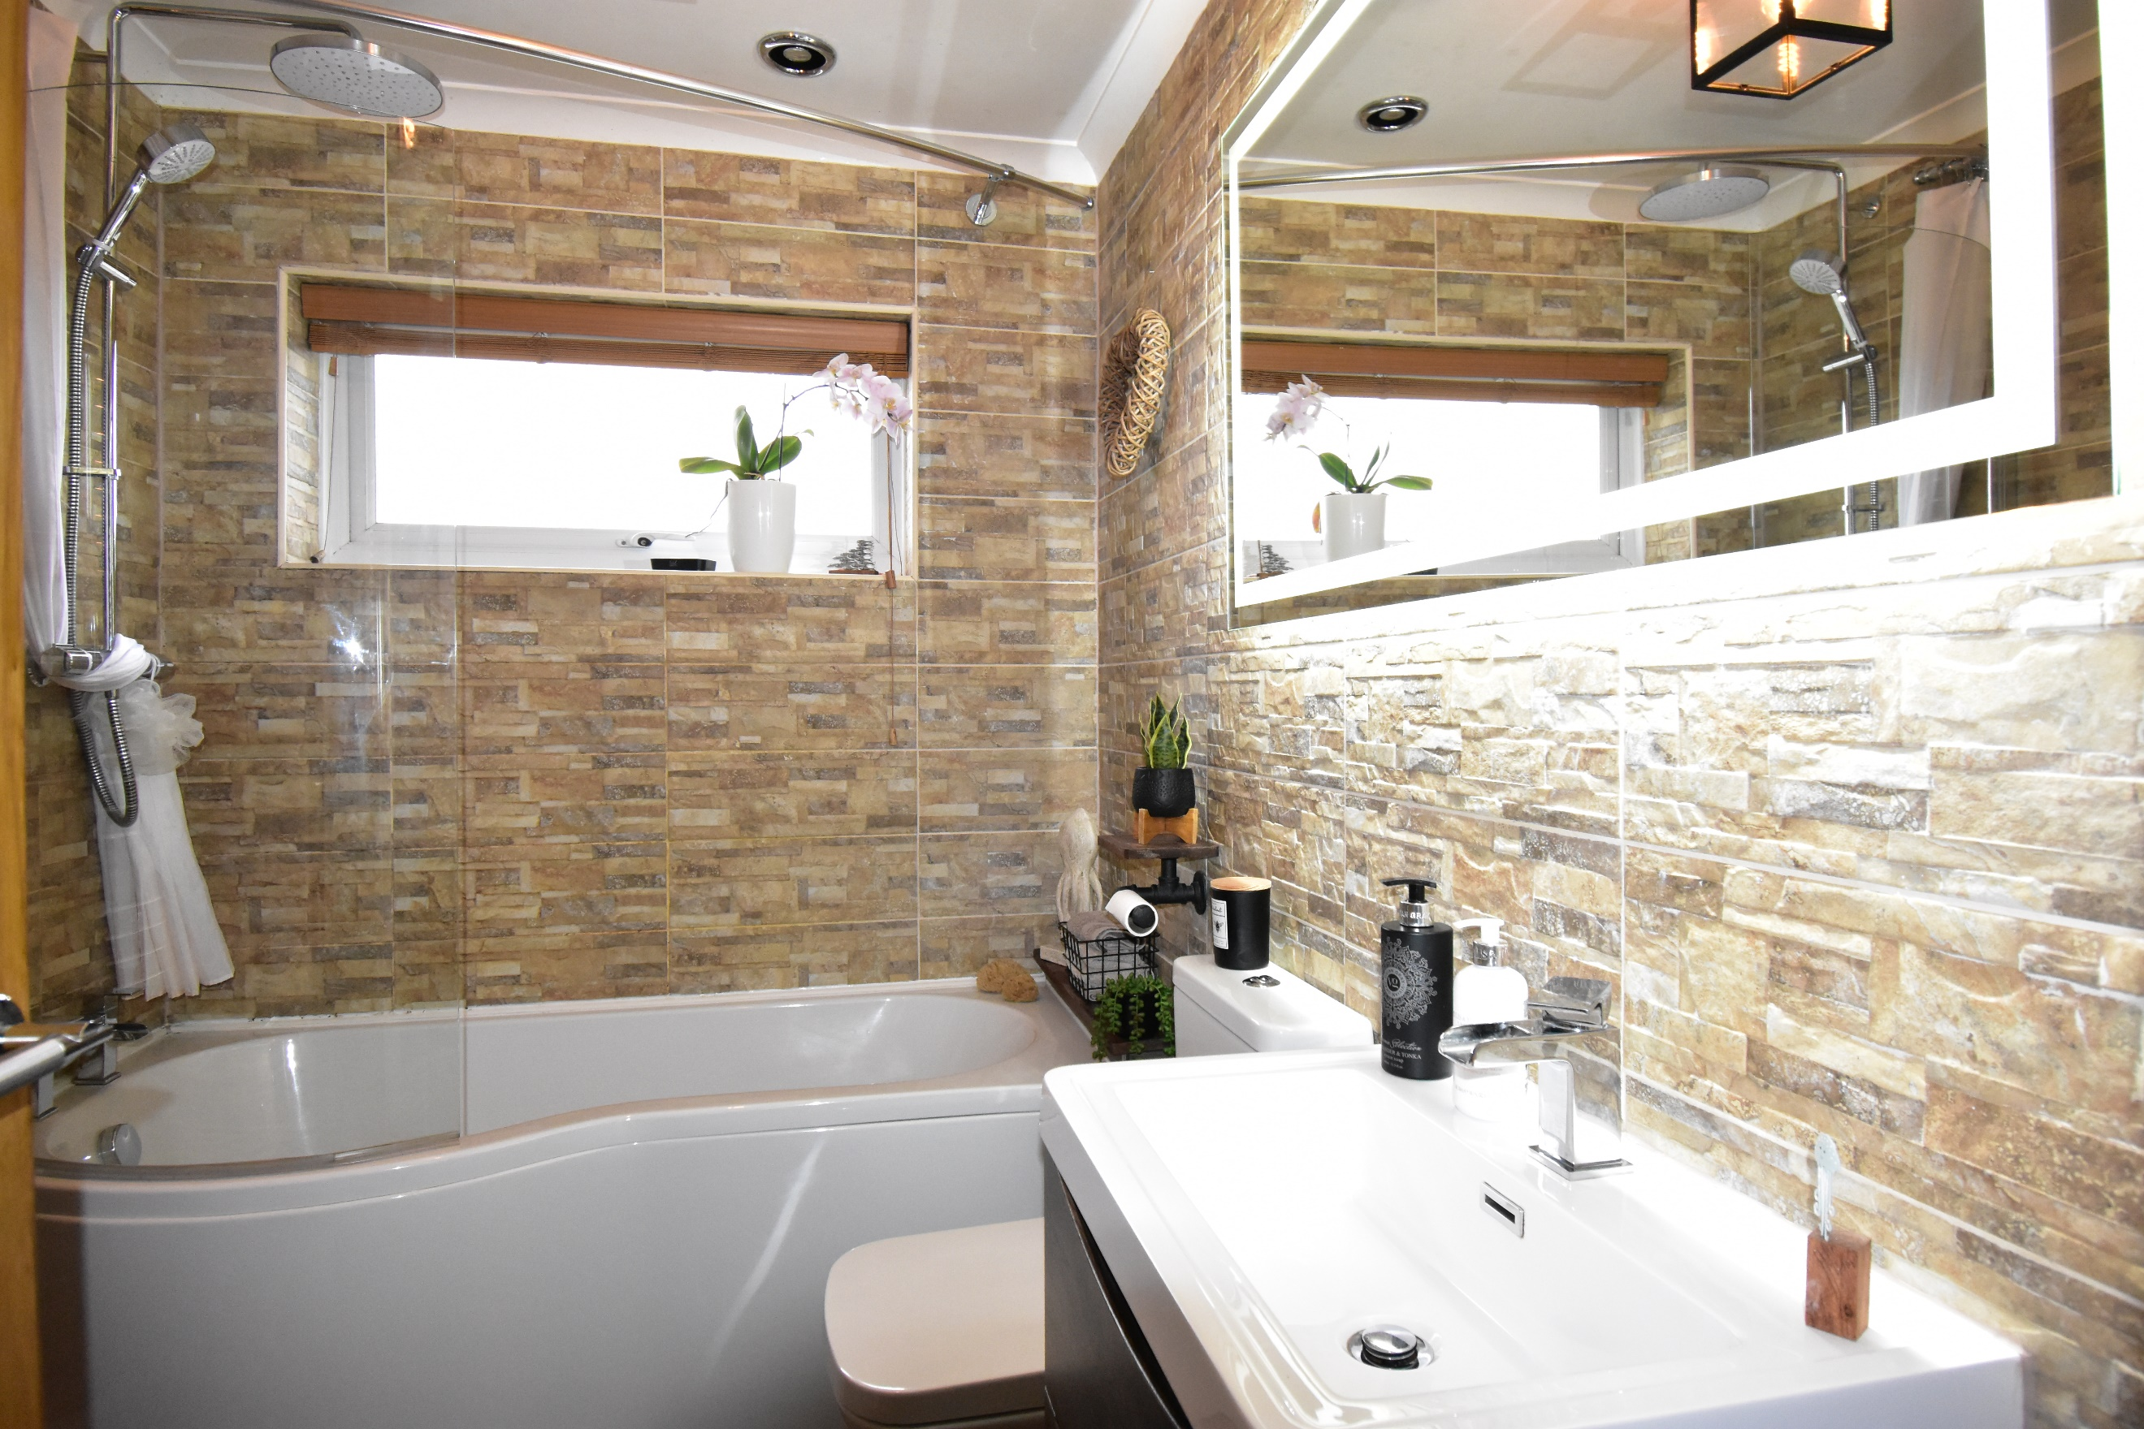

This floorplan is provided for guidance only as an approximate layout of the property and should not be relied upon as a statement of fact.

**Agents Note**

These property details are set out as a general outline only and do not constitute any part of an Offer or Contract. Any services equipment, fittings or central heating systems have not been tested and no warranty

is given or implied by Engall Castle Ltd that these are in working order. Buyers are advised to obtain verification from their solicitor or surveyor. Fixtures and fittings or other items are not included

unless specifically described. All measurements, distances and areas are approximate and for guidance only and should not be relied upon for the purposes of fitting carpets or furniture etc.

These property details and all statements within this document are provided without responsibility on behalf of Engall Castle Ltd or its employees or representatives and should not be relied on as statements

of fact. Prospective purchasers must satisfy themselves as to the accuracy of all details pertaining to the property.

