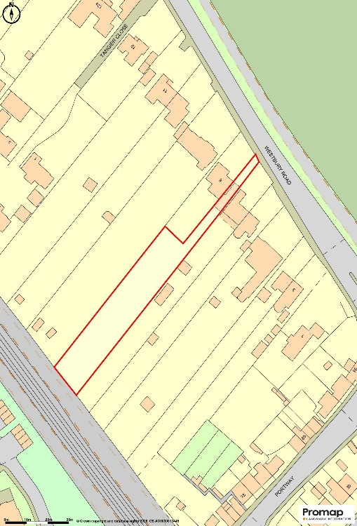
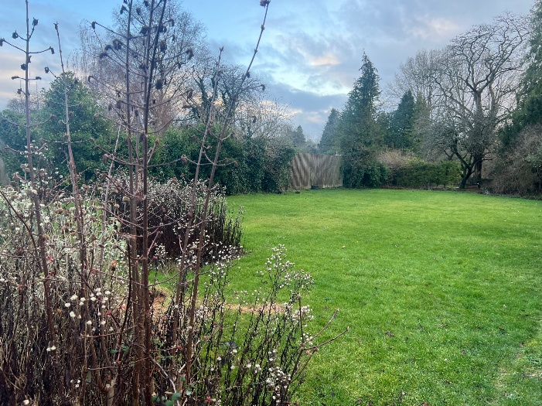
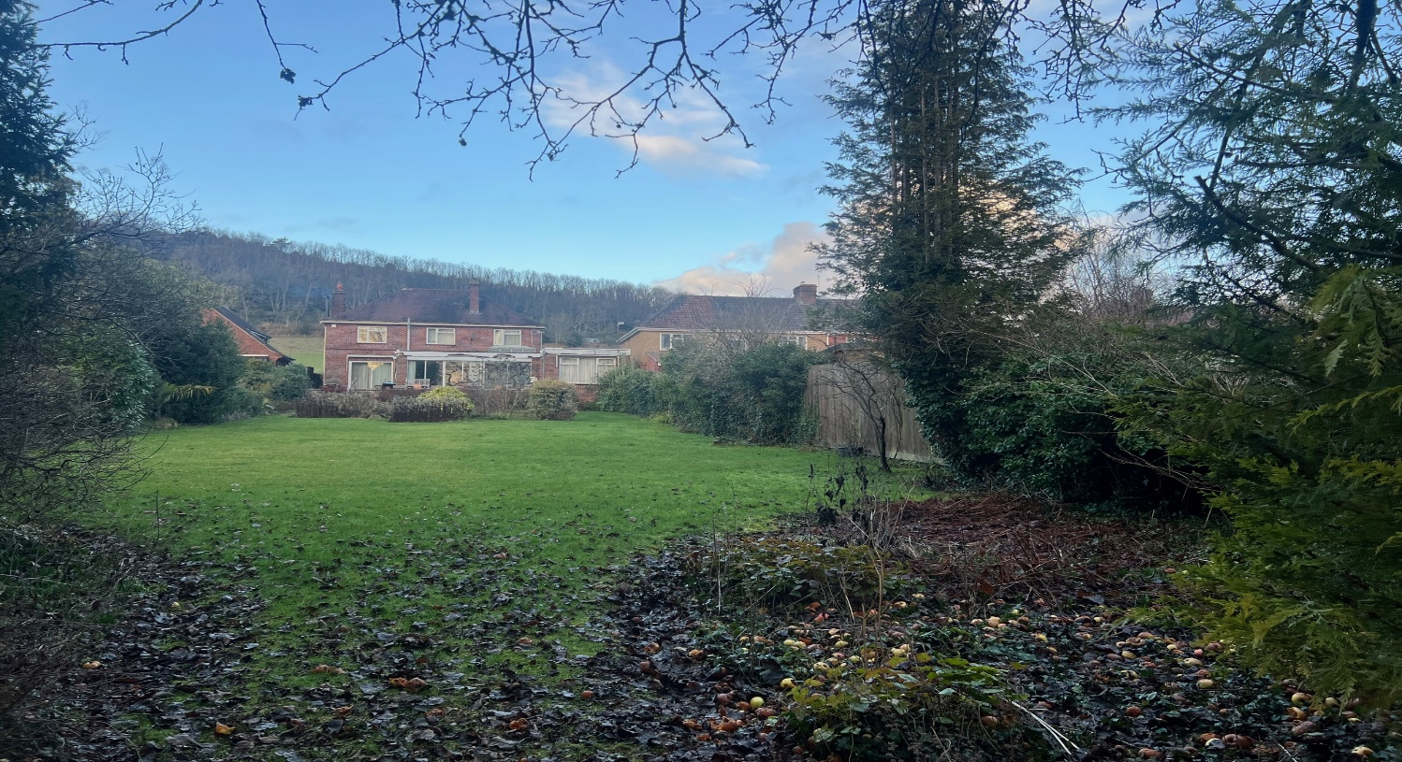
Land rear of 8 Westbury Road, Warminster
SALE AGREED
Residential development site with full Planning for 2 detached dwellings and 3 pitched roof garages

