Chestnut Barn, 25a Church Street, Semington, Trowbridge, Wilts, BA14 6JS bBBA12Warminster, Wiltshire, BA12 8AH
Guide Price - £645,000 Freehold

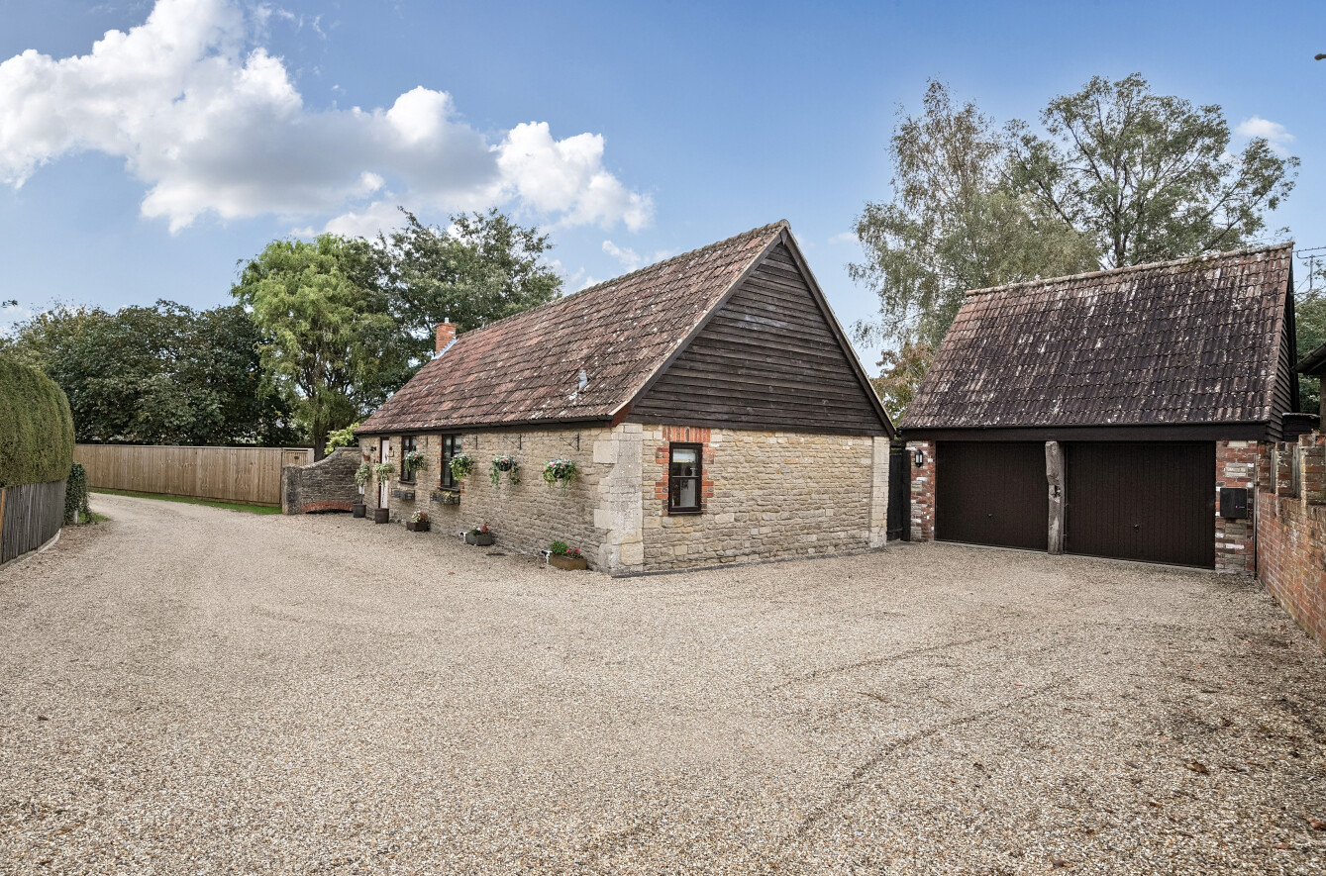
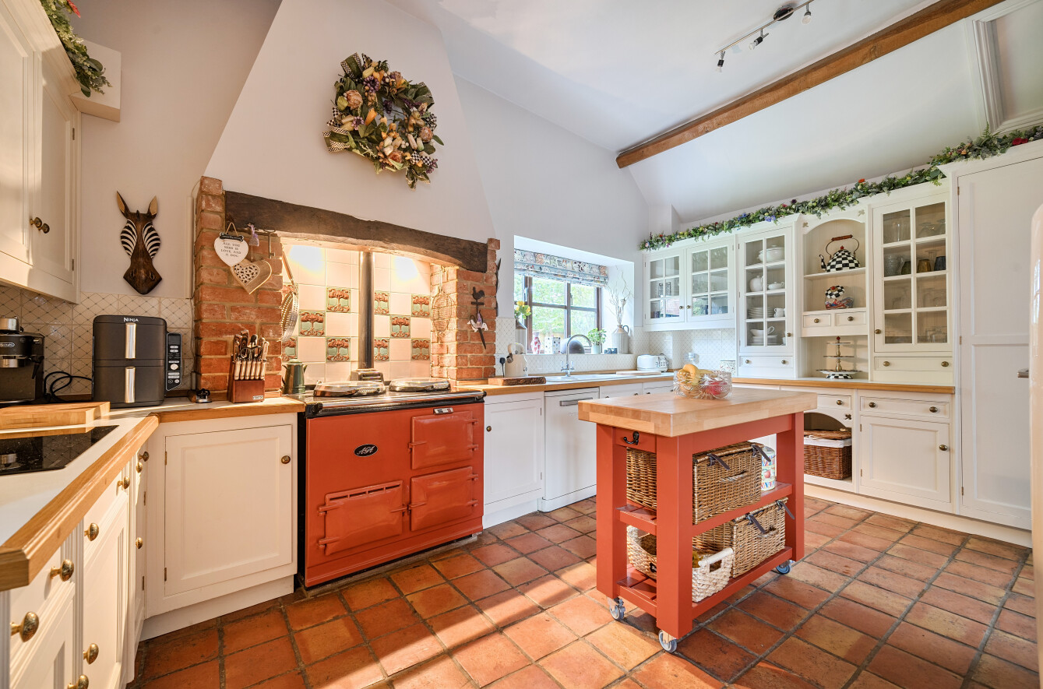
Chestnut Barn is an exceptional barn converted in 1990, which was formally the stable block for the historic 17th century ‘Old Coach House’ in Semington. It boasts character and charm throughout with the original ceiling beams and has been tastefully updated by its current owners. The barn is tucked away down a quiet lane and is surrounded by open countryside right on its doorstep. It really is a ‘Perfect Home/ Retreat’. The accommodation is on the ground level throughout offering a large kitchen/dining room with high ceilings and beams with a country feel. The focal point is the feature chimney breast with a Range electric cooker. There is a beautiful, handmade fitted kitchen with plenty of cupboards and work surfaces, in addition there is a centre island. An Orangery with skylights and double-glazed doors provides plenty of light with views to the garden. An inner hall with a double-glazed stable door to the garden. The sitting room is a fantastic room with a feature fireplace. There are views to the different aspects of the gardens from here. Double glazed French doors open out into the courtyard and garden. Leading from the Orangery there is a hallway where you will find a spacious bathroom newly fitted with a large shower. You will then find bedrooms 1 and 2 both designed with built in cupboard space. The main bedroom has an en- suite bathroom. All the downstairs is a mixture of tiles and Manor Oak LVT flooring. Bedroom 3 is located over the double garage and has a separate WC. This has potential to be used as an annex or an opportunity to be used for a holiday let as it has its own private entrance. NO ONWARD CHAIN.
Outside- A double garage with electric charging points and additional driveway parking and gated access to the side. The barn is surrounded by extensive gardens all around it. Offering a courtyard and patio, with a long pergola it has a real Mediterranean feel to it. The vast gardens have several areas, a large lawn area round to the side and front with a summer house/ cabin, there is a gate giving direct access to the field and a gate to the front. The large lawn at the back is full of borders stacked with roses and shrubs and trees. A gate leads into the ‘Secret Garden’ in here you will find an area of lawn, a garden shed and access to a wooded area which could easily be used as an allotment. From the patio, steps lead up to give access to Bedroom 3 which has its own entrance. The gardens are totally secure, for pets and children with private fencing and back onto open fields.

.
Viewing – By appointment only

(

Chestnut Barn, 25a Church Street, Semington, Trowbridge, Wilts, BA14 6JS
 3  2  2 EPC D
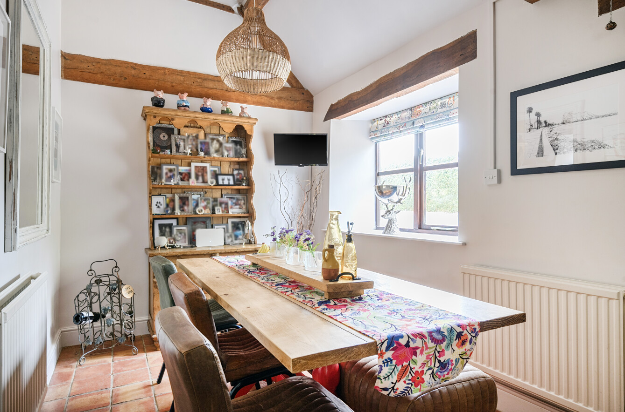
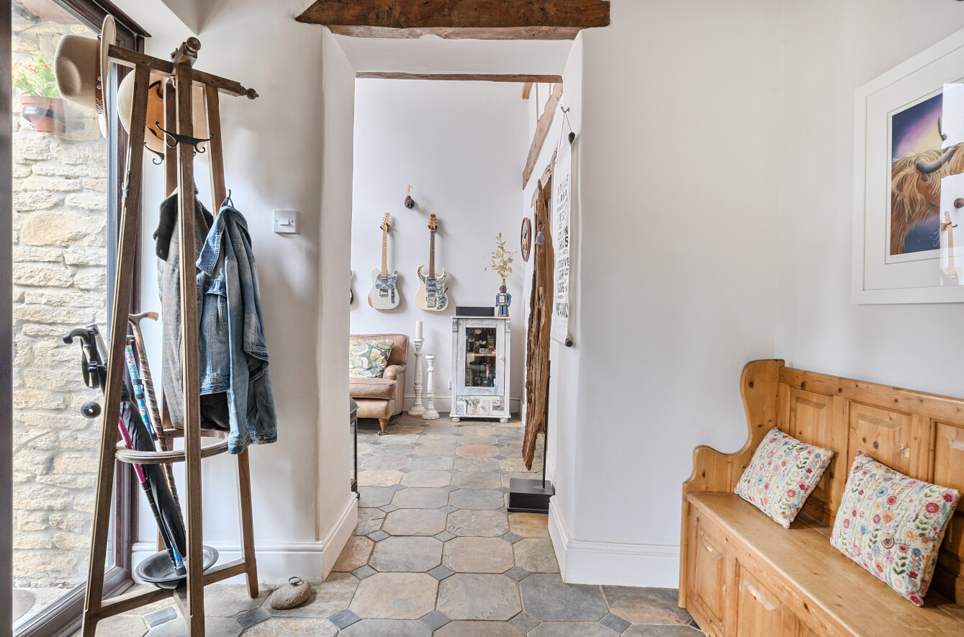
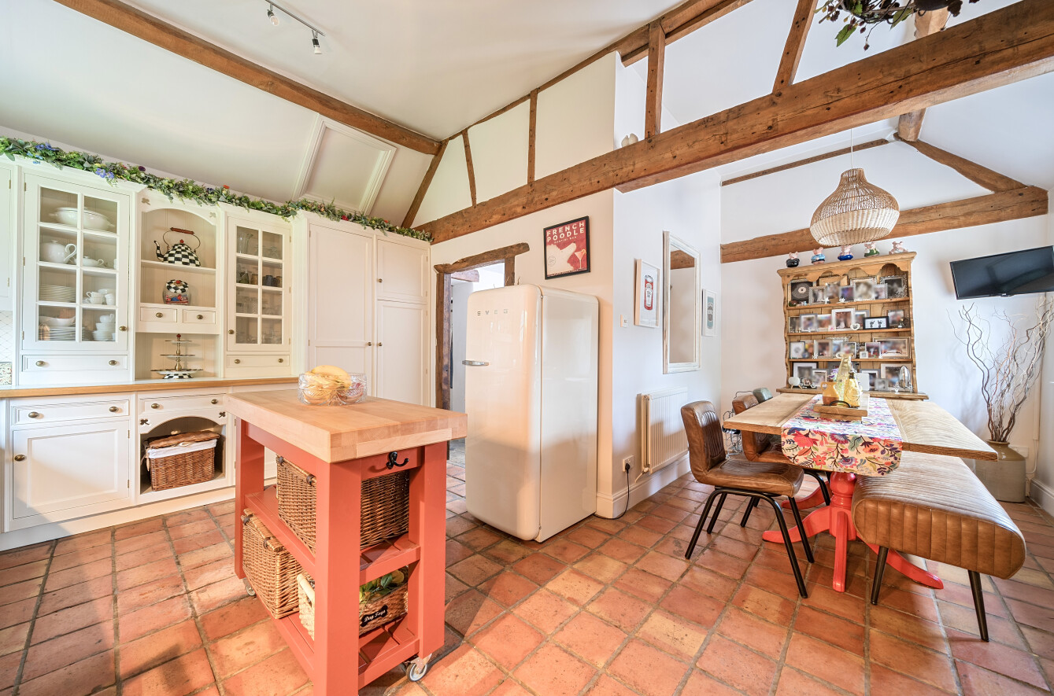
Guide Price - £660,000 - Freehold
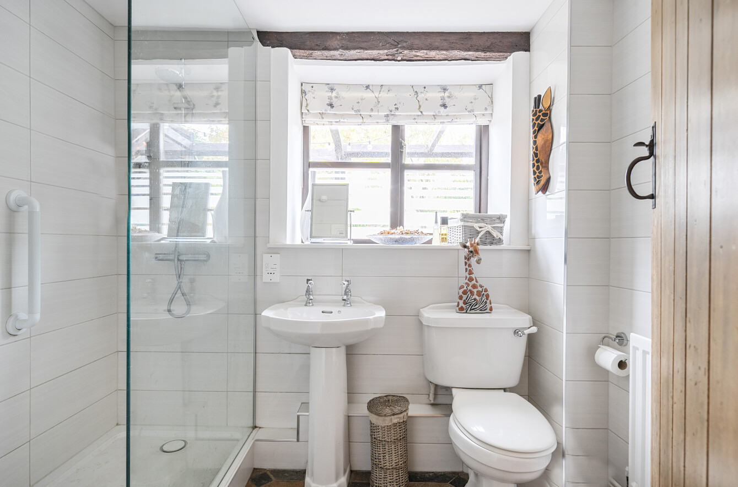
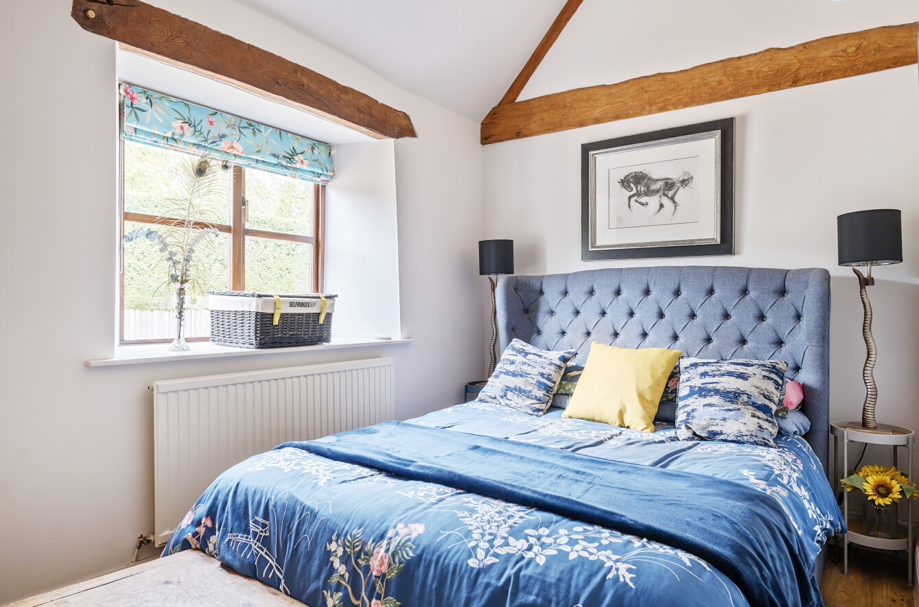
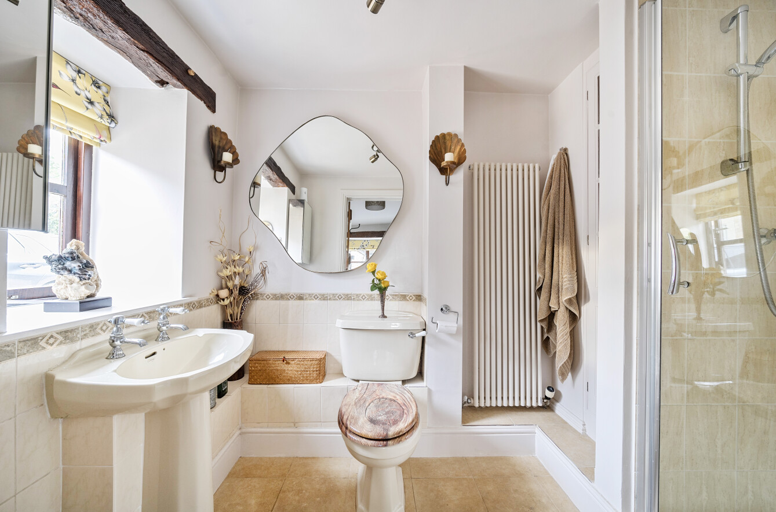
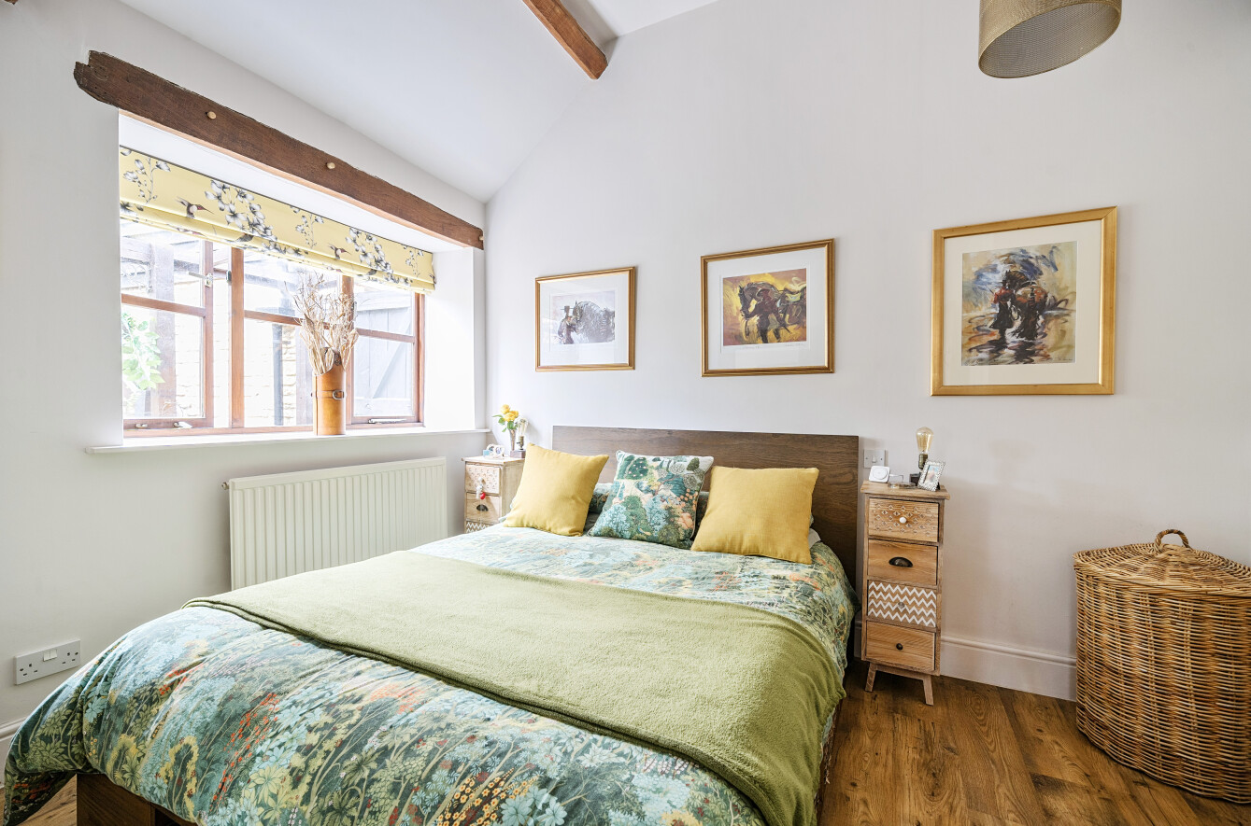
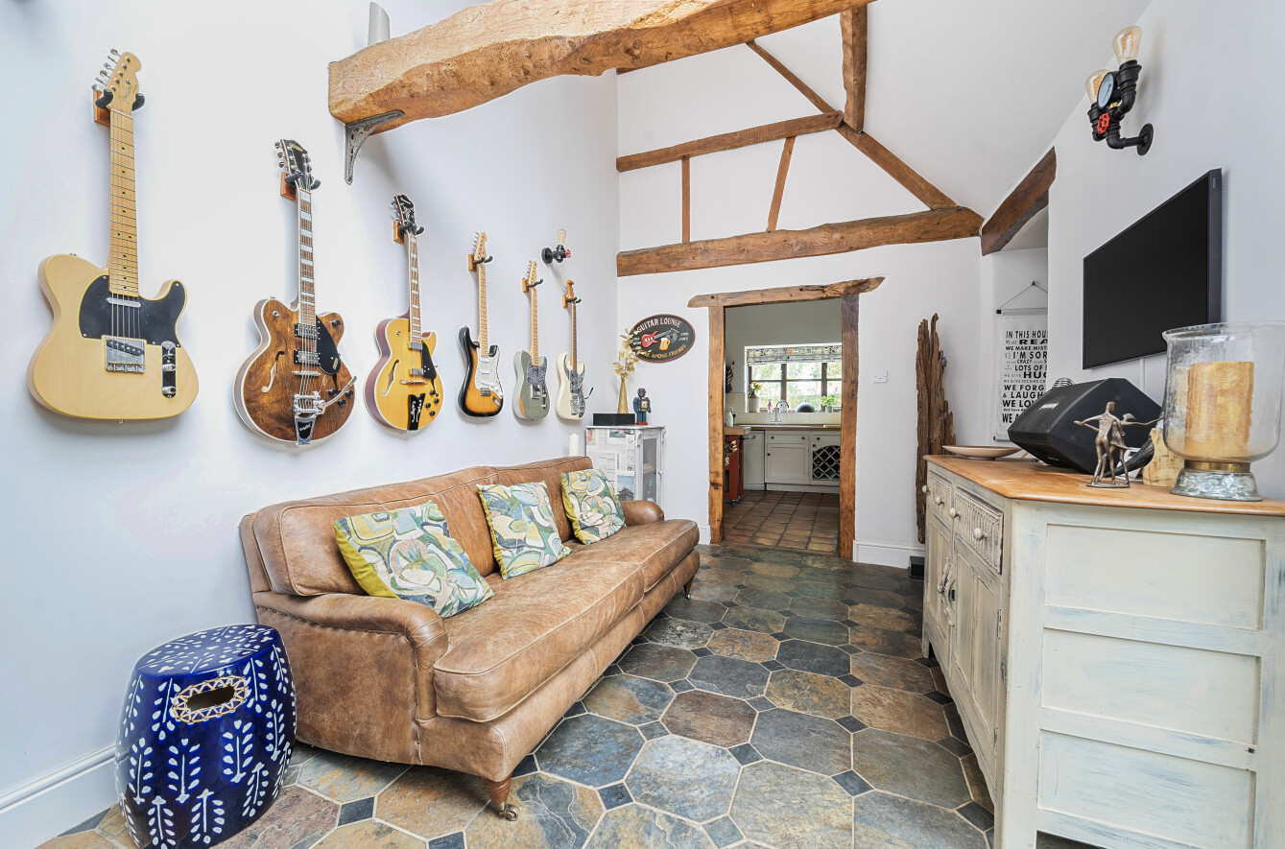
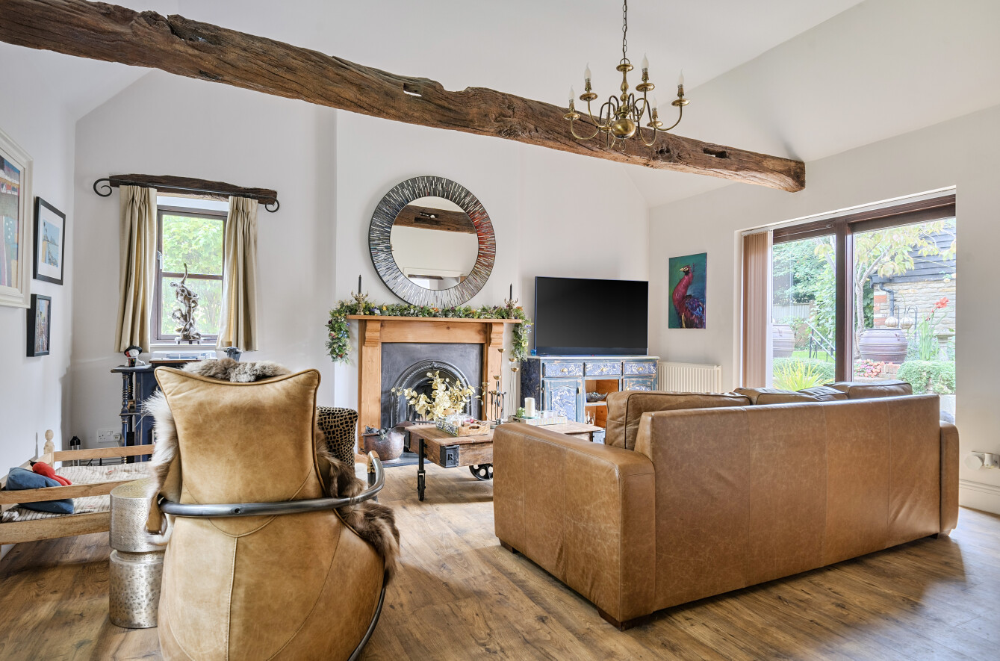
Local Information
Local Council: Wiltshire Council
Council Tax Band: E
Heating: Electric Heating
Services: Main water and drainage
Tenure: Freehold

Location

Semington is a village and civil parish in Wiltshire, England. The Village s located about 2 miles south of Melksham and about 3 miles northeast of Trowbridge. The parish includes the hamlets of Little Marsh and Littleton.

The Village has two locks on the Kennet and Avon Canal, known as the Semington Locks.

Within the Village there are over 500 houses, a primary school, a village hall, public tennis courts and a park for children. Semington has a pub, The Somerset Arms, an 18th – century building.

 Motorway Links
- A303/M3/A361/A350
- M4
 Train Links – From Trowbridge to:
- London (Paddington / Waterloo)
- Salisbury
- Westbury, Trowbridge, Bath, Bristol
 Nearest Schools
- Trowbridge

