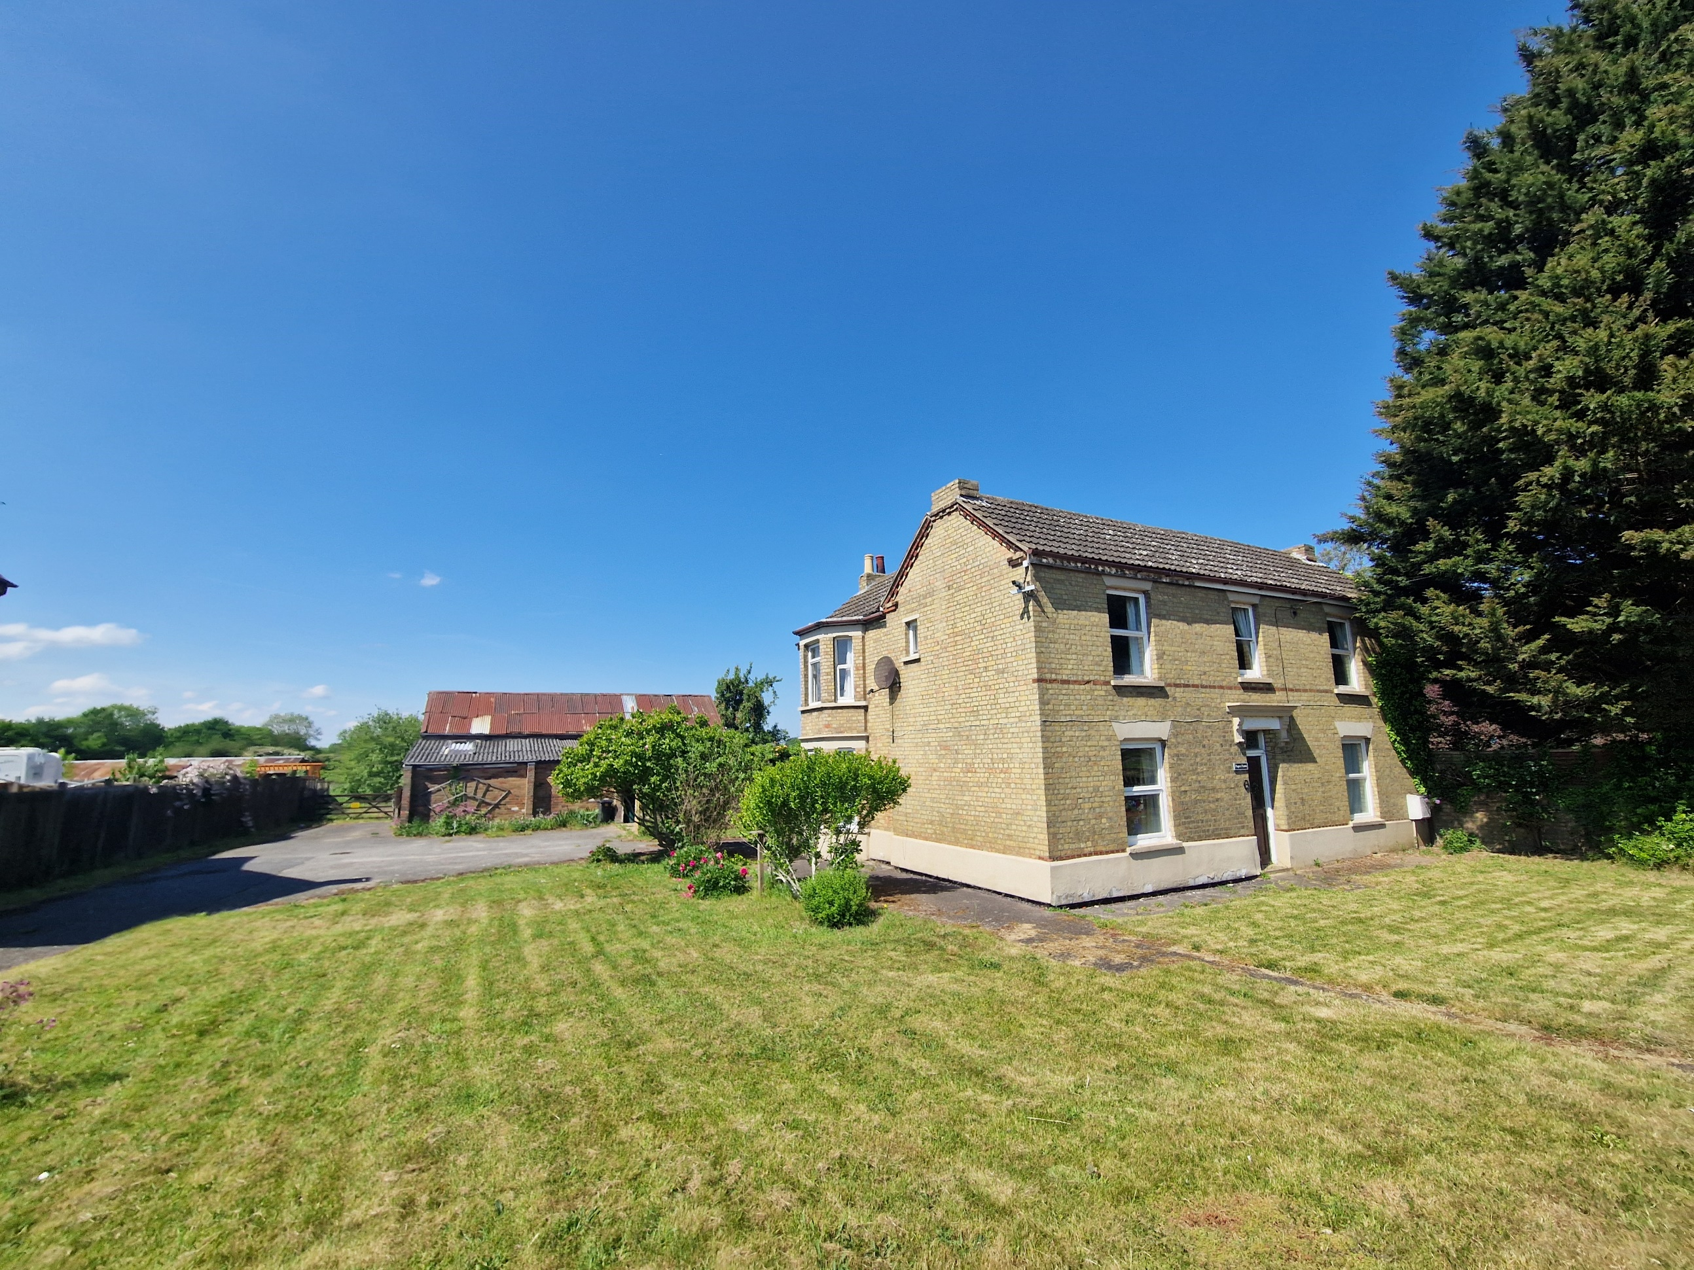
Tempsford Road, Sandy, SG19 2AE

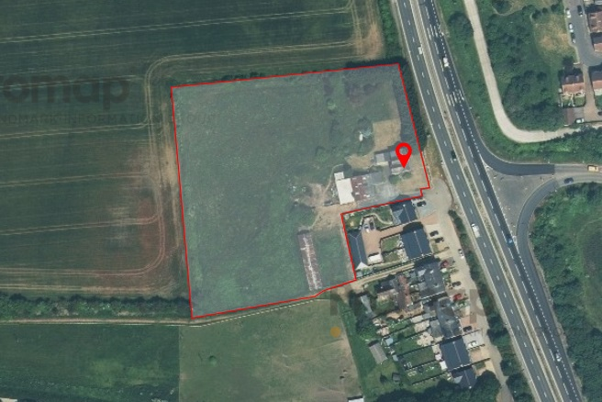
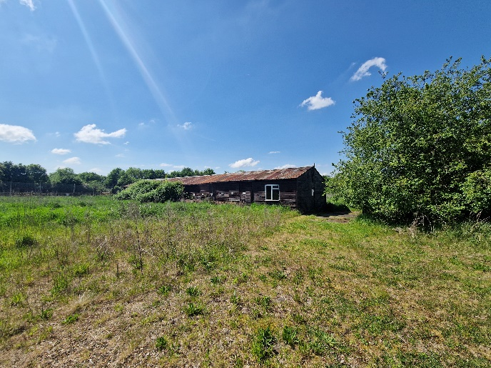
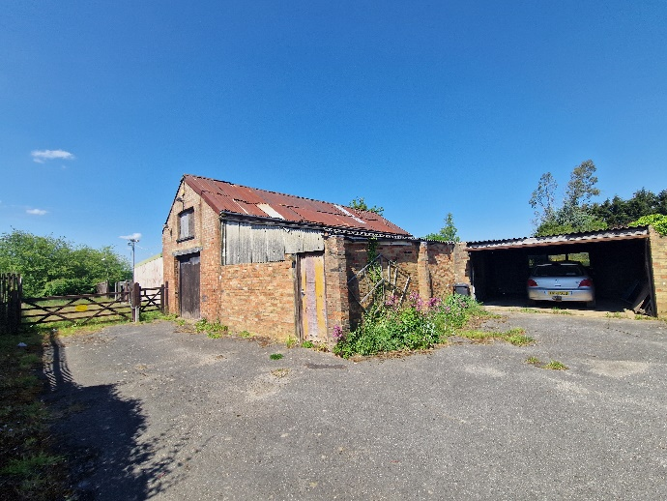
Pope’s Farm
DEVELOPMENT OPPORTUNITY!

The Existing four-bedroom detached house measures approximately 2,076 SQ.FT and requires complete renovation throughout. Currently sitting on a plot of approximately 2.8 Acres. Internally the accommodation briefly comprises an entrance hallway, 27FT living room, dining room, snug, kitchen, utility room, downstairs cloakroom, and office. Upstairs you will find four bedrooms and a large family bathroom. Externally there is a large detached barn, previously used to run a business, double garage and a further barn style building set up for Boarding kennels, where a business used to also run.

The planning permission CB/23/00913/FULL permits the demolition of the existing kennels and build Two, Two bedroom detached bungalows each measuring approximately 890 SQ.FT.

The following planning application CB/25/00624/FULL has also been granted and permits the demolition of the existing barn and build a Four-bedroom detached house measuring approximately 1,862 SQ.FT with garage.

The existing property will be left with a plot of around 2 Acres after the builds are complete.

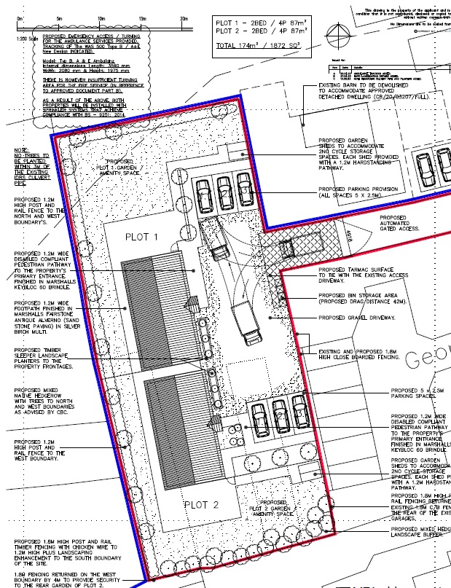
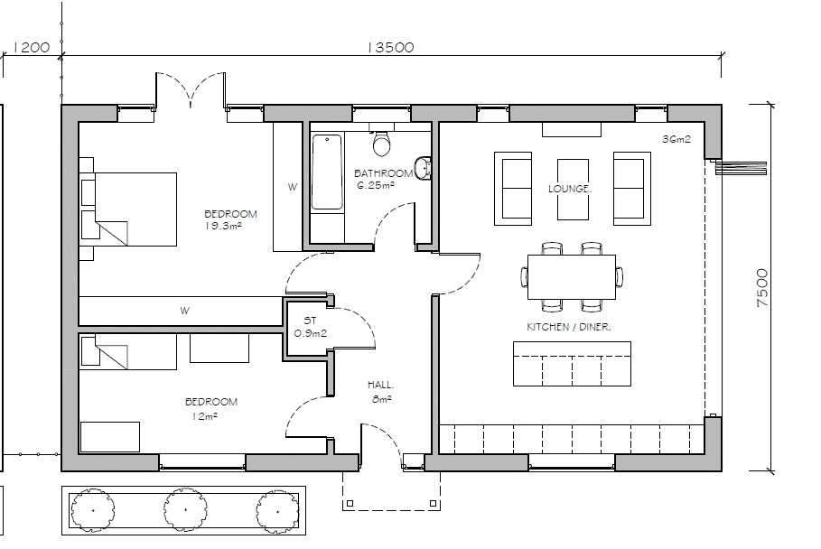
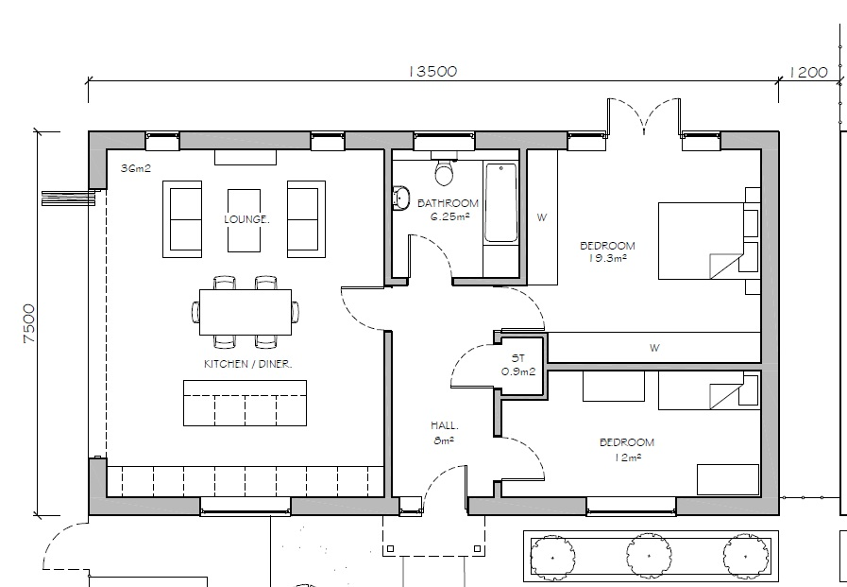
Planning Application granted

CB/23/00913/FULL
Plot 2

Plot 1
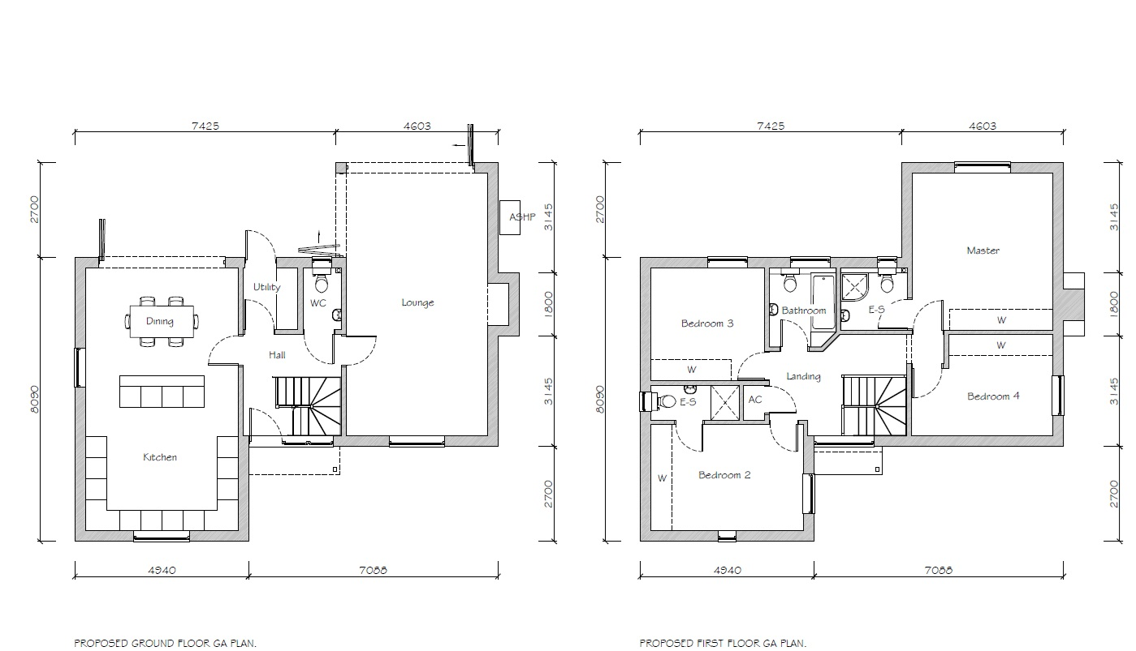
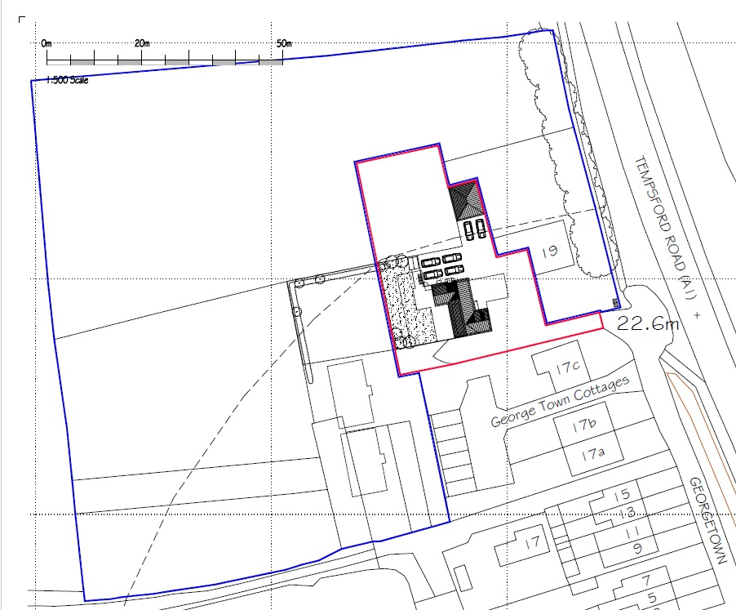
Planning Application – granted

CB/25/00624/FULL

The Local Area

This property is located to the west of Sandy just a short walk to the local lower school and convenience store. If you are fond of nature and walks you will love the Sandy 'Sand Hills' and the popular RSPB nature reserve set within 100 acres of nature reserve with 5 miles of woodland trails to enjoy.

Nation Cycle route 51 runs close to the property offering beautiful cycling and walking routes to the Willington Danish camp and beyond.

Sandy itself is conveniently located just off of the A1(m) and its mainline train station links to Peterborough and London Kings Cross, St Pancras. The town centre offers a variety of shops, cafes, hairdressers, and restaurants. Within the town, there is also a church, a range of schools, a leisure centre, dentists, and doctors.
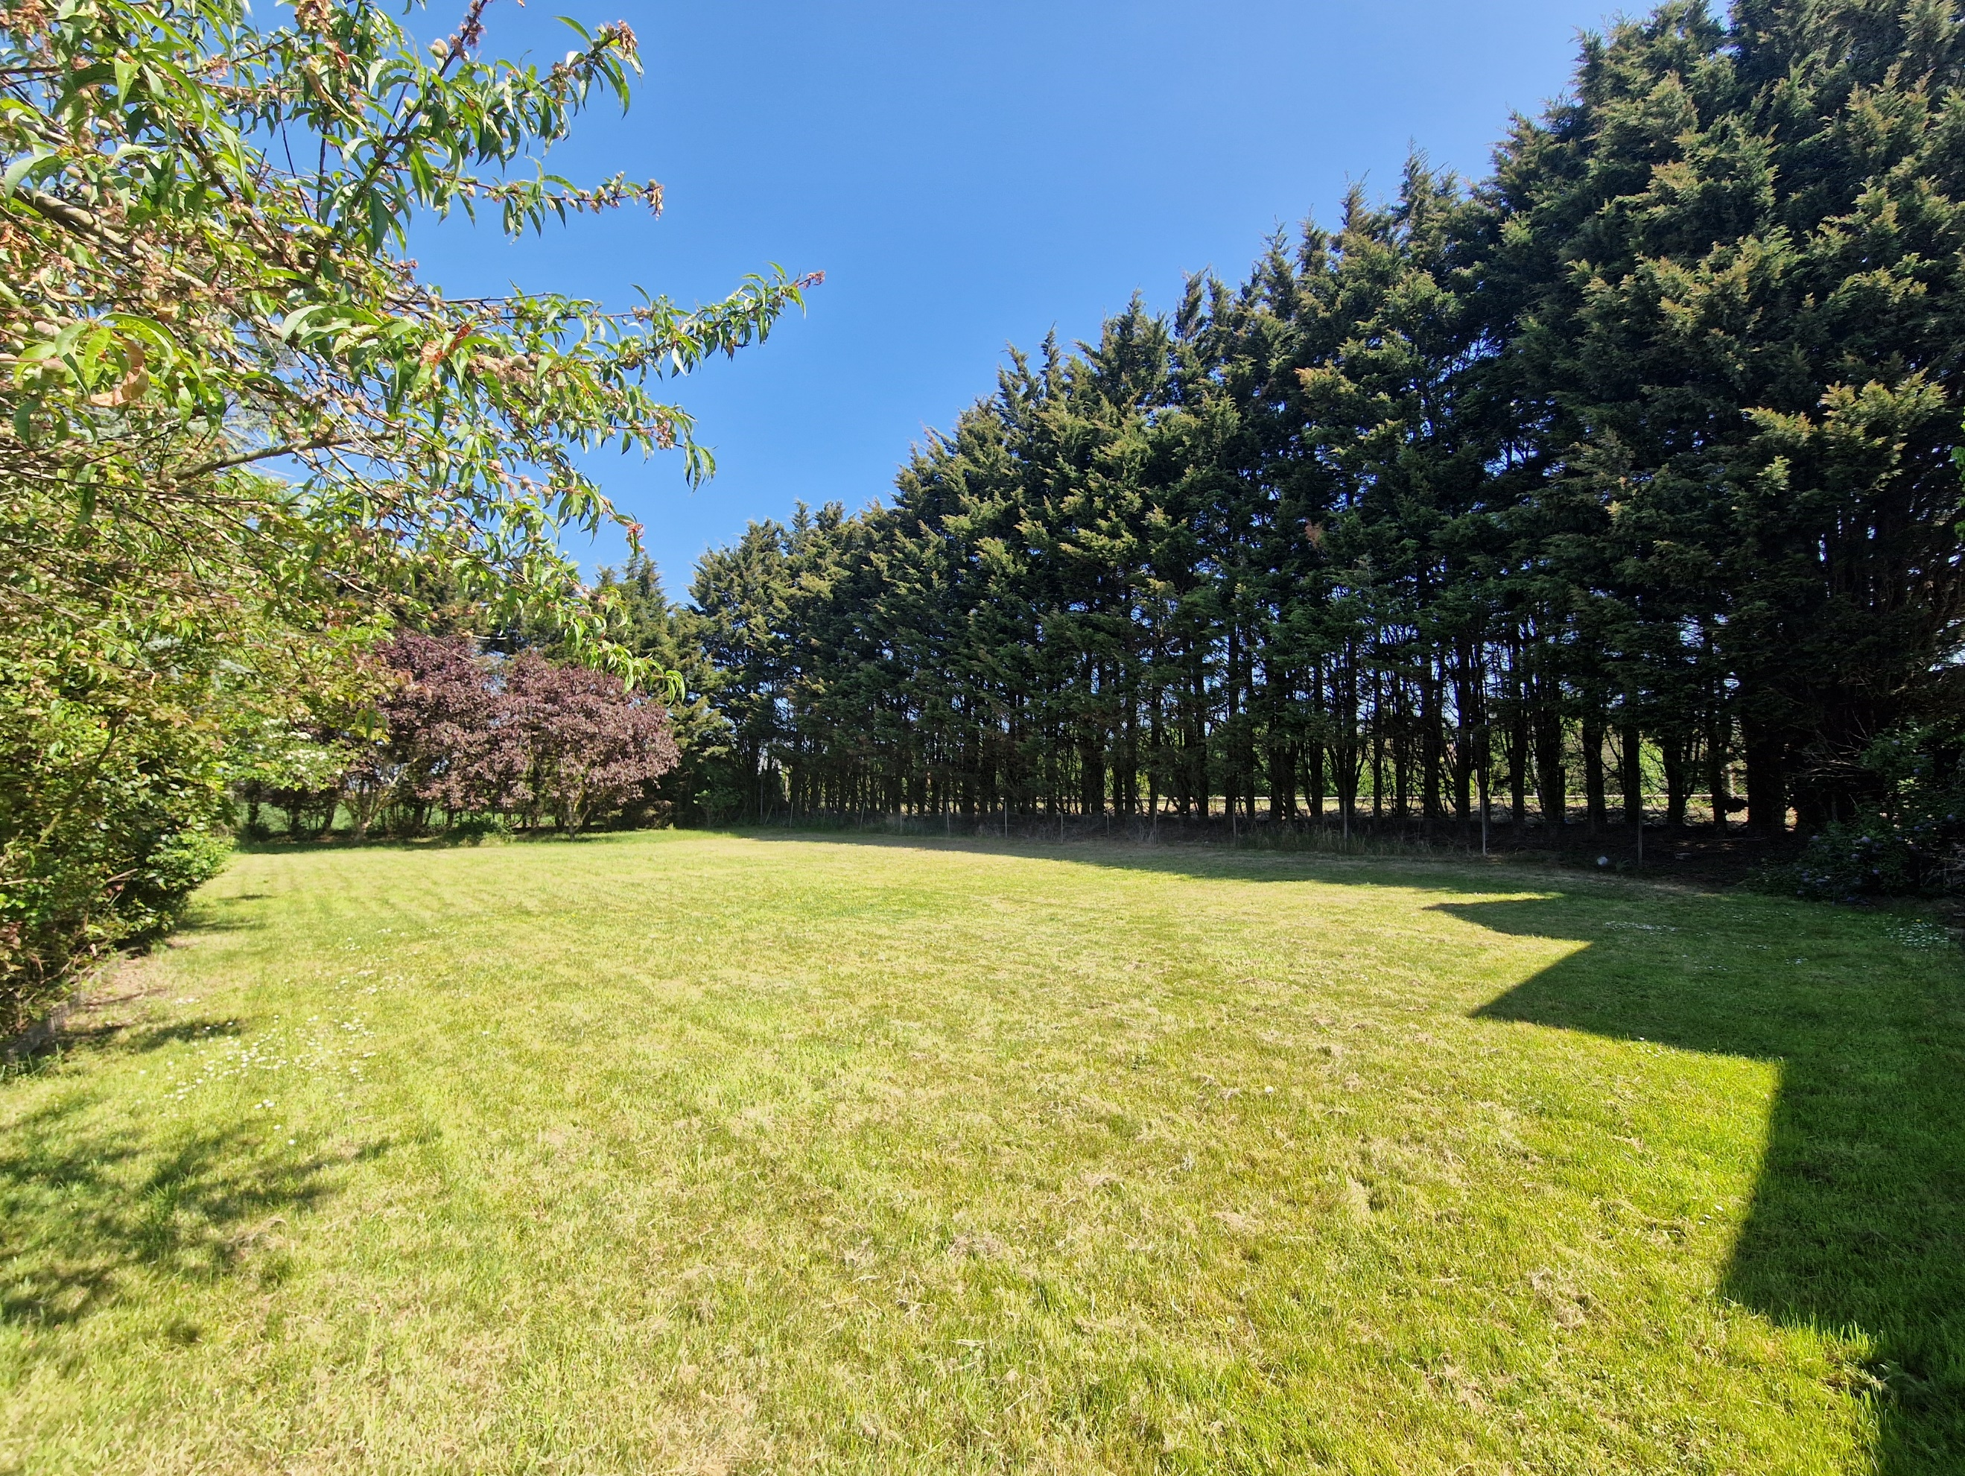
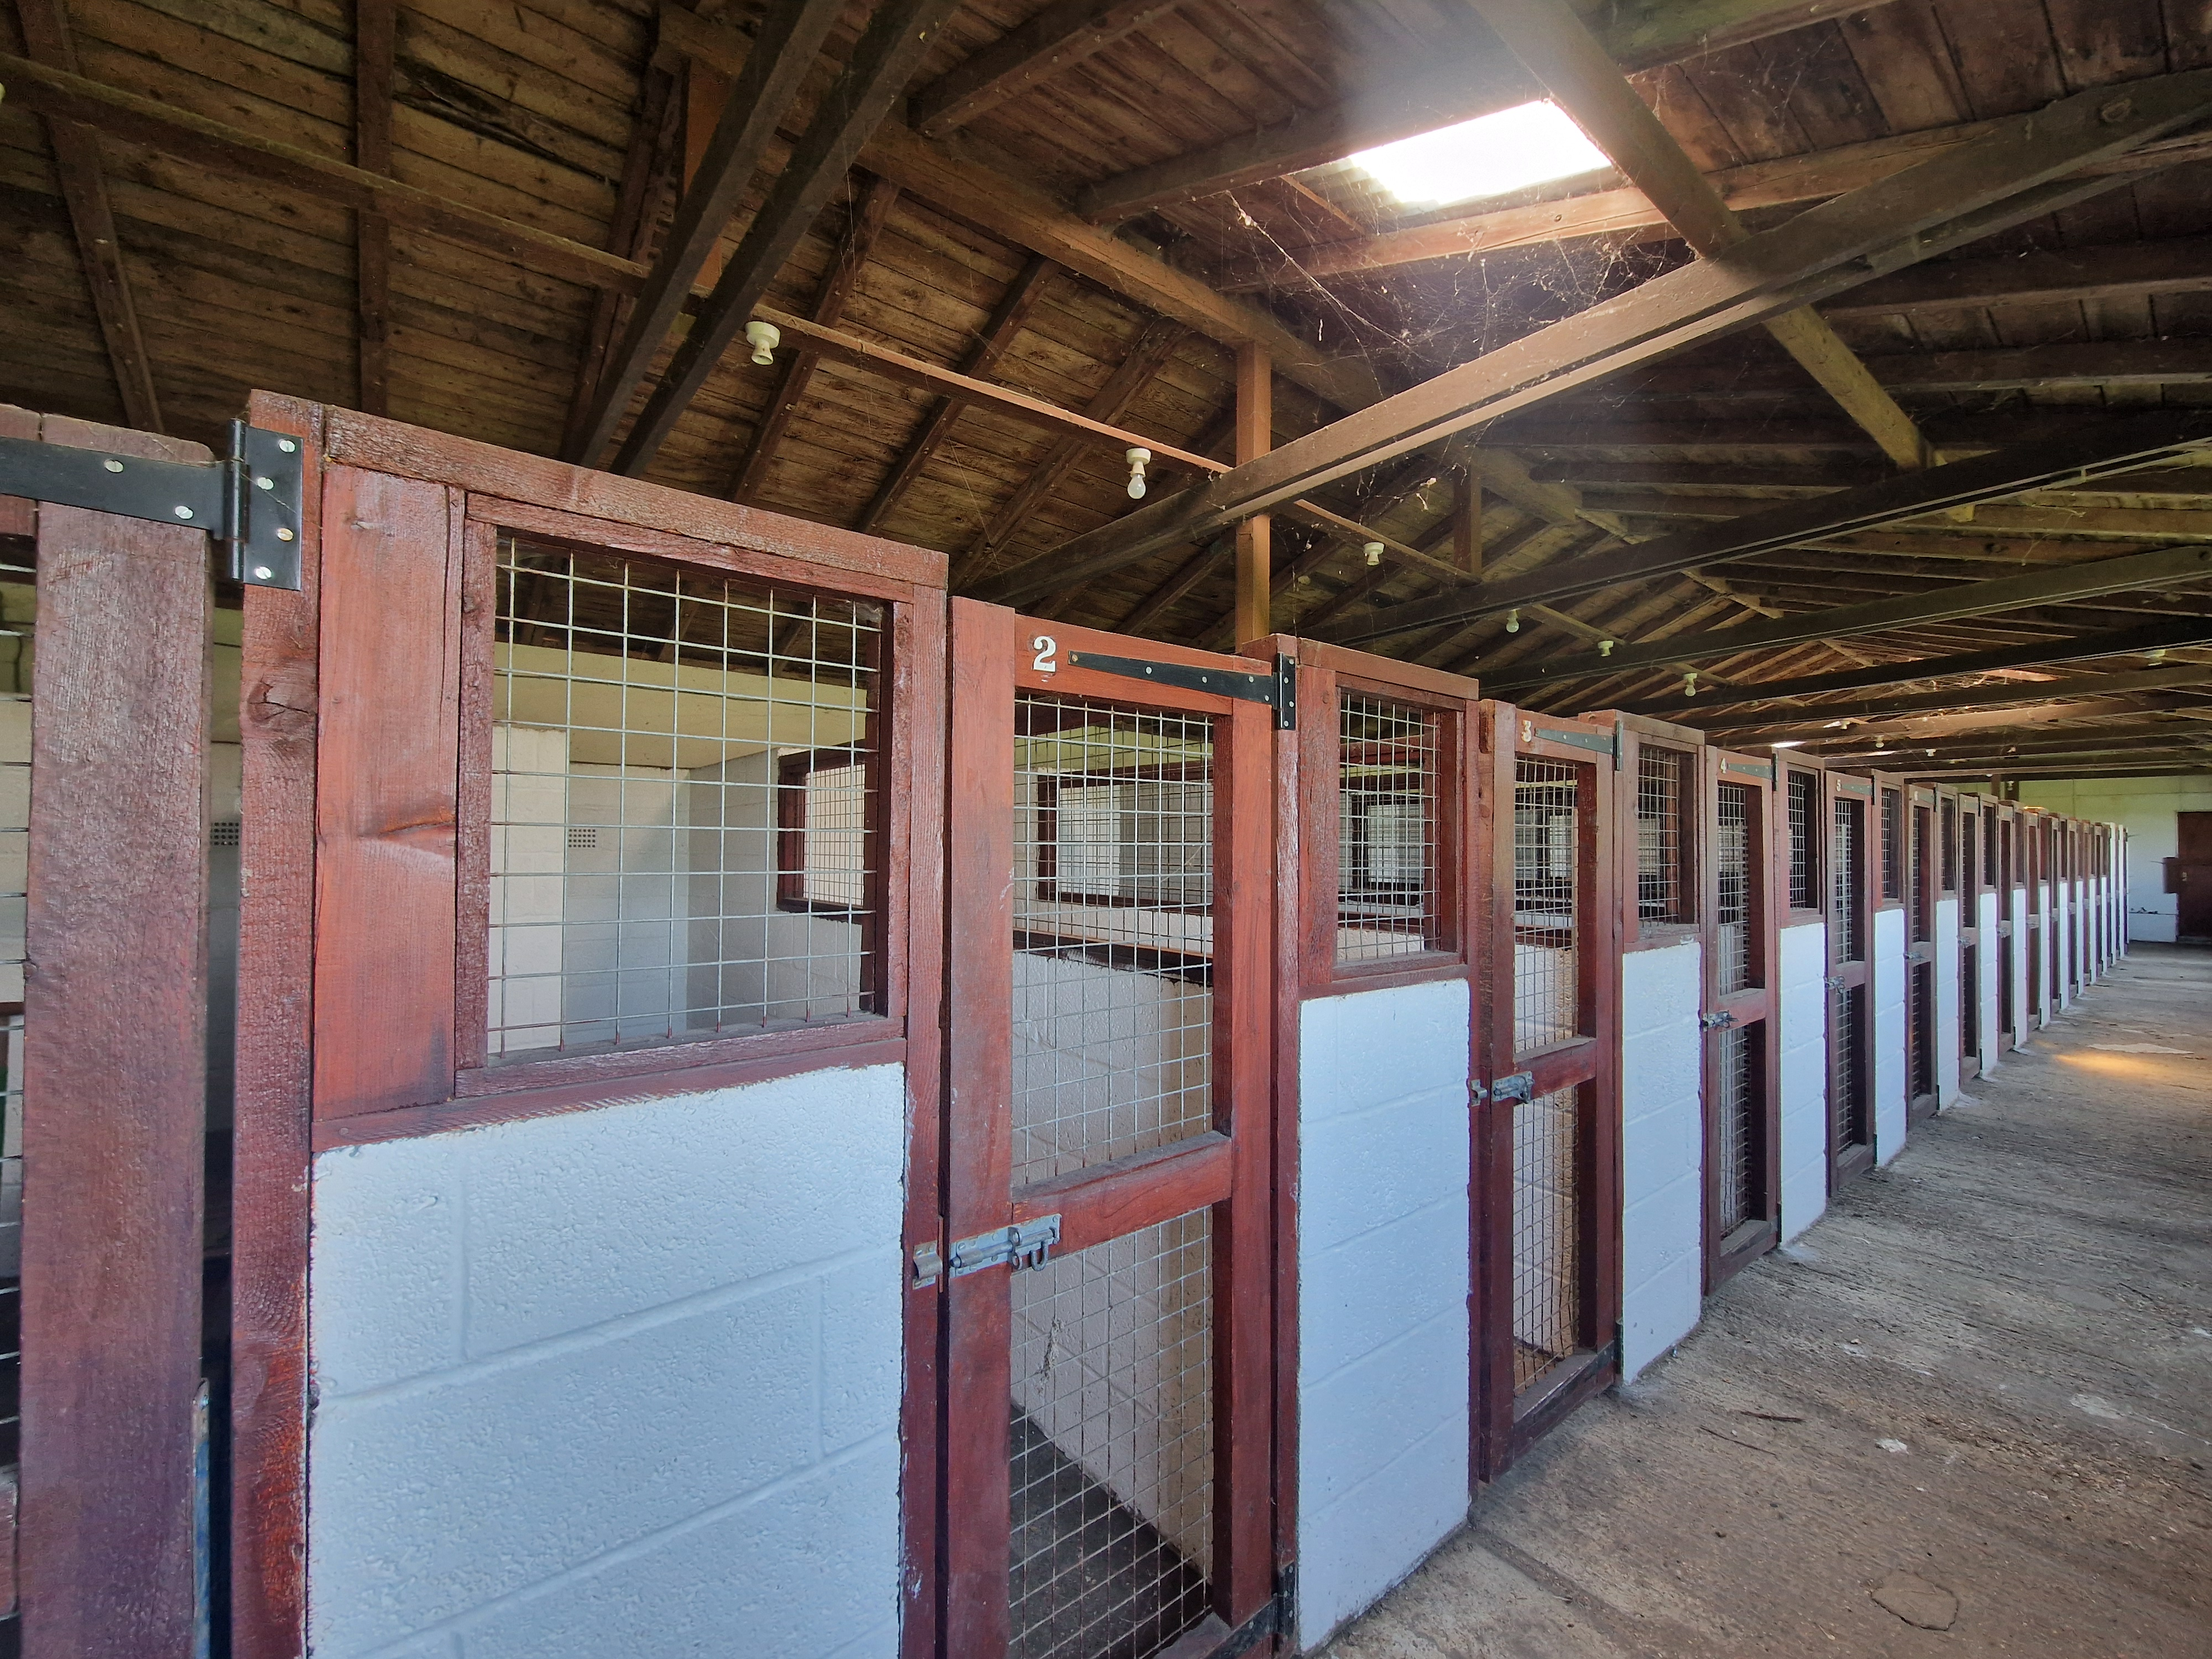
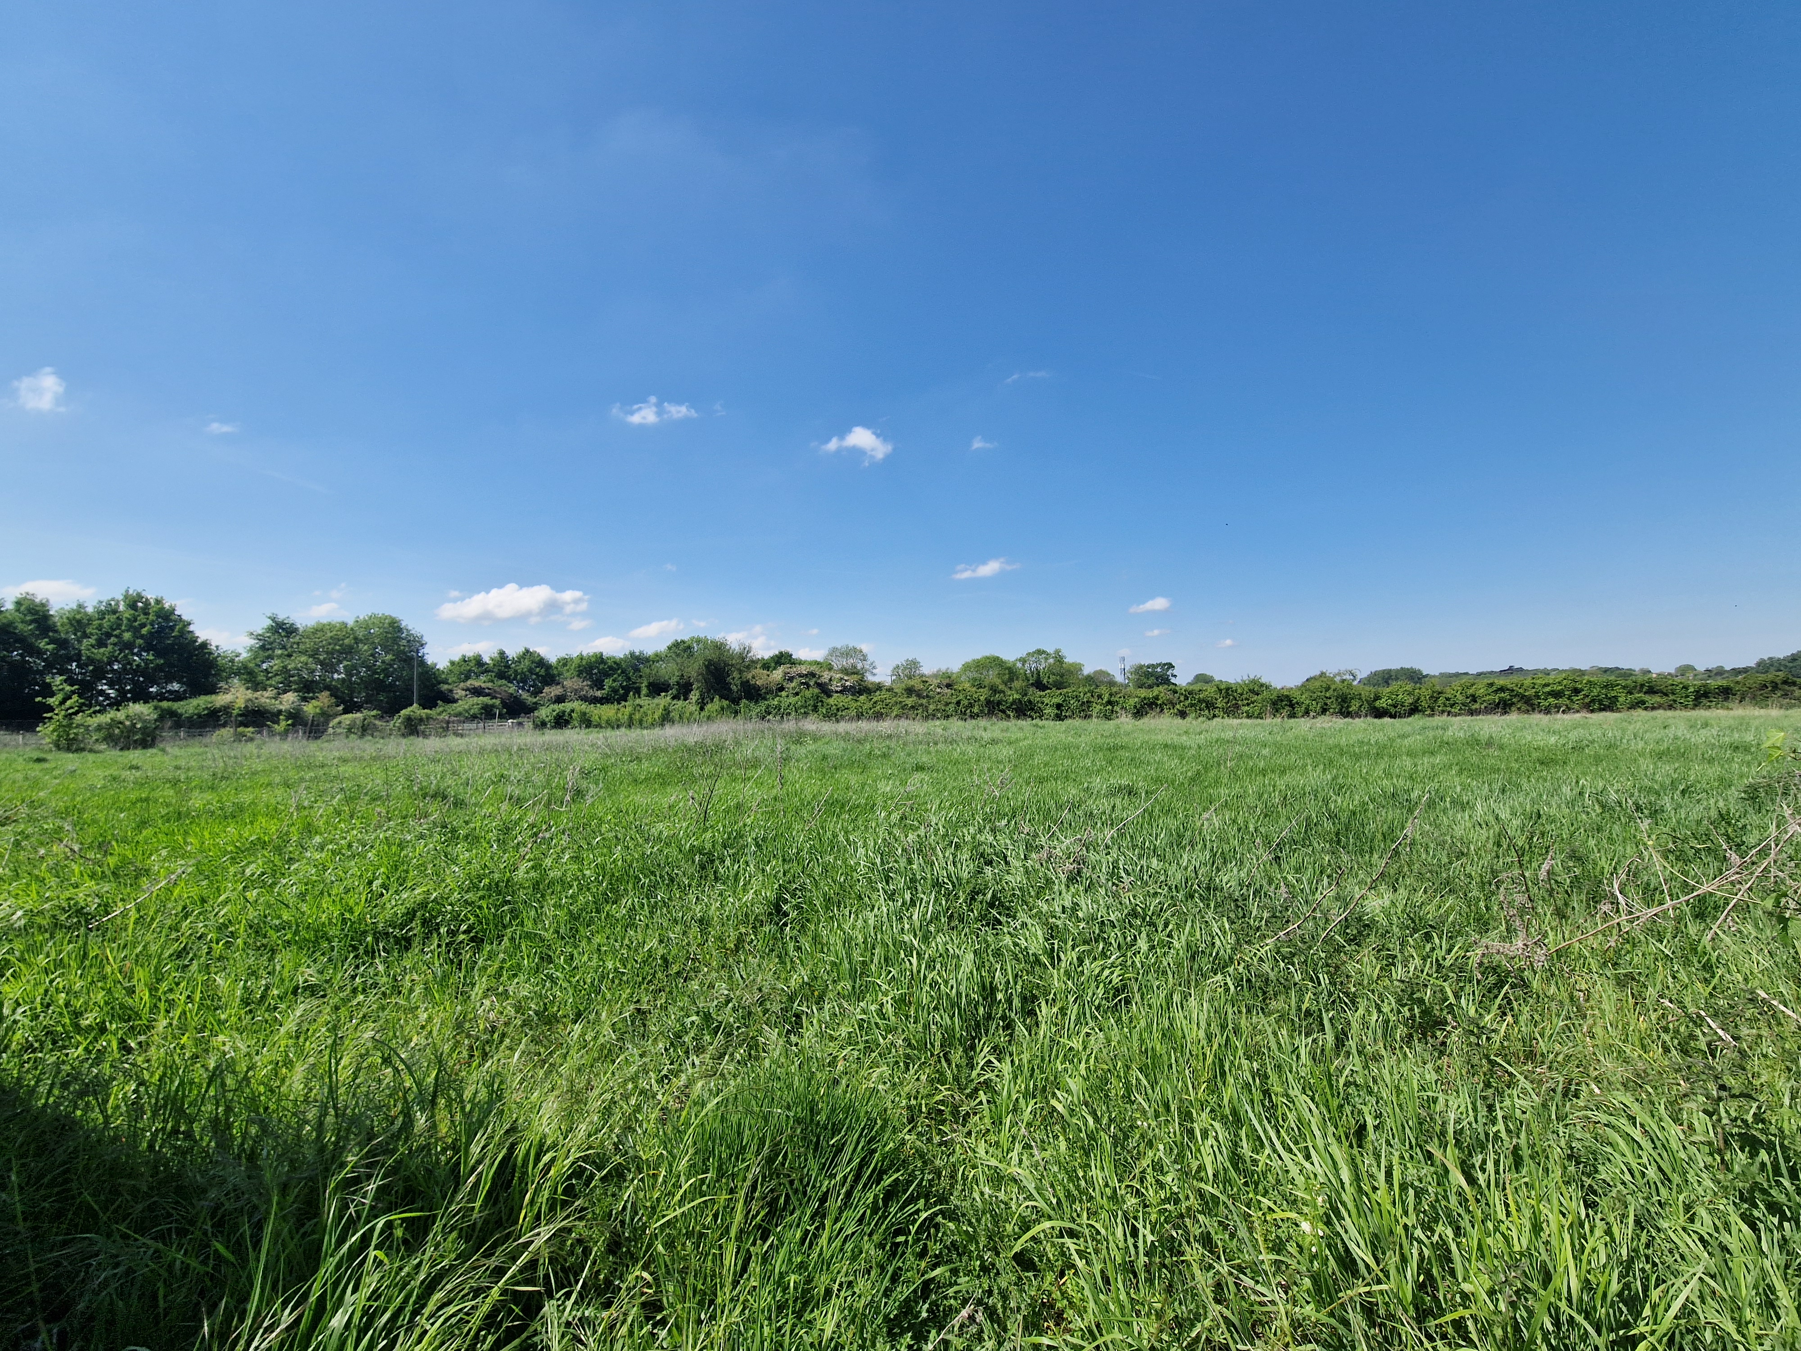
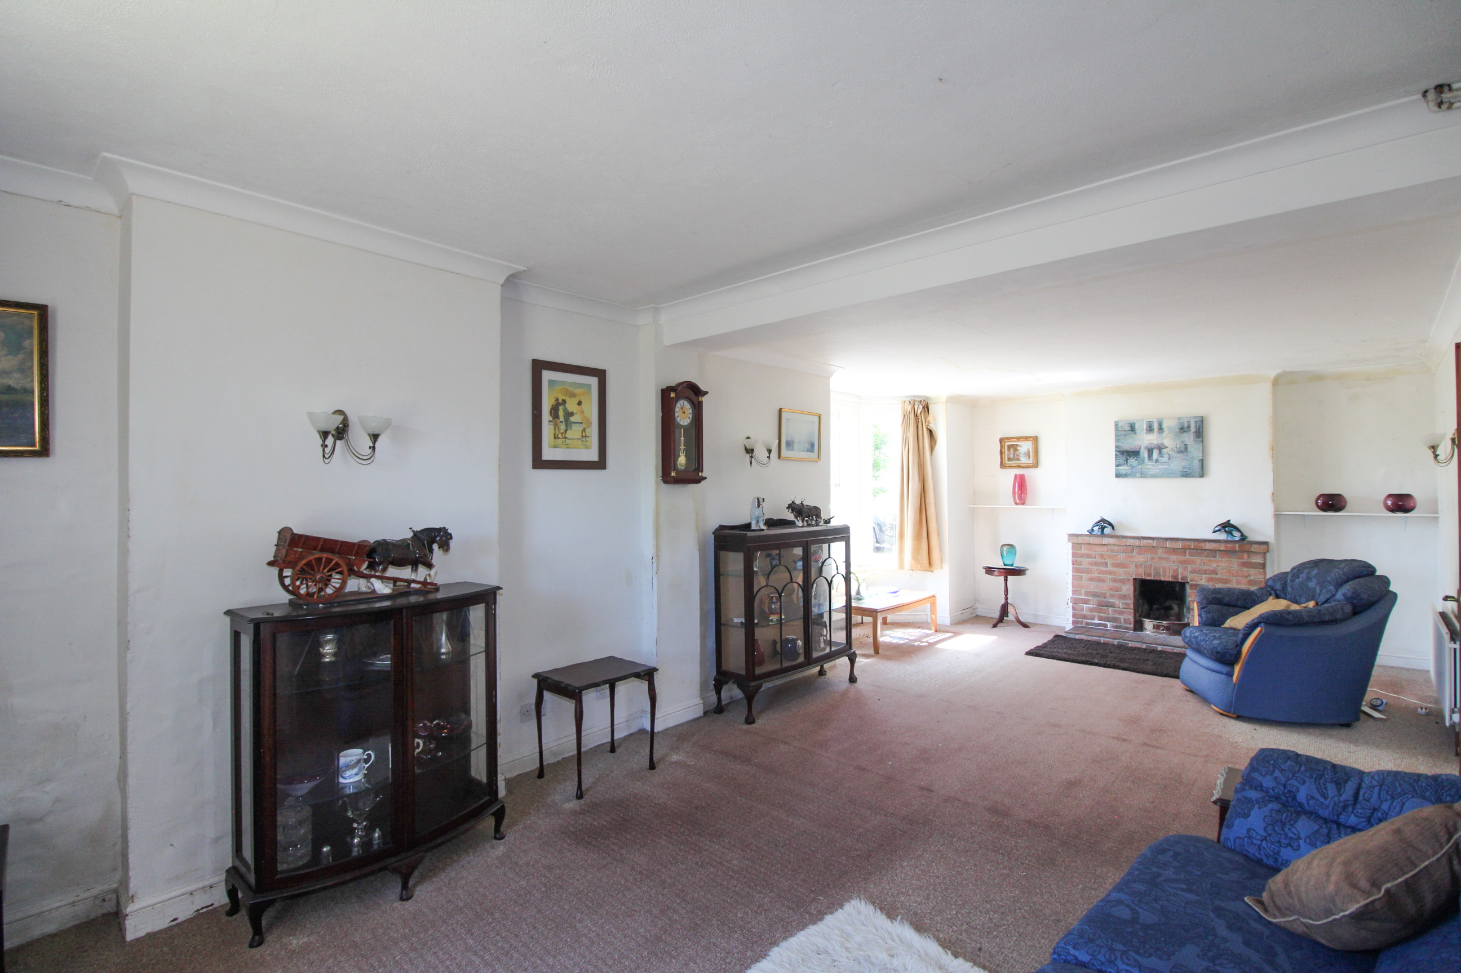
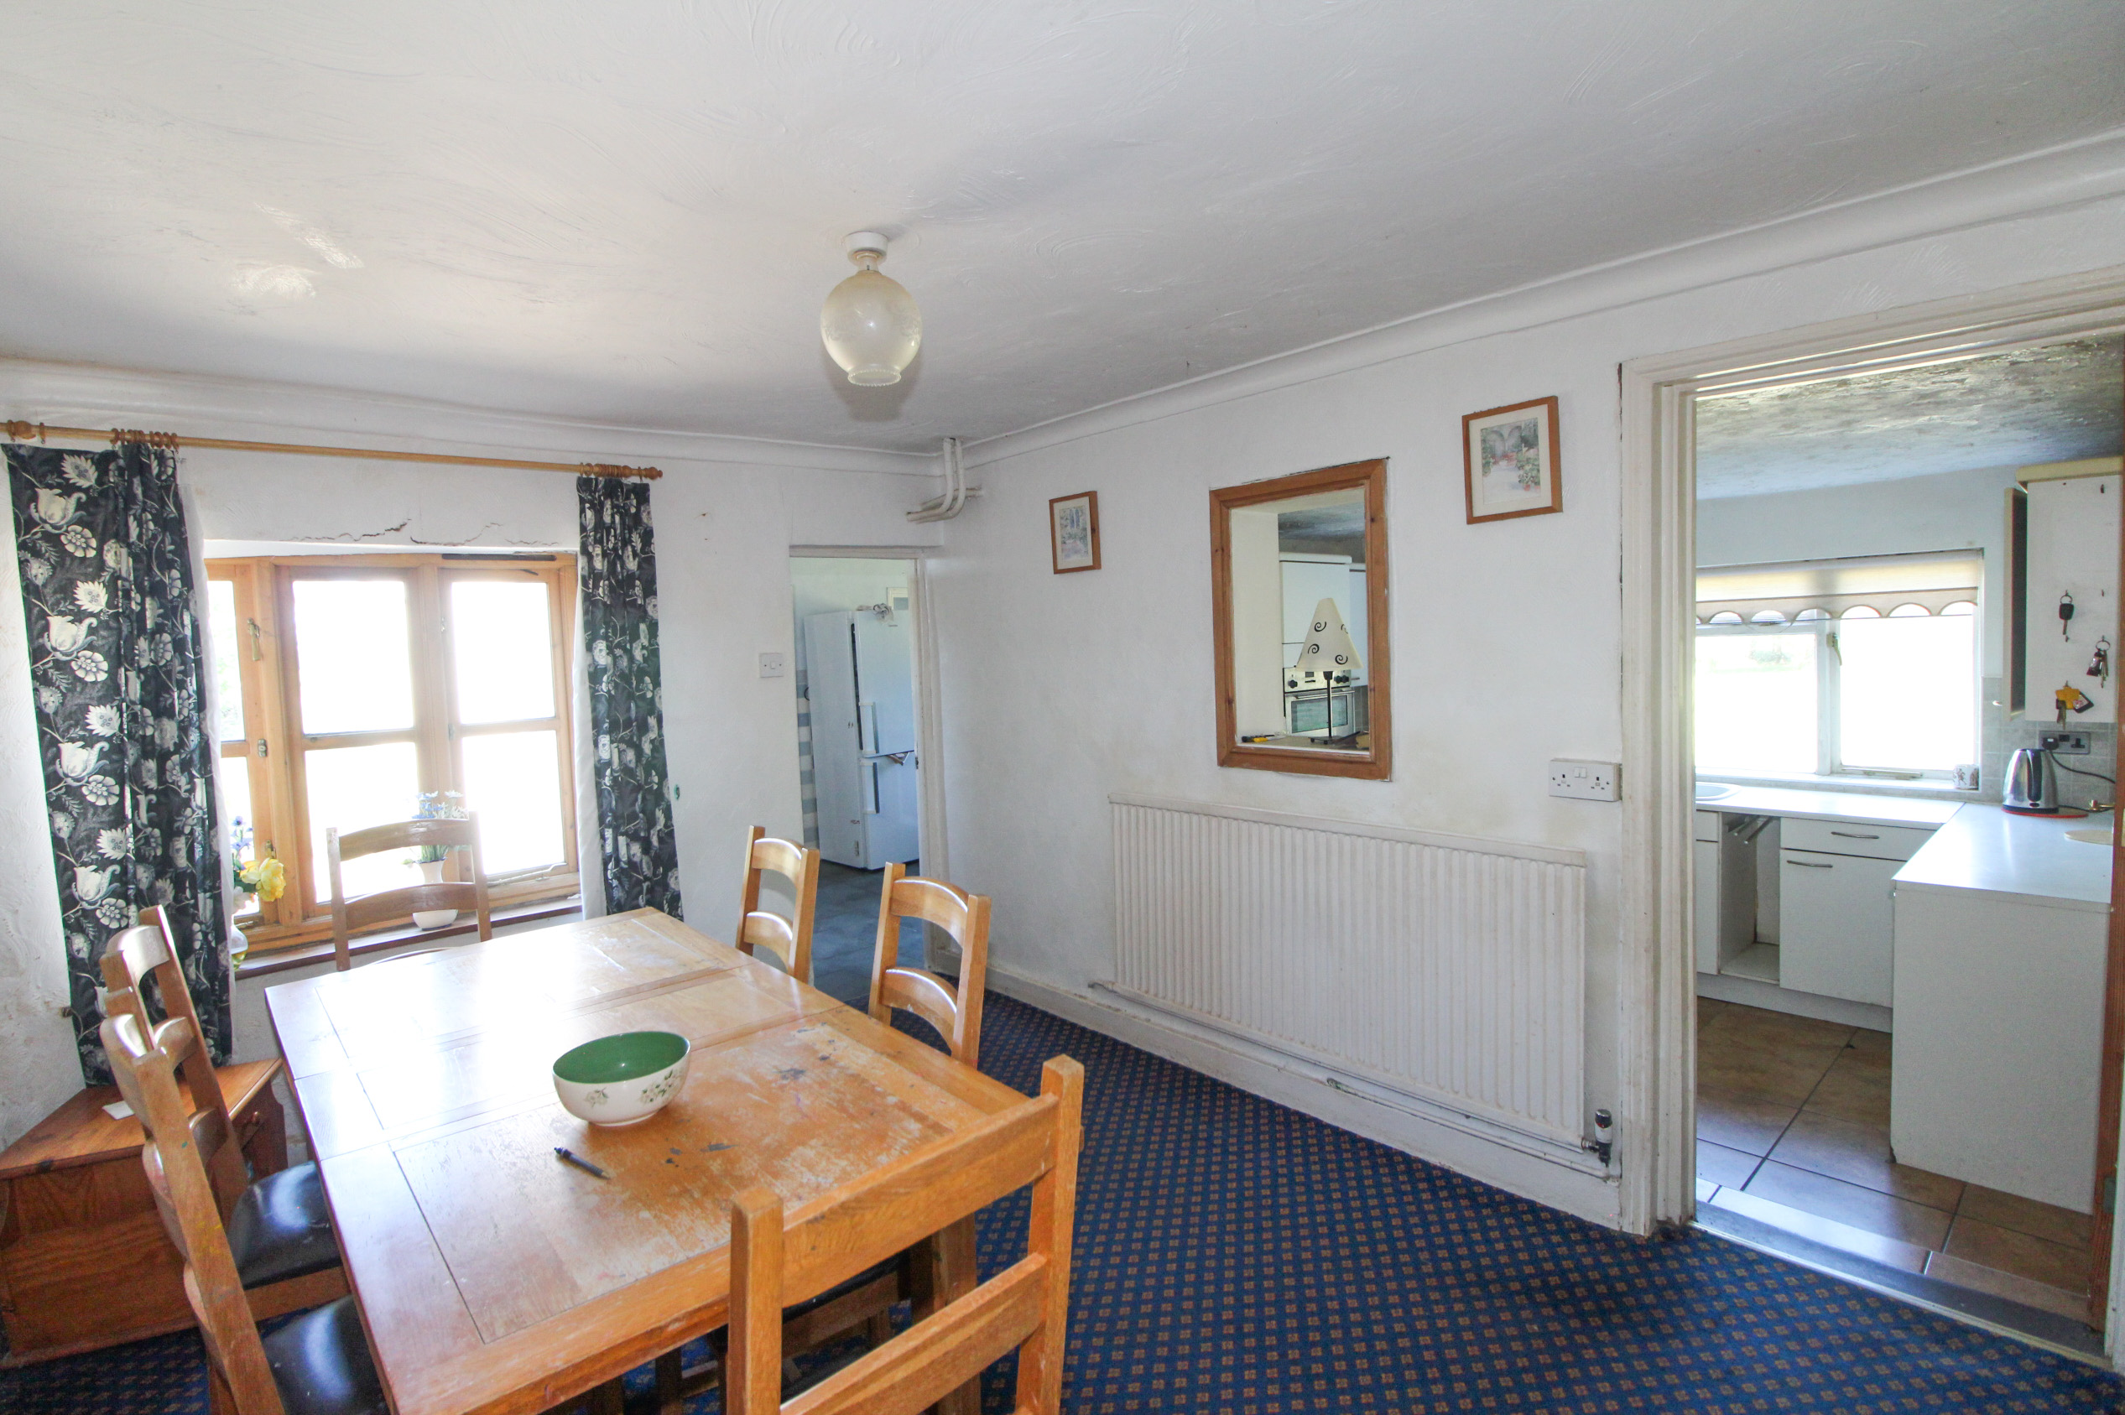
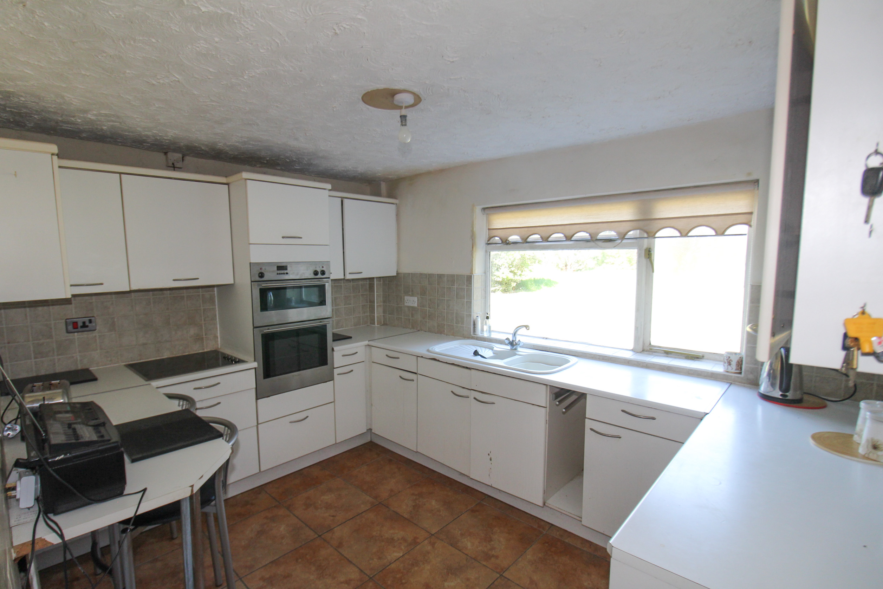
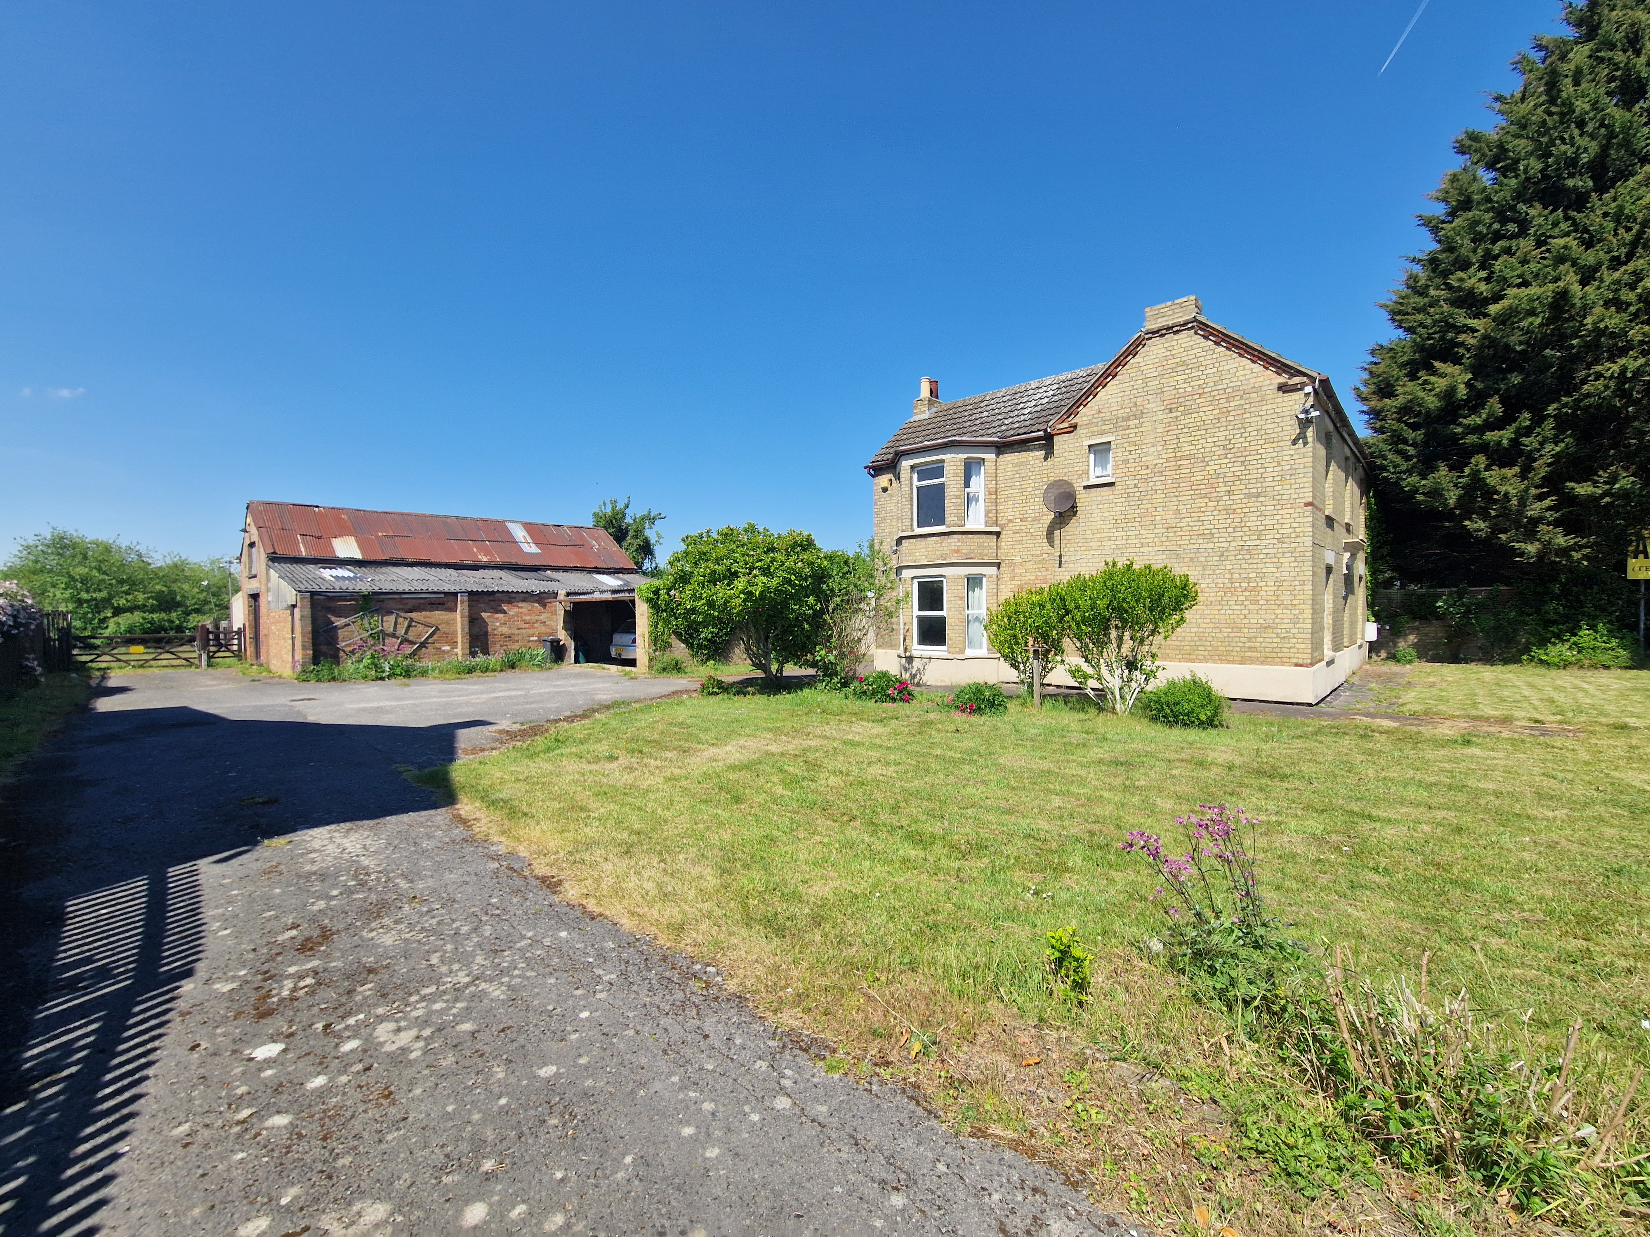
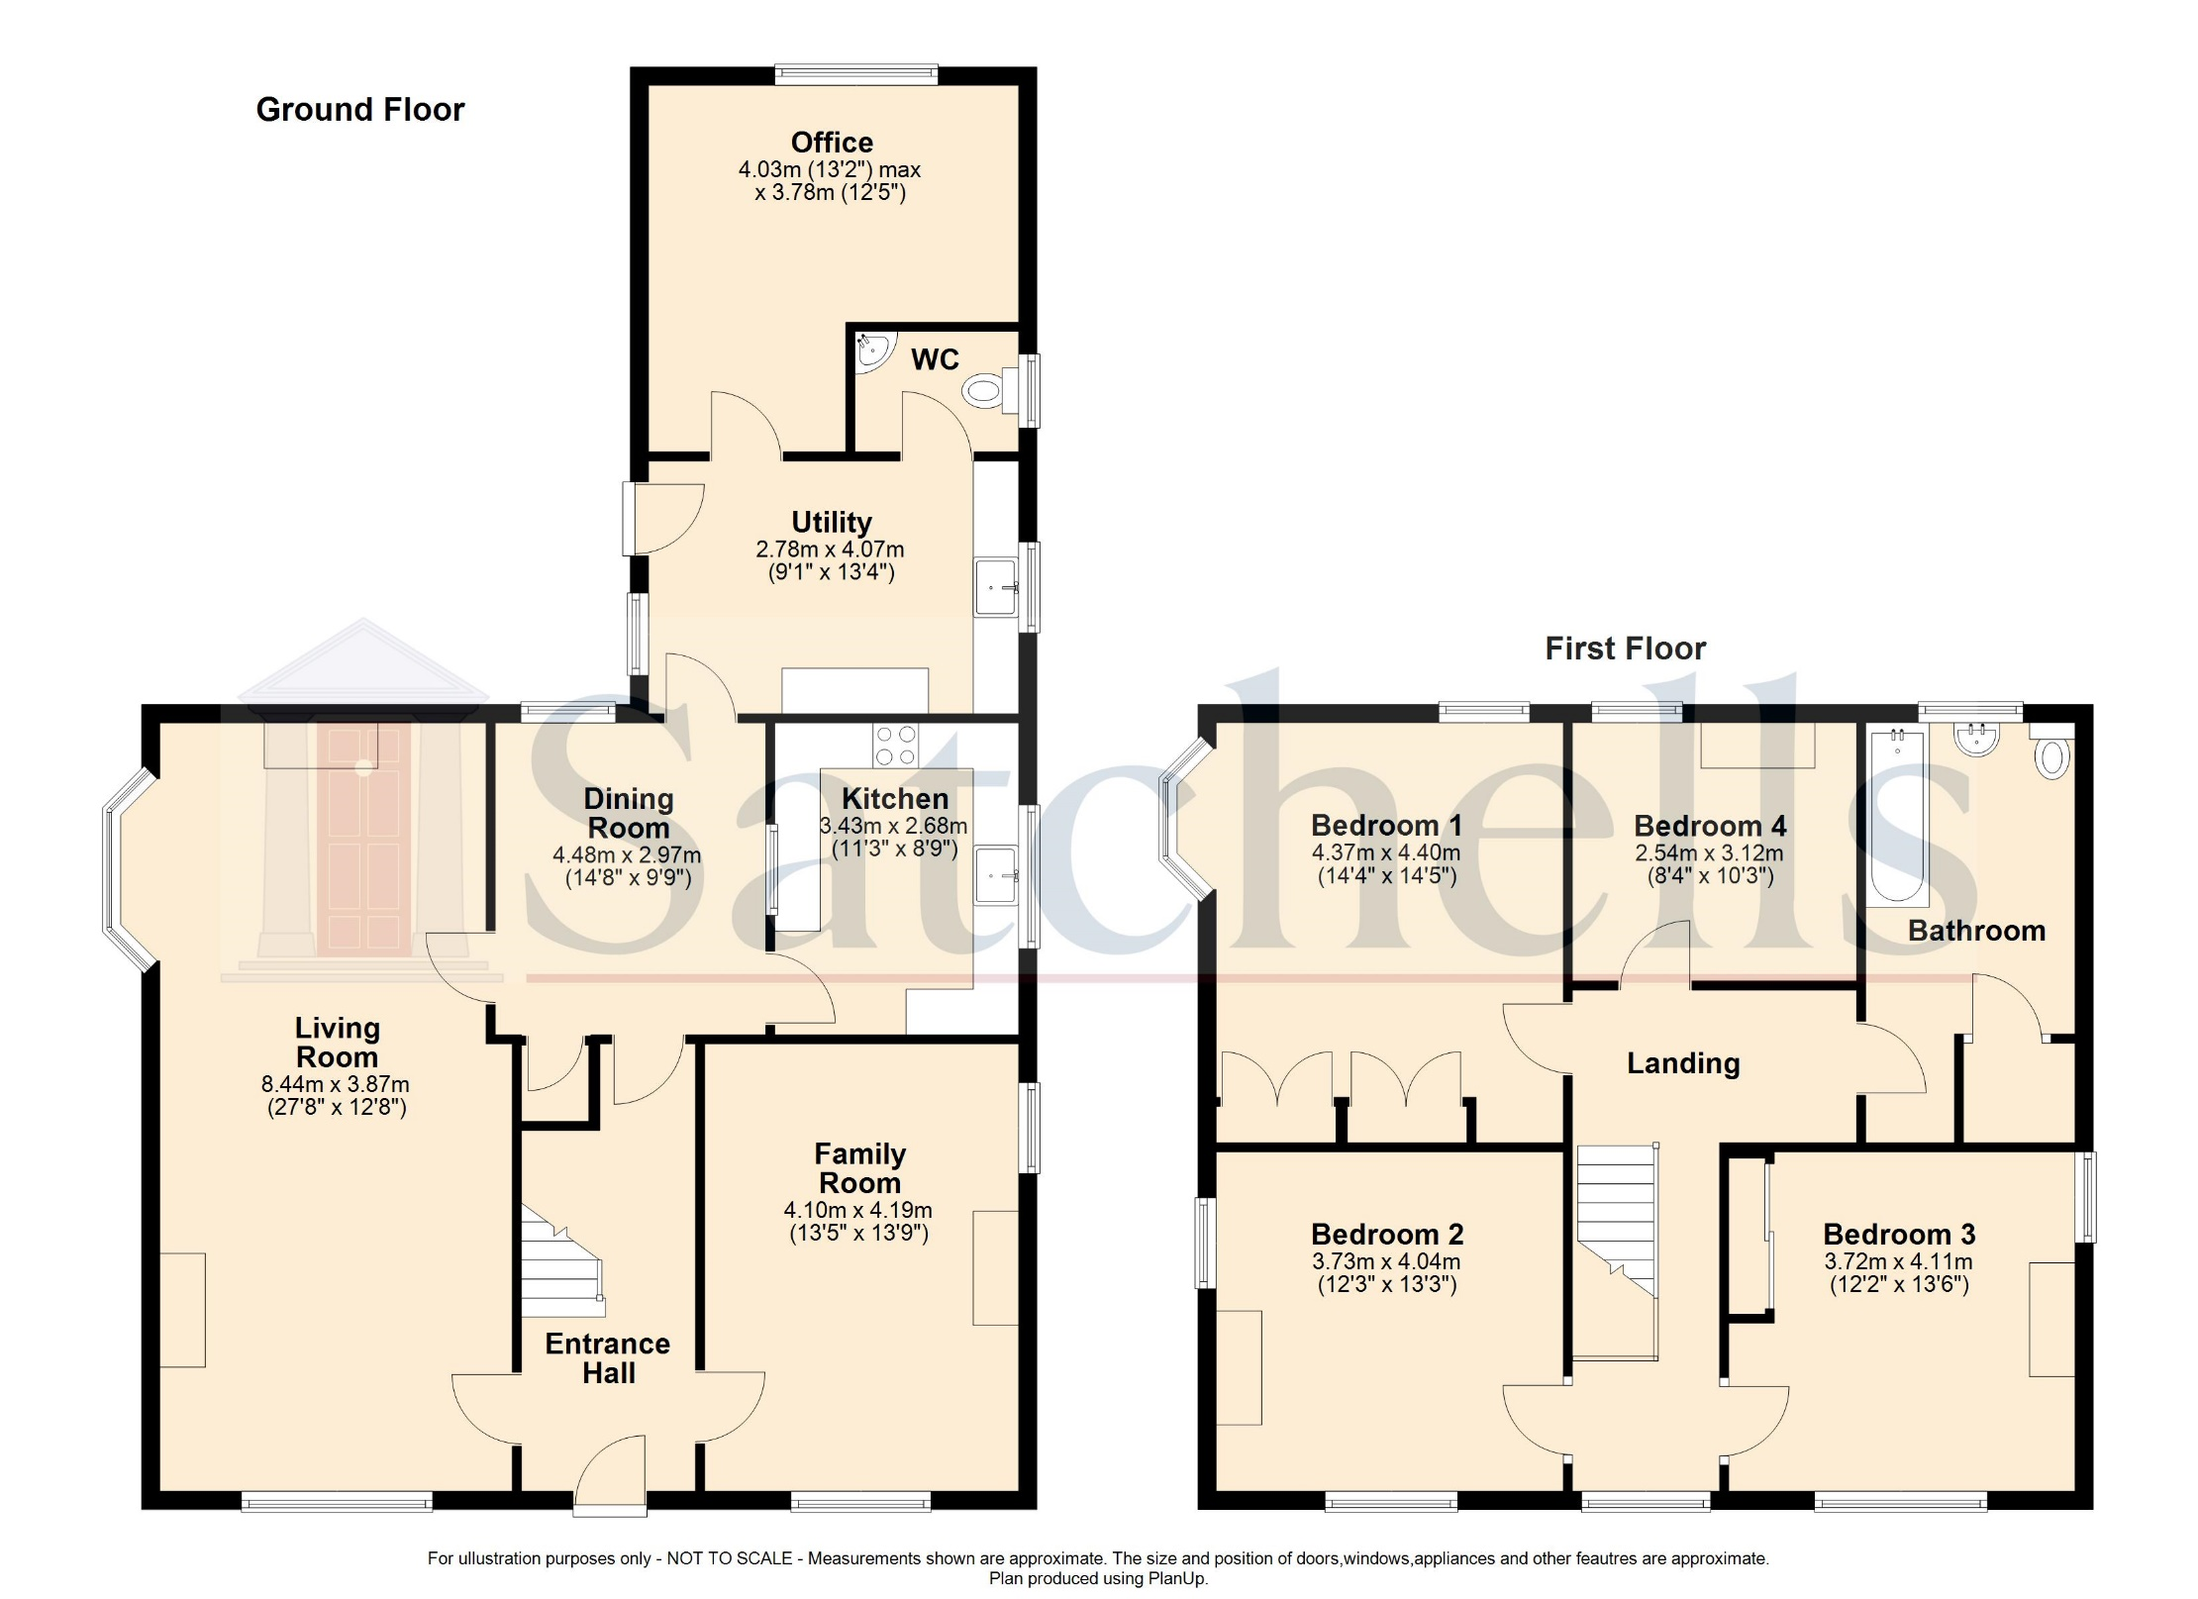
Existing House

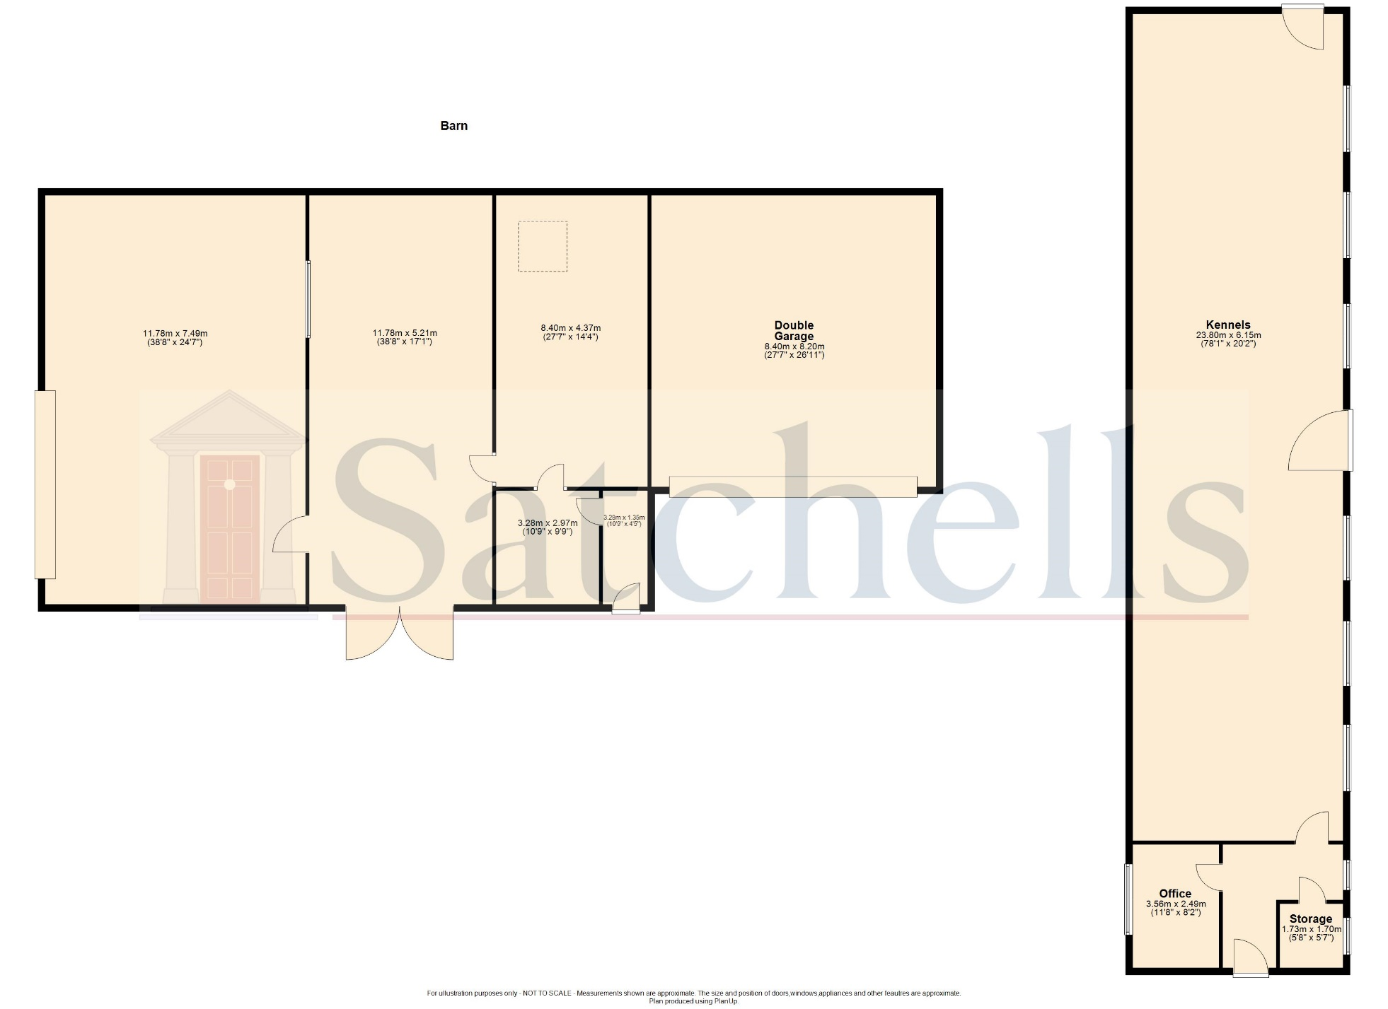
Existing Outbuildings

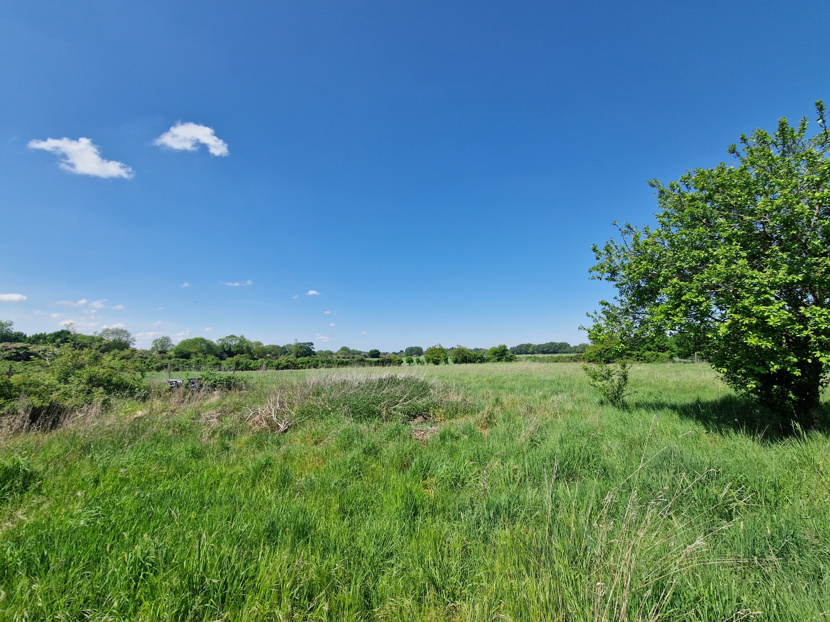
Satchells
49 High Street, Biggleswade, Bedfordshire. SG18 0JH.
Tel: +44 (0)1767 313256
E mail: biggleswade@satchells.co.uk www.satchells.com

