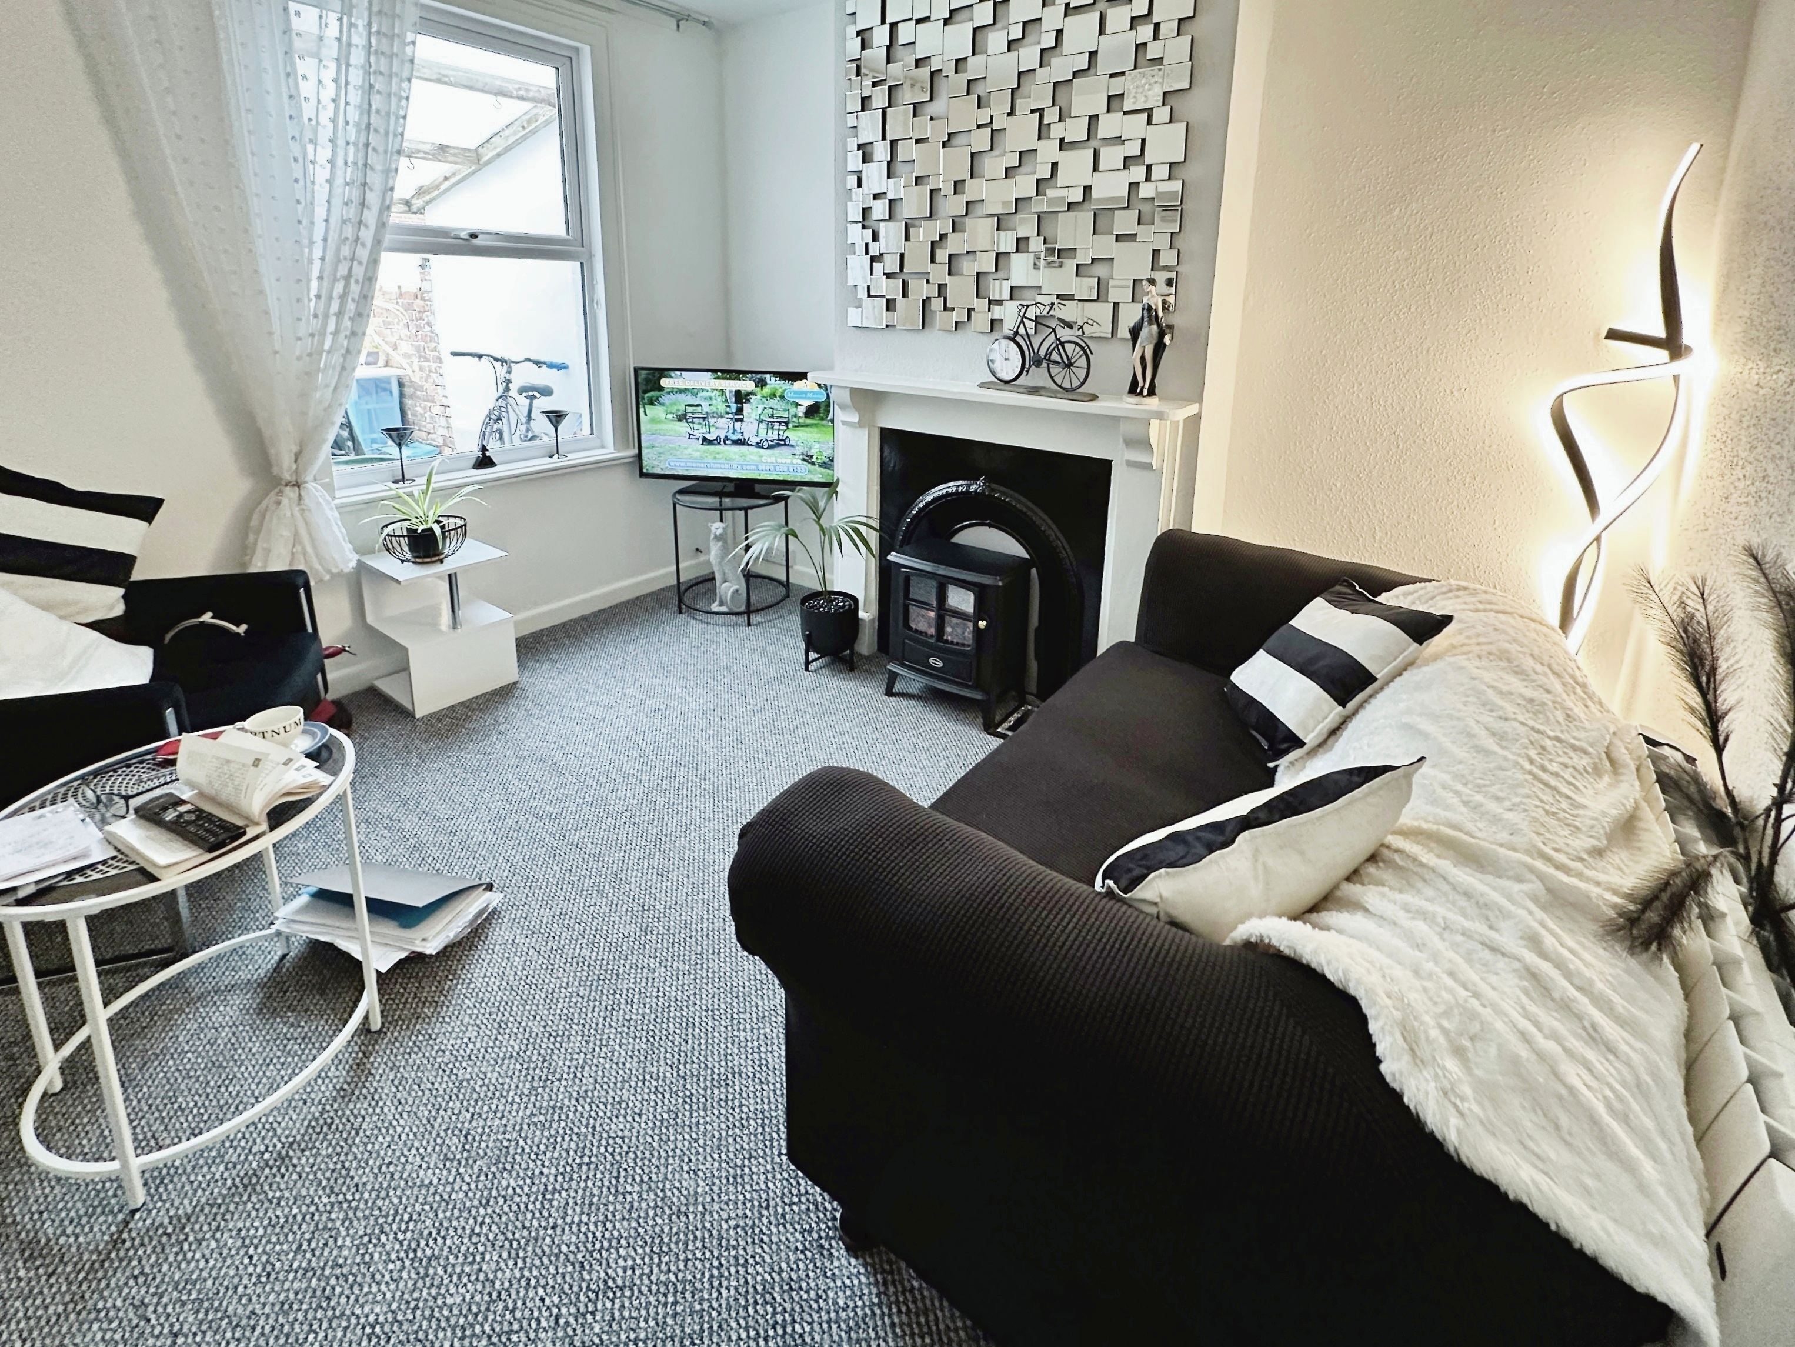

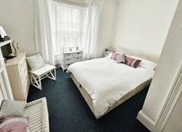

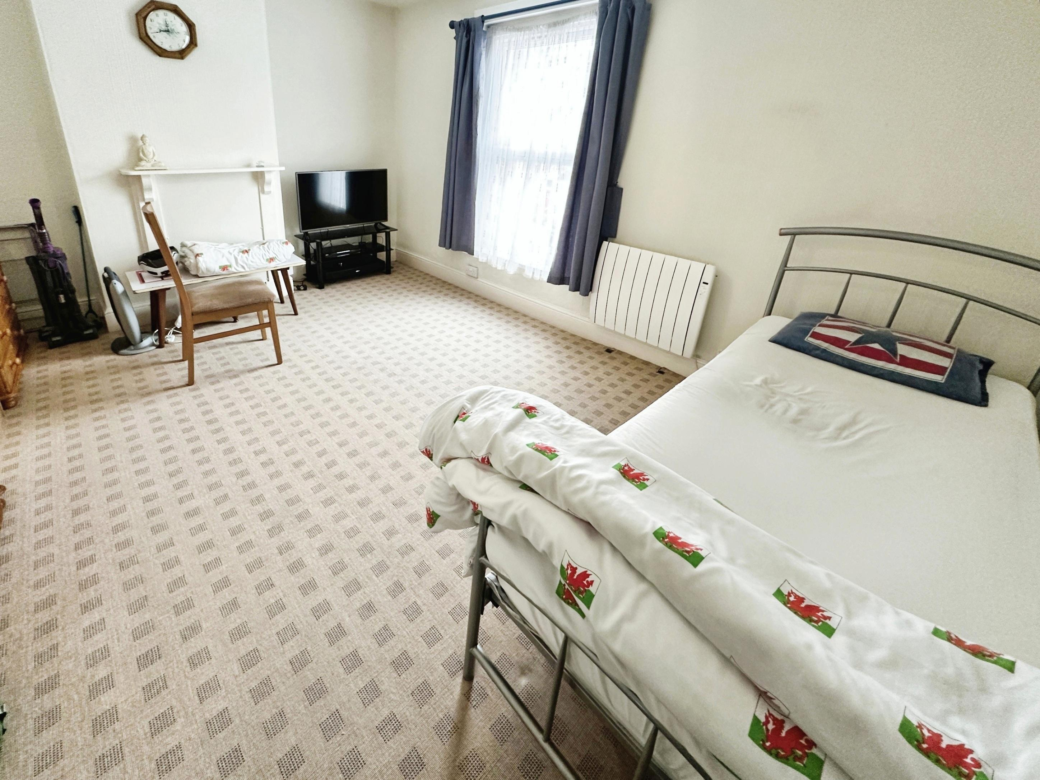

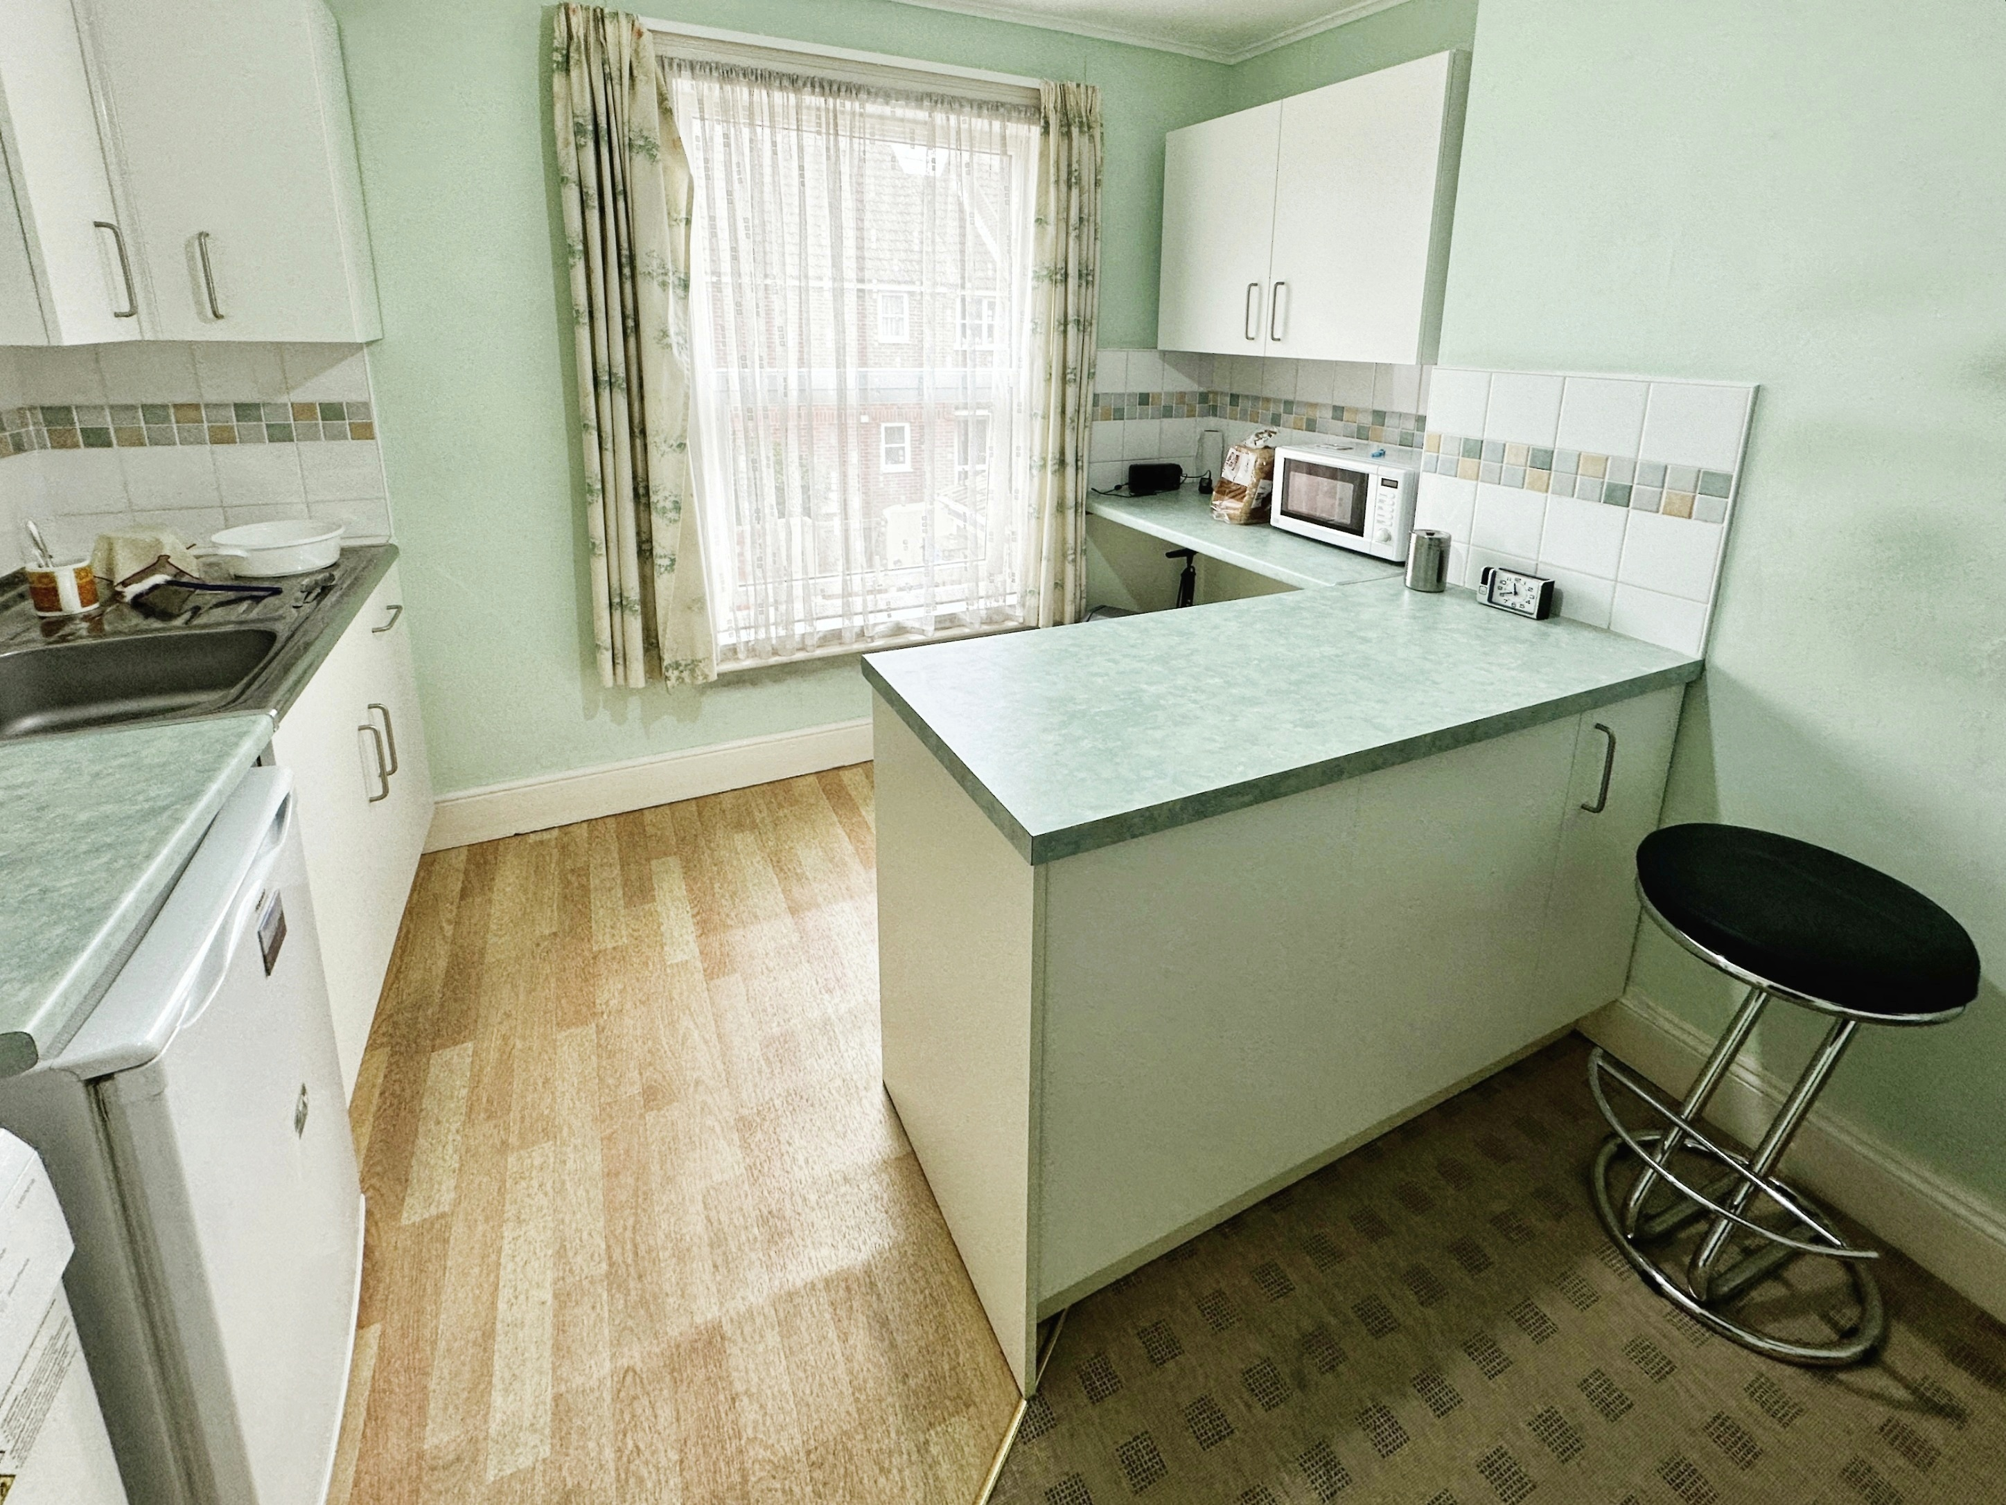

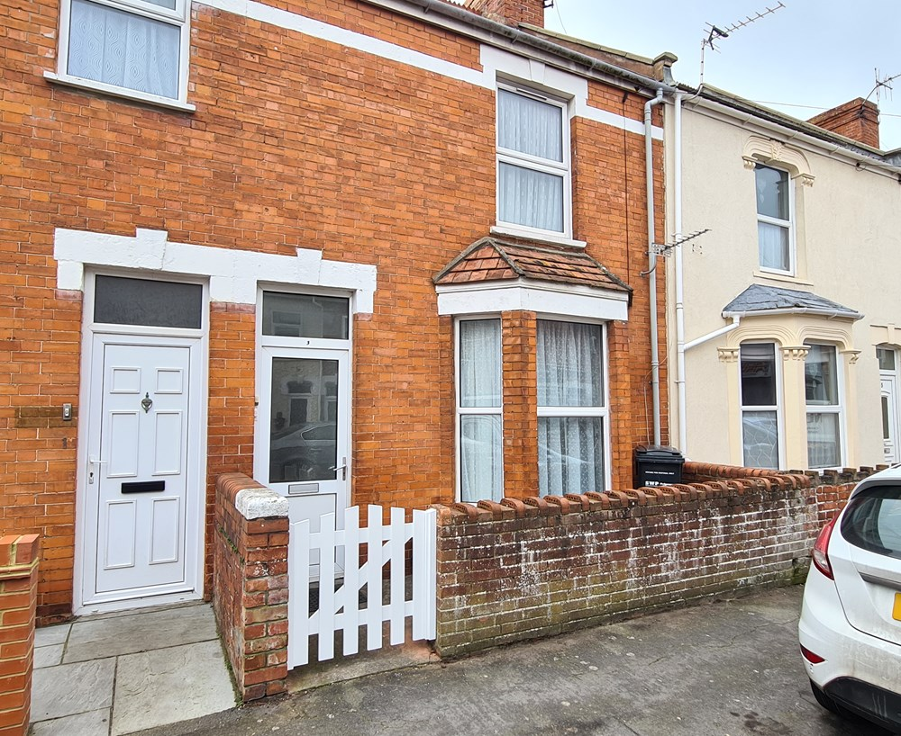



**Guide Price**

**£199,950**

**Freehold**

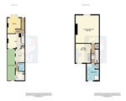 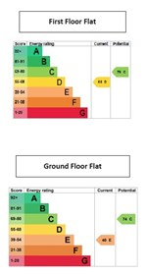 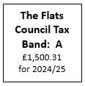

* Walking Distance to Town and Amenities
* Courtyard Garden with GFF
* Communal Front Entrance Door

* Fantastic Investment
* Only to be sold with tenants in situ.
* Freehold Property

**Em: Residential@aandfproperty.co.uk**

**Office: 18 College Street, Burnham-on-Sea, TA8 1AE Tel: 01278 782266**

**Jubilee Street, Burnham-on-Sea, TA8 1PT**

**2 Bedroom, Terraced House  •  Ground Floor Flat   •  First Floor Studio Flat   •  * Tenants in Situ * Investment Only \***