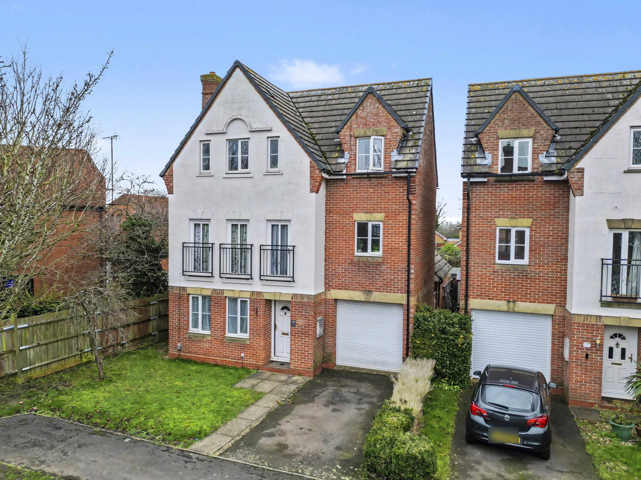
Kristiansand Way, Letchworth Garden City, Hertfordshire SG6 1TY
£500,000 Freehold

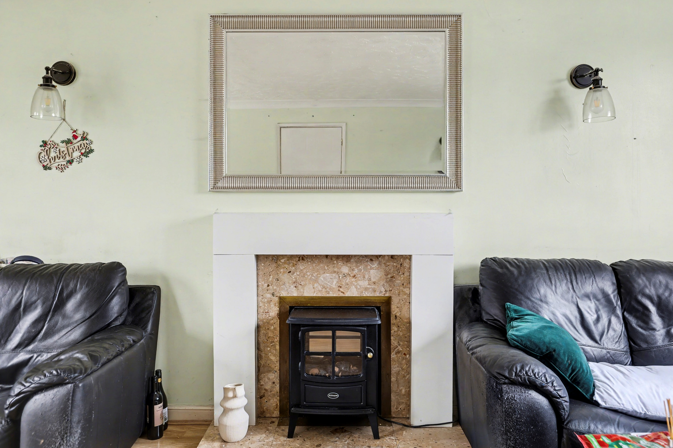
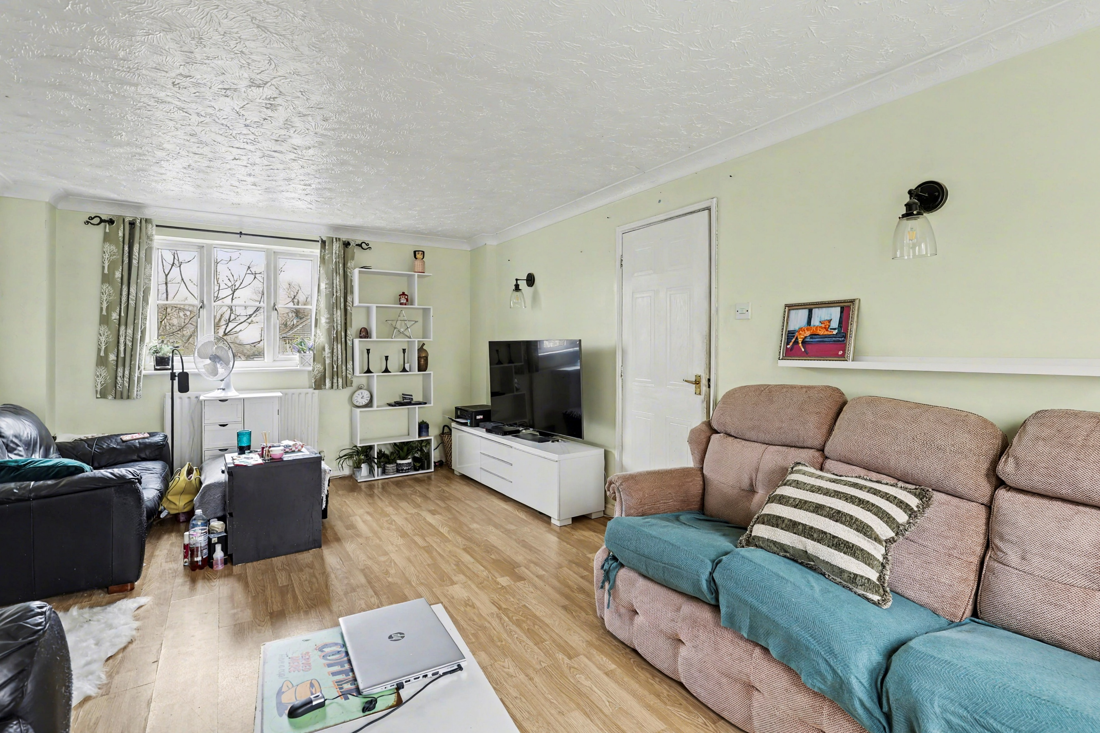
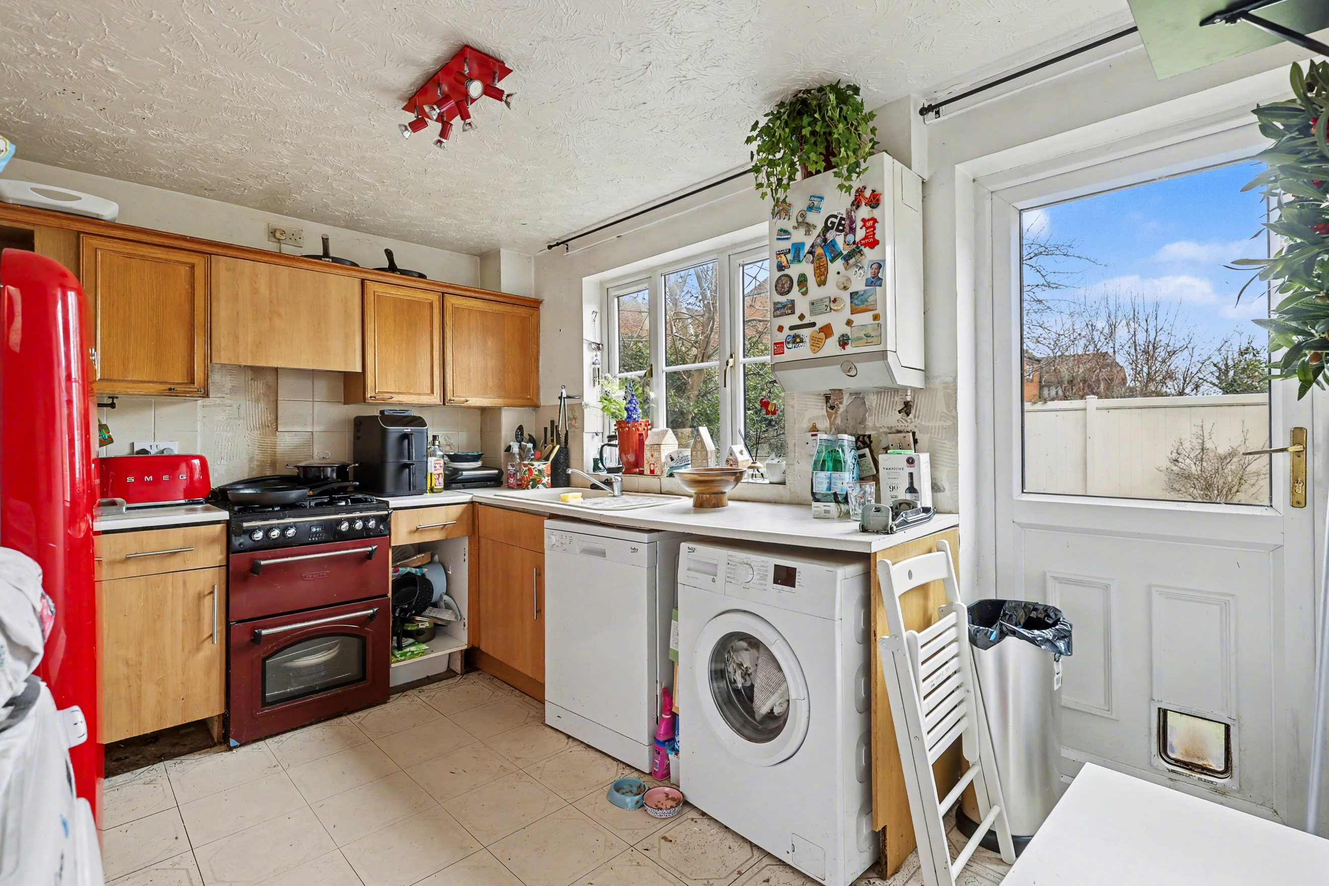
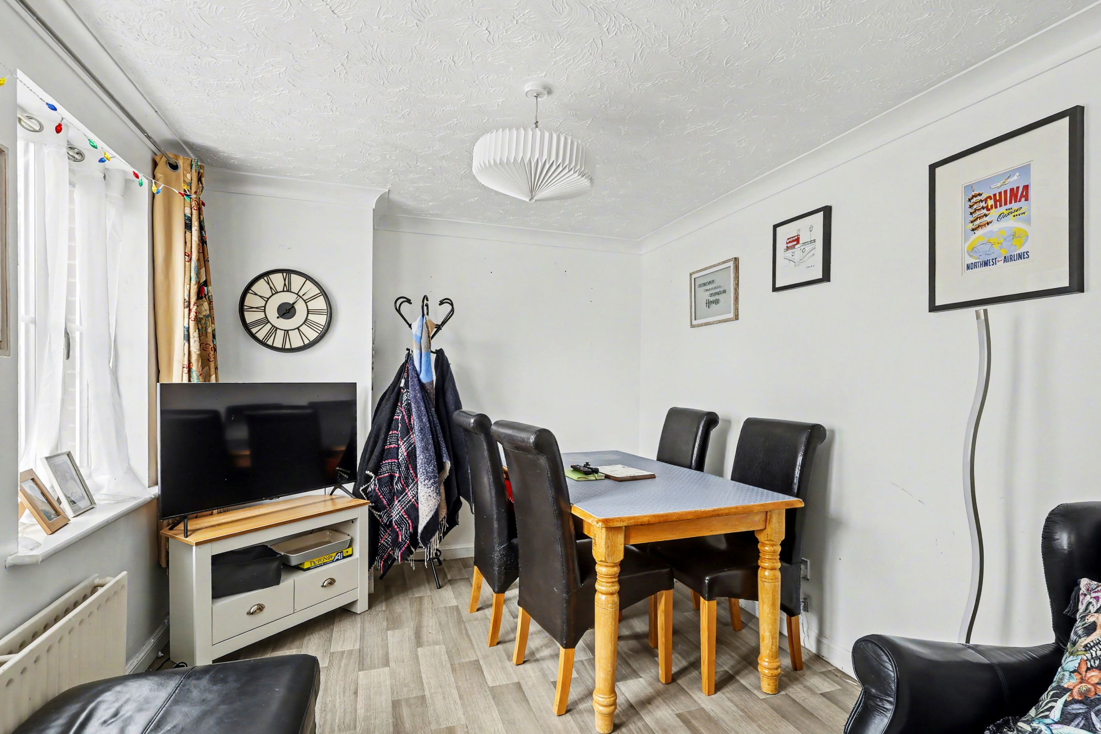
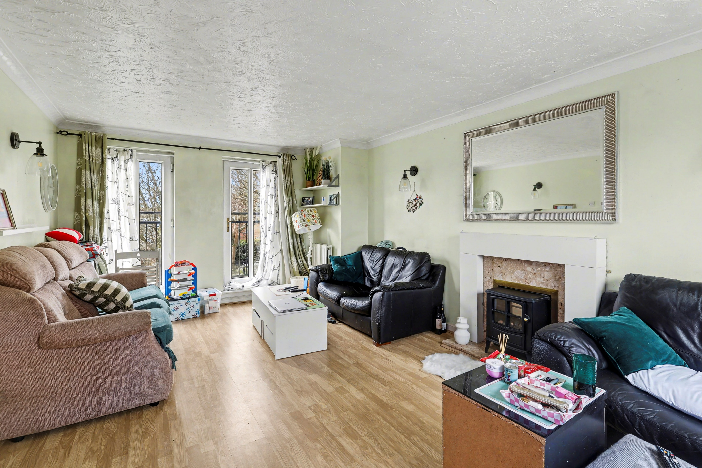
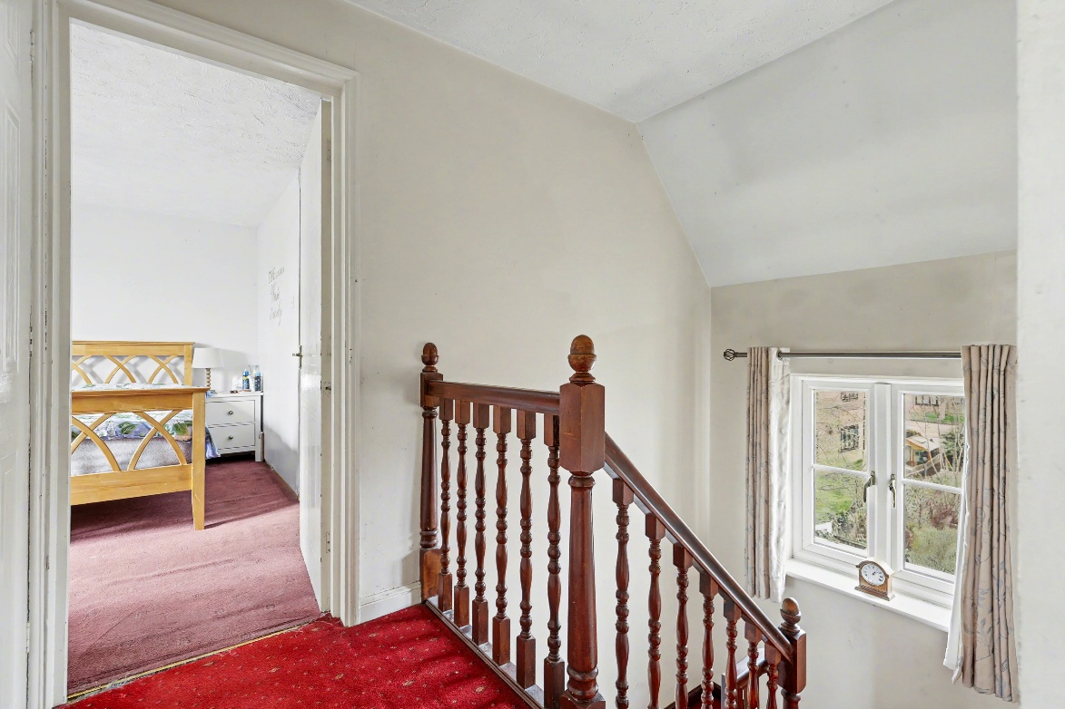
Situated within a well-regarded residential setting, Kristiansand Way enjoys a convenient position within the popular town of Letchworth Garden City, widely recognised as the world’s first Garden City and designed to combine town and country living. The town is known for its tree-lined avenues, generous green spaces and strong community feel, making it particularly attractive for families and professionals alike.
Letchworth offers an excellent range of day-to-day amenities including supermarkets, independent shops, cafés, restaurants and leisure facilities, alongside attractive parks and open spaces that reflect its original Garden City design principles. The town centre provides a mix of well-known high street brands and local businesses, creating a vibrant yet relaxed environment for residents.
For commuters, the area benefits from a mainline railway station providing regular services into London, making it a practical choice for those working in the capital while wanting to enjoy a quieter lifestyle. The town is also well positioned for access to surrounding areas including Hertfordshire and Bedfordshire via road.
The area is also well served by a selection of well-regarded schools for all age groups, further enhancing its appeal for families looking to settle in a well-connected yet characterful location.
Overall, Kristiansand Way offers buyers the opportunity to enjoy a peaceful residential setting while remaining within easy reach of everything that makes this Garden City location such a desirable place to live.
About Letchworth

Step through the front door into a welcoming entrance hallway, setting the tone for the space and layout this home offers. The staircase rises ahead, while to the side you’ll find a convenient ground floor cloakroom/WC, ideal for visiting guests and day-to-day family use.
The ground floor flows nicely for modern living. To the front sits the dining room, a great space for family meals or entertaining, with good natural light. To the rear, the kitchen is well laid out with plenty of worktop and storage space, perfectly positioned for busy family life. From the hallway there is also access out to the covered carport, providing sheltered parking, while a separate garage offers further parking, storage or potential workshop space.
Moving up to the first floor, the landing opens into a superb reception room spanning the width of the house. This is a fantastic main living space, bright, spacious and versatile, whether set up as a lounge, media room or family hub. This floor also hosts two bedrooms, including a well-proportioned double and a further room ideal as a child’s bedroom, nursery or home office.
The second floor is dedicated to further bedroom accommodation. The principal bedroom is particularly impressive in size and benefits from its own ensuite shower room. Two further bedrooms sit alongside, both offering flexibility for family, guests or working from home. A modern family bathroom completes this floor.
Overall, this is a spacious and versatile home arranged over three floors, offering excellent separation between living and sleeping areas, with the added benefits of a carport and separate garage, ideal for modern family living.
Step Inside

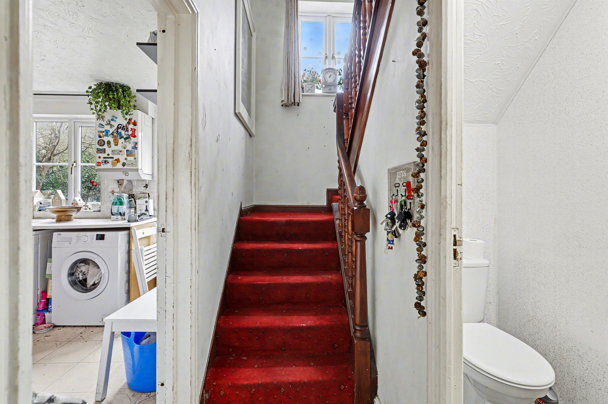
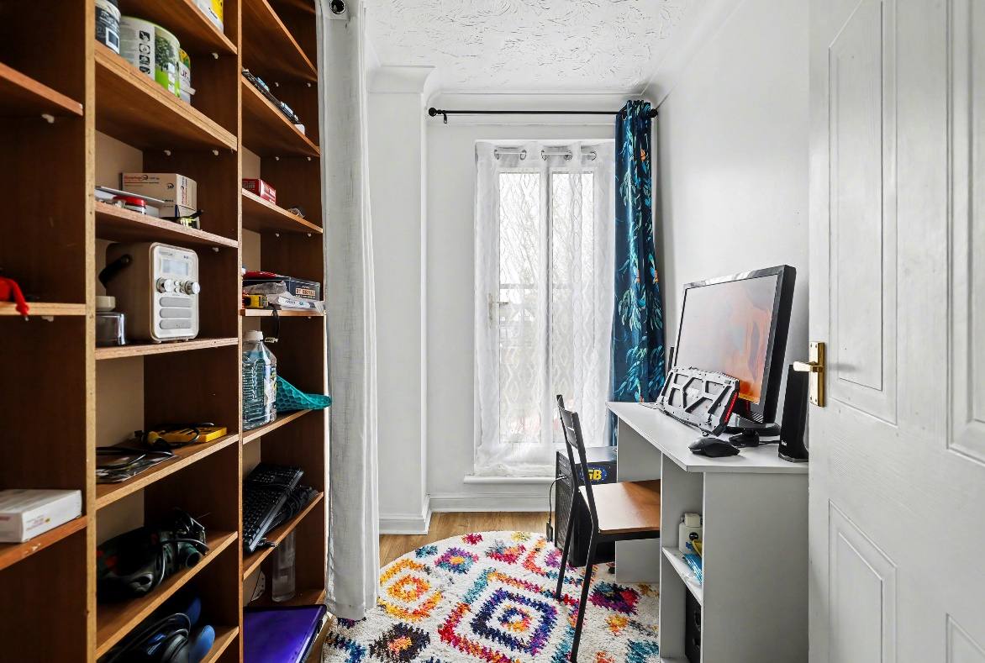
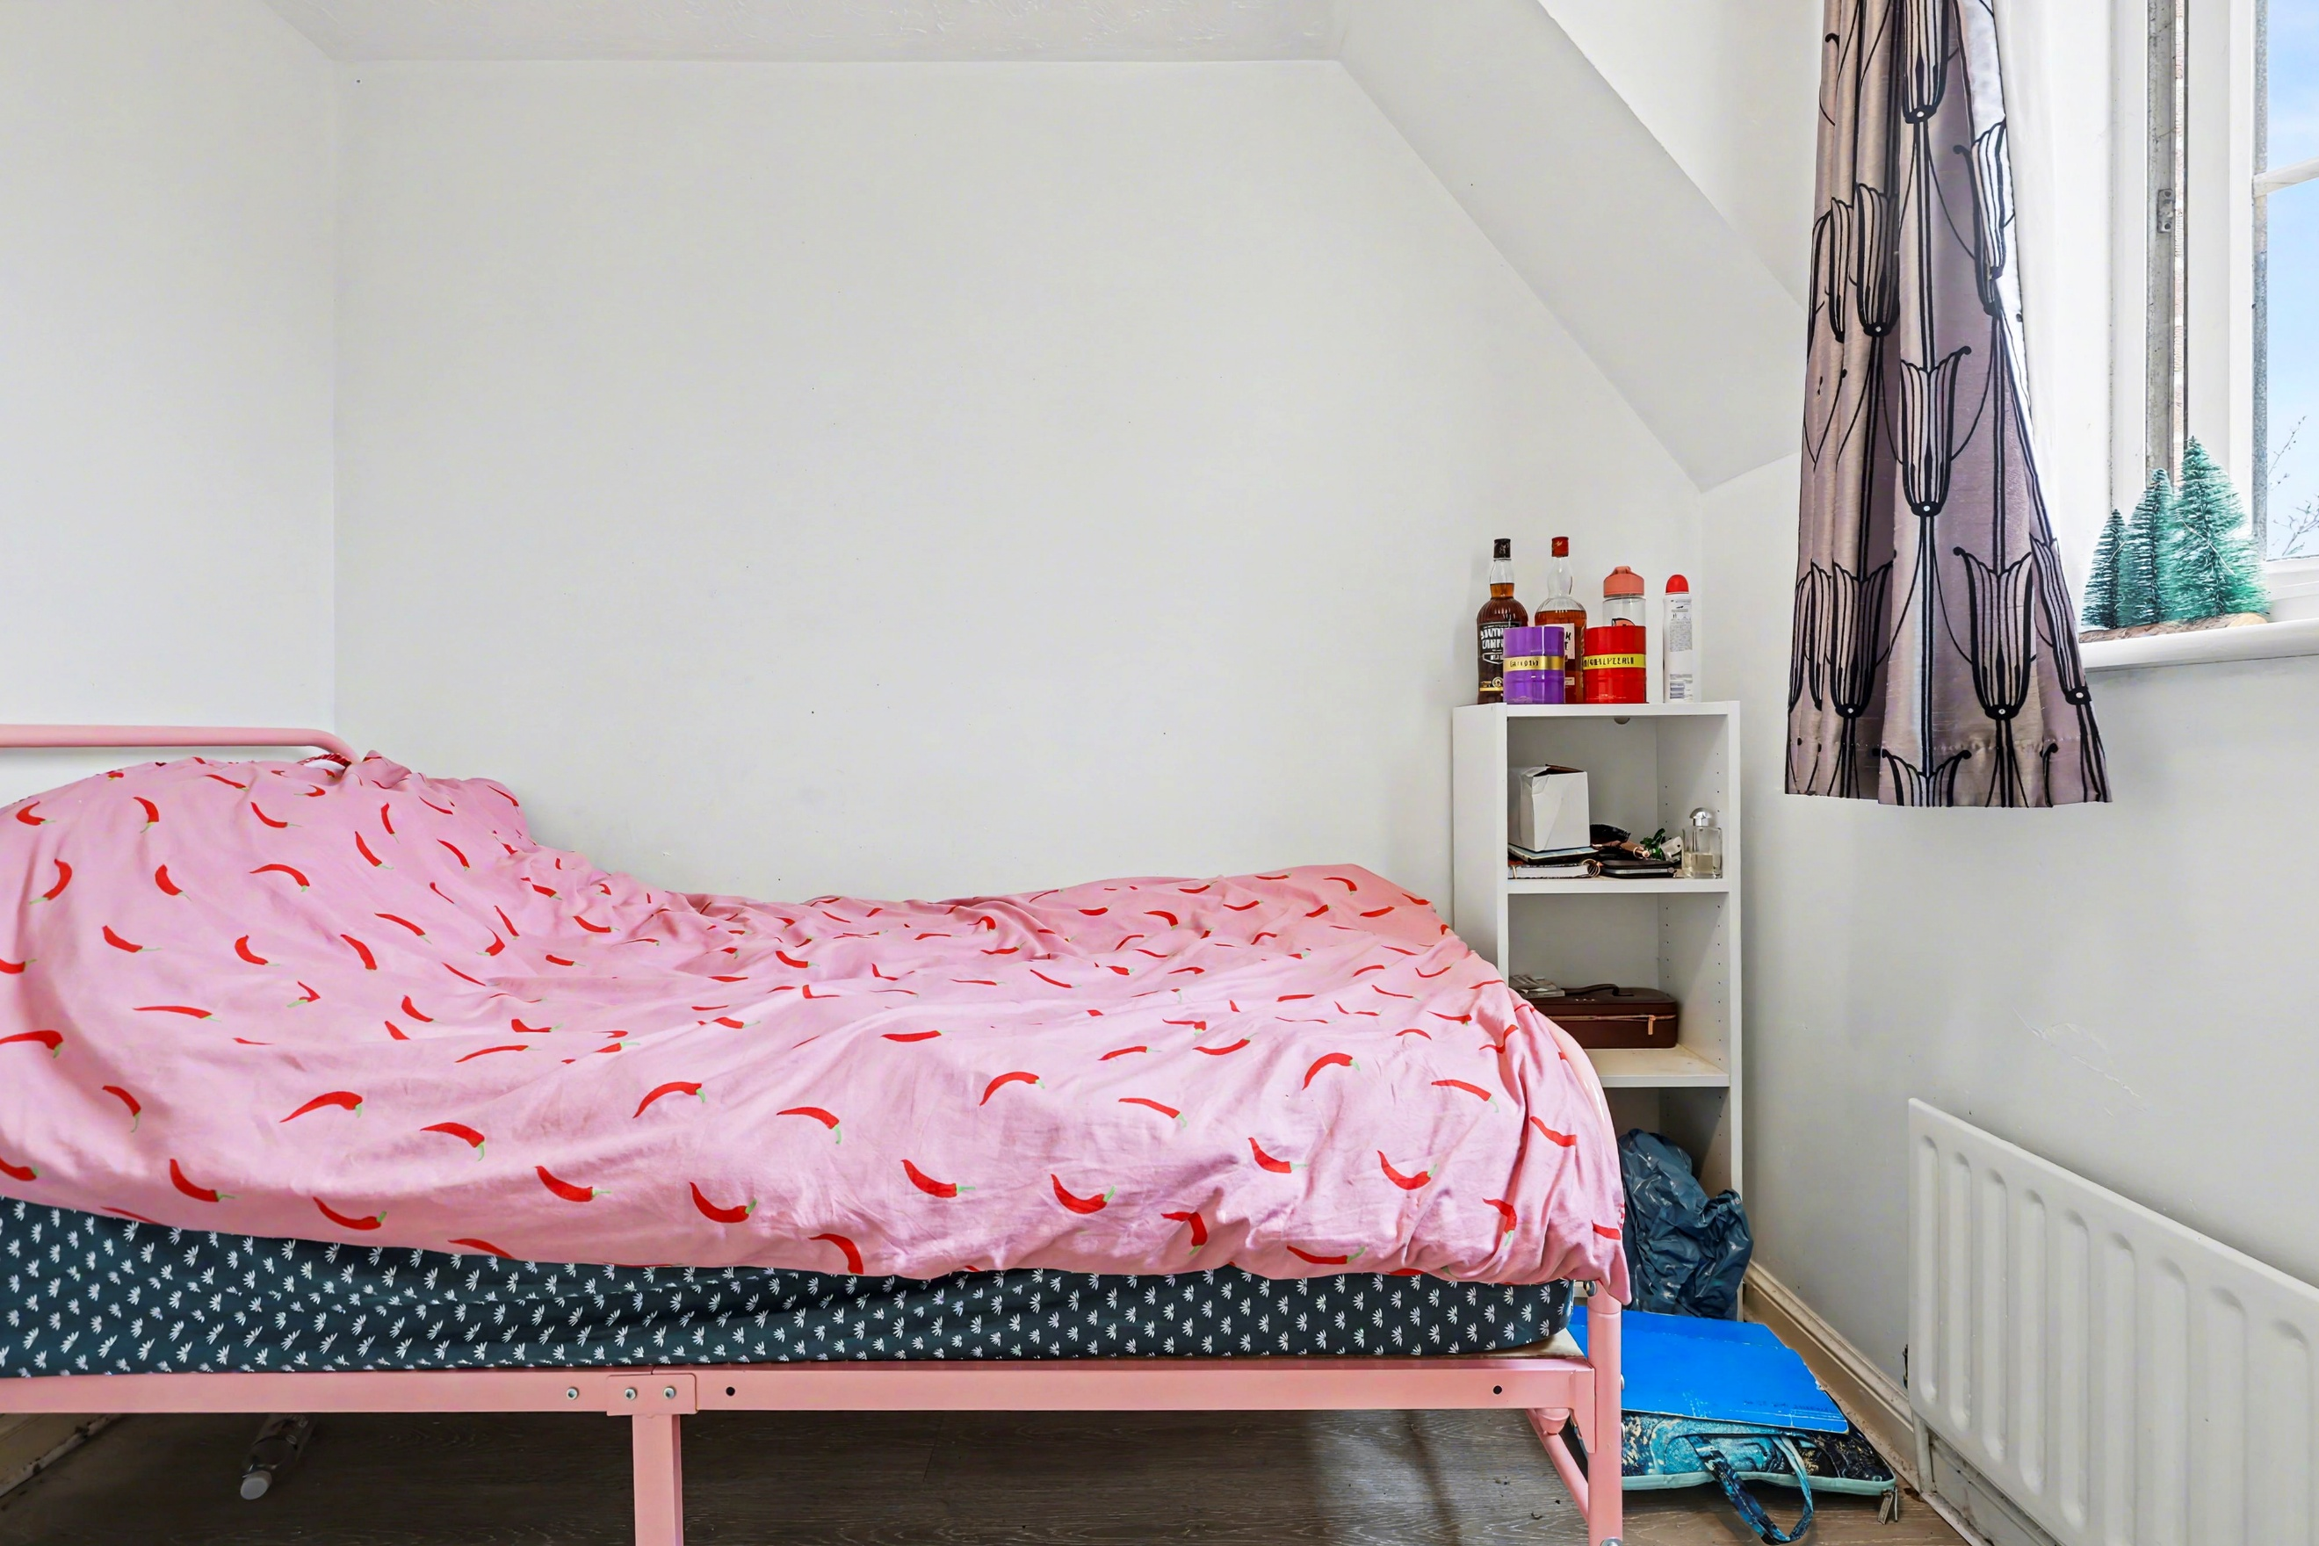
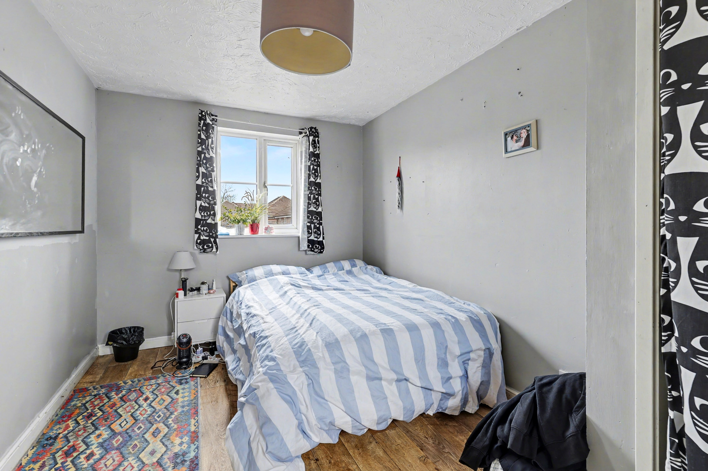
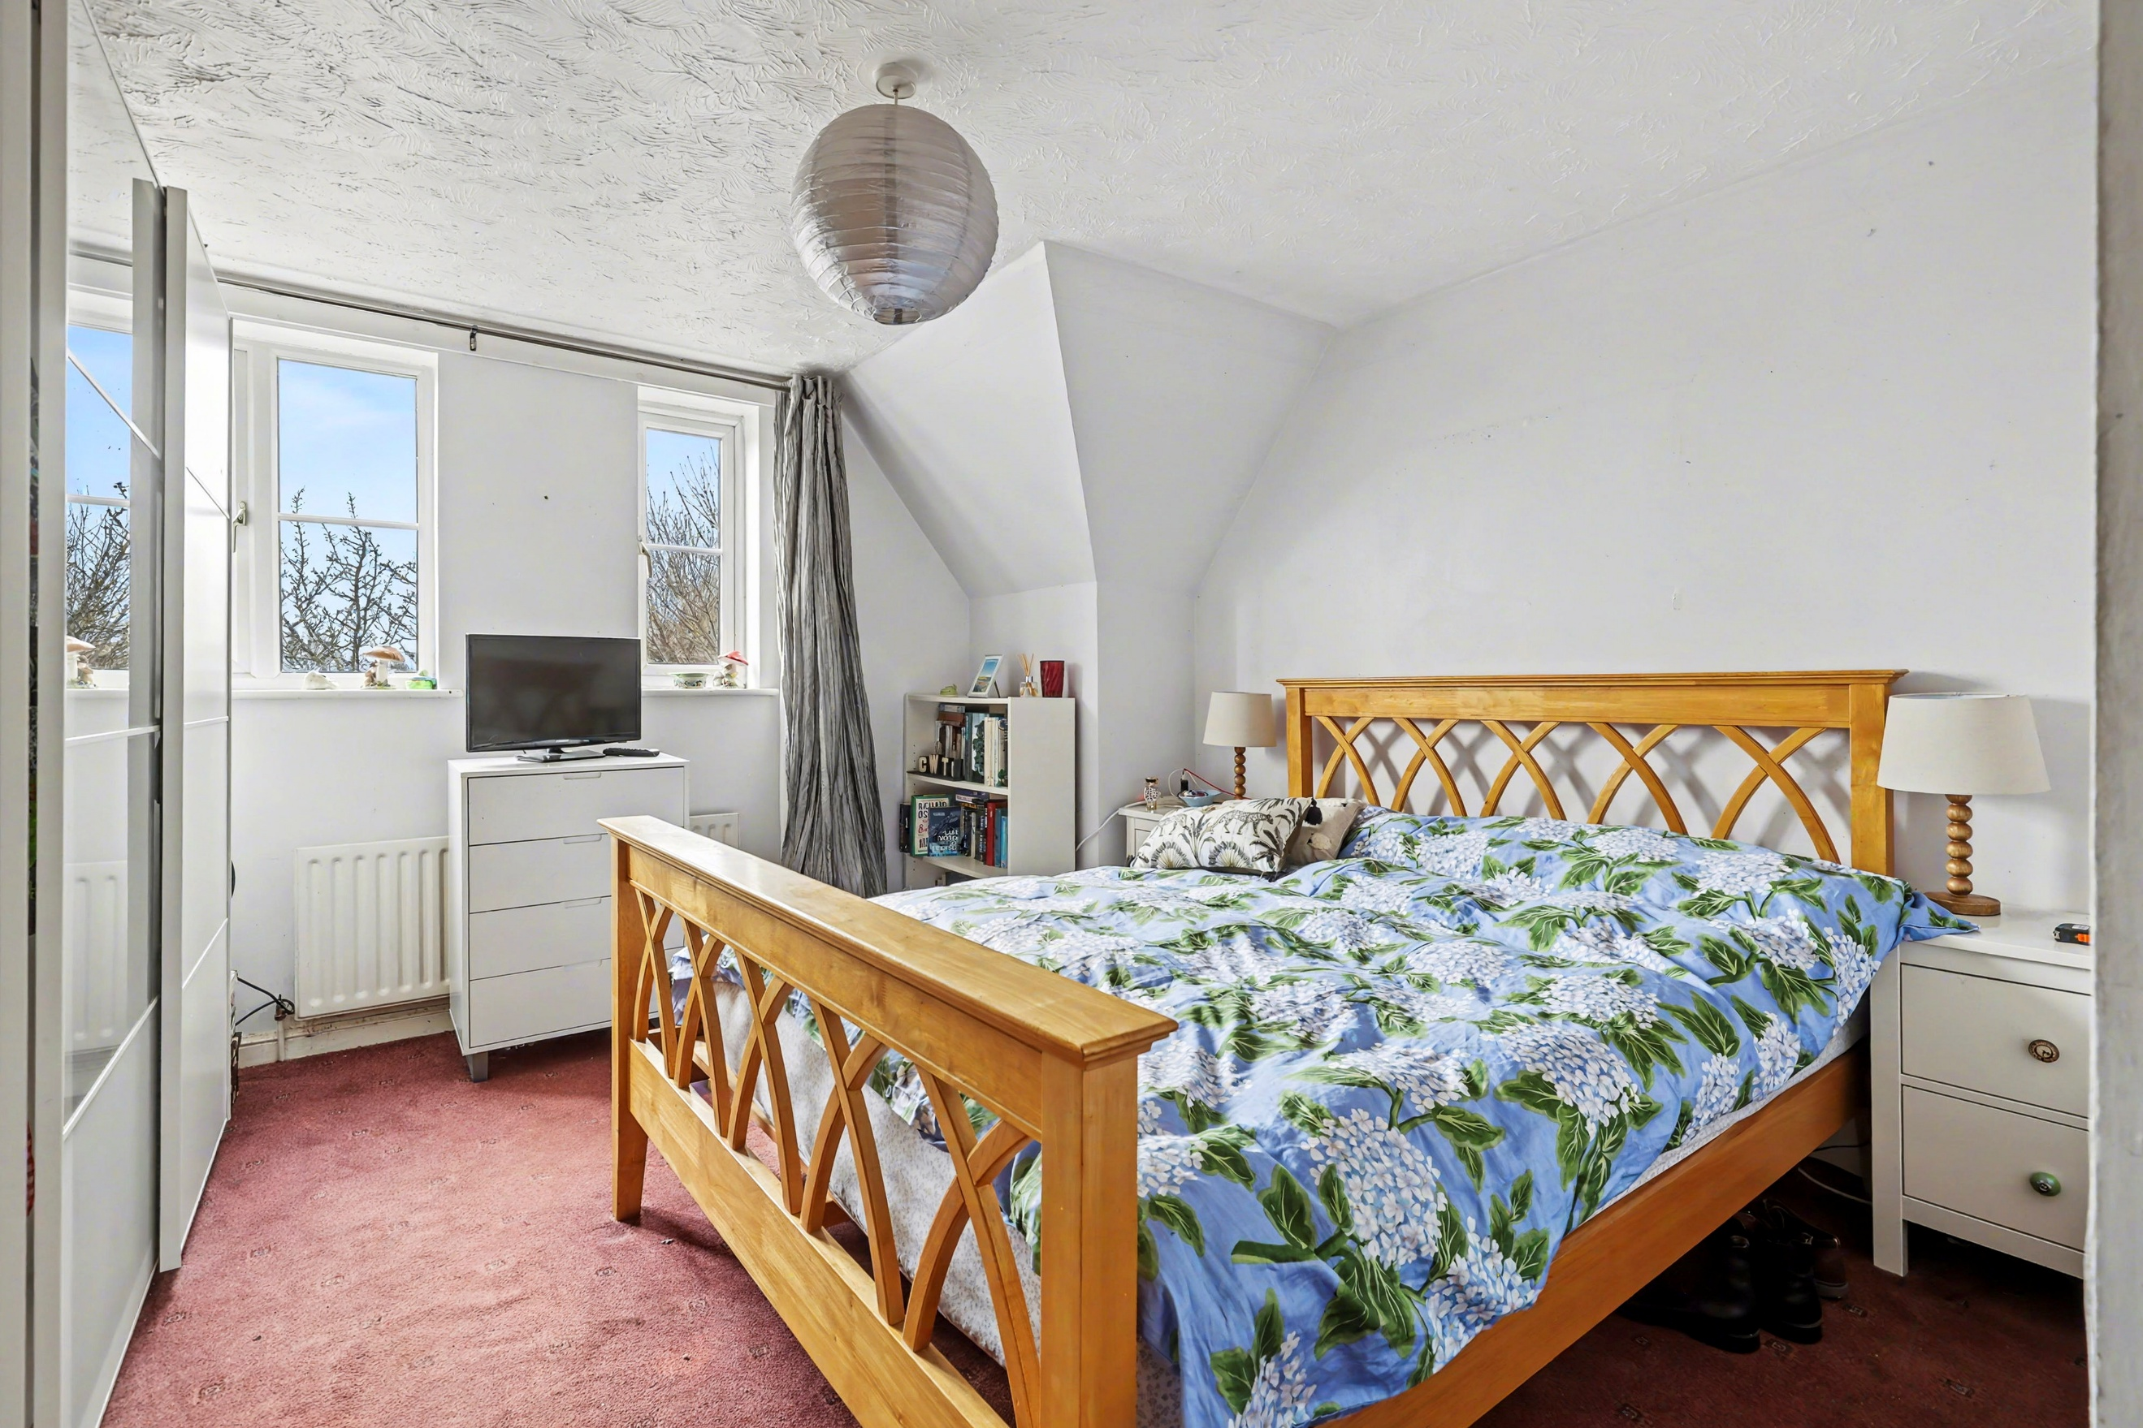
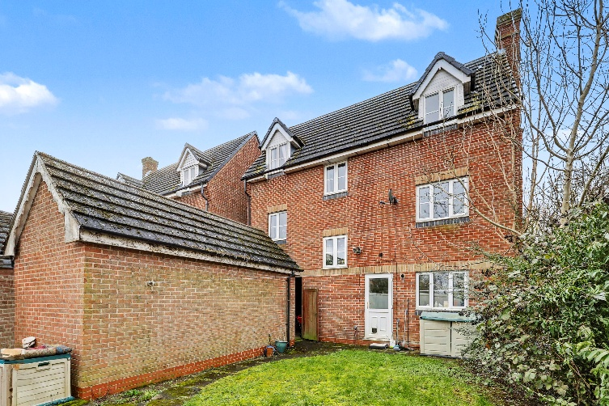
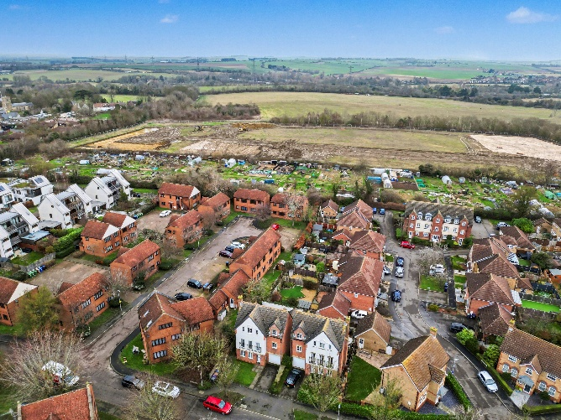
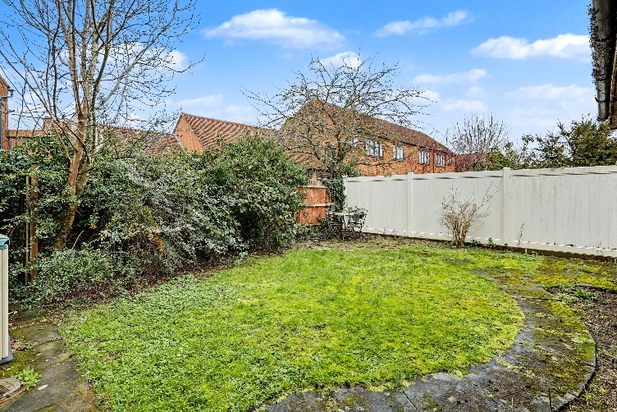
Step outside and you’ll find a private, enclosed rear garden offering a great balance of lawn and patio space, ideal for both relaxing and entertaining. The garden is mainly laid to lawn, providing a safe and usable space for children or pets, while the patio area offers the perfect spot for outdoor seating or summer dining.
The garden is bordered by mature shrubs and fencing, creating a good sense of privacy and a pleasant green outlook. There is also useful side access, making it practical for day-to-day use, gardening, or bringing items through from the front of the property.
To the rear, the property itself presents well, with access back into the home and the benefit of the nearby garage, offering excellent additional storage or secure parking. Overall, the outside space is low maintenance while still offering plenty of potential for landscaping or personalisation to suit the next owner.
Step Outside

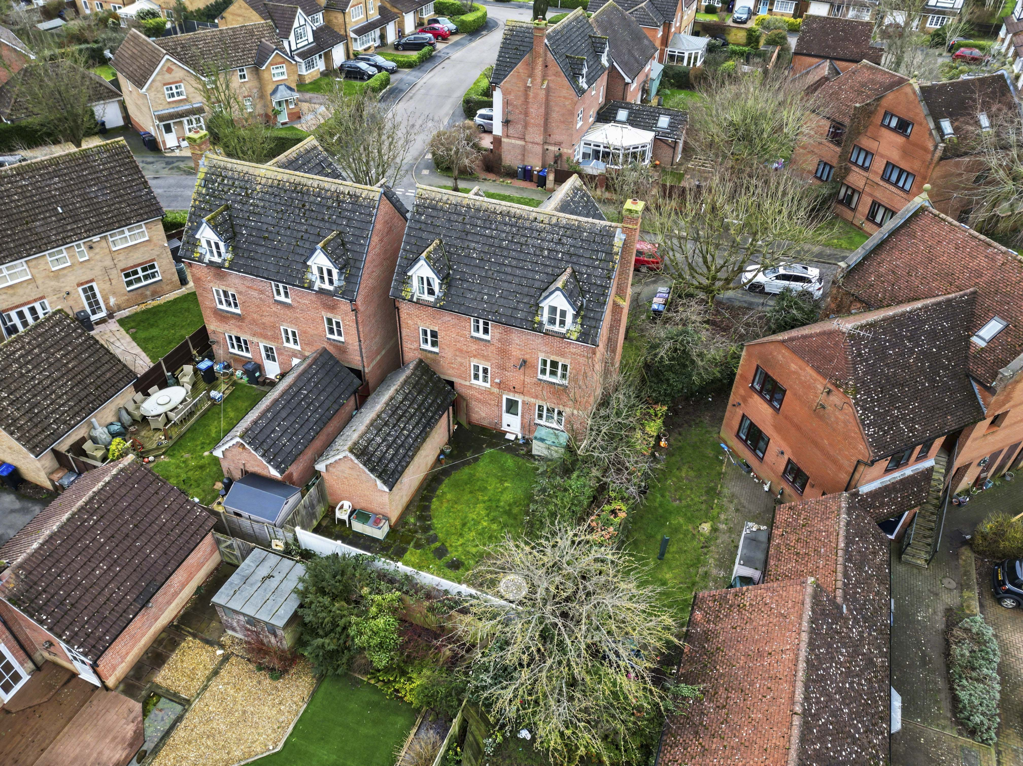

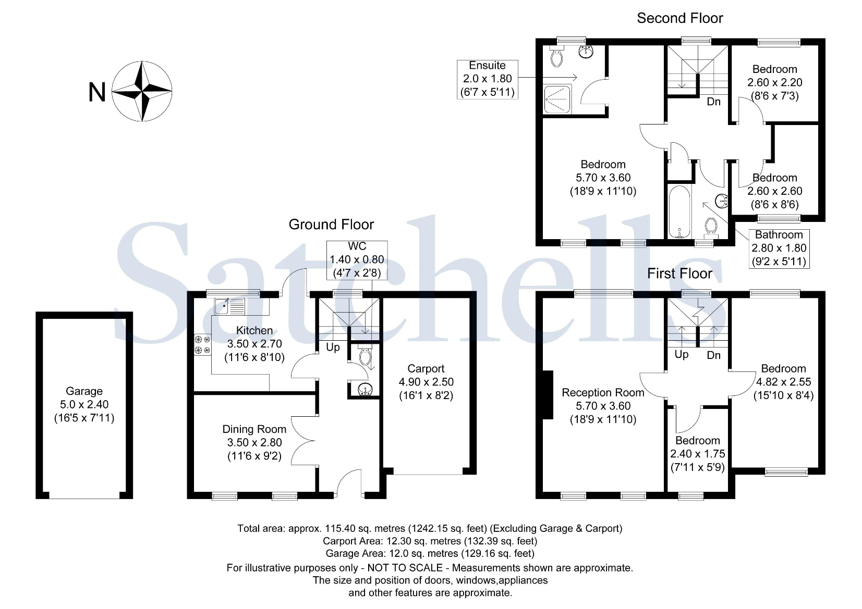

These particulars are a guide only and do not constitute an offer or a contract. The floorplan is for identification purposes only and not to scale. All measurements are approximate and should not be relied upon if ordering furniture, white goods and flooring etc. We have presented the property as we feel fairly describes it but before arranging a viewing or deciding to buy, should there be anything specific you would like to know about the property please enquire. Satchells have not tested any of the appliances or carried out any form of survey and advise you to carry out your own investigations on the state, condition, structure, services, title, tenure, and council tax band of the property. Some images may have been enhanced and the contents shown may not be included in the sale. Satchells routinely refer to 3rd party services for which we receive an income from their fee. If you would like us to refer you to one of these services, please ask one of our staff who will pass your details on. We advise you check the availability of the property on the day of your viewing.



Station Place, Letchworth Garden City, Hertfordshire, SG6 3AQ.
01462 480077
letchworth@satchells.co.uk
www.satchells.com

