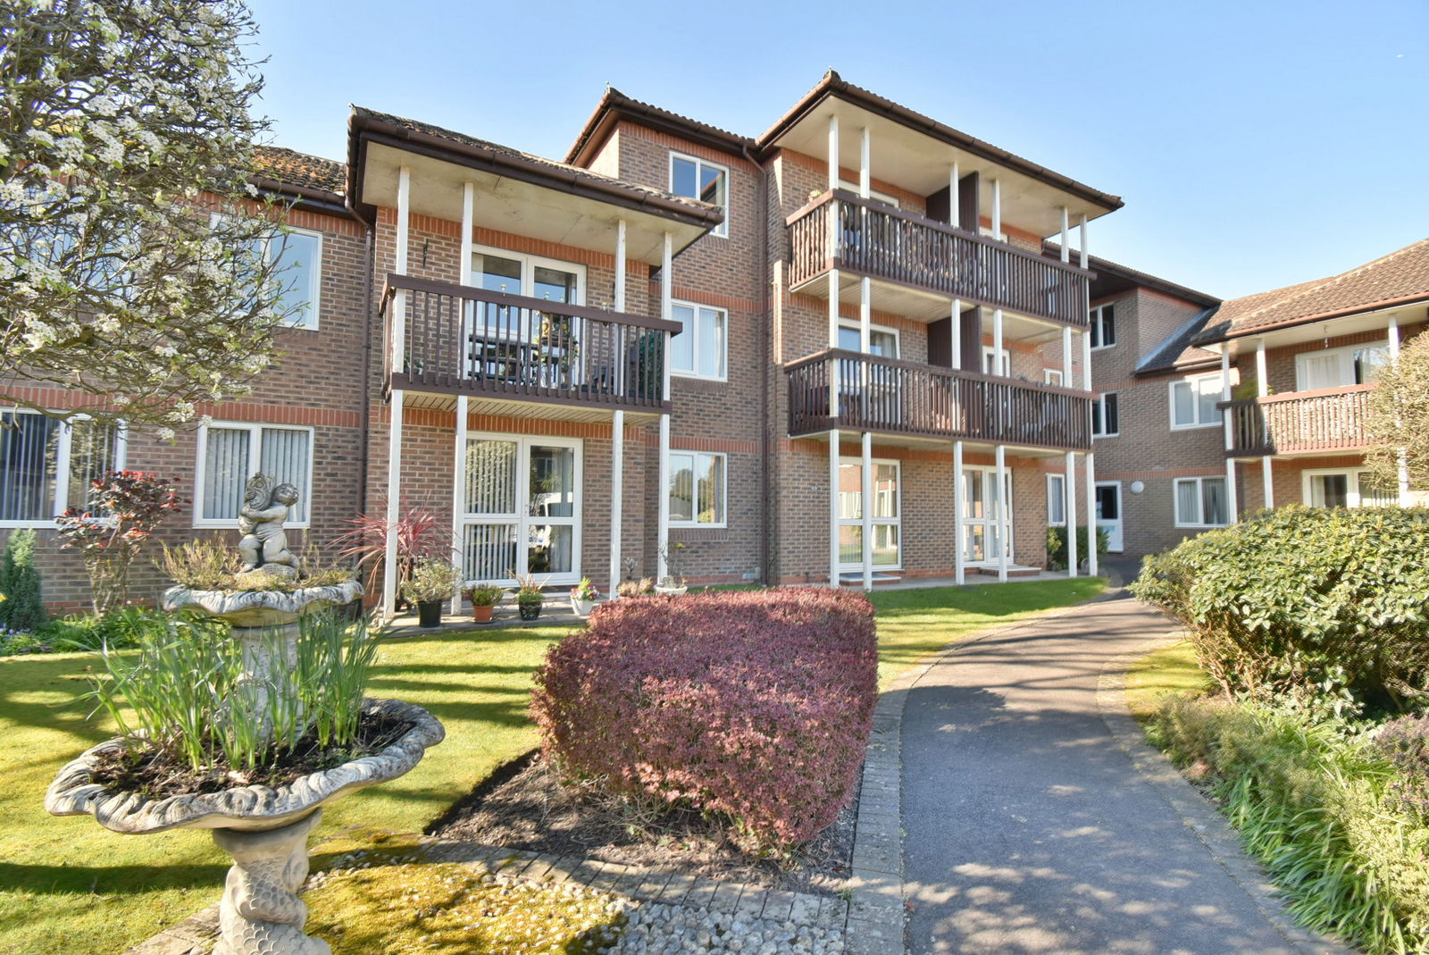
Flat 16 St Mary’s Mews, 1 Fernlea Avenue
Ferndown, Dorset, BH22 8HF
“Extremely well-appointed ground floor retirement apartment with its own private patio and no chain”
This conveniently located and well presented one double bedroom ground floor retirement apartment has its own private patio area which enjoys a pleasant outlook over the communal gardens.

The property now comes to the market offered with no onward chain and keys are held within the office.

St Marys Mews is located within level walking distance of Ferndown town centre.

- One double bedroom ground floor retirement apartment with its own private patio area

- Good sized entrance hall with double storage/airing cupboard
- 18’ Living room with space for dining table and chairs, wall-mounted modern electric heater, double glazed door leading out onto the patio area
- The patio area faces a south easterly aspect and enjoys a pleasant outlook across the communal grounds/courtyard
- Kitchen incorporates a range of base and wall-mounted units, modern worktops, sink unit with mixer tap, tiled splashbacks, concealed underlighting, plumbing for a washing machine and space for a tumble dryer and tall standing fridge/freezer, integrated raised oven, inset four ring electric hob with extractor hood above
- Good sized double bedroom with fitted floor to ceiling wardrobes with mirrored sliding doors and wall-mounted electric heater
- Shower room incorporating a partially updated suite with walk in dual width shower cubicle with wall-mounted Mira electric shower unit, tiled walls, WC, wash hand basin, extractor fan and heated towel rail
- Further benefits include a house manager who works 9am to 5pm five days a week, 24 hour careline system, double glazing, electric radiators and an entry phone intercom system
- The communal gardens are beautifully kept, predominantly laid to lawn with well stocked shrub borders and flower beds. A path provides access to communal areas and various accesses into St Marys Mews. A gate at the rear provides access to the nearby Ringwood Road which allows easy access to the town centre with a supermarket, post office, library, health centre and other amenities.
- All residents have the use of the communal facilities in St Marys Mews which include a laundry room, refuse store, communal lounge, kitchen, hairdressing salon with visiting hairdressers and conservatory
- We understand that there is a nominal charge for the guest suite

Lease: Approximately 105 years (extended 2012)
Maintenance Charge: Approximately £3,327 per annum
Ground Rent: Approximately £130 every 6 months

COUNCIL TAX BAND: C EPC RATING: TBC

COUNCIL TAX BAND: C EPC RATING:
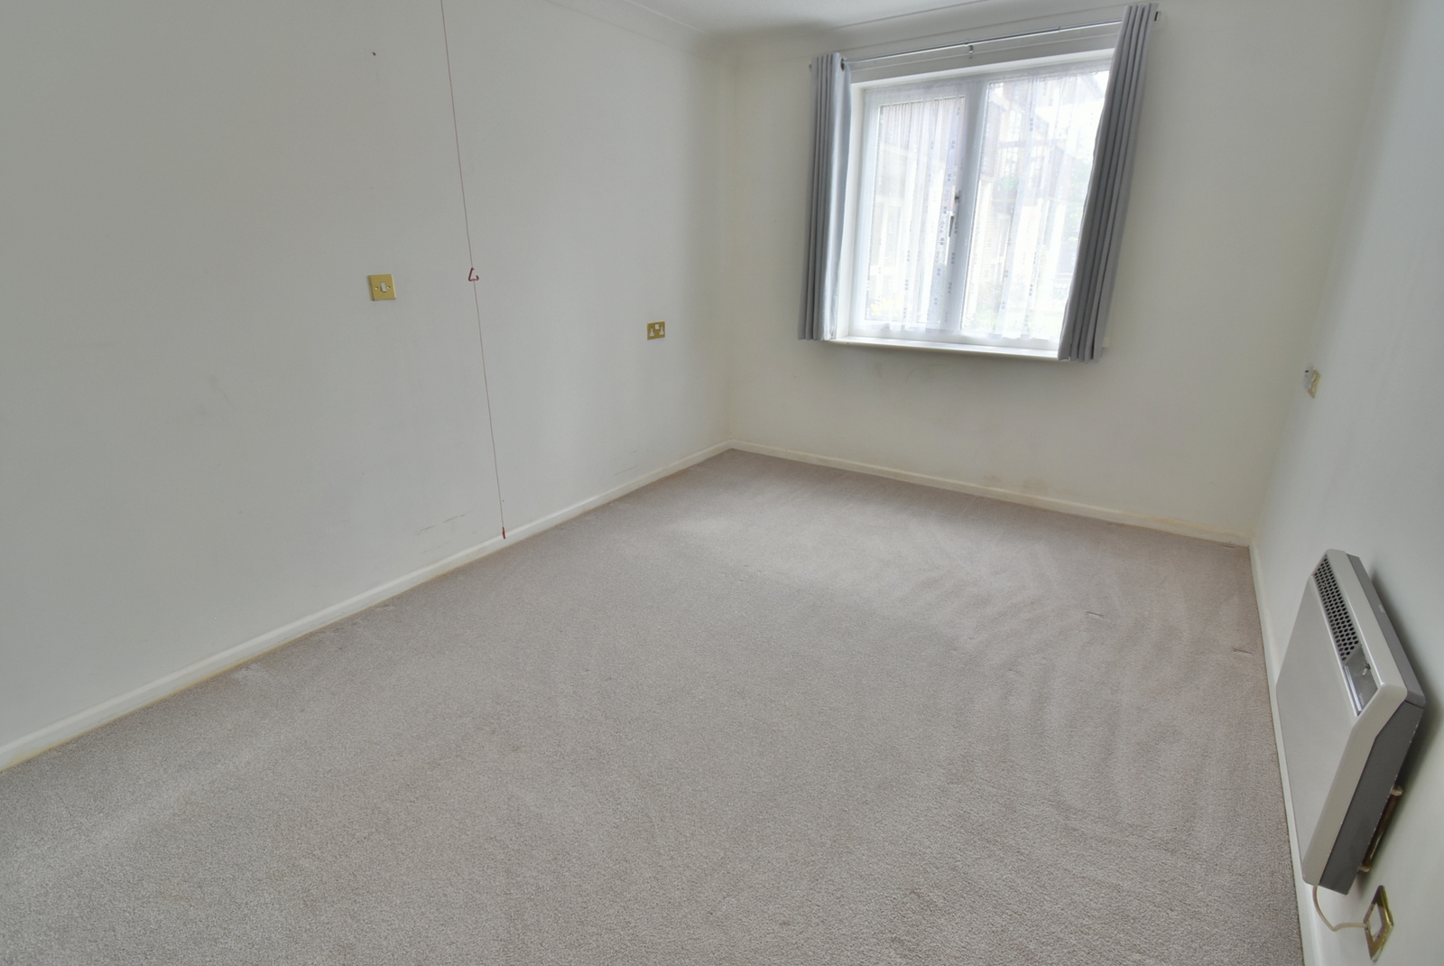
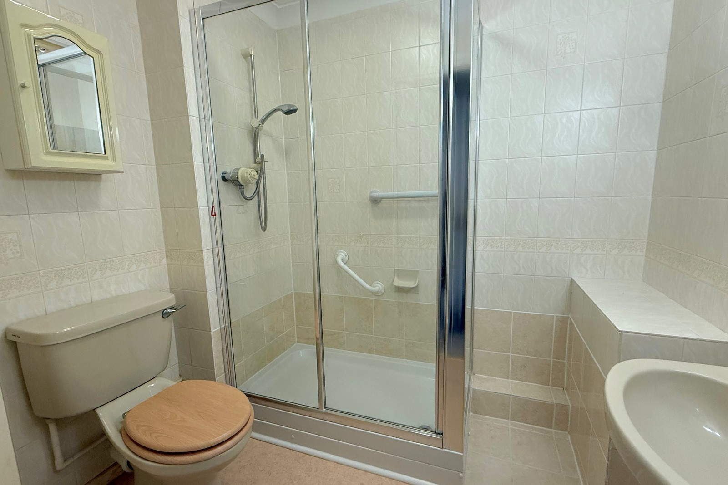
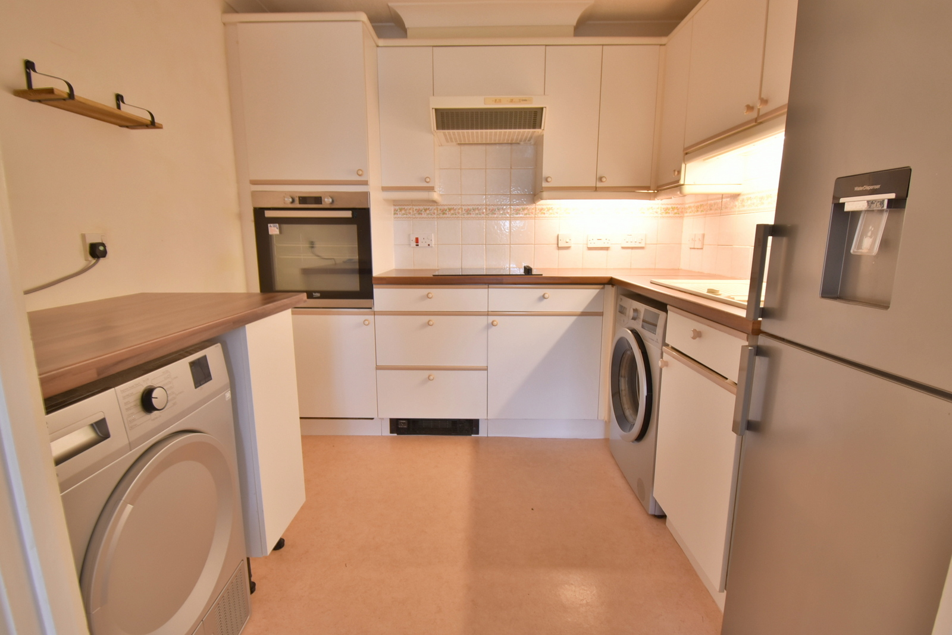
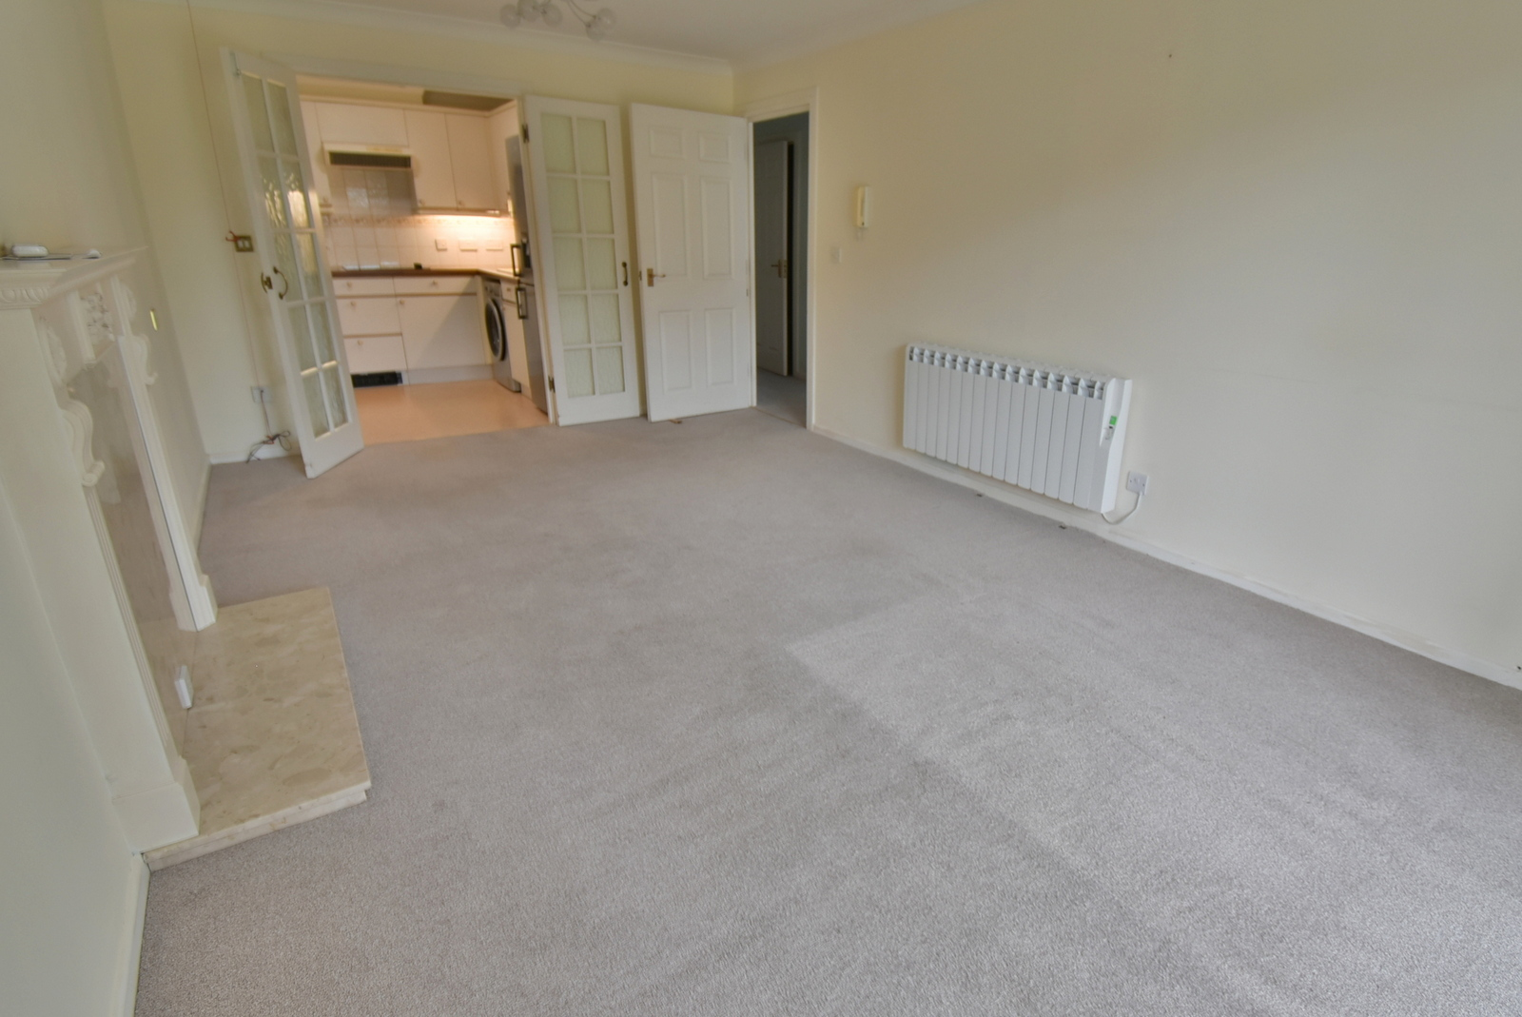
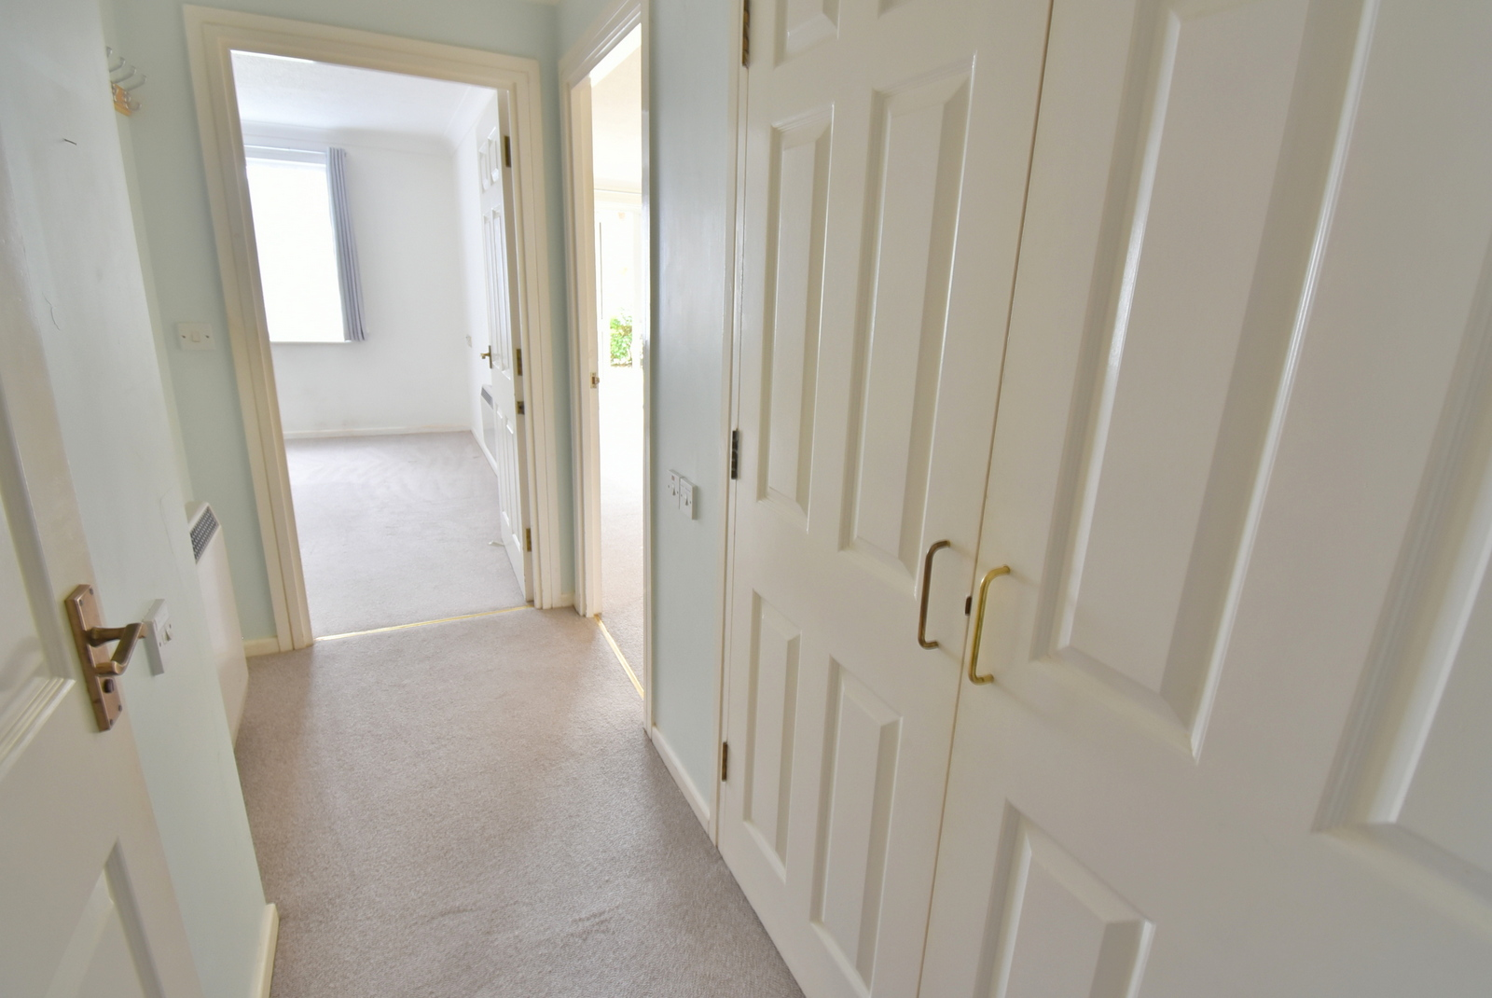
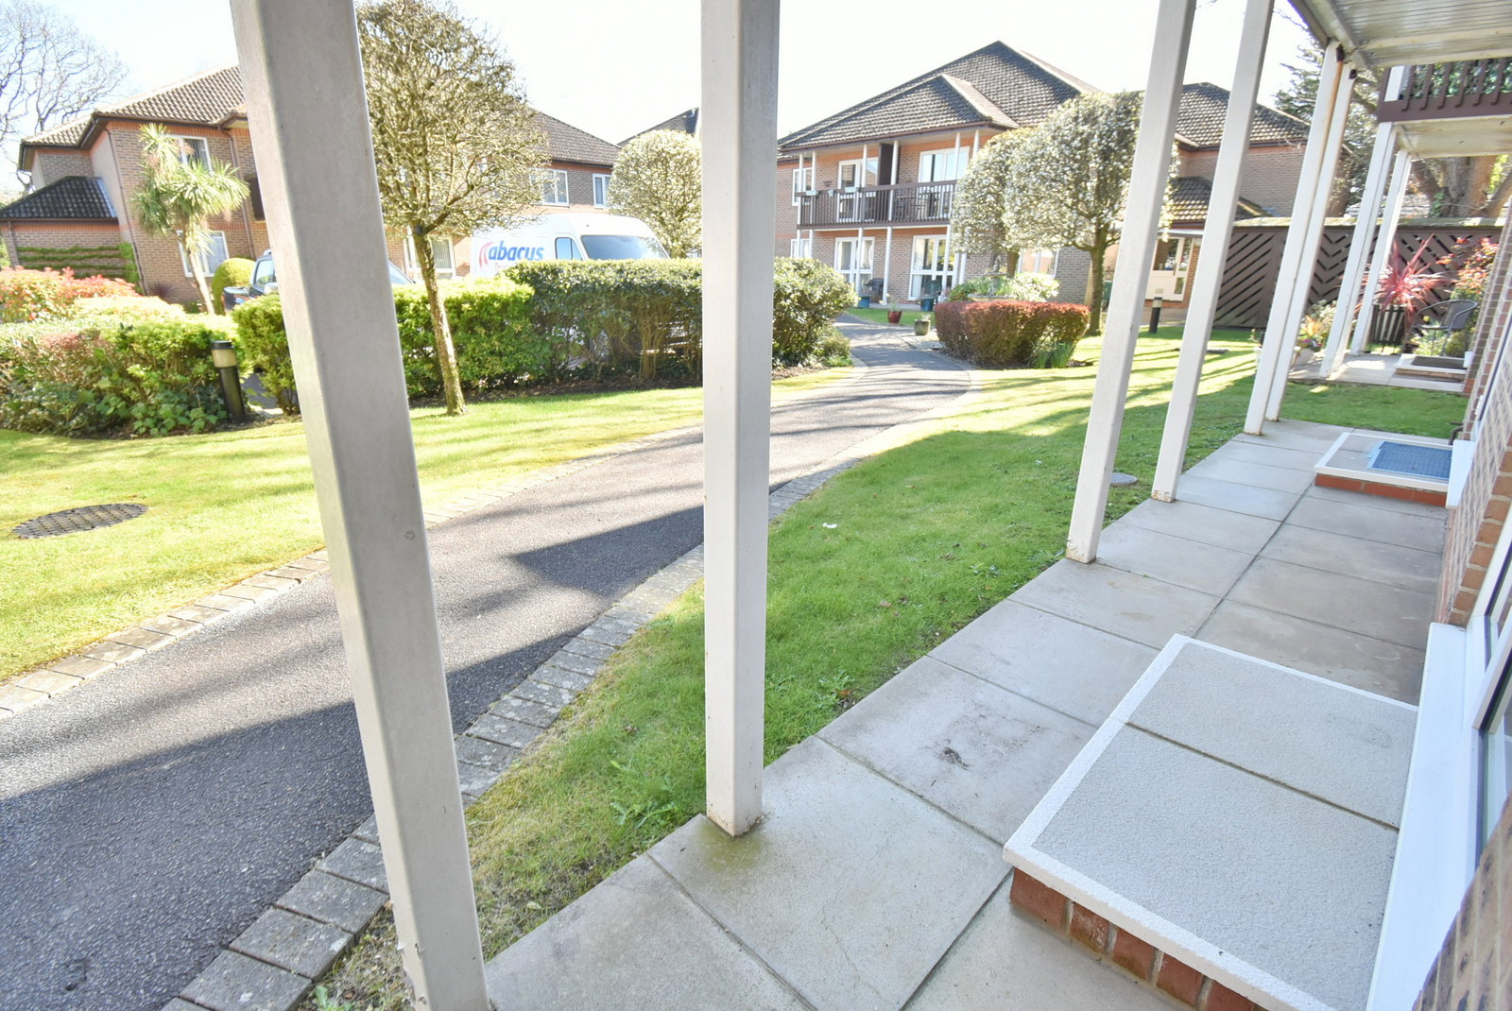
LEASEHOLD PRICE
£150,000
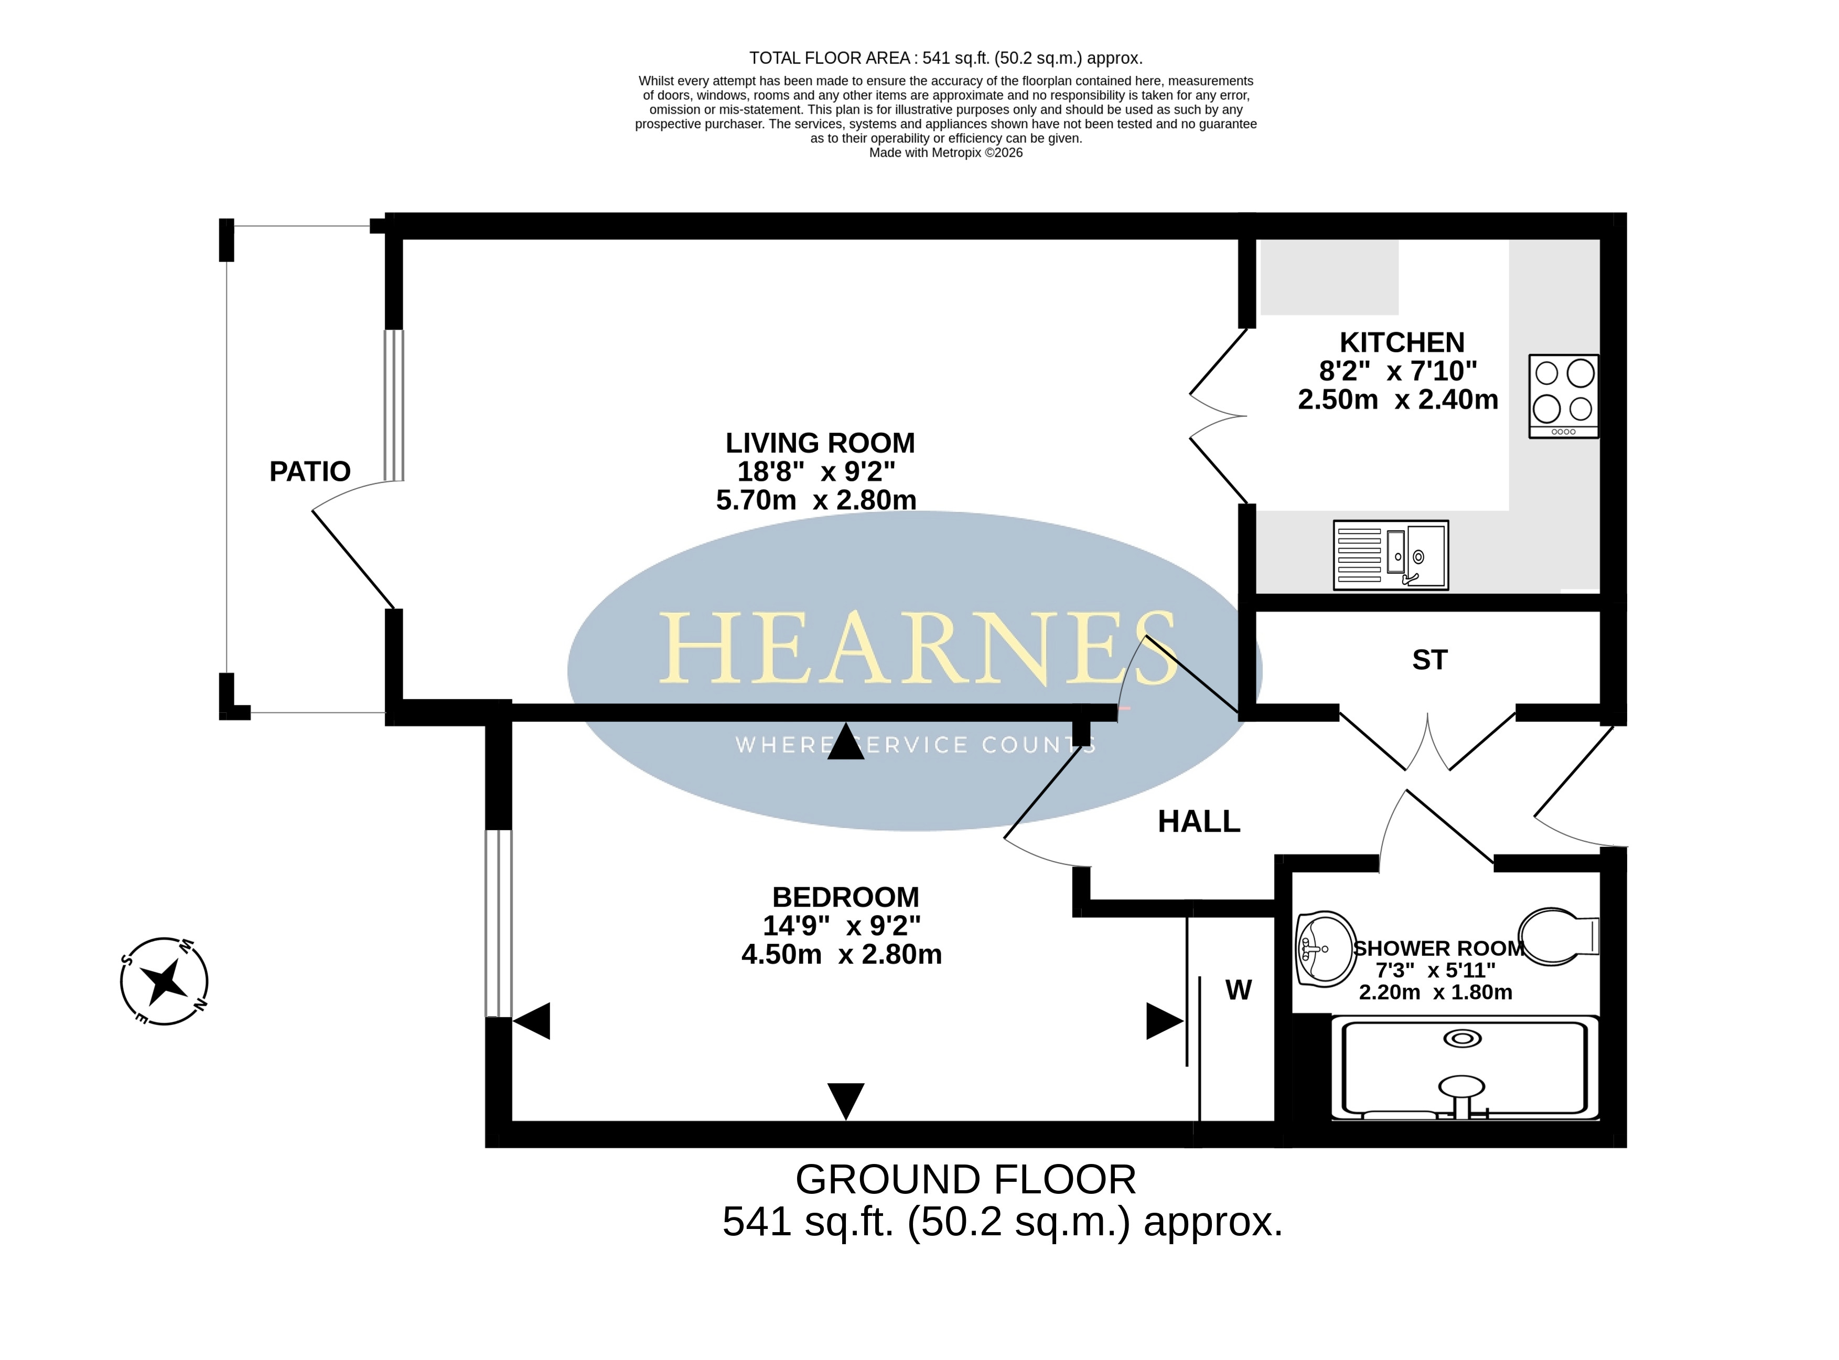

6-8 Victoria Road, Ferndown, Dorset. BH22 9HZ Tel: 01202 890890 Email: ferndown@hearnes.com www.hearnes.com
OFFICES ALSO AT: BOURNEMOUTH, POOLE, RINGWOOD & WIMBORNE

