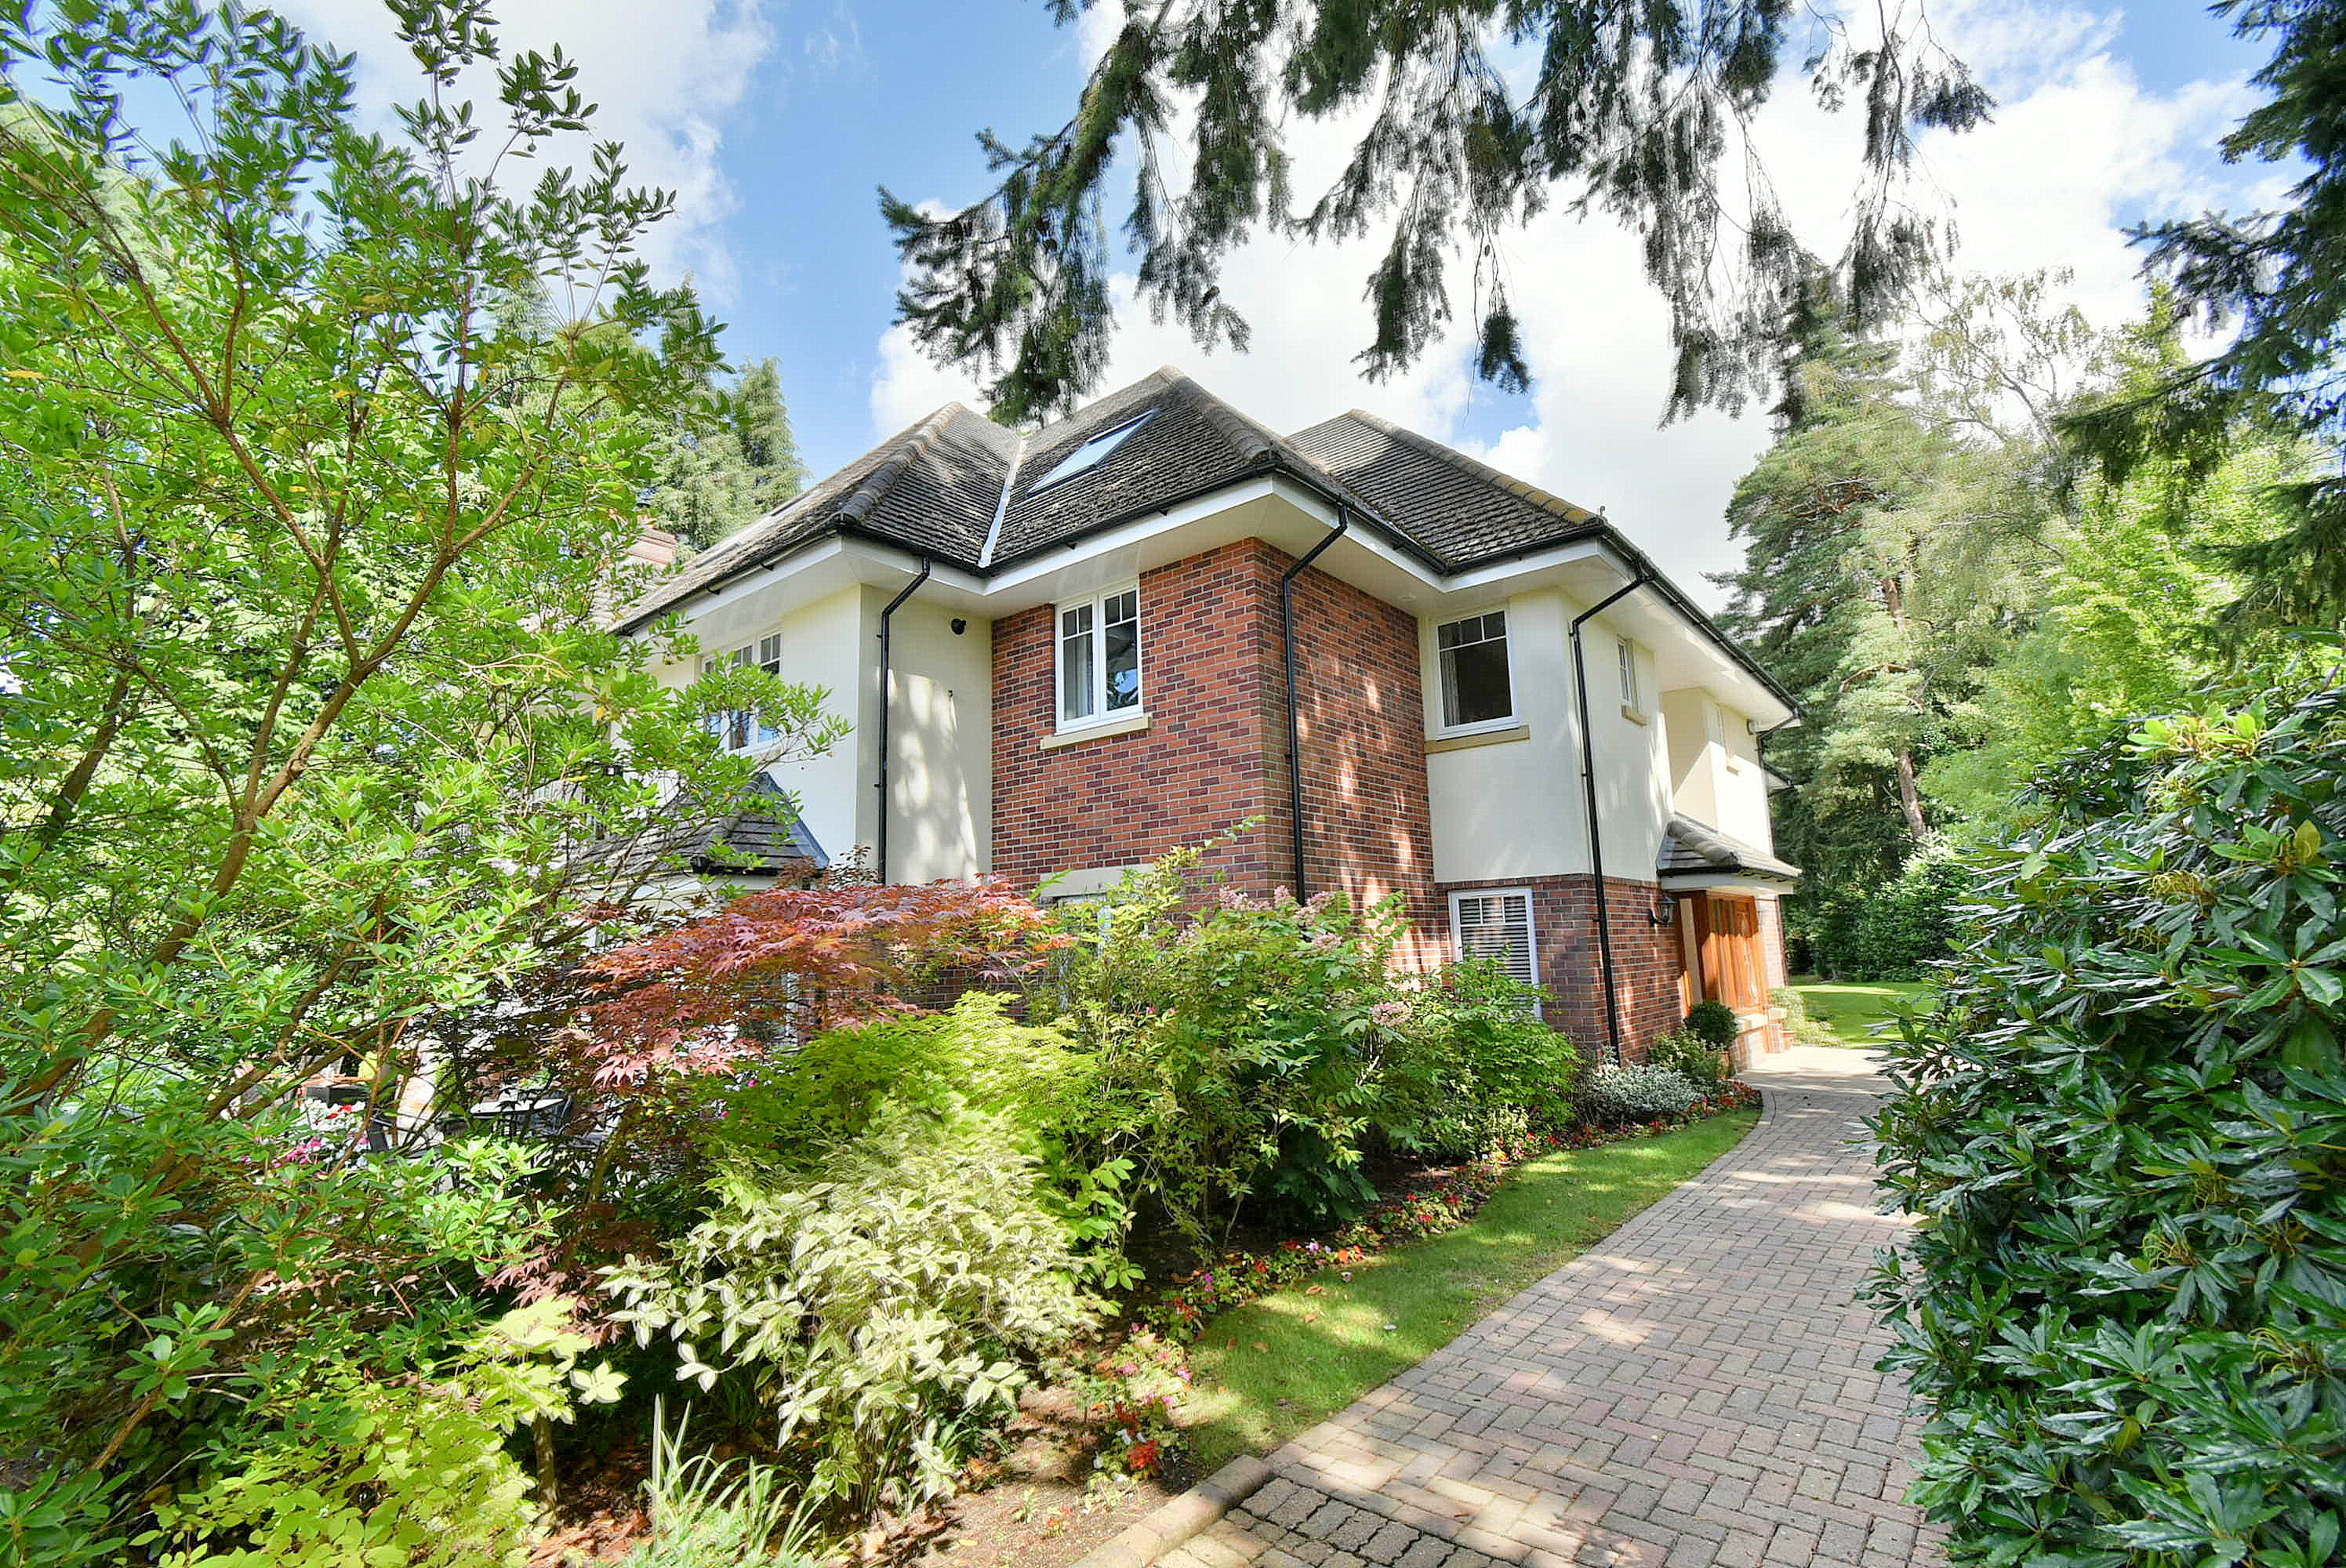
Flat 7 Pembroke House
24 Dudsbury Avenue, Ferndown, BH22 8DU
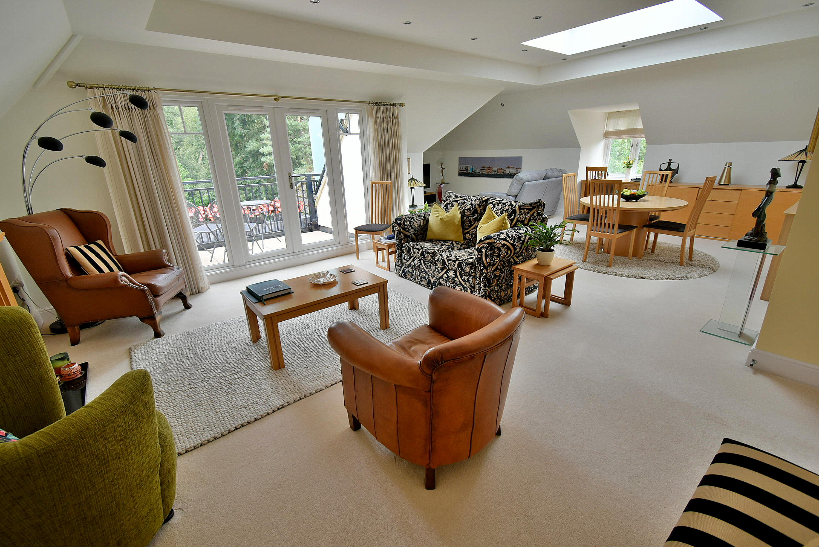
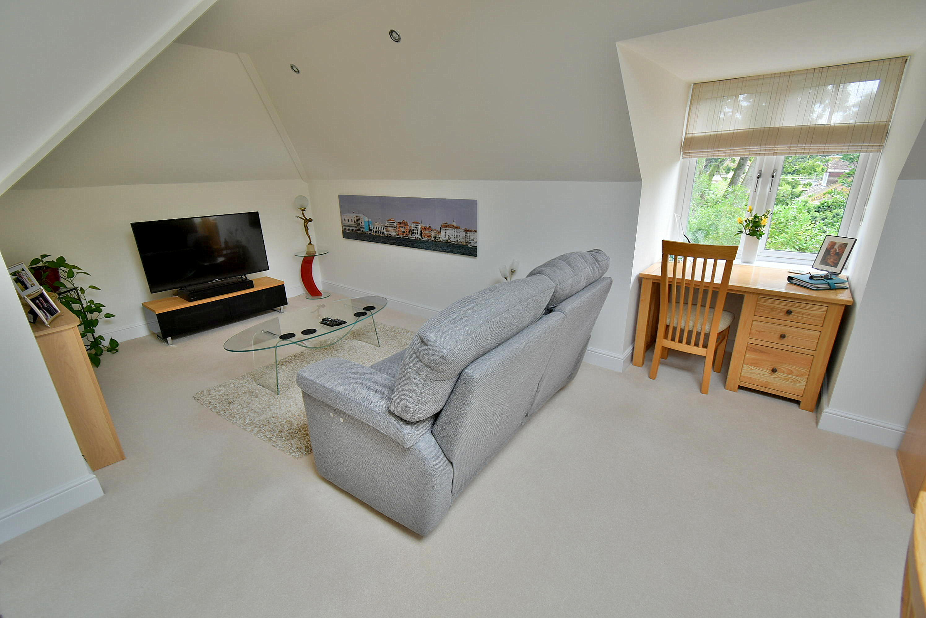
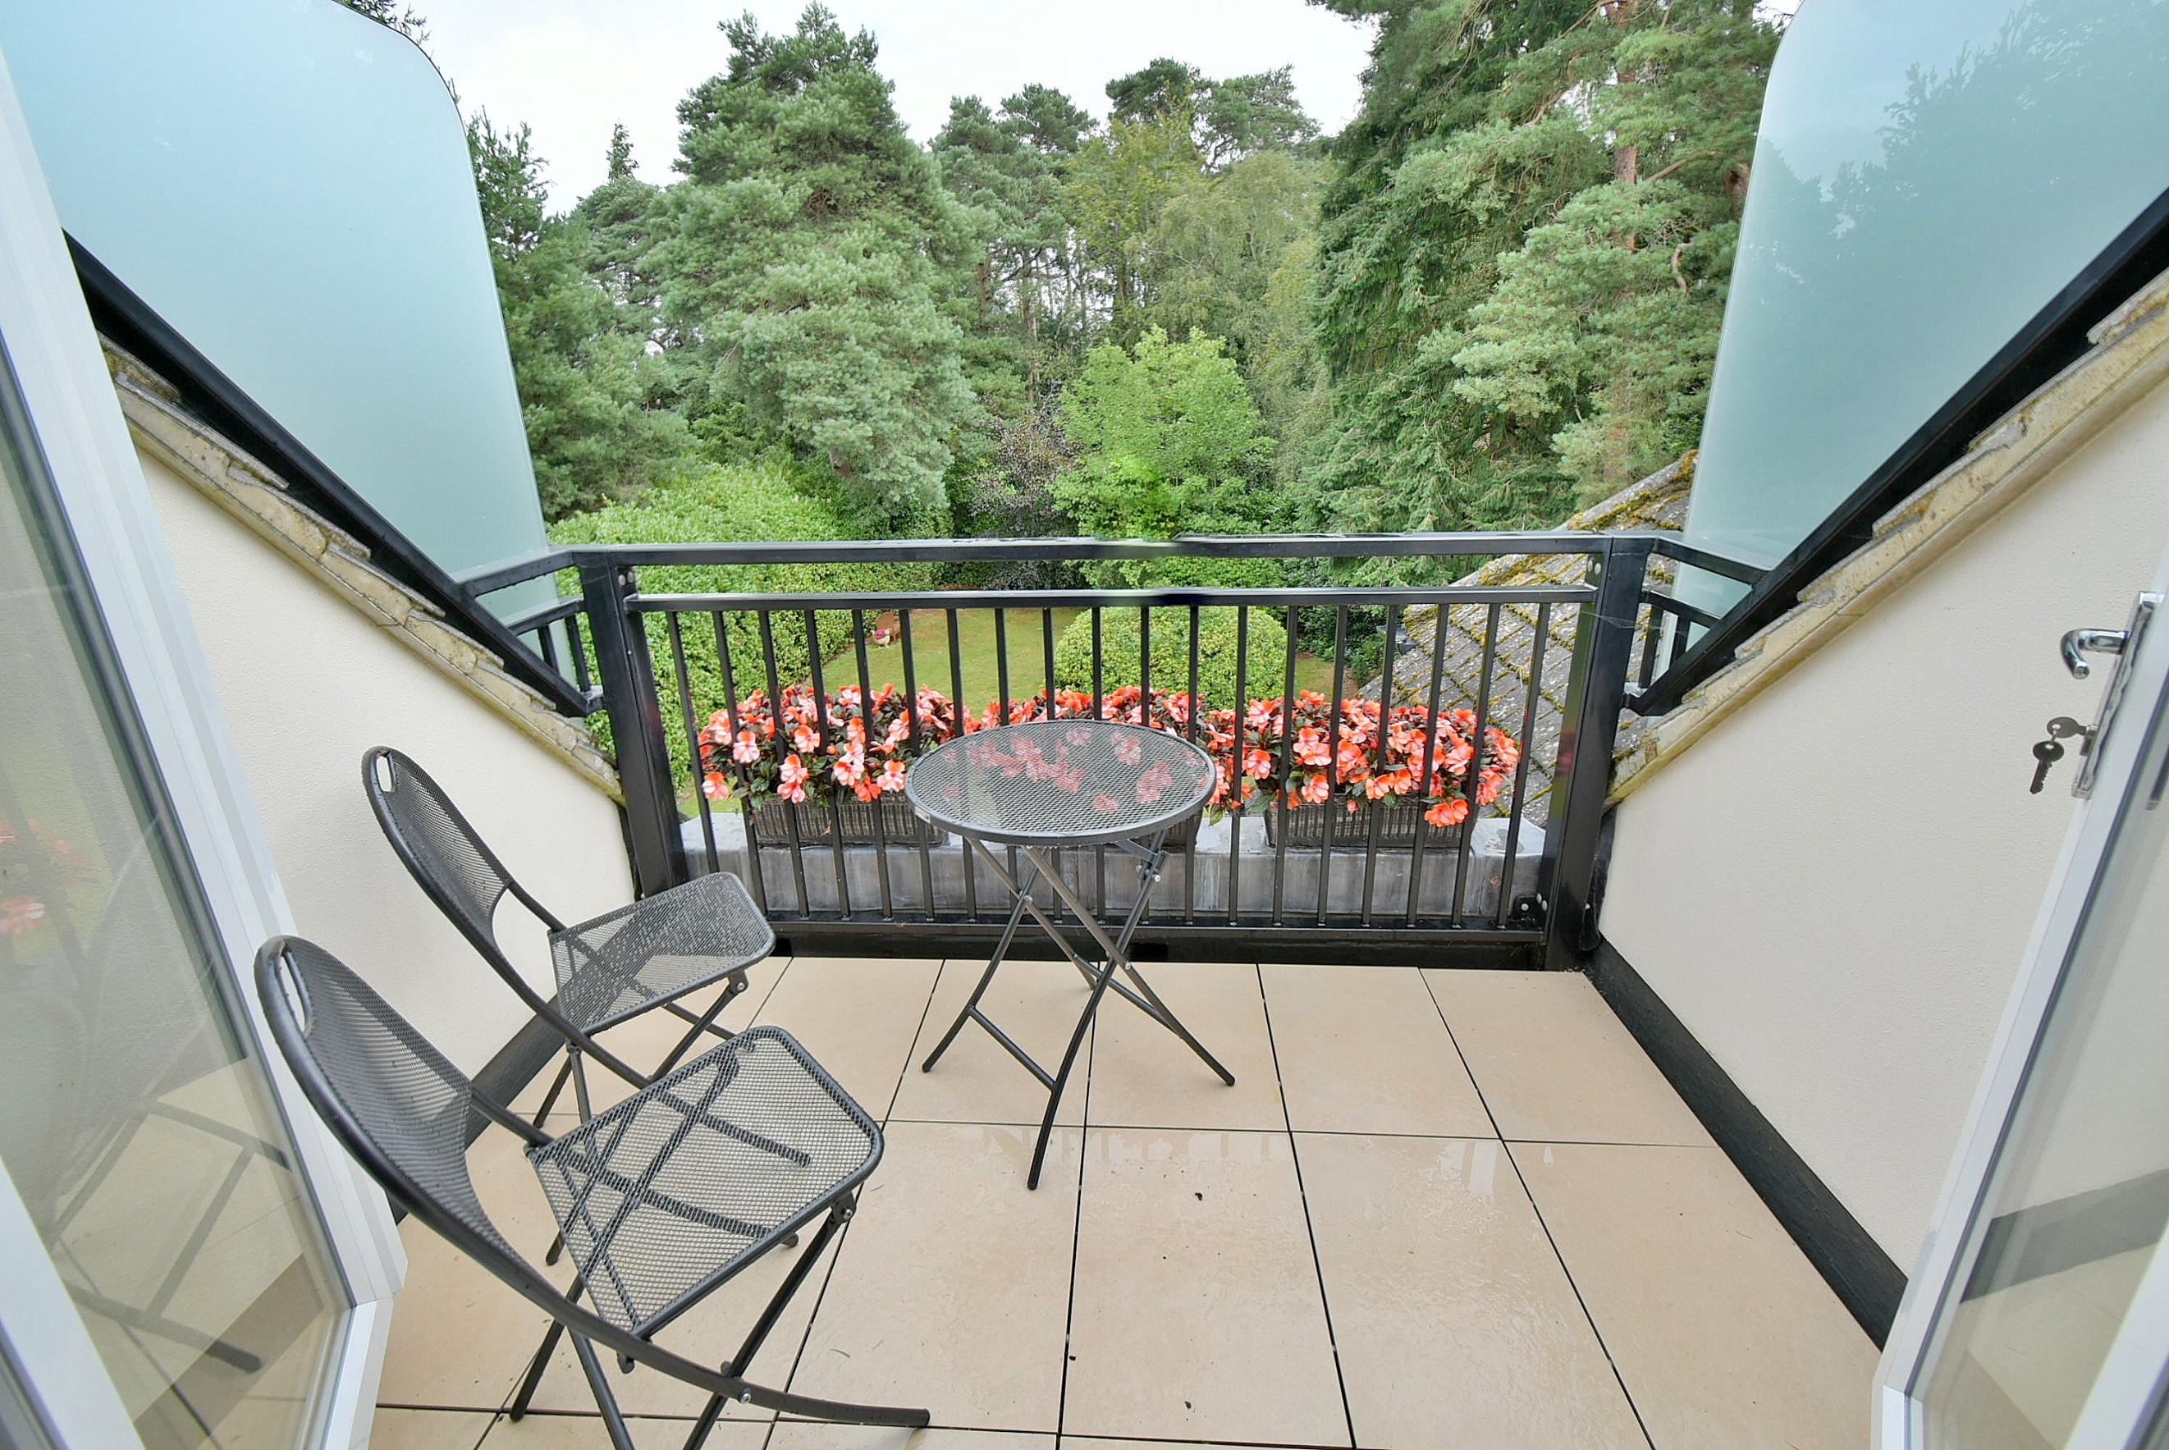
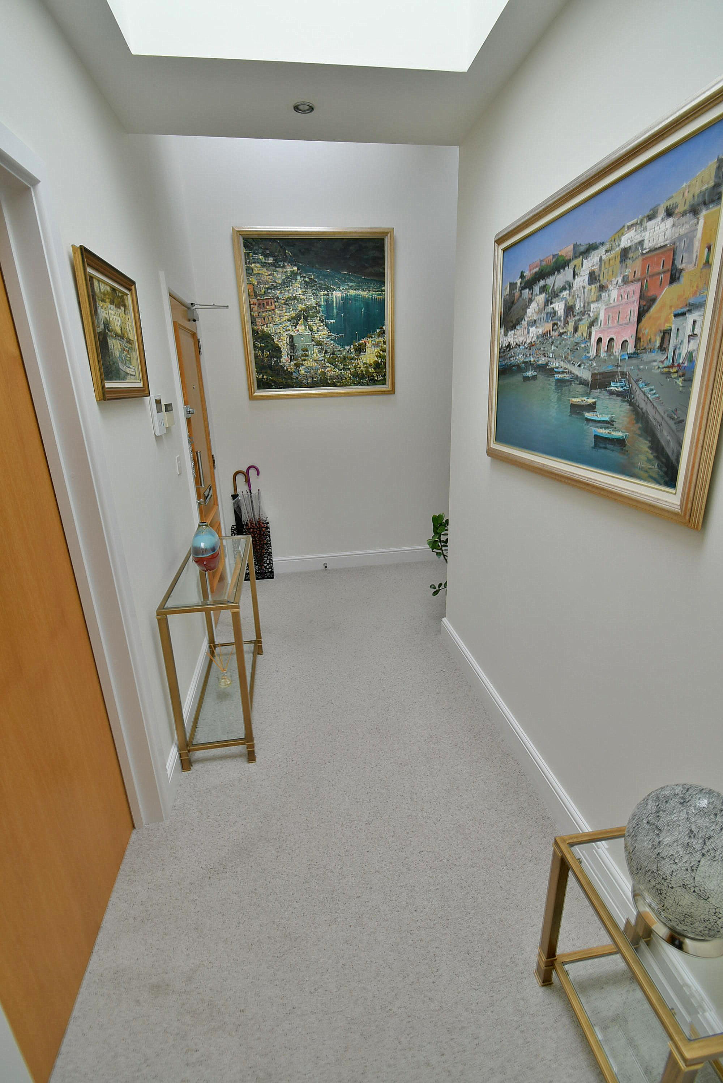
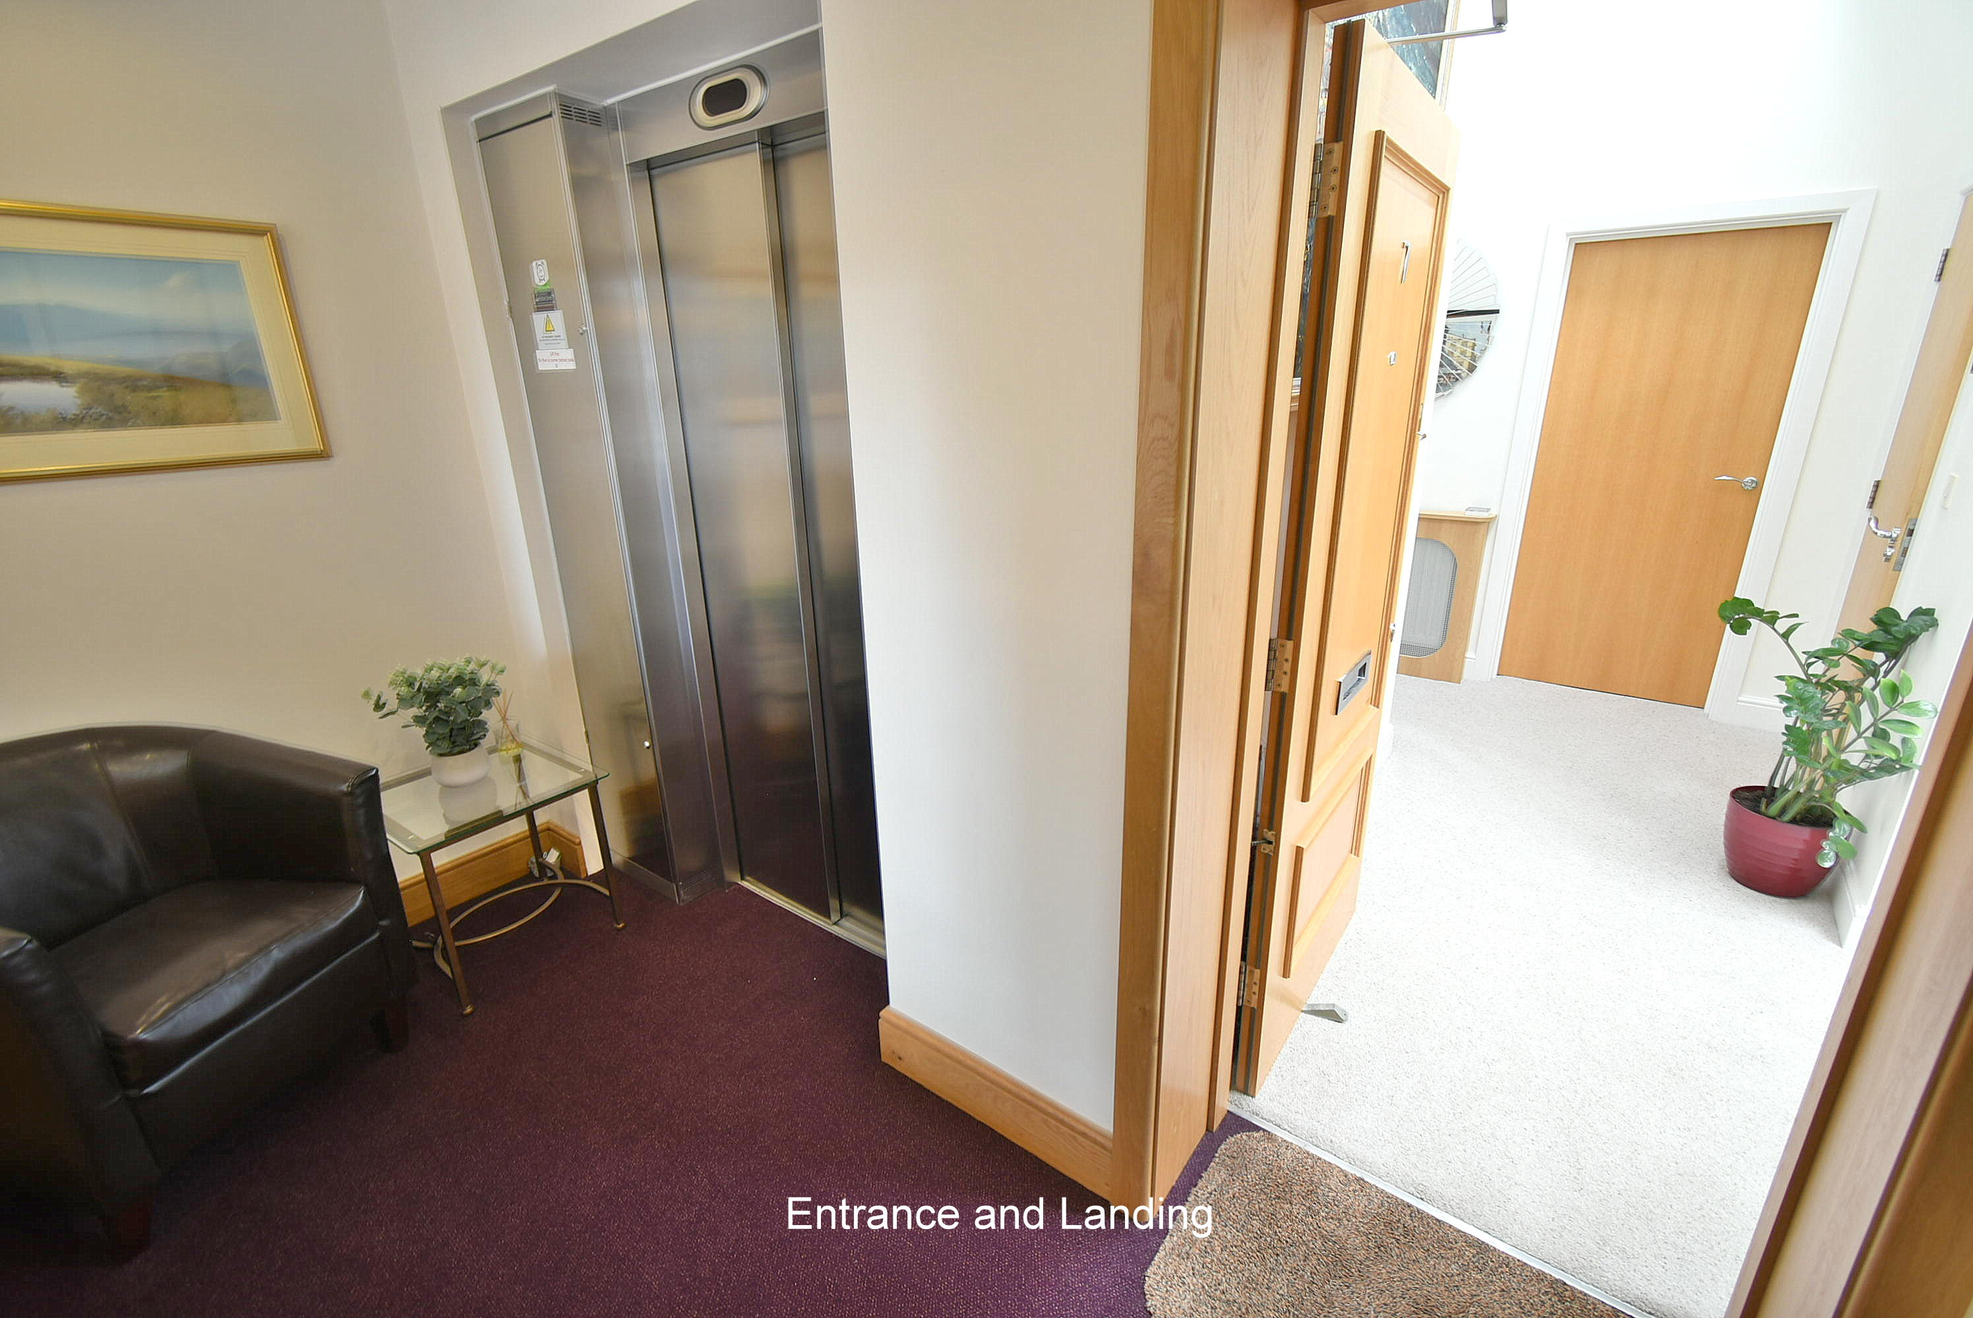
LEASEHOLD PRICE £475,000

“A beautifully light and spacious apartment in a delightful setting providing a lovely aspect from the living room and balcony”

We are delighted to offer for sale this unique and impeccably presented penthouse apartment. The vaulted hallway and high-ceilings throughout add to the feeling of space. The apartment is flooded with natural light thanks to a roof lantern in the main living space and a number of Velux windows, most of which open and close via remote control, as do their fitted blinds.

The accommodation, which the current owners refer to as their ‘bungalow in the sky’ briefly comprises a large and flexible main living/dining space, beautiful kitchen, separate utility room, three large double bedrooms, substantial bathroom, and en-suite to the master bedroom. The apartment also benefits from an abundance of storage space, has a lift giving access to a private lobby area and has two parking spaces, which are owned.

Pembroke House is situated in a sought after and convenient location and some 850 metres from the clubhouse of Ferndown Championship golf course.

- A stunning 1,700 sq ft three double bedroom penthouse apartment with a good sized private balcony and two owned parking spaces

- Communal entrance hall with a staircase and lift giving access to a private second floor lobby
- Private entrance hall with vaulted ceiling, three double glazed velux roof windows flooding the hall with lots of natural light
- Stunning open plan 27’ x 25’ TV/dining/lounge area
- The lounge area has double glazed French doors leading out onto a good sized private balcony and a living flame coal effect electric fire with granite hearth and wooden surround
- The dining area has a roof lantern with a remote control blind which floods the space with lots of natural light, an opening through into the kitchen and a study area with a double glazed window to the side aspect
- The TV area has ample space for sofa and television
- 8’ x 5’ Private enclosed balcony with tiled floor enclosed by obscure glass and wrought iron railings offering a glorious outlook over the beautifully kept communal gardens
- Superbly appointed and beautifully finished kitchen incorporating ample granite worktops with matching upstands and an excellent range of integrated appliances to include a 5 ring gas hob with extractor canopy above, fridge and freezer, dishwasher, twin ovens and a stainless steel 1.5 bowl inset sink, tiled floor, double glazed velux roof window flooding the kitchen with lots of natural light and a walk-in larder with space for wine fridge, additional freezer and tiled floor
- Utility room with rolltop work surfaces and a stainless steel sink, recess for washing machine, space for condensing tumble drier, cupboard housing wall mounted gas fired Gloworm boiler, tiled floor
- Bedroom one is a generous sized double bedroom enjoying a dual aspect benefitting from fitted wardrobes and drawer storage
- Spacious en-suite shower room finished in a stylish white Villeroy & Boch sink incorporating a good sized shower cubicle with chrome raindrop shower head and shower attachment, WC with concealed cistern, wall mounted wash hand basin, tiled floor and partly tiled walls
- Bedroom two is also a generous sized double bedroom currently being used as an office/snug benefitting from a fitted wardrobe with sliding doors
- Walk-in storage cupboard
- Bedroom three is again a good sized double bedroom benefitting from an excellent range of fitted bedroom furniture to include wardrobes, drawer and cupboard storage and dressing table
- Spacious family bathroom finished in a high quality Villeroy & Boch suite incorporating a panelled bath with mixer taps and separate shower attachment, WC with concealed cistern, wall mounted wash hand basin, tiled floor, partly tiled walls

COUNCIL TAX BAND: E EPC RATING: C

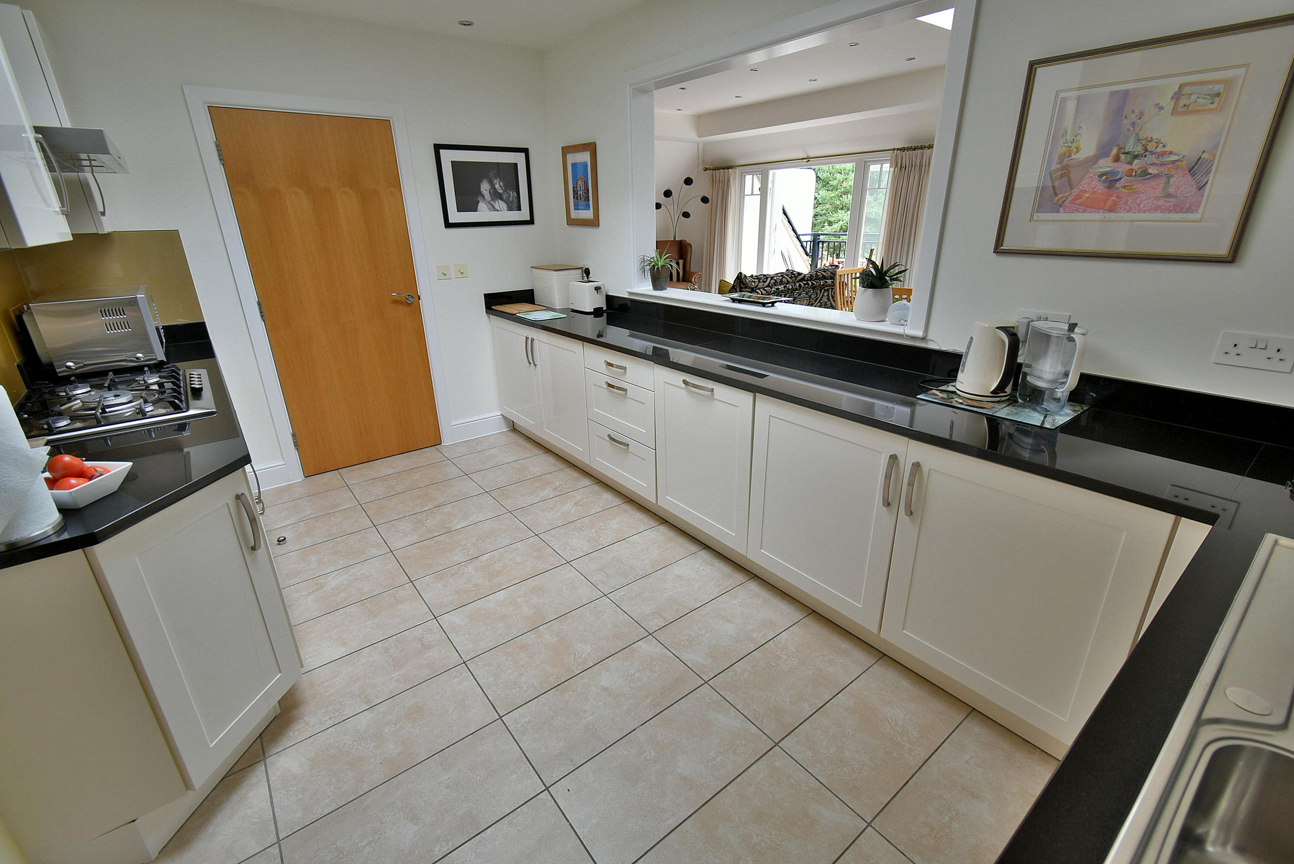
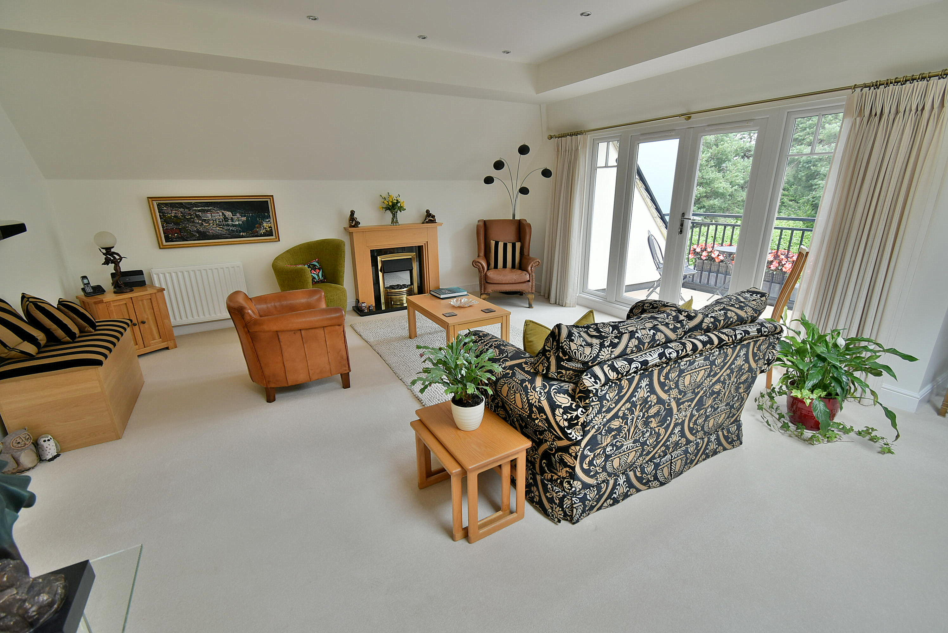
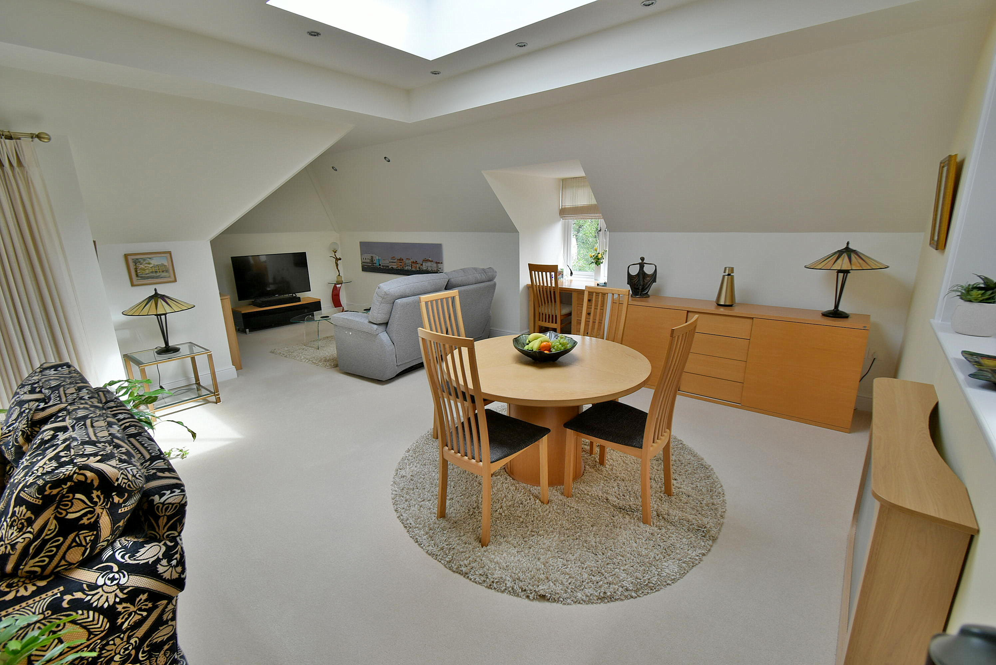
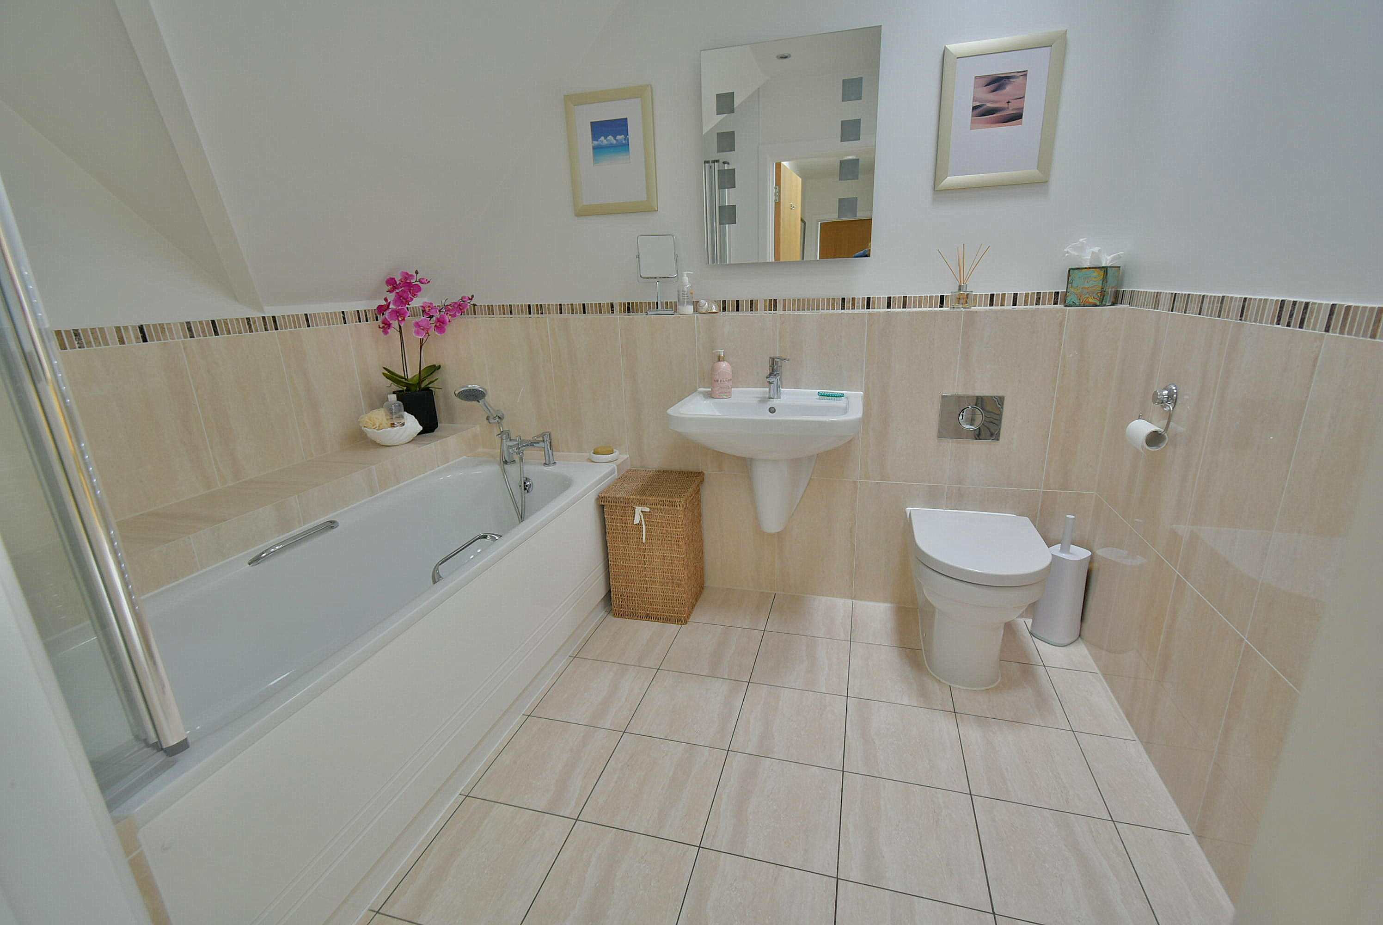
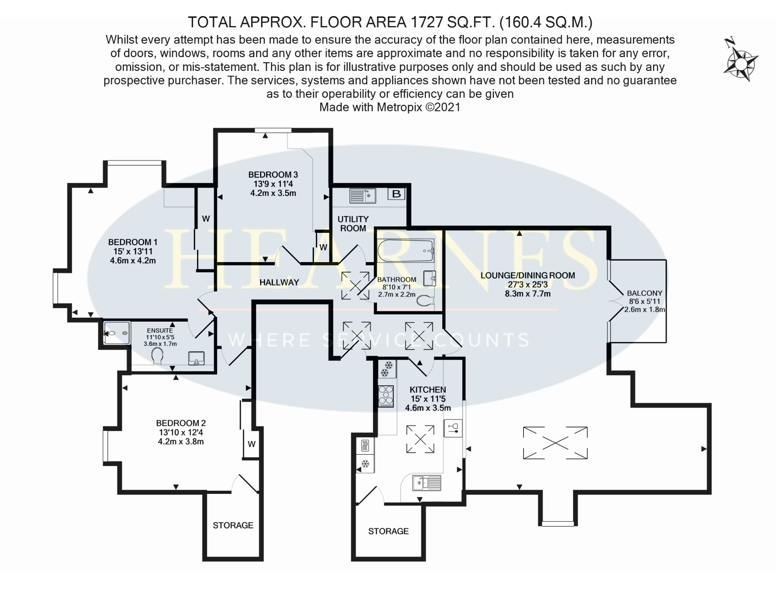

AGENTS NOTE: The heating system, mains and appliances have not been tested by Hearnes Estate Agents. Any areas, measurements or distances are approximate. The text, photographs and plans are for guidance only and are not necessarily comprehensive.

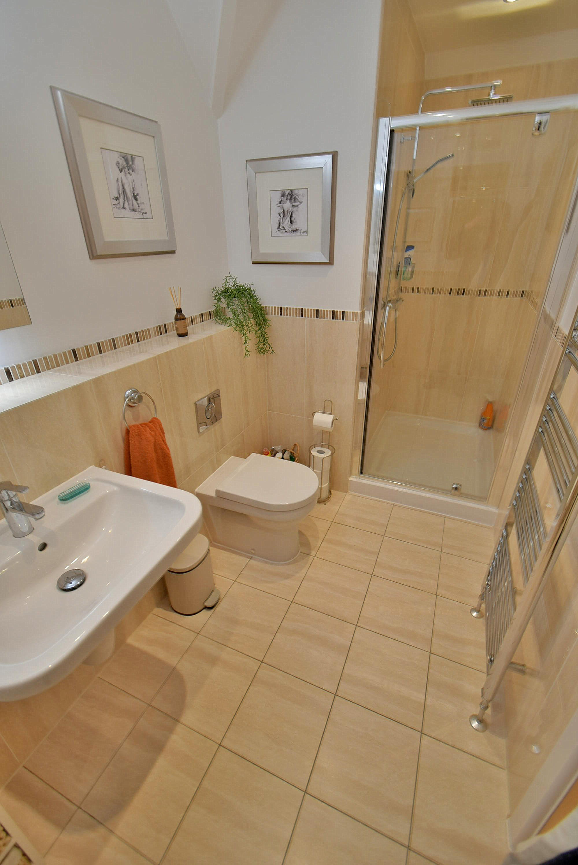
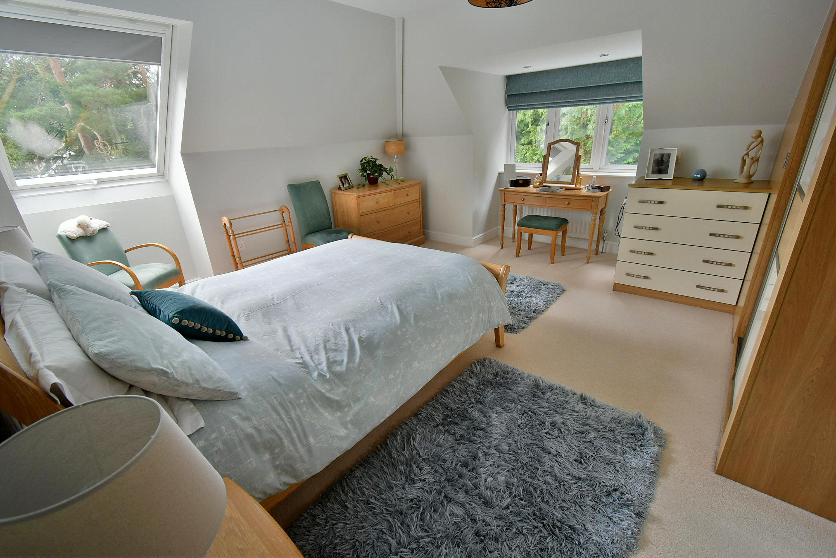
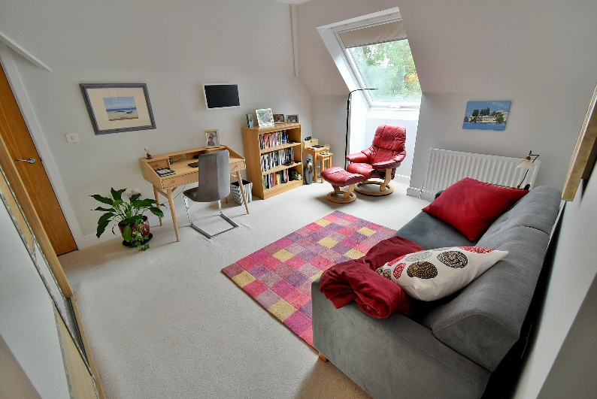
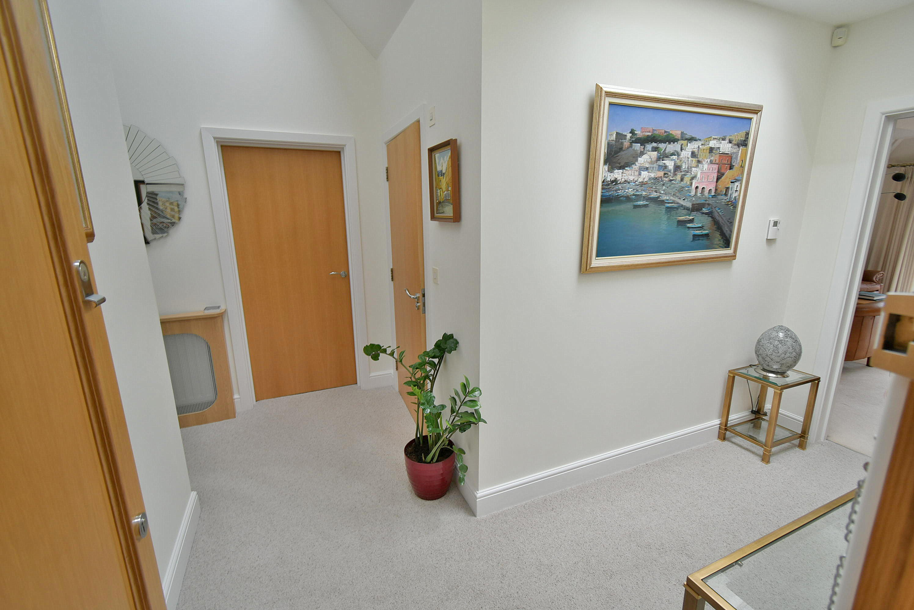
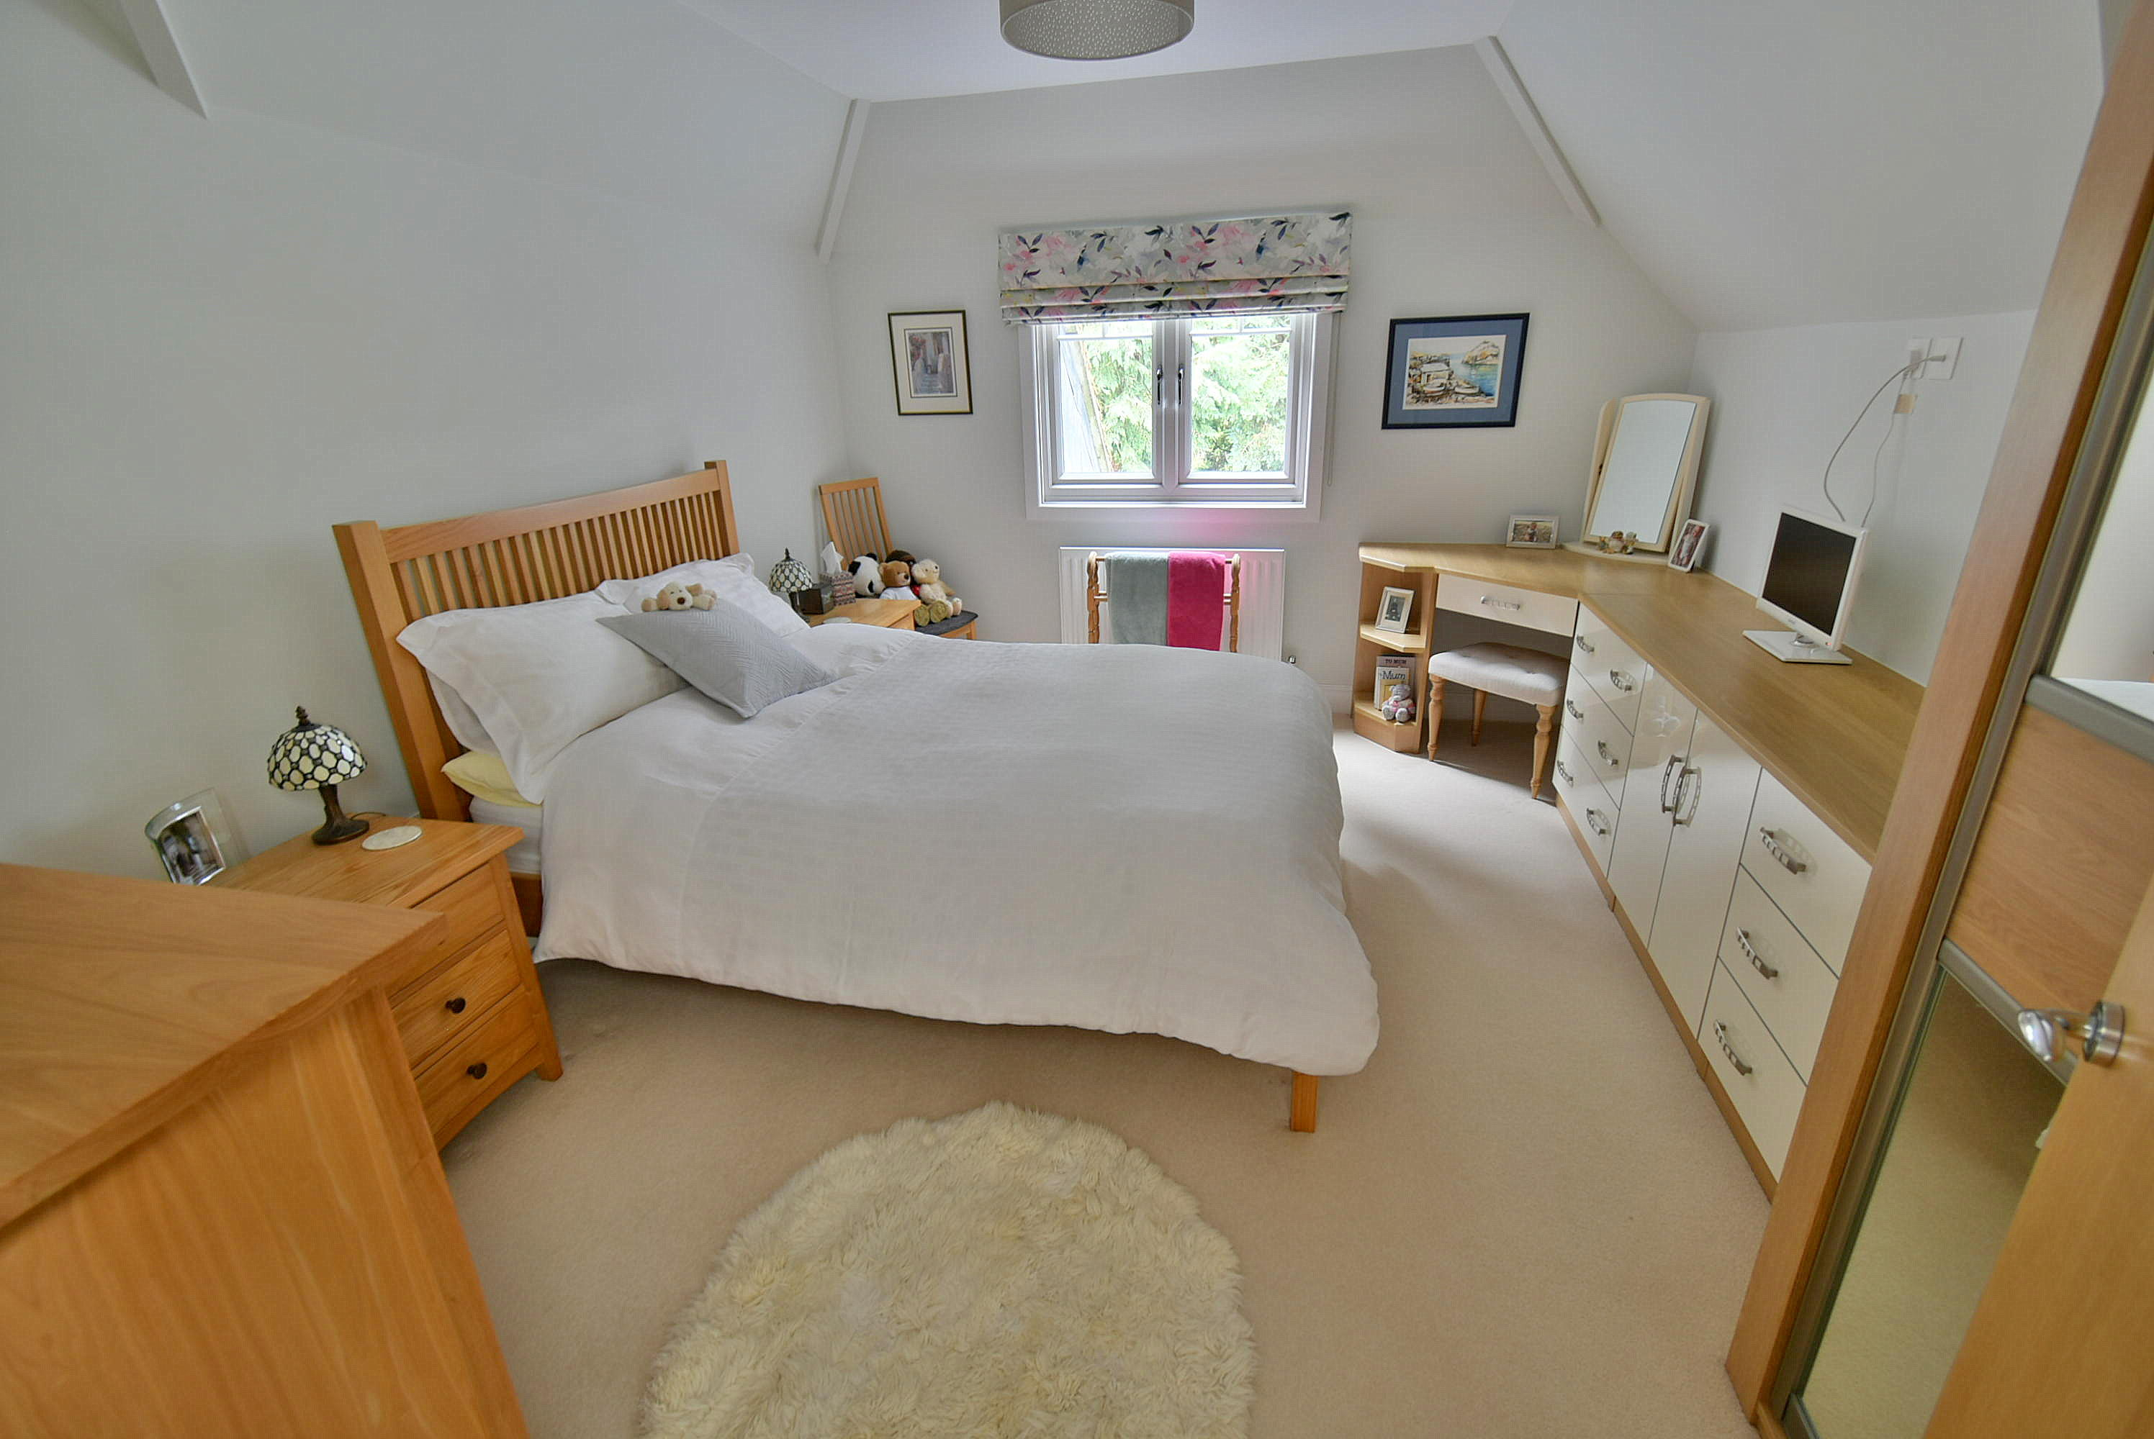
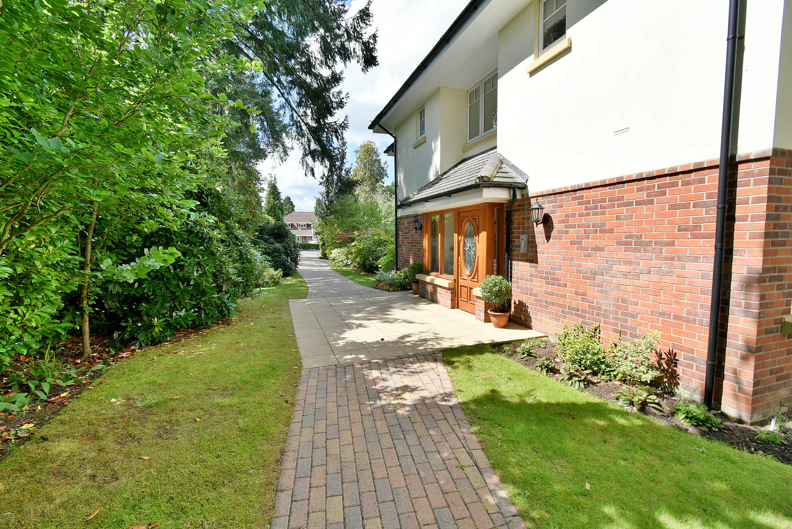
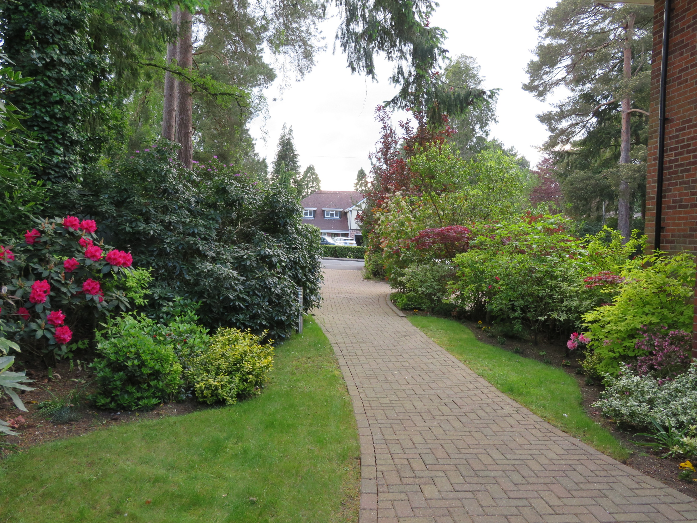
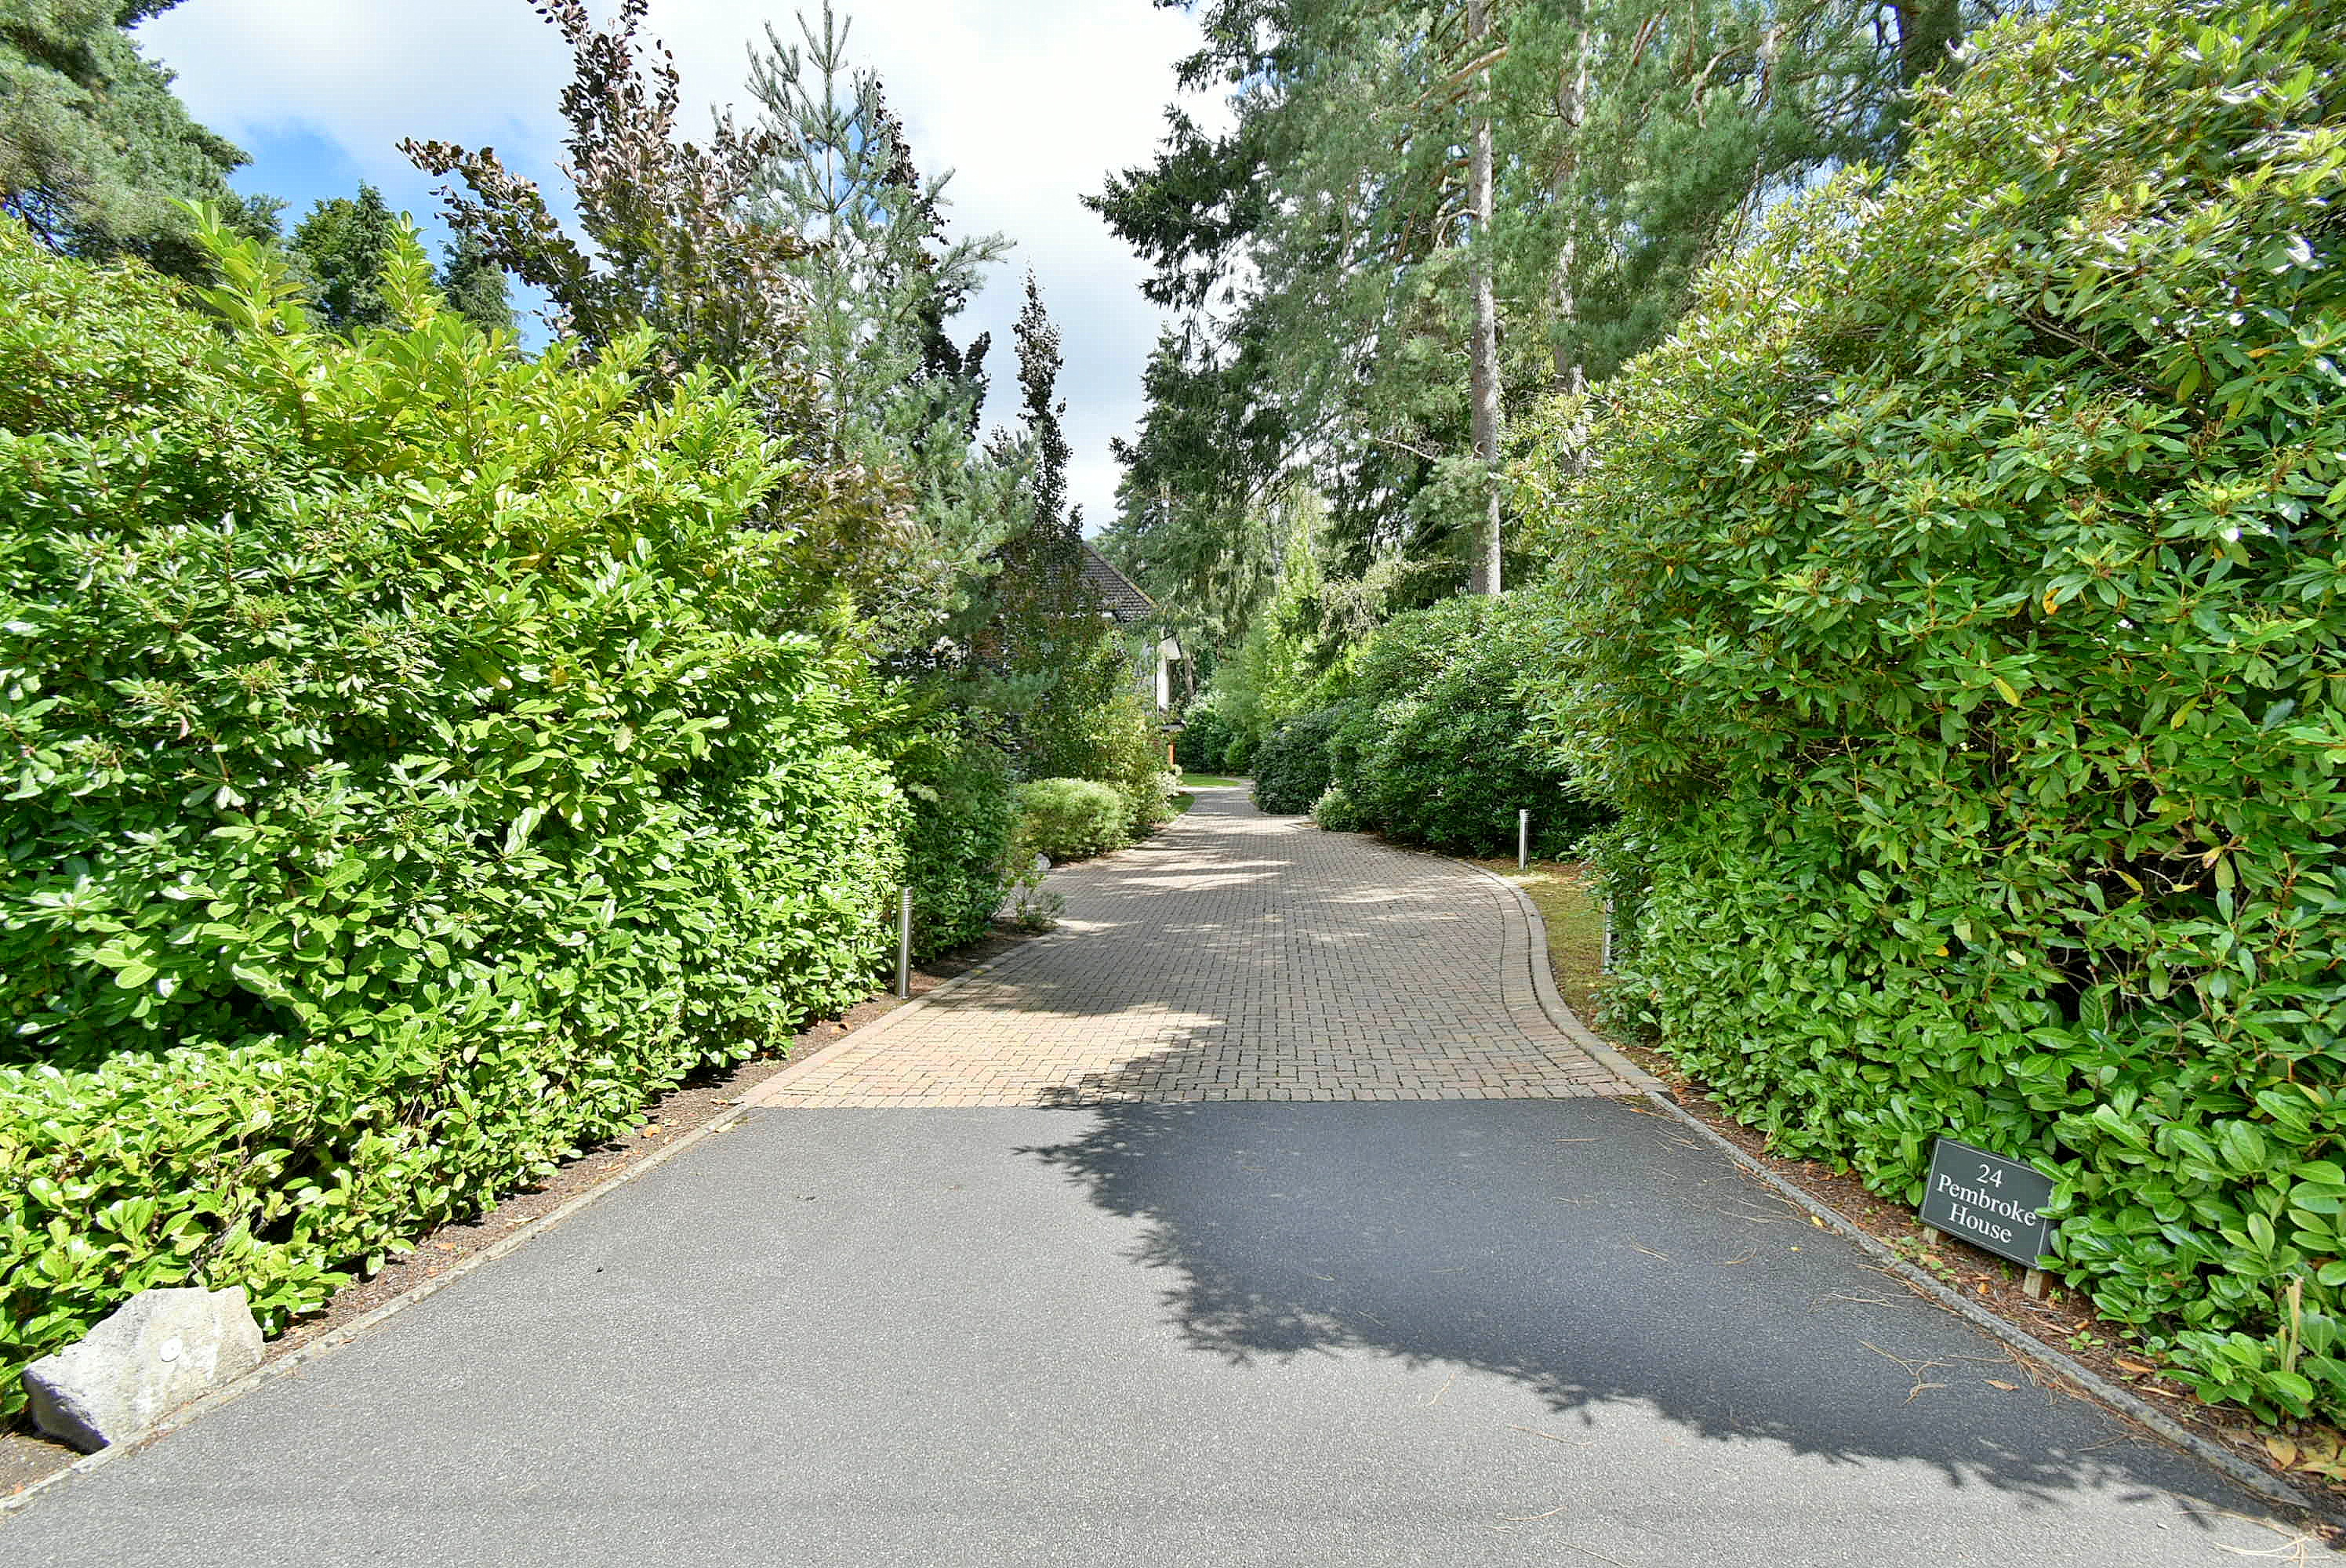
Outside

- This particular apartment has two owned parking spaces with an area designated for visitors parking
- All residents have the use of the beautifully kept communal gardens

Further benefits include a gas fired heating system, with recently replaced boiler (2025) security alarm and a video entry phone intercom system

Ferndown offers an excellent range of shopping, leisure and recreational facilities. Ferndown also has a championship golf course on Golf Links Road.

Lease: 125 years from 2011
Maintenance Charge: Approximately £3,250 per annum
Ground Rent: £250 per annum

7
