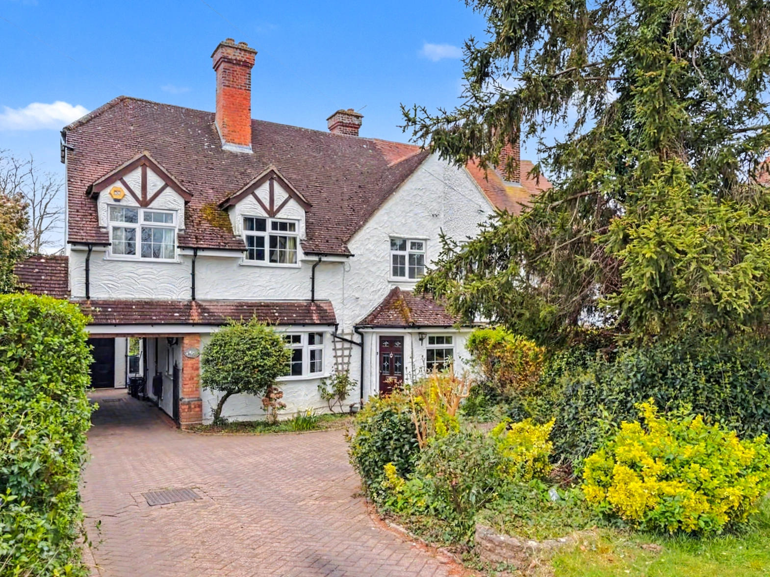
Norton Road, Letchworth Garden City, Hertfordshire SG6 1AA
£730,000 Freehold

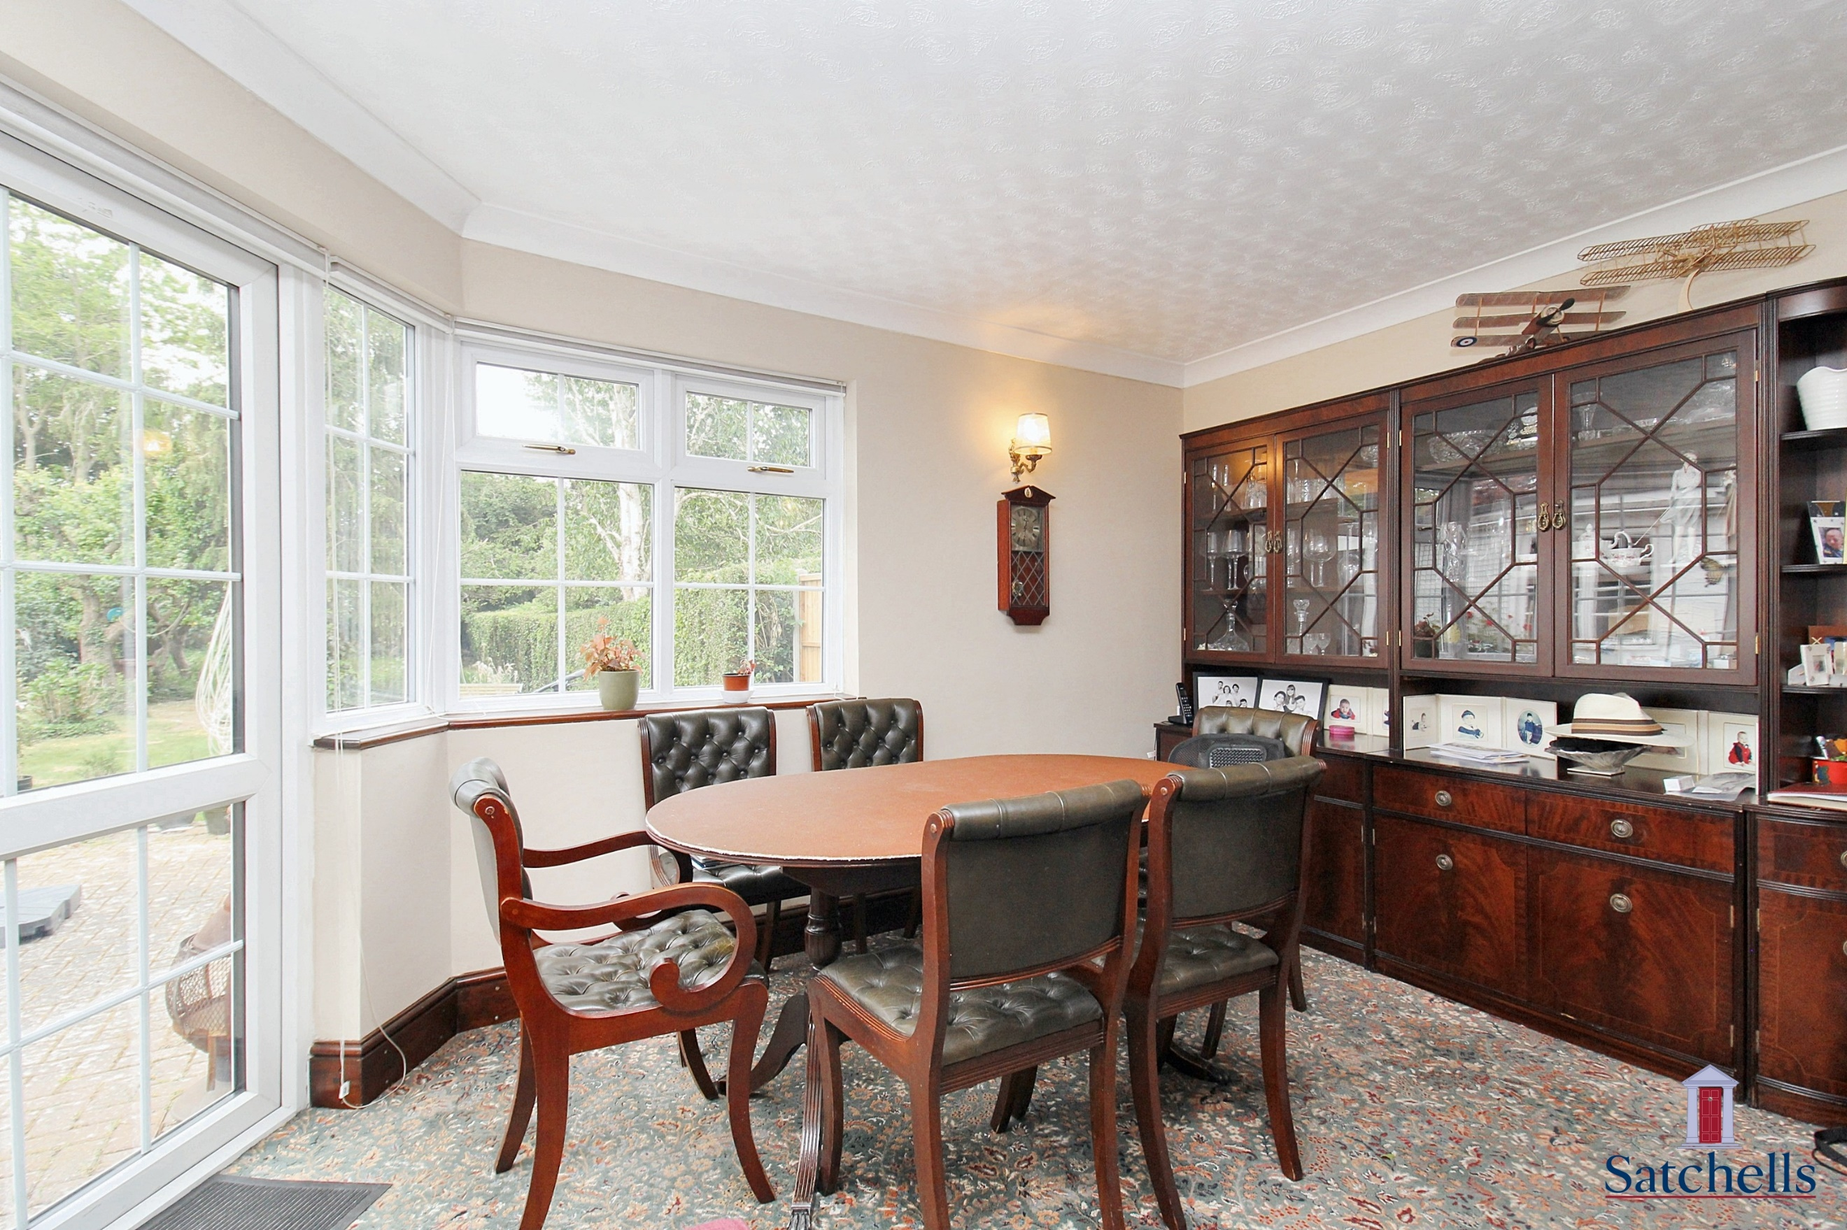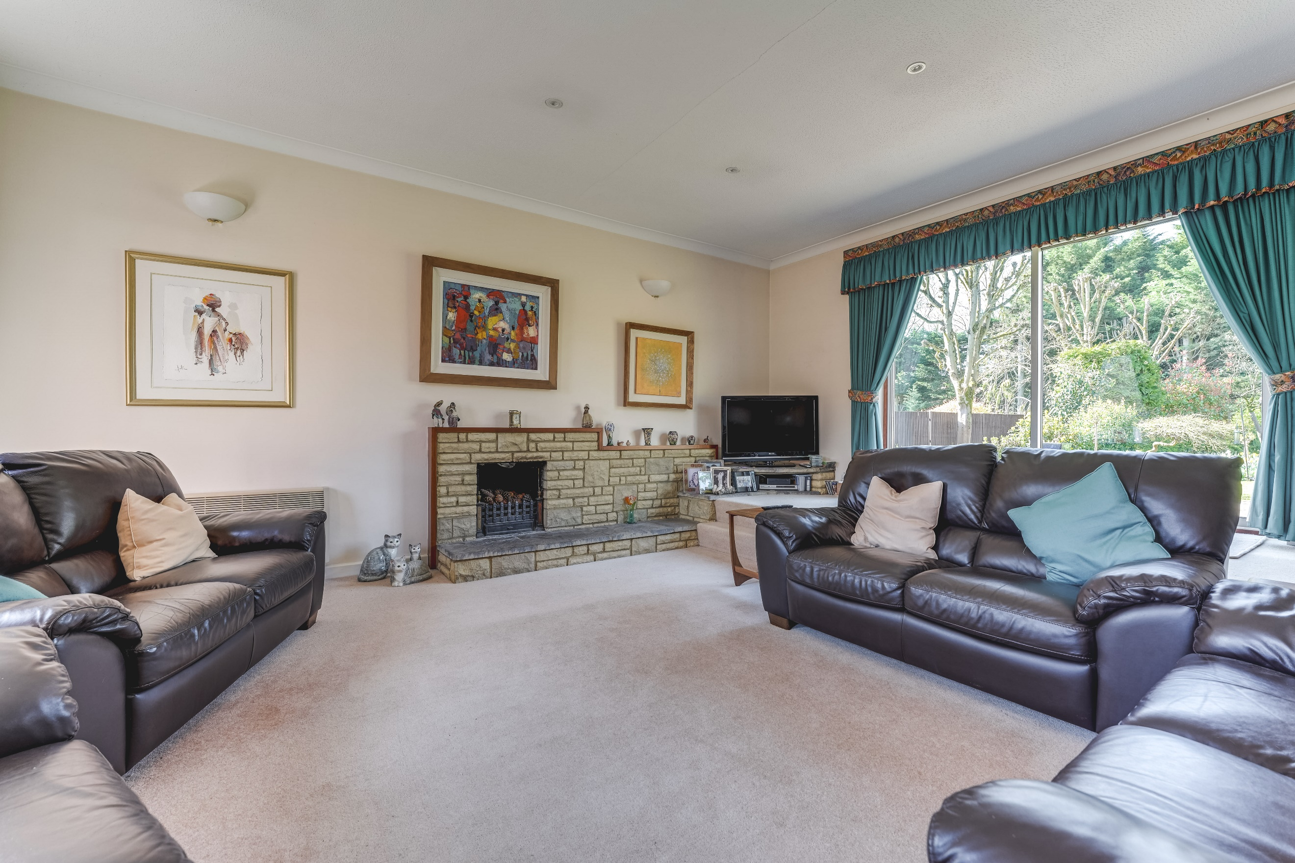
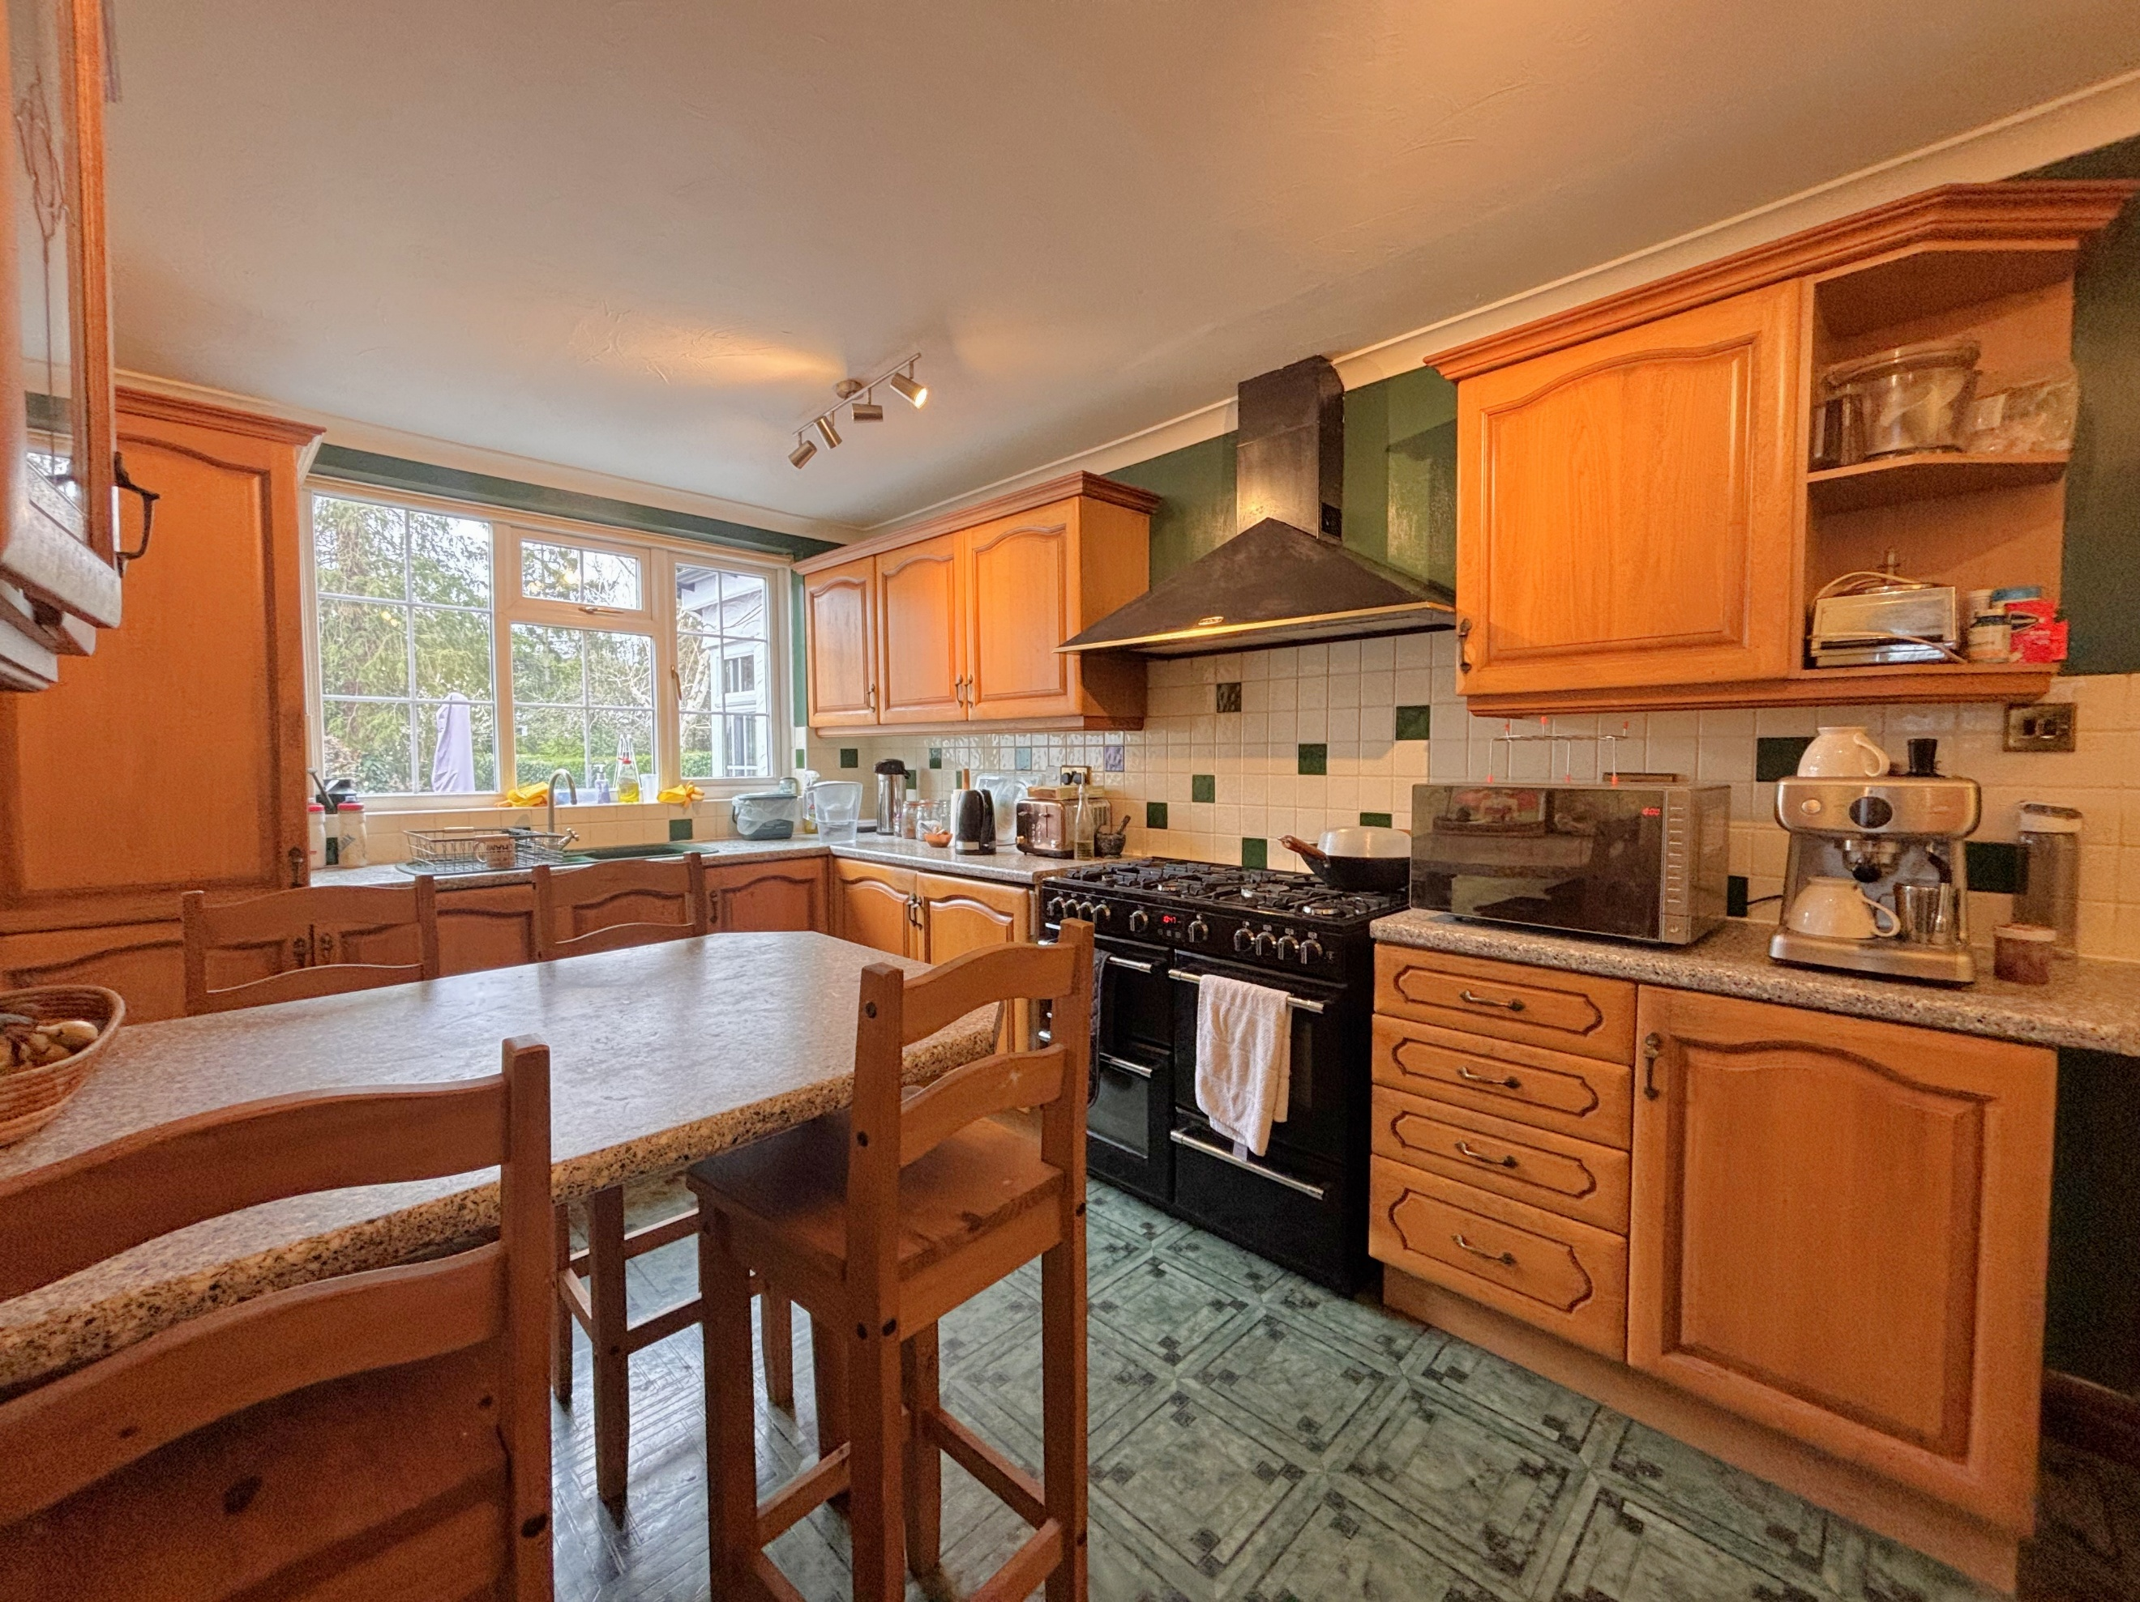
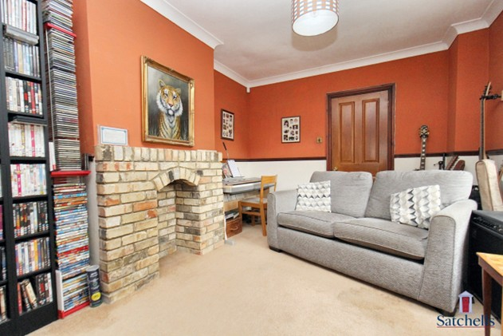
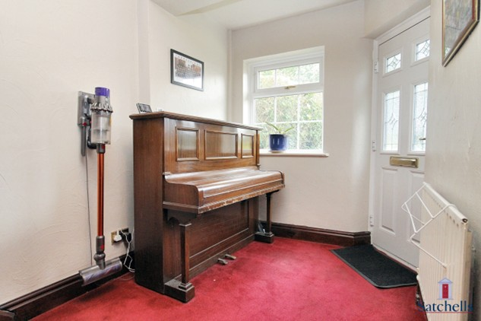
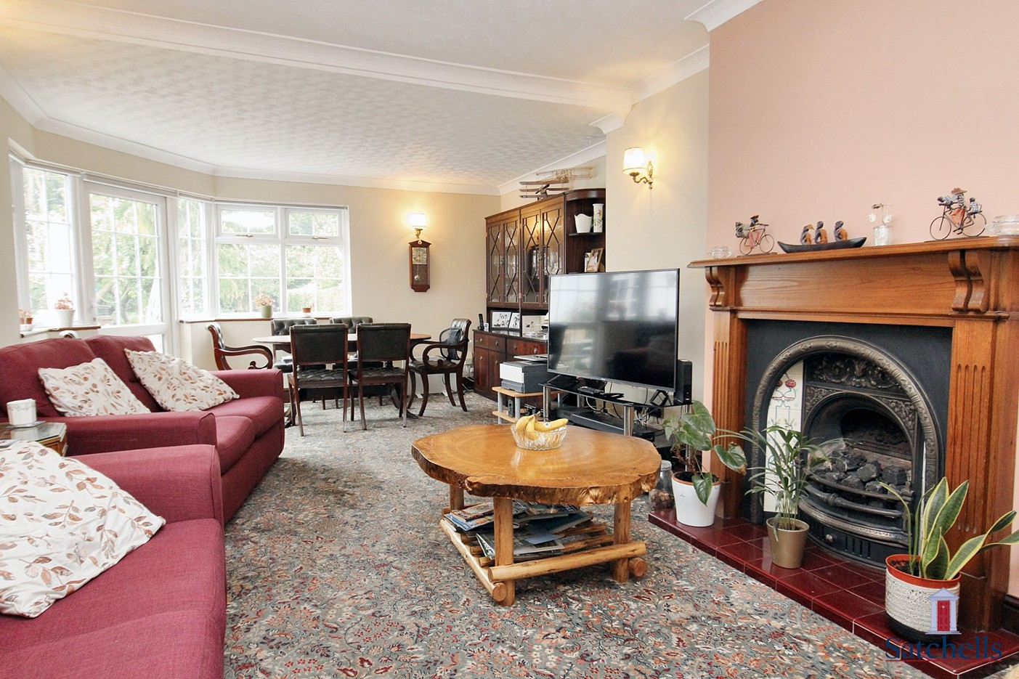
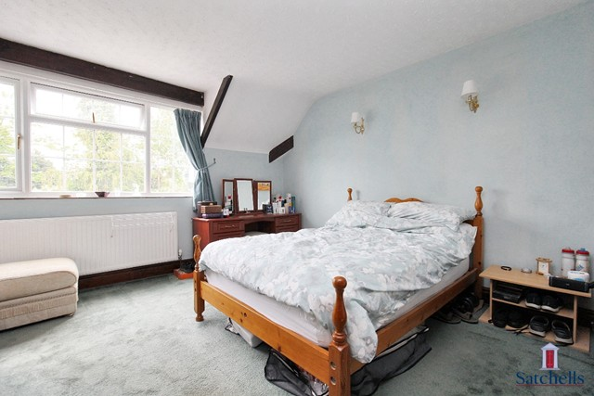
Situated on one of Letchworth Garden City’s most desirable and characterful roads, this delightful early Garden City property is a spacious four-bedroom semi-detached family home, offering generous and versatile accommodation throughout with ample off-road parking and large mature rear garden. Upon entering, you are welcomed into a spacious entrance hall with a handy storage cupboard and stairs with a characterful banister leading to the first floor, setting the tone for the blend of period charm and modern comfort that runs throughout the home. To the front, the inviting lounge features a bay window and fireplace, creating a warm and cozy space for relaxation, ideal for a snug or play room for families.

The heart of the home lies to the rear, where an extended open-plan family living and dining room boasts garden views, a second fireplace, and ample space for entertaining. A back door and large window lead directly onto the patio, making it ideal for indoor-outdoor living. Adjacent is a well-appointed kitchen/breakfast room, complete with breakfast bar and garden outlook with ample storage also provides side access via the car port to the side.
Upstairs, the generous principal suite enjoys rear views and is enhanced by a private en-suite shower room and dressing area. Bedrooms two and three are both spacious doubles, while the fourth bedroom, though the smallest, can still comfortably accommodate a double bed or serve as an ideal home office or nursery. A well-sized family bathroom completes the first floor.

With its characterful setting, extended living space, and well-proportioned rooms, this home presents a rare opportunity to secure a beautiful property in a prime Garden City location. Early viewing is highly recommended.

Letchworth Garden City, often regarded as the world’s first garden city, is a vibrant and well-connected community offering a perfect blend of urban convenience and natural beauty. Known for its tree-lined streets, green spaces, and family-friendly atmosphere, Letchworth is a sought-after location for those seeking both tranquility and easy access to modern amenities. The town boasts a variety of shops, from independent boutiques and cafes to larger retail outlets, making everyday shopping a pleasure. The pedestrianized town center features a lively market and offers a range of supermarkets, fashion stores, and a selection of restaurants and cafes for dining and socializing.

For families, Letchworth is well-served by excellent schools, including a range of primary and secondary schools, all known for their strong academic performance and community focus. The town also offers a variety of parks and recreational facilities, providing plenty of space for outdoor activities and leisure. Transport links from Letchworth are superb, with a mainline train station offering regular services into London King’s Cross in under 40 minutes, making it ideal for commuters. The town is also well-connected by road, with easy access to the A1(M) for travel to surrounding areas.

About Letchworth

Step Inside

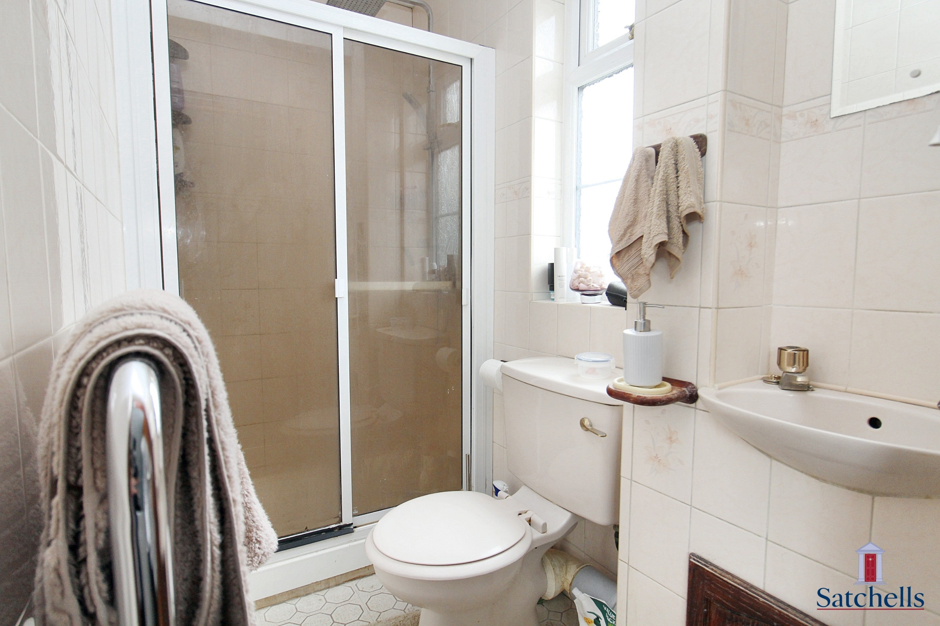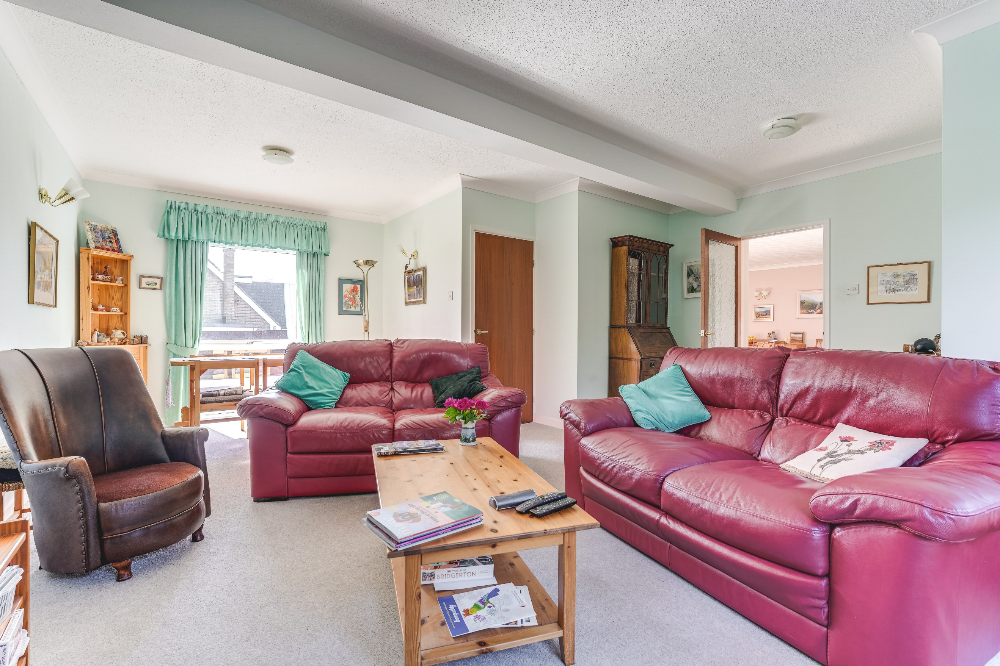
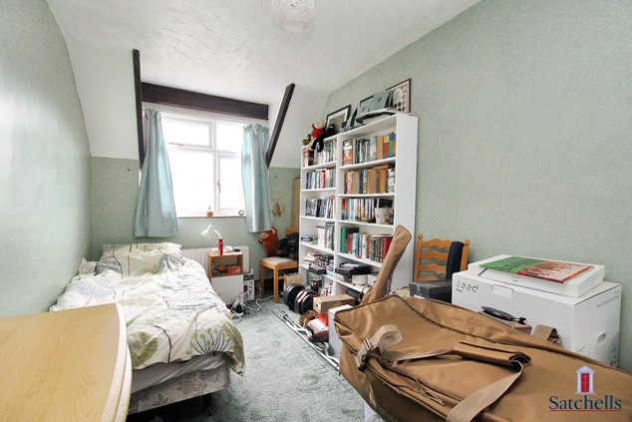
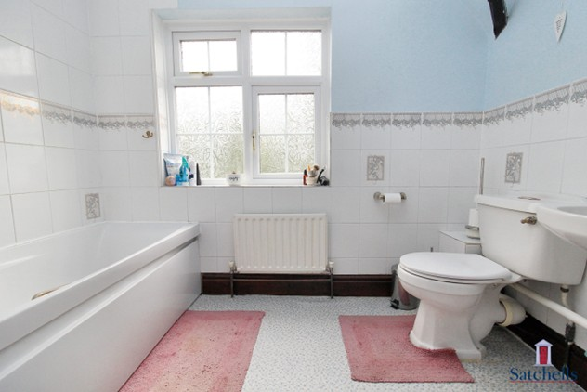
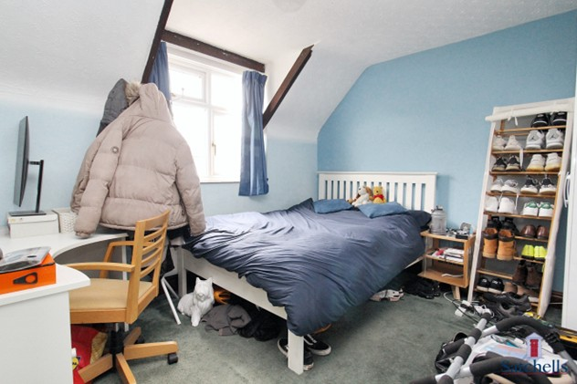
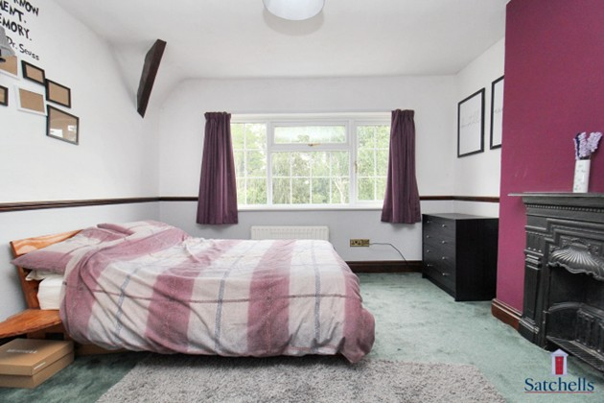
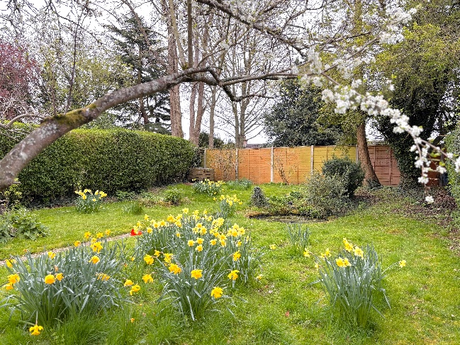
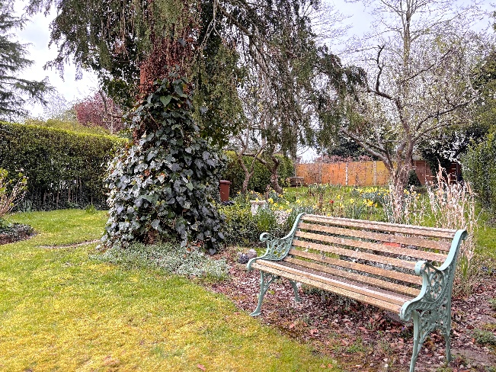
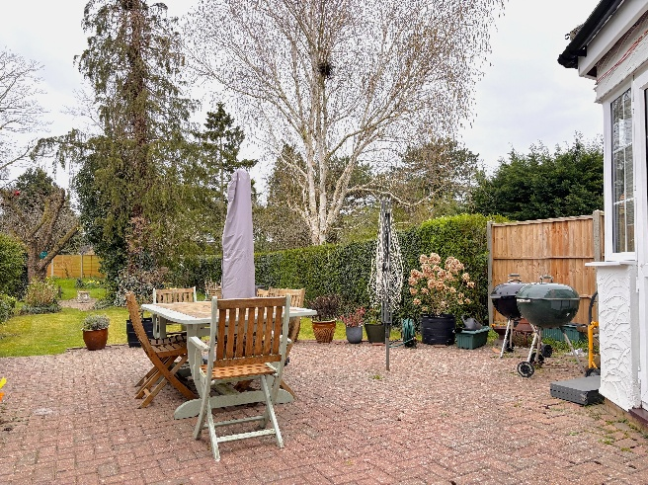
This charming Garden City home enjoys a superb position, set well back from the road behind a spacious block-paved driveway that provides ample off-street parking. The driveway extends along the side of the property beneath a carport, offering sheltered parking and leading to a detached garage with an up-and-over door, side access from the garden, and a useful outdoor utility space to the rear.
The front garden is beautifully landscaped with mature planting flanking the path to the entrance and beneath the front bay window, enhancing the home’s curb appeal. Established hedging offers privacy and defines the boundary with neighboring properties.
To the rear, the garden is a true sanctuary — generous in size and thoughtfully laid out. Immediately behind the house is a large patio area, ideal for al fresco dining and entertaining. This opens out onto a well-tended lawn that leads to a further patio with a sunken garden, creating a tranquil space to enjoy the garden’s natural charm. The rear section of the garden features a more wild and wildlife-friendly area, with wildlife pond and mature fruit trees providing dappled shade and a sense of peaceful seclusion — perfect for relaxing on warm summer days.
This beautifully maintained outdoor space perfectly complements the home’s character and offers a rare combination of practicality and natural beauty in one of Letchworth’s most sought-after locations.

Step Outside

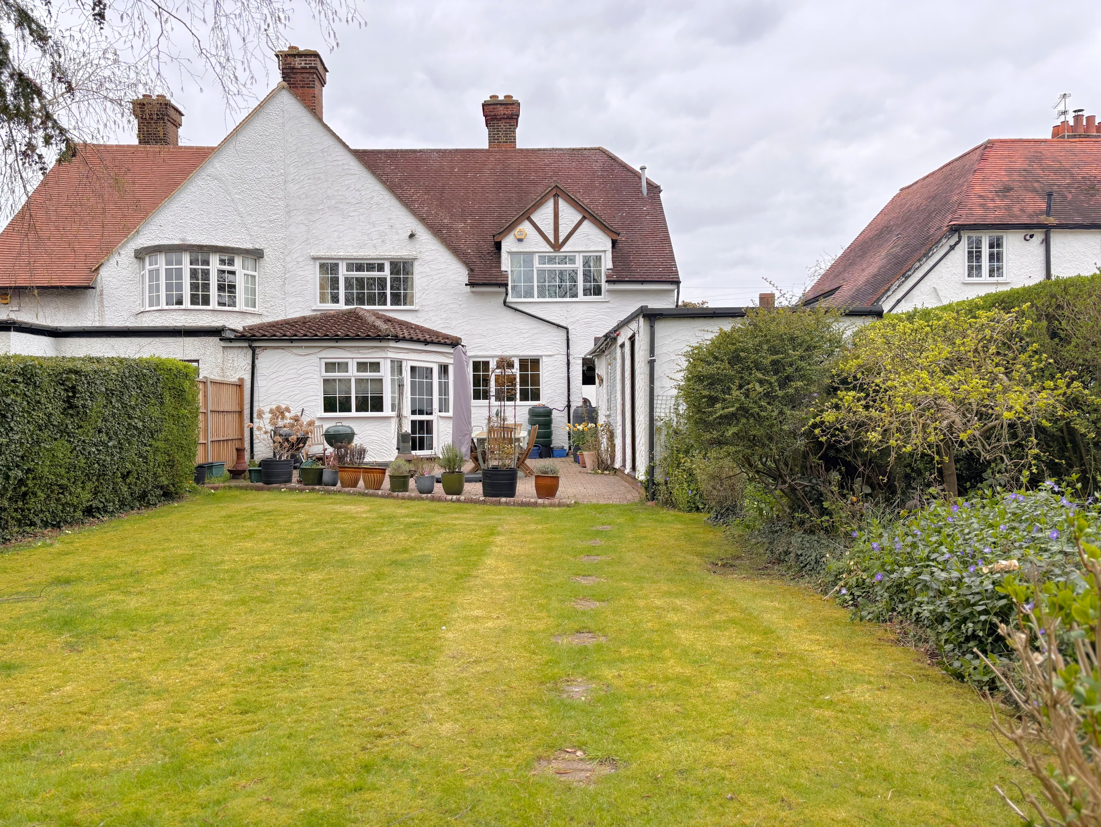

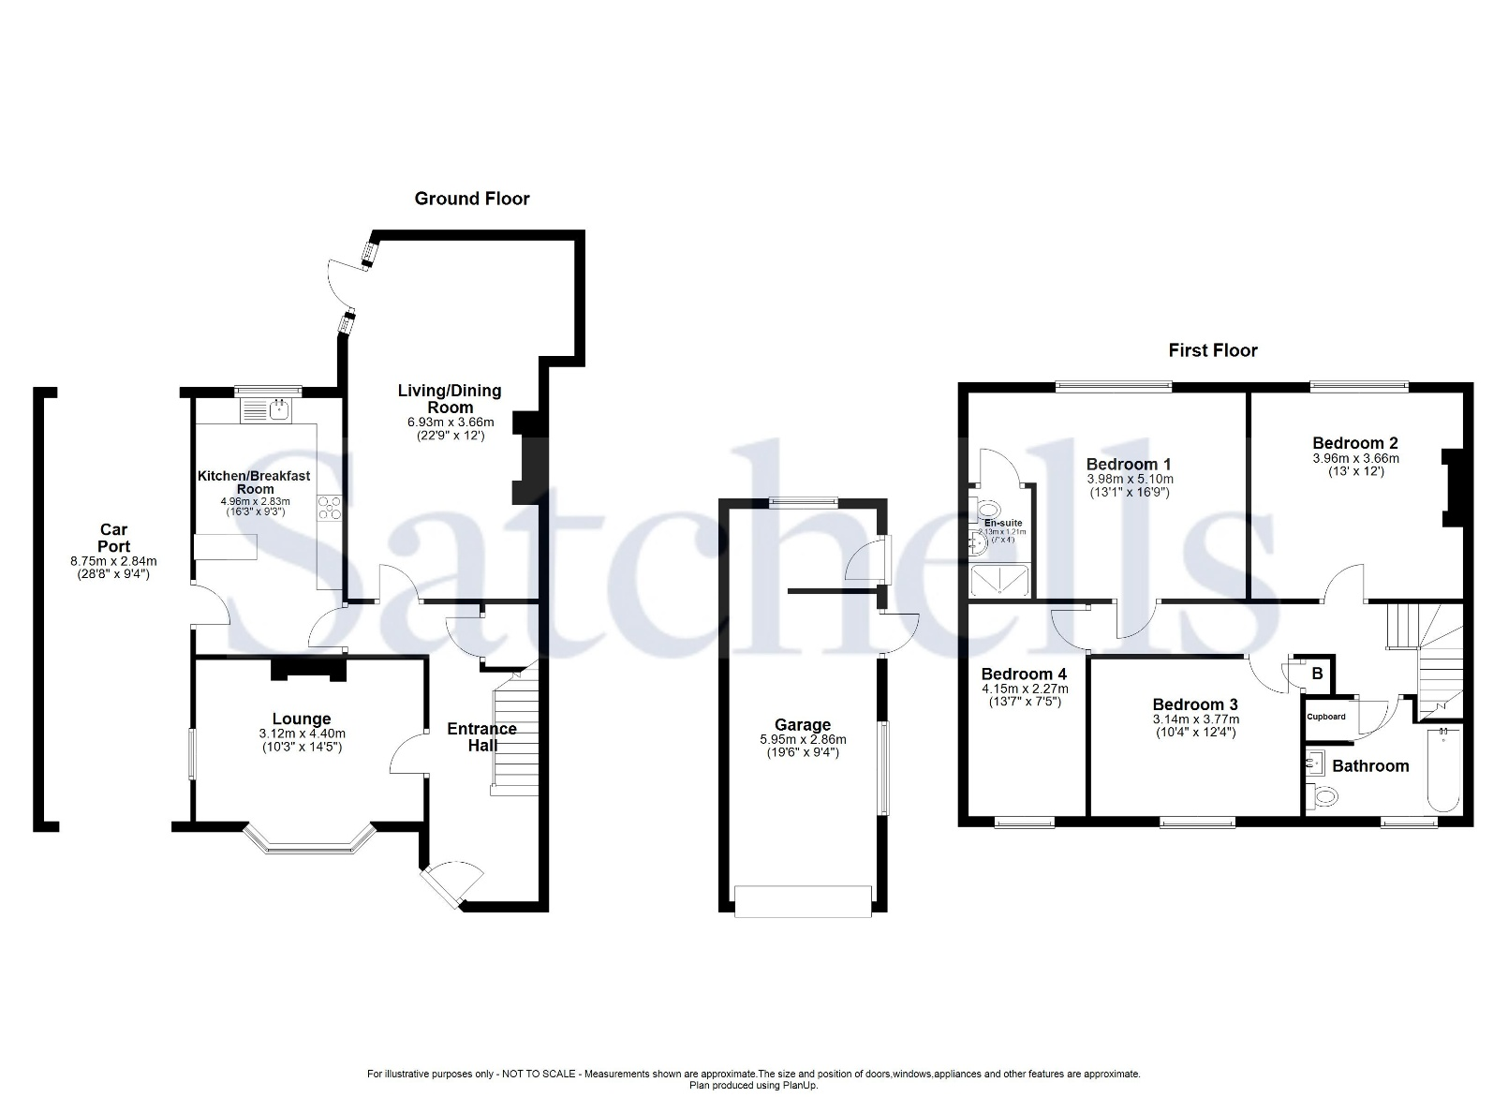

These particulars are a guide only and do not constitute an offer or a contract. The floorplan is for identification purposes only and not to scale. All measurements are approximate and should not be relied upon if ordering furniture, white goods and flooring etc. We have presented the property as we feel fairly describes it but before arranging a viewing or deciding to buy, should there be anything specific you would like to know about the property please enquire. Satchells have not tested any of the appliances or carried out any form of survey and advise you to carry out your own investigations on the state, condition, structure, services, title, tenure, and council tax band of the property. Some images may have been enhanced and the contents shown may not be included in the sale. Satchells routinely refer to 3rd party services for which we receive an income from their fee. If you would like us to refer you to one of these services, please ask one of our staff who will pass your details on. We advise you check the availability of the property on the day of your viewing.



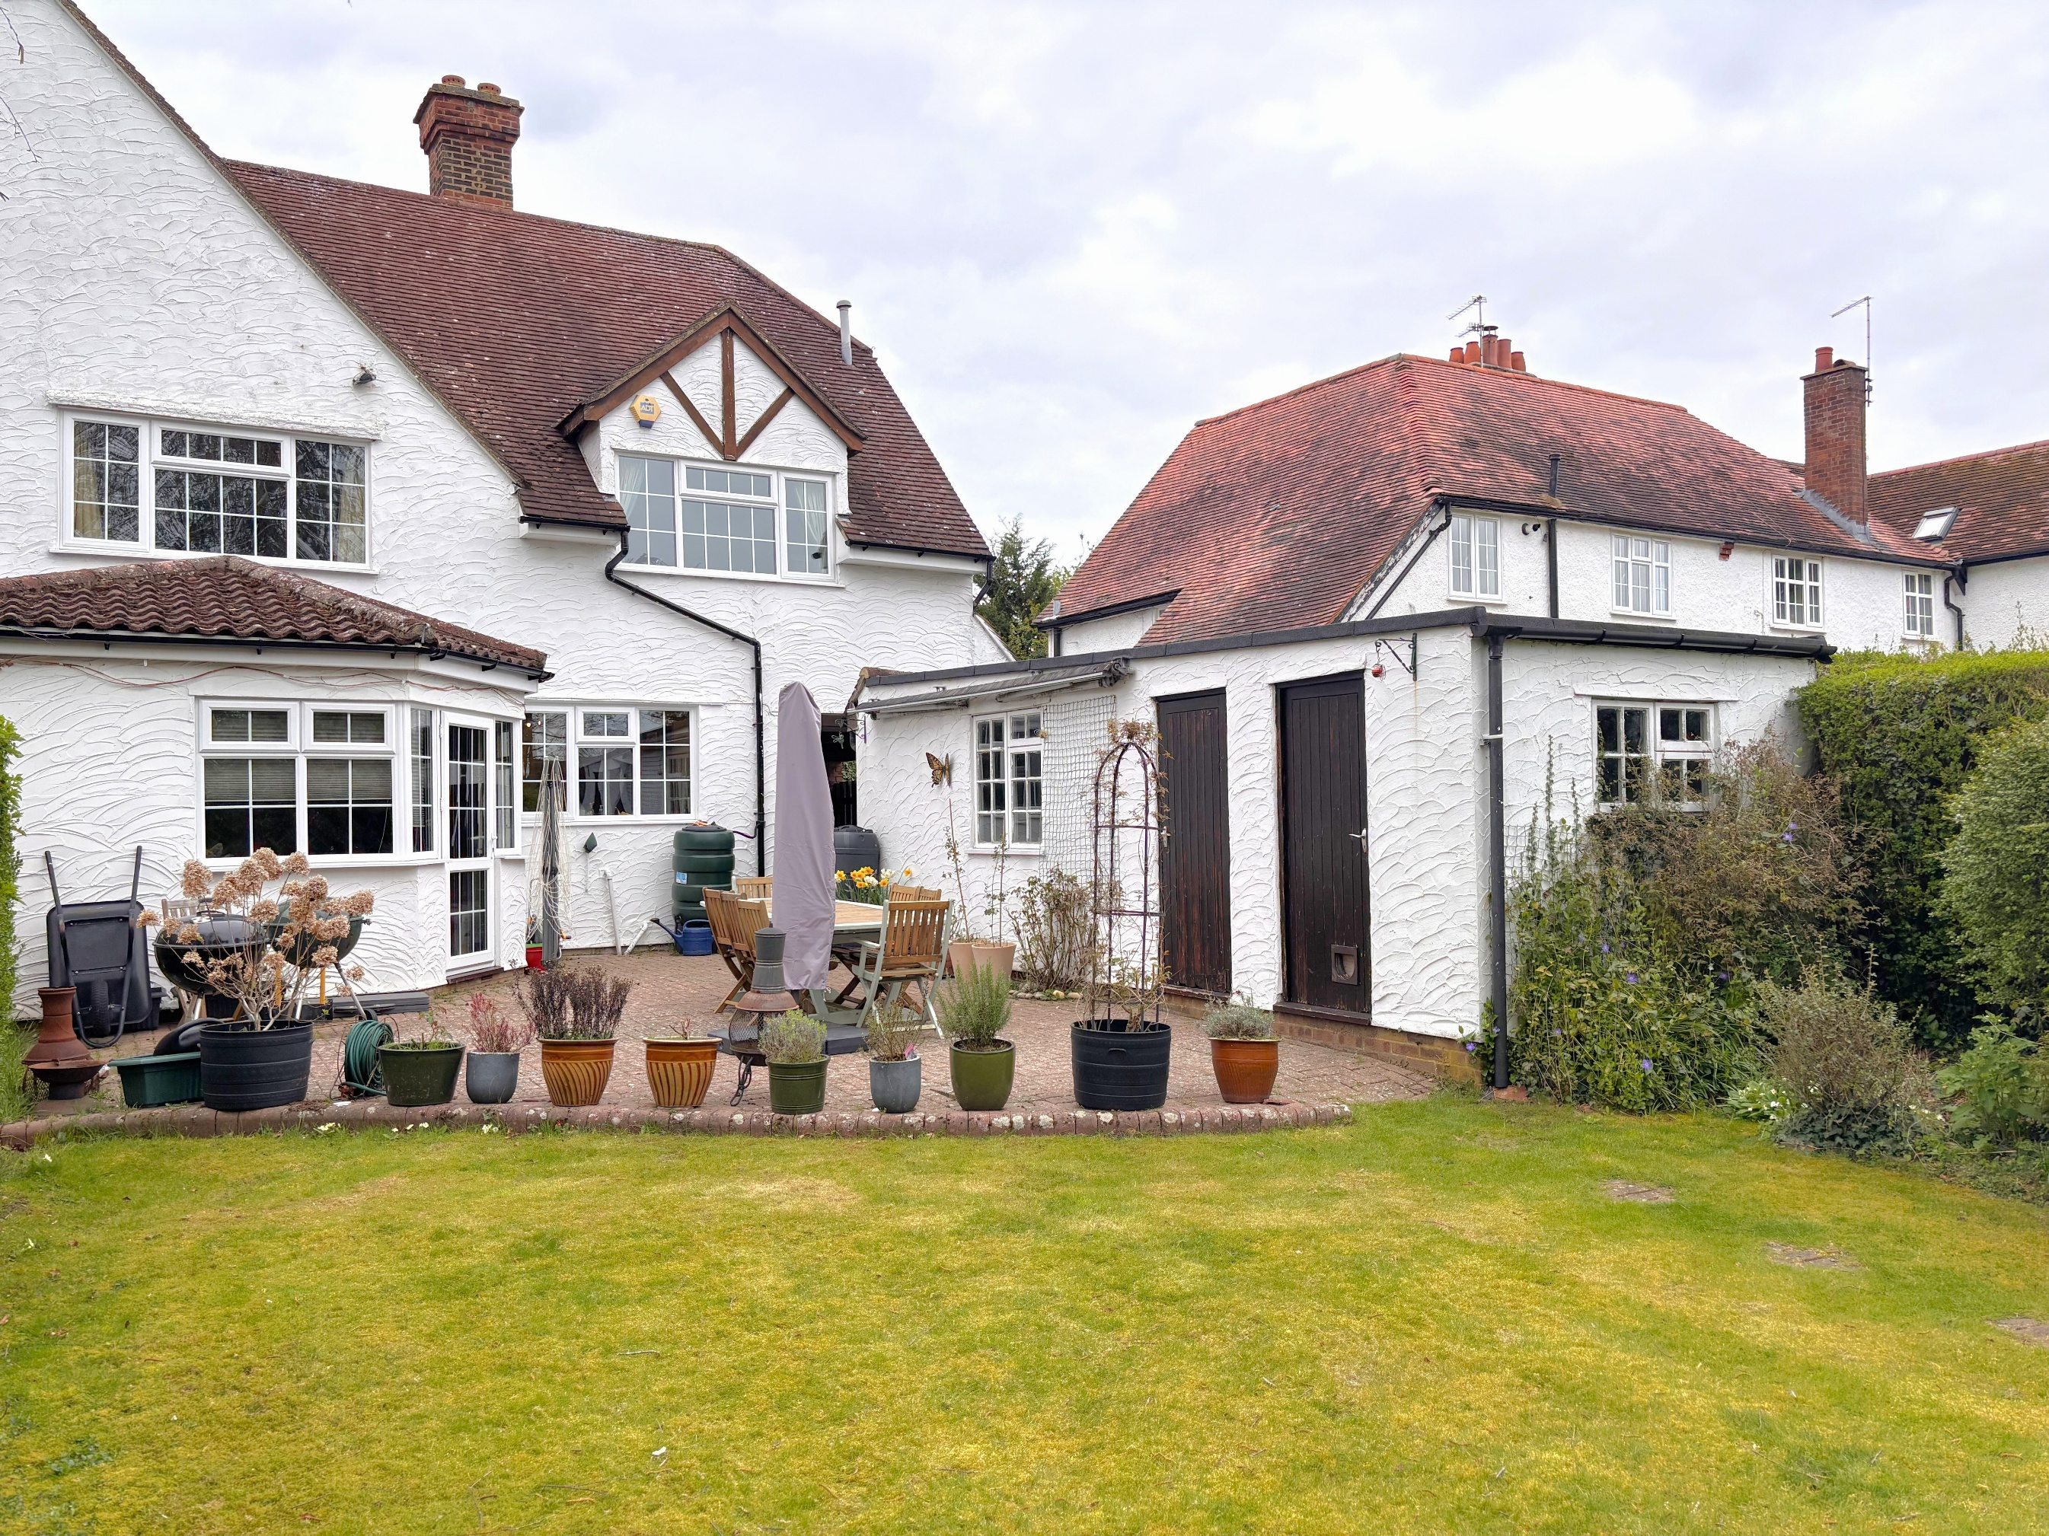
Station Place, Letchworth Garden City, Hertfordshire, SG6 3AQ.
01462 480077
letchworth@satchells.co.uk
www.satchells.com

