Guide Price £1,000,000 Freehold

Hawkeridge Farm, Hawkeridge,

Westbury, Wiltshire, BA13 4LD



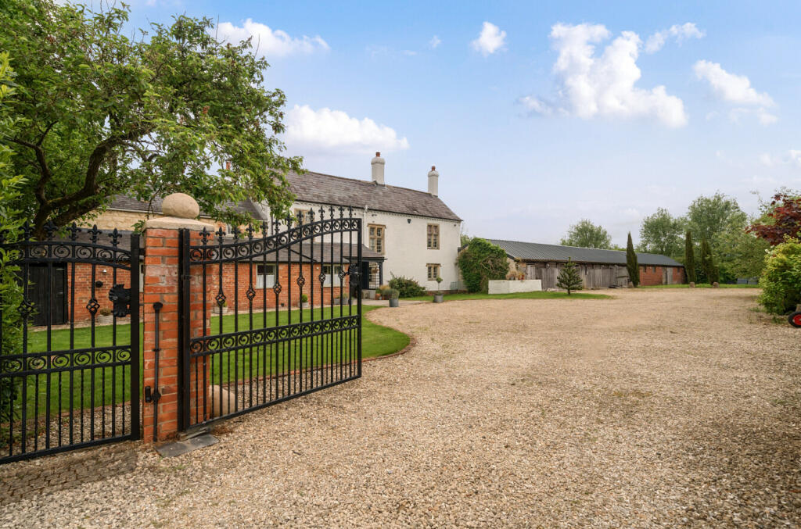

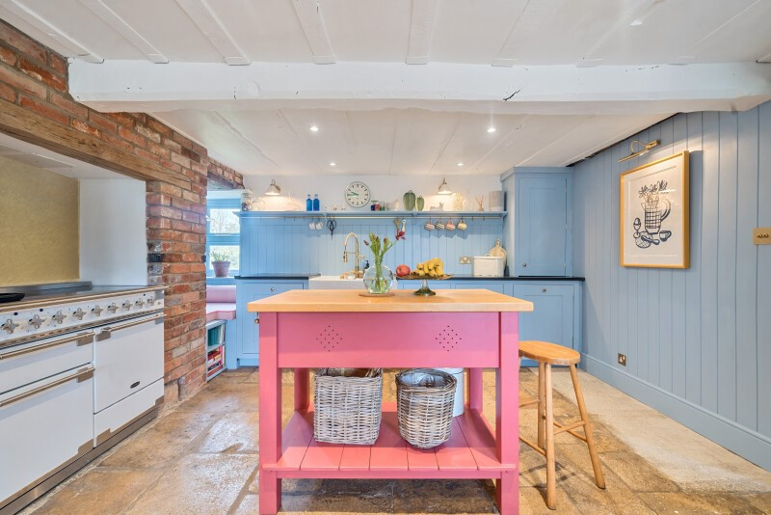

# Description

Cooper and Tanner are delighted to offer what we consider to be an exceptional Grade II listed former farmhouse that is set in approximately 3.5 acres, and dating back to circa 1600’s. This handsome residence has had later additions added around the 1860’s. This beautifully presented Farmhouse has had numerous upgrades and improvements carried out by the current owner including decoration, floor coverings, and kitchen. The property retains many charming and period features including open fireplaces, exposed brick walling, original doors, and Oak beams. At the front you will find the original walling, railings and gate The vast accommodation is spread over three floors. The adjoining paddock land is approximately three acres. The accommodation comprises an entrance hall, a bespoke and newly installed kitchen, breakfast room, utility room, WC, storeroom, sitting room with fireplace and burner, dining room, office / study, first floor landing, five bedrooms, two en-suites, family bathroom.

**Outside**

This impressive residence is approached via an automated gate with brick pillars and a separate pedestrian security gate. A large gravel courtyard offers turning, parking, and access to the outbuildings and the substantial former Cattle barn that subject to planning permission, could provide additional accommodation or a possible Airbnb income stream. At the rear is an enclosed level and mainly lawned garden with walling and original railings. A gate gives access to the further substantial grounds that extend to approx. 3 acres.

**Viewing**

Viewing comes highly recommended to realise the full charm of this substantial village residence.

(BY APPOINTMENT ONLY)

Hawkeridge Farm, Hawkeridge,

Westbury, Wiltshire, BA13 4LD

 5  4  3EPC F

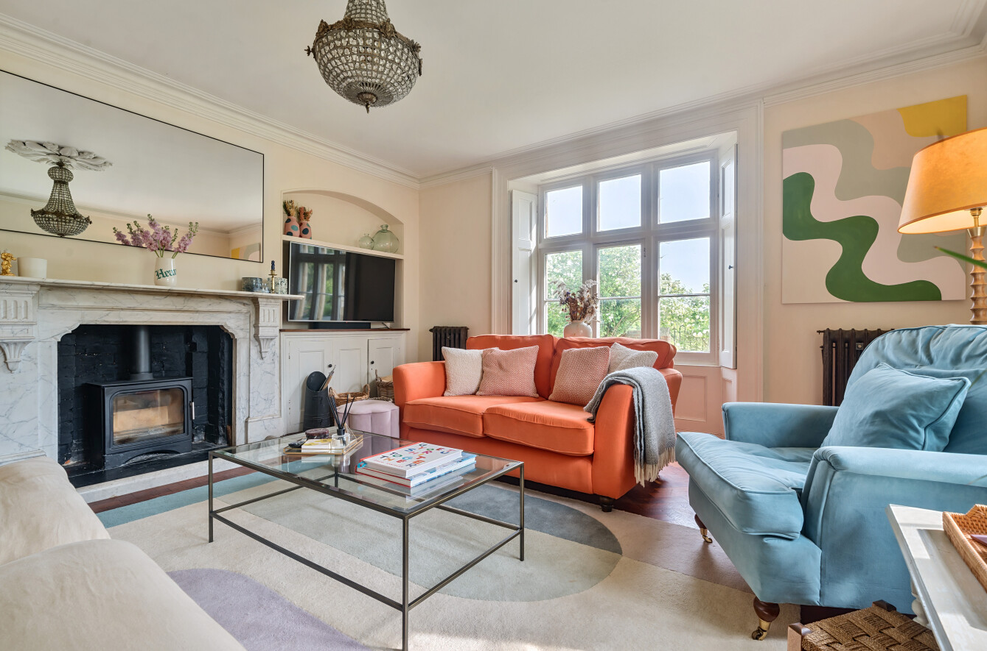

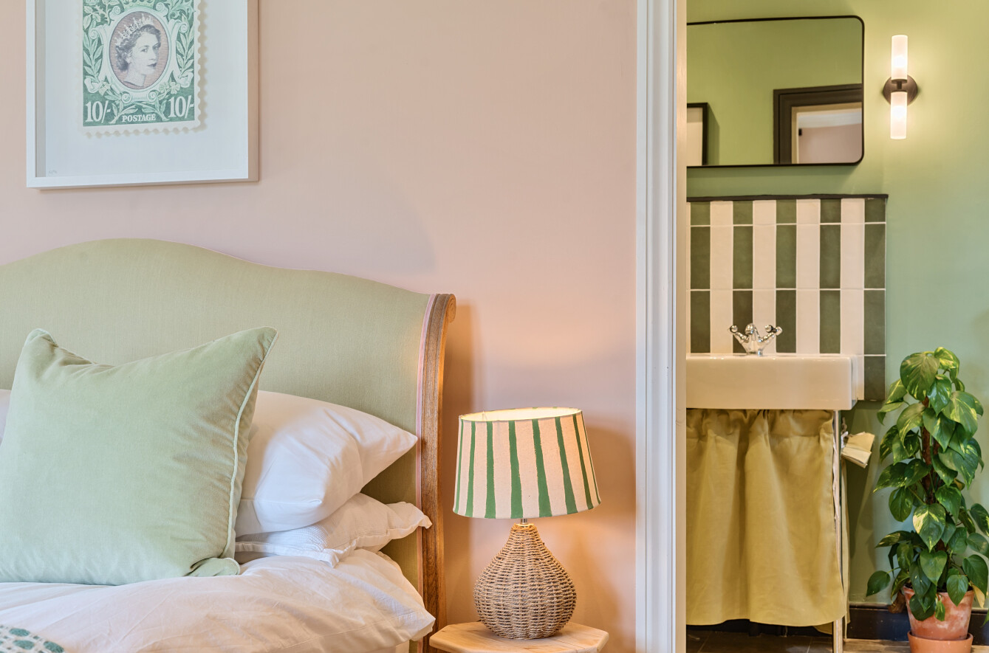

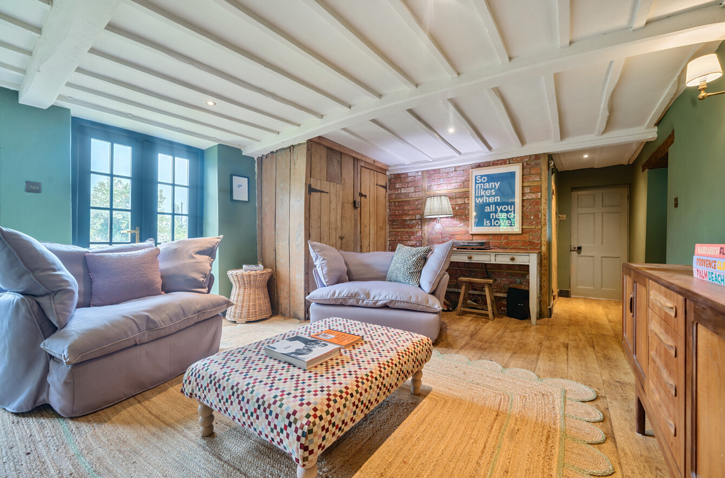

Guide Price £1,000,000 Freehold

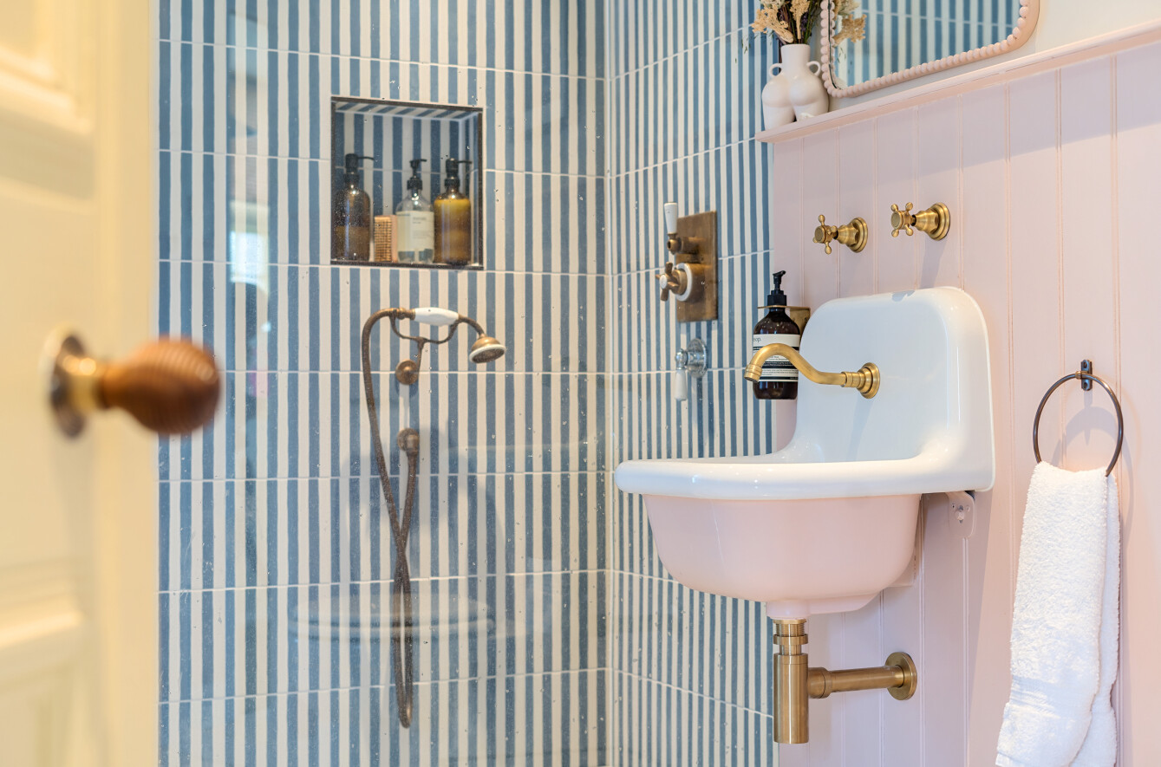

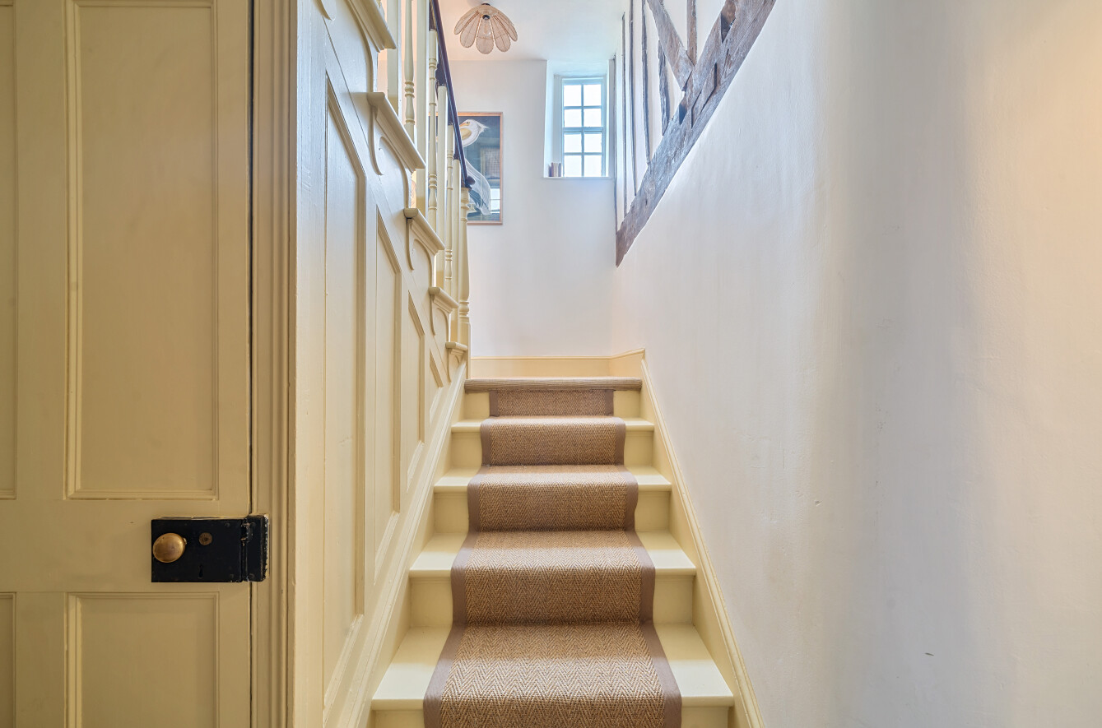

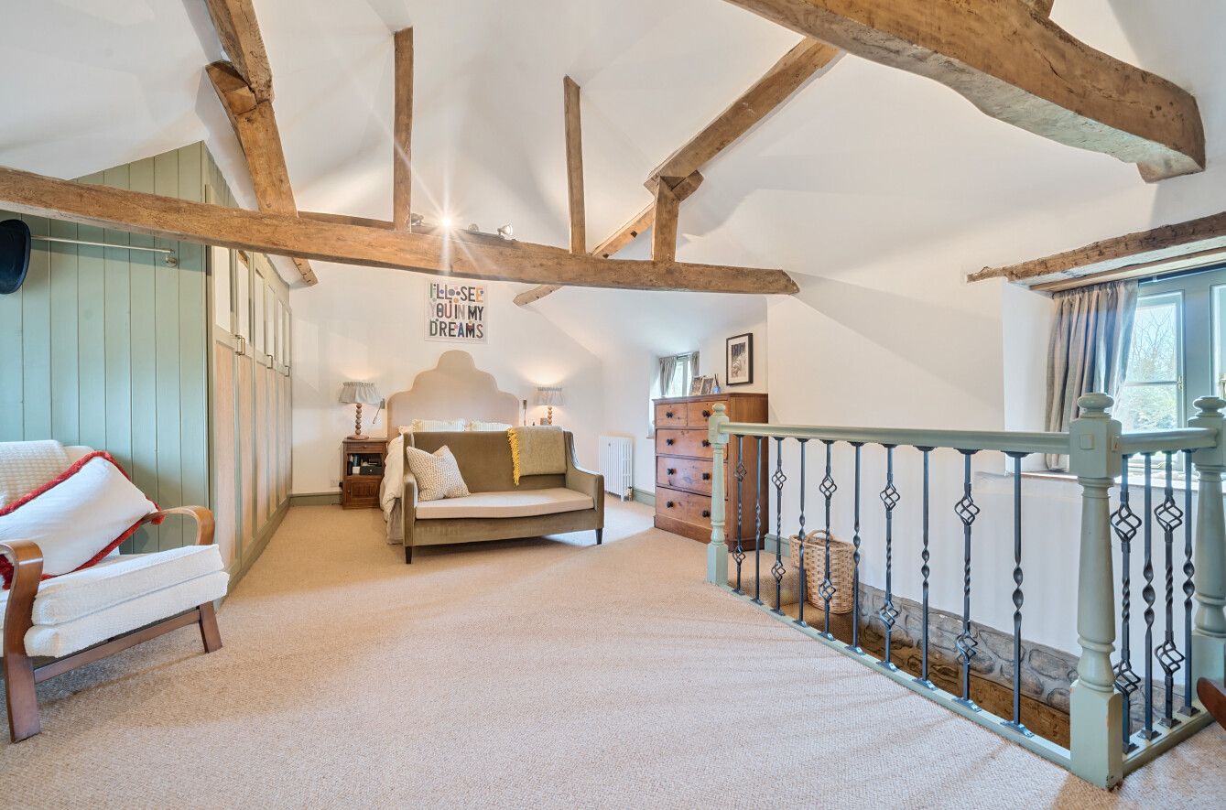

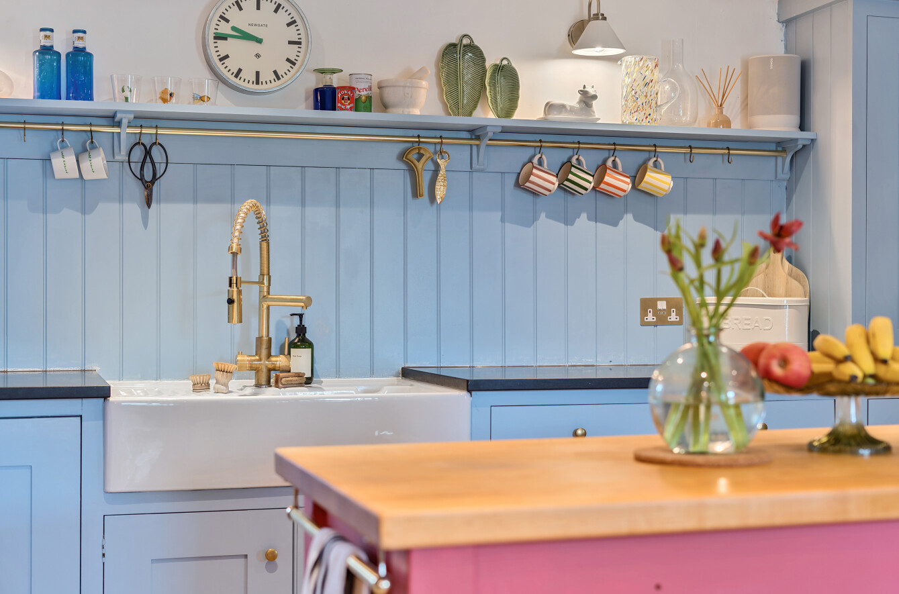

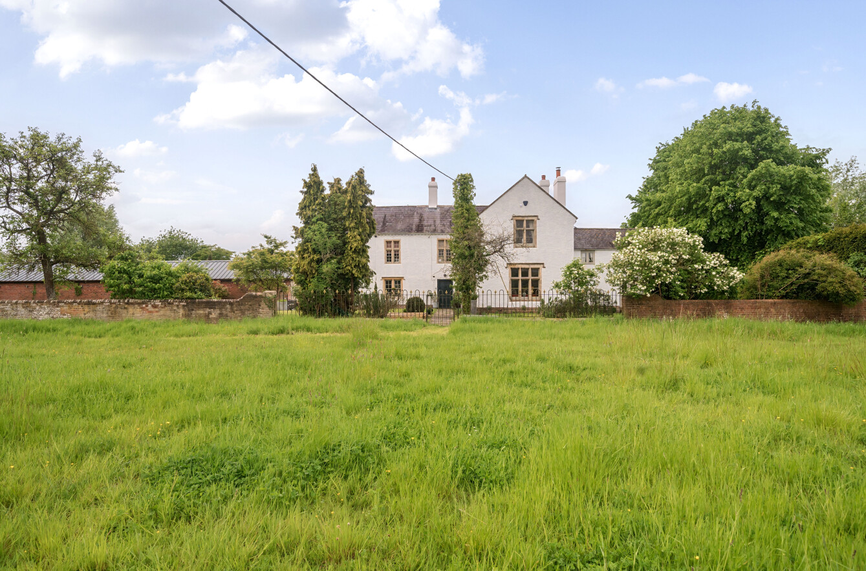

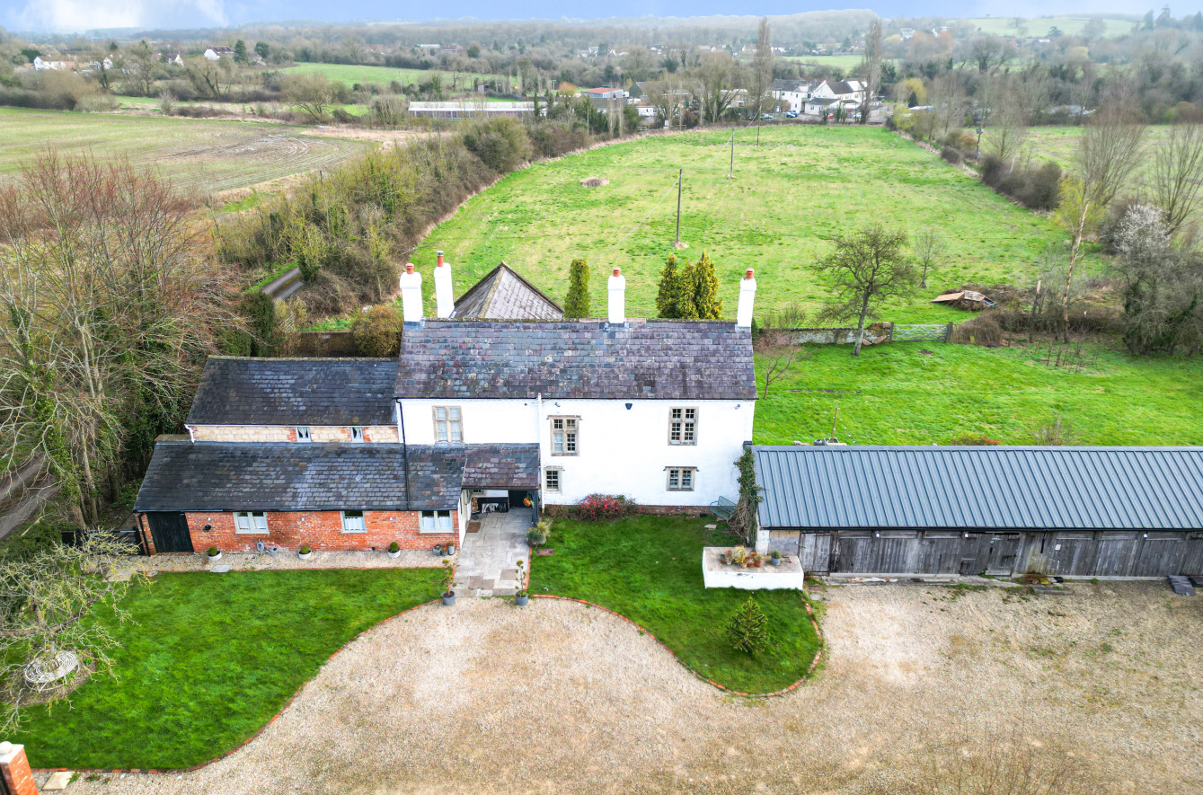

**Local Information**

**Local Council:** Wiltshire Council

**Council Tax Band:** F

**Heating:** tbc

**Services:** Mains Electricity and Water

**Tenure:** Freehold

# Location

The property is situated in a semi-rural location on the edge of Westbury in an area known as Hawkeridge. The home is close to many countryside walks and equestrian hacks. Hawkeridge is located approximately 2 miles from the medieval town of Westbury, just 18 miles from the historic City of Bath. Close by is the infamous Westbury White Horse hill carving, and this can be seen from the grounds of the property. The town of Westbury offers a wide range of shopping and leisure facilities with library, sports centre, swimming pool, school, churches, doctors and dentist surgeries and post office. Westbury also benefits from a train station with main line to London Paddington and the local commuter service to Bath, Dilton Marsh request stop station with good links to Bath, Bristol or Southampton or Salisbury. The nearby A350, A36, A303 and M4 provides excellent road links to London, Bath, Salisbury, Winchester and Exeter. Local attractions include Westbury White Horse, Longleat House and Safari Park, Shearwater Lake, Stourhead and Salisbury Plain. Iford Manor and Babington House are also close to hand.

** Motorway Links**

* A303/M4/A361/A350

** Train Links**

* Westbury
* Warminster

** Nearest Schools**

* Trowbridge/Frome/Bath
* Warminster/Westbury/BOA

