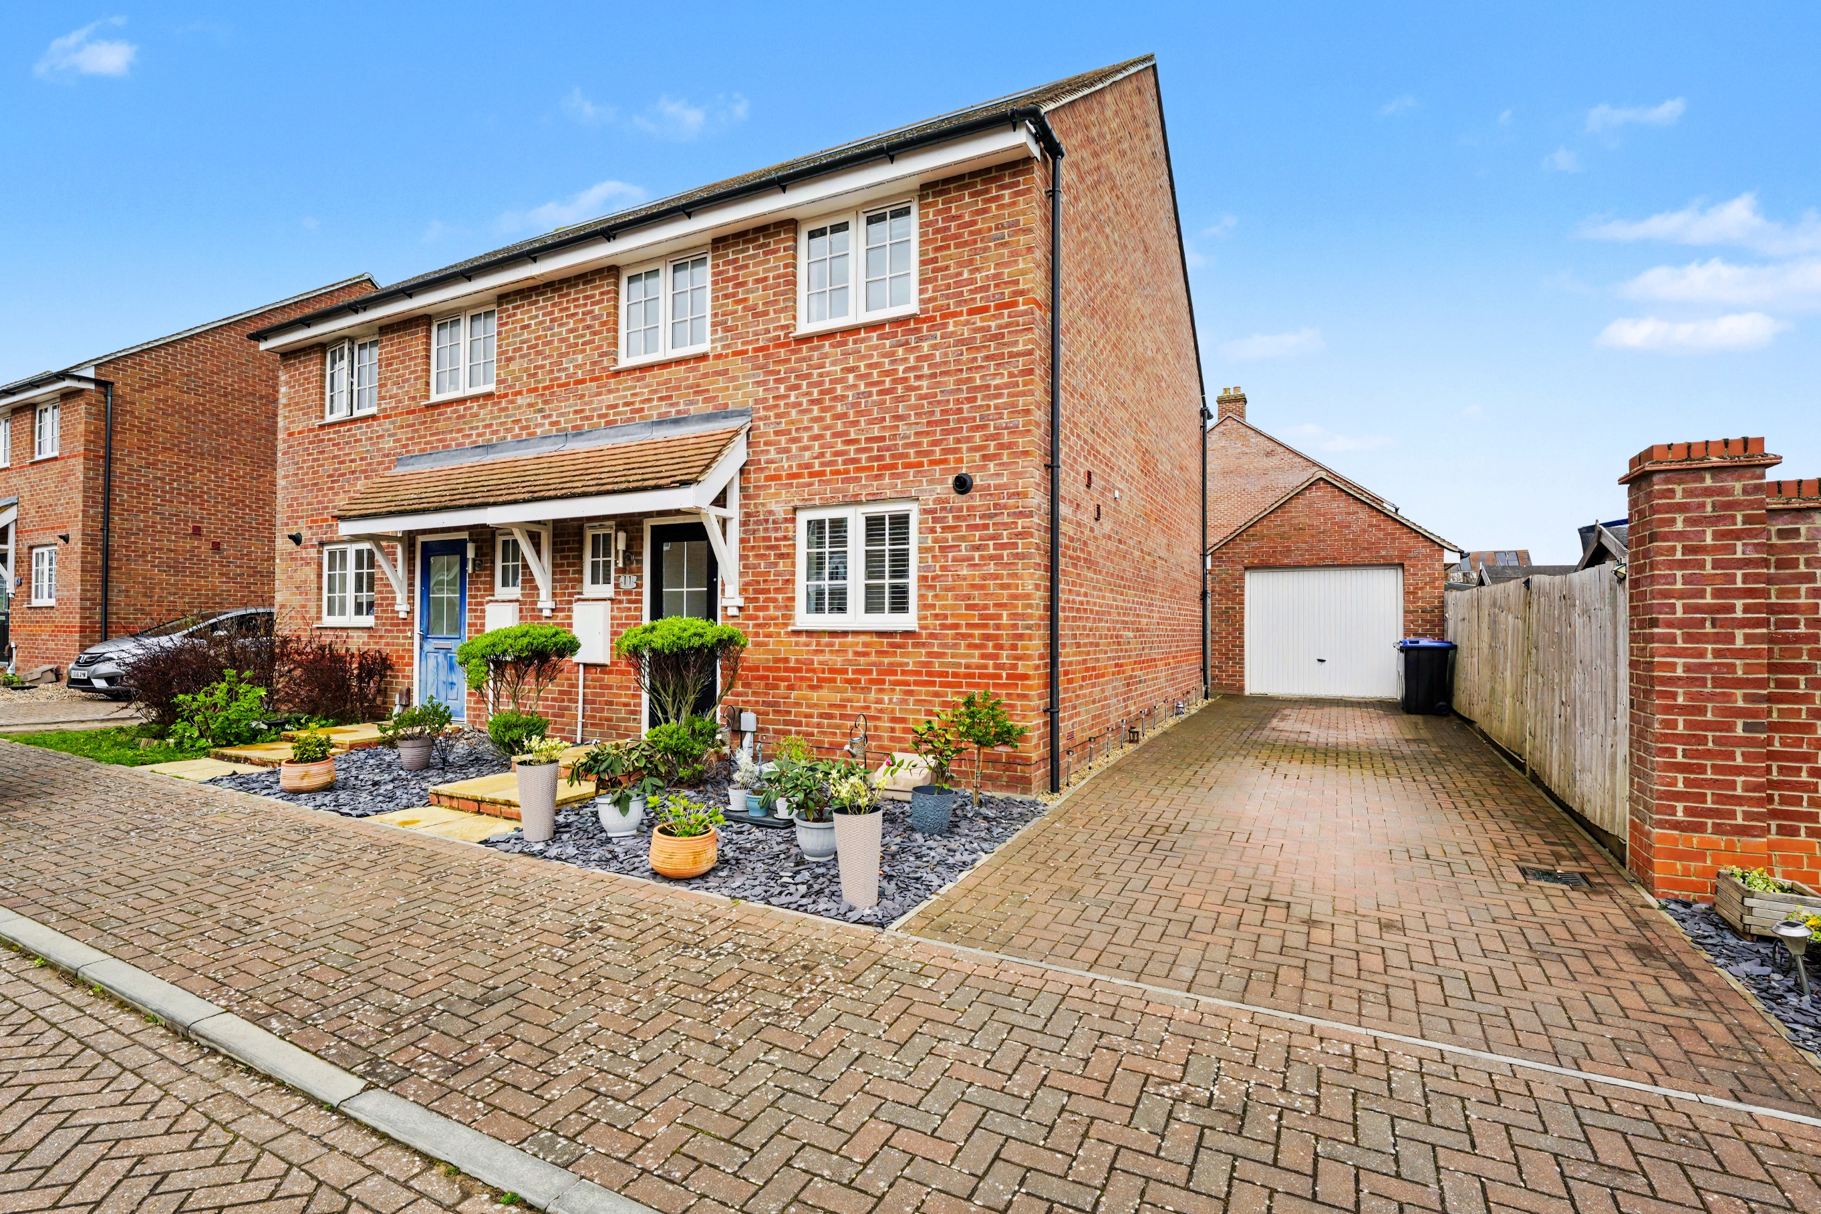
Blackwood Avenue, Letchworth Garden City, Hertfordshire SG6 1GR
£475,000 Leasehold

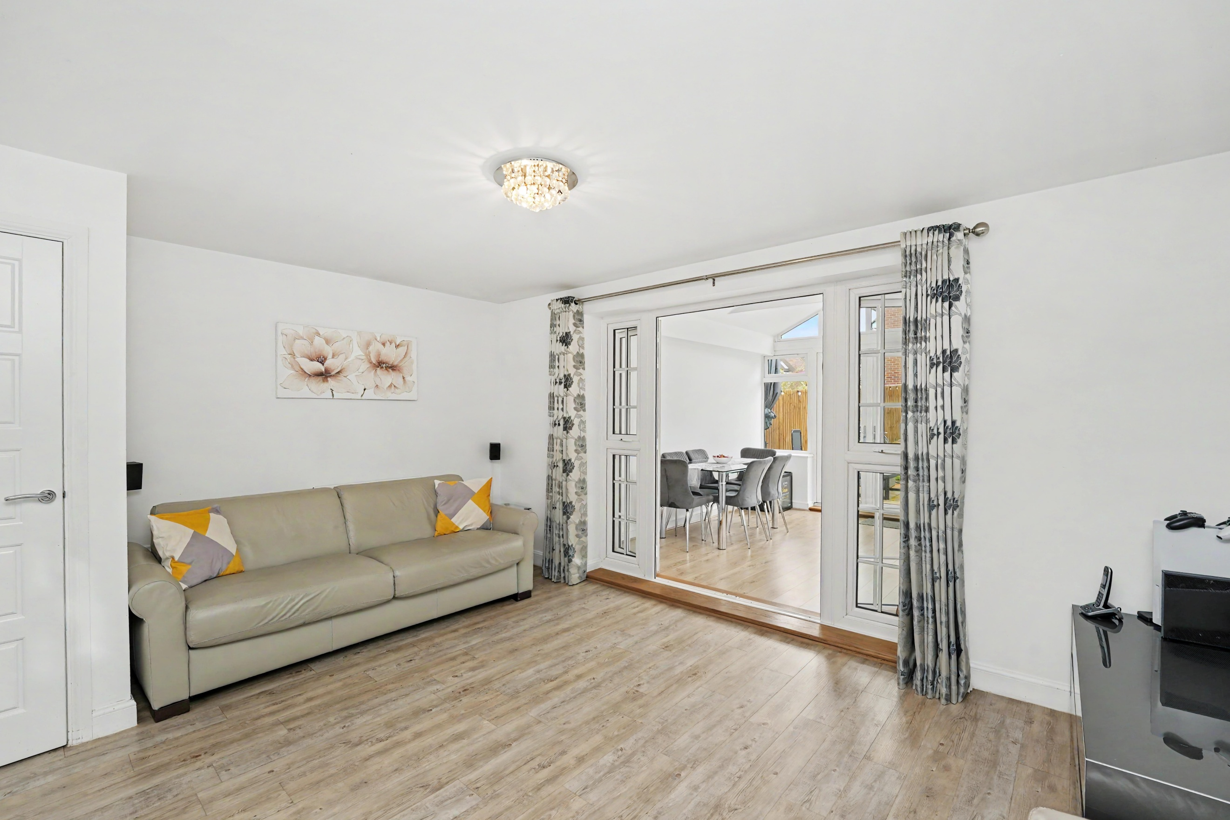
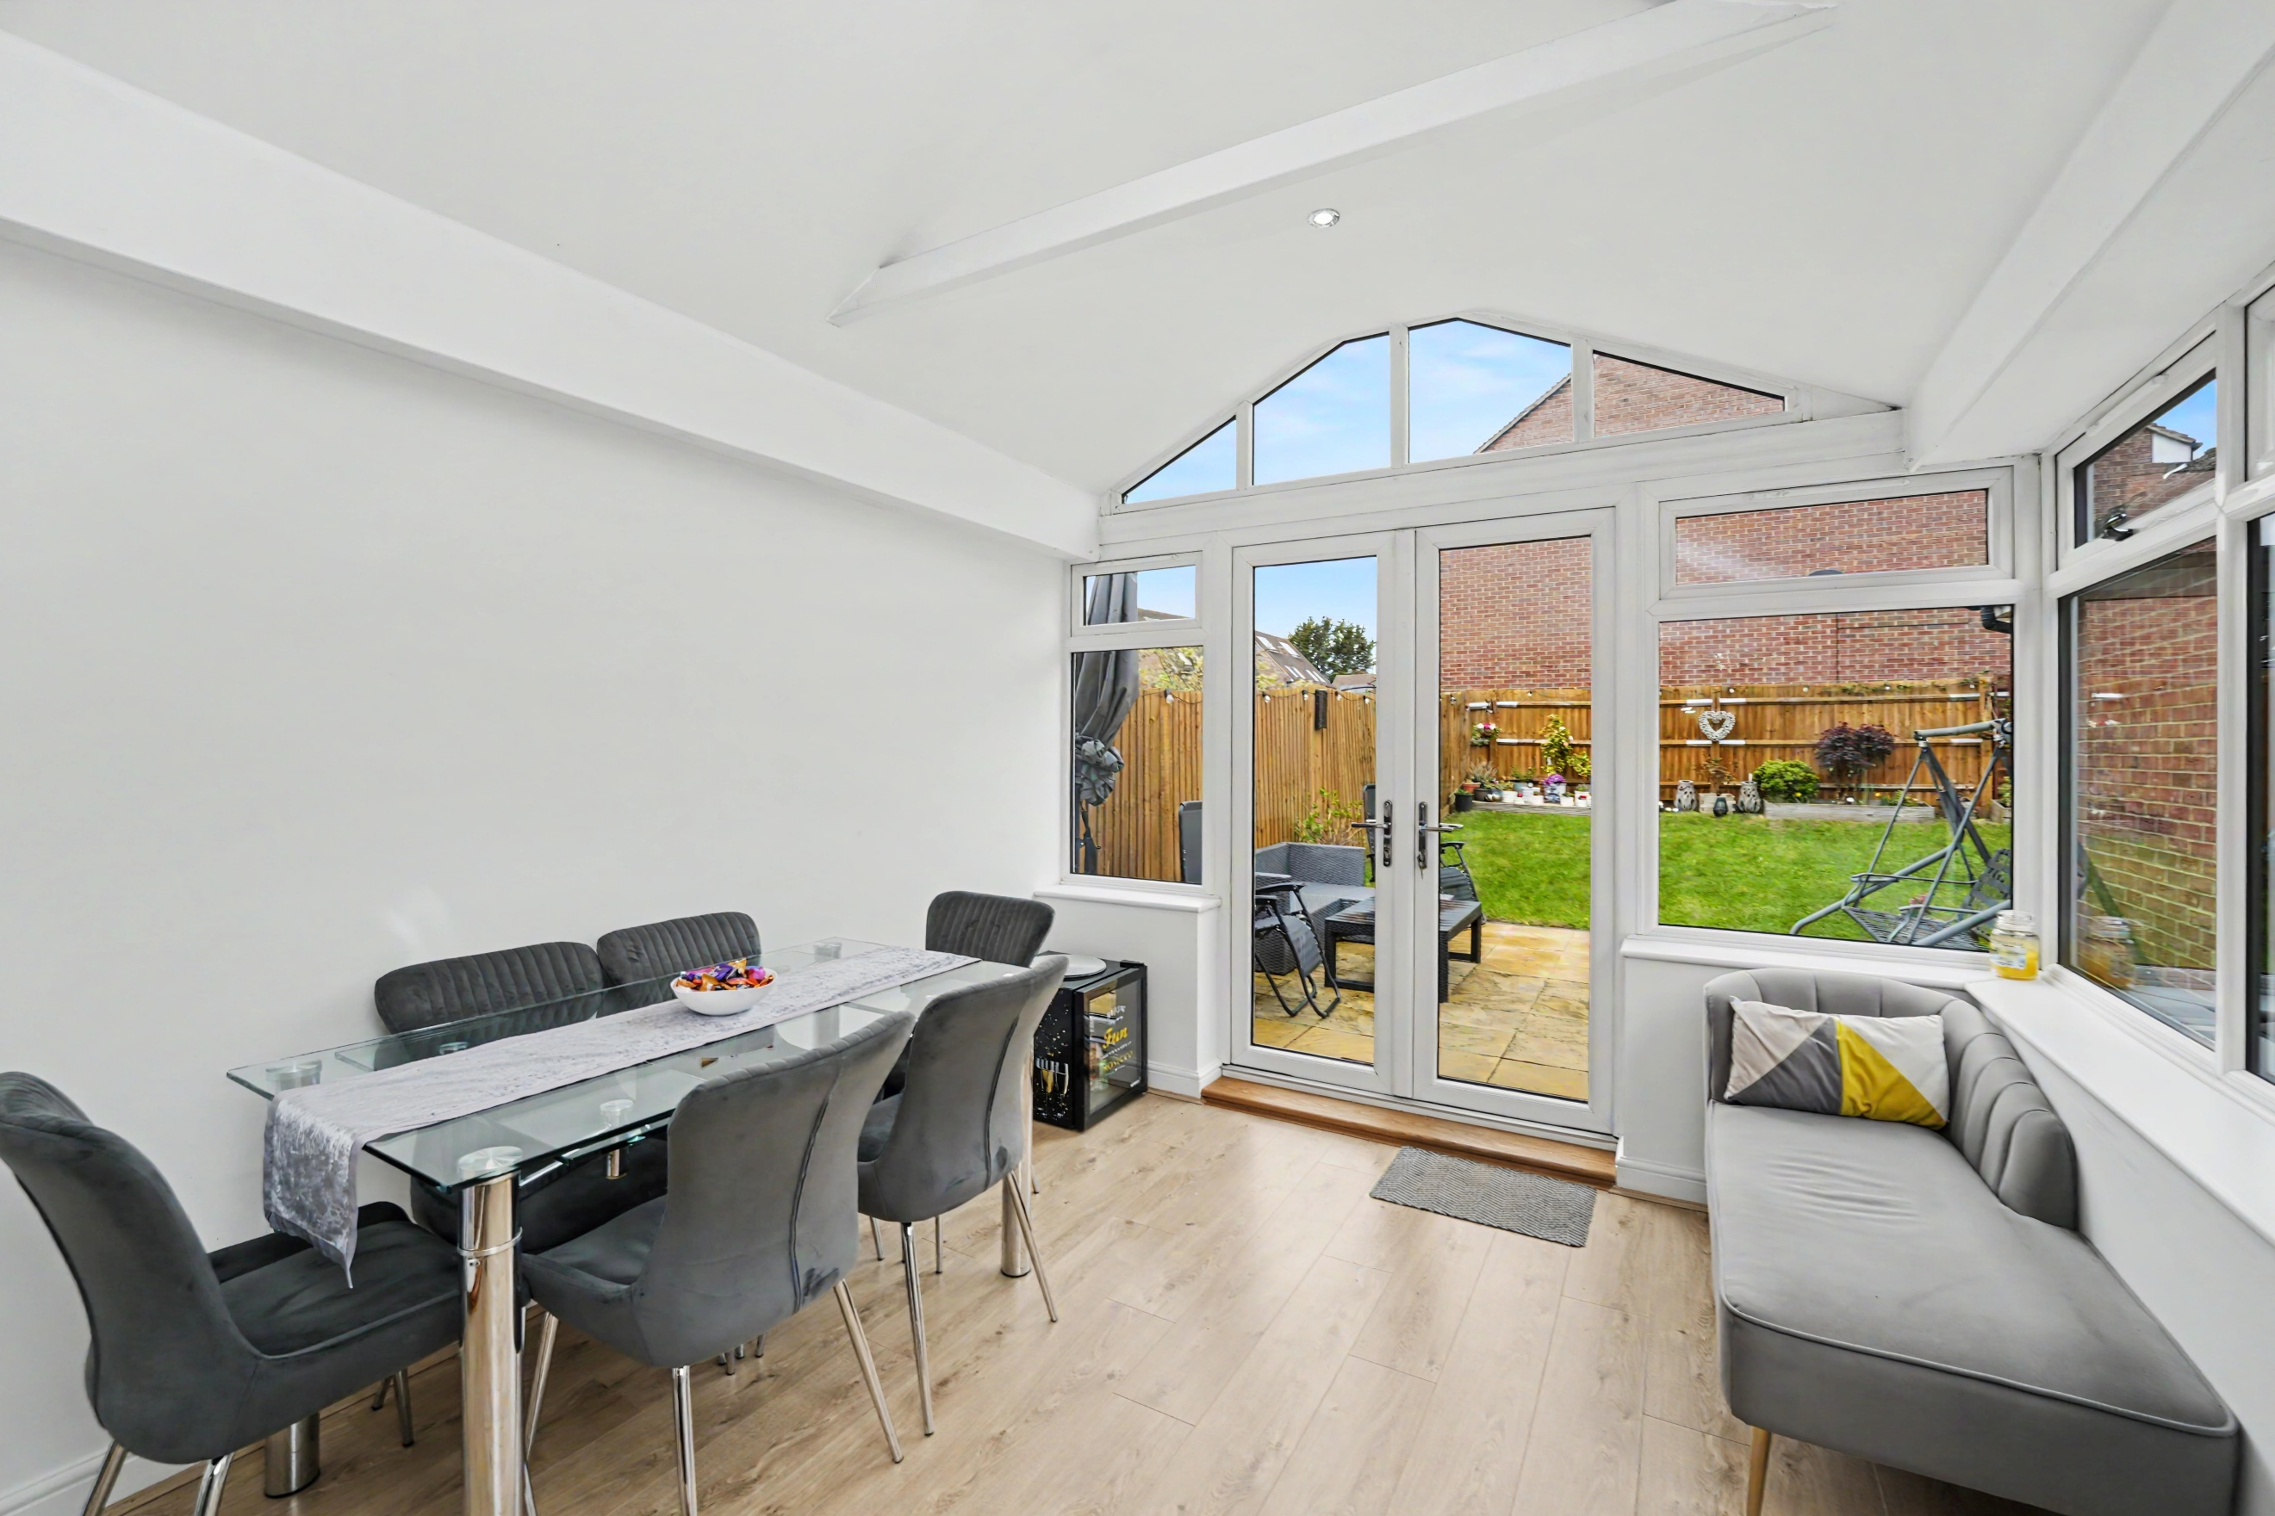
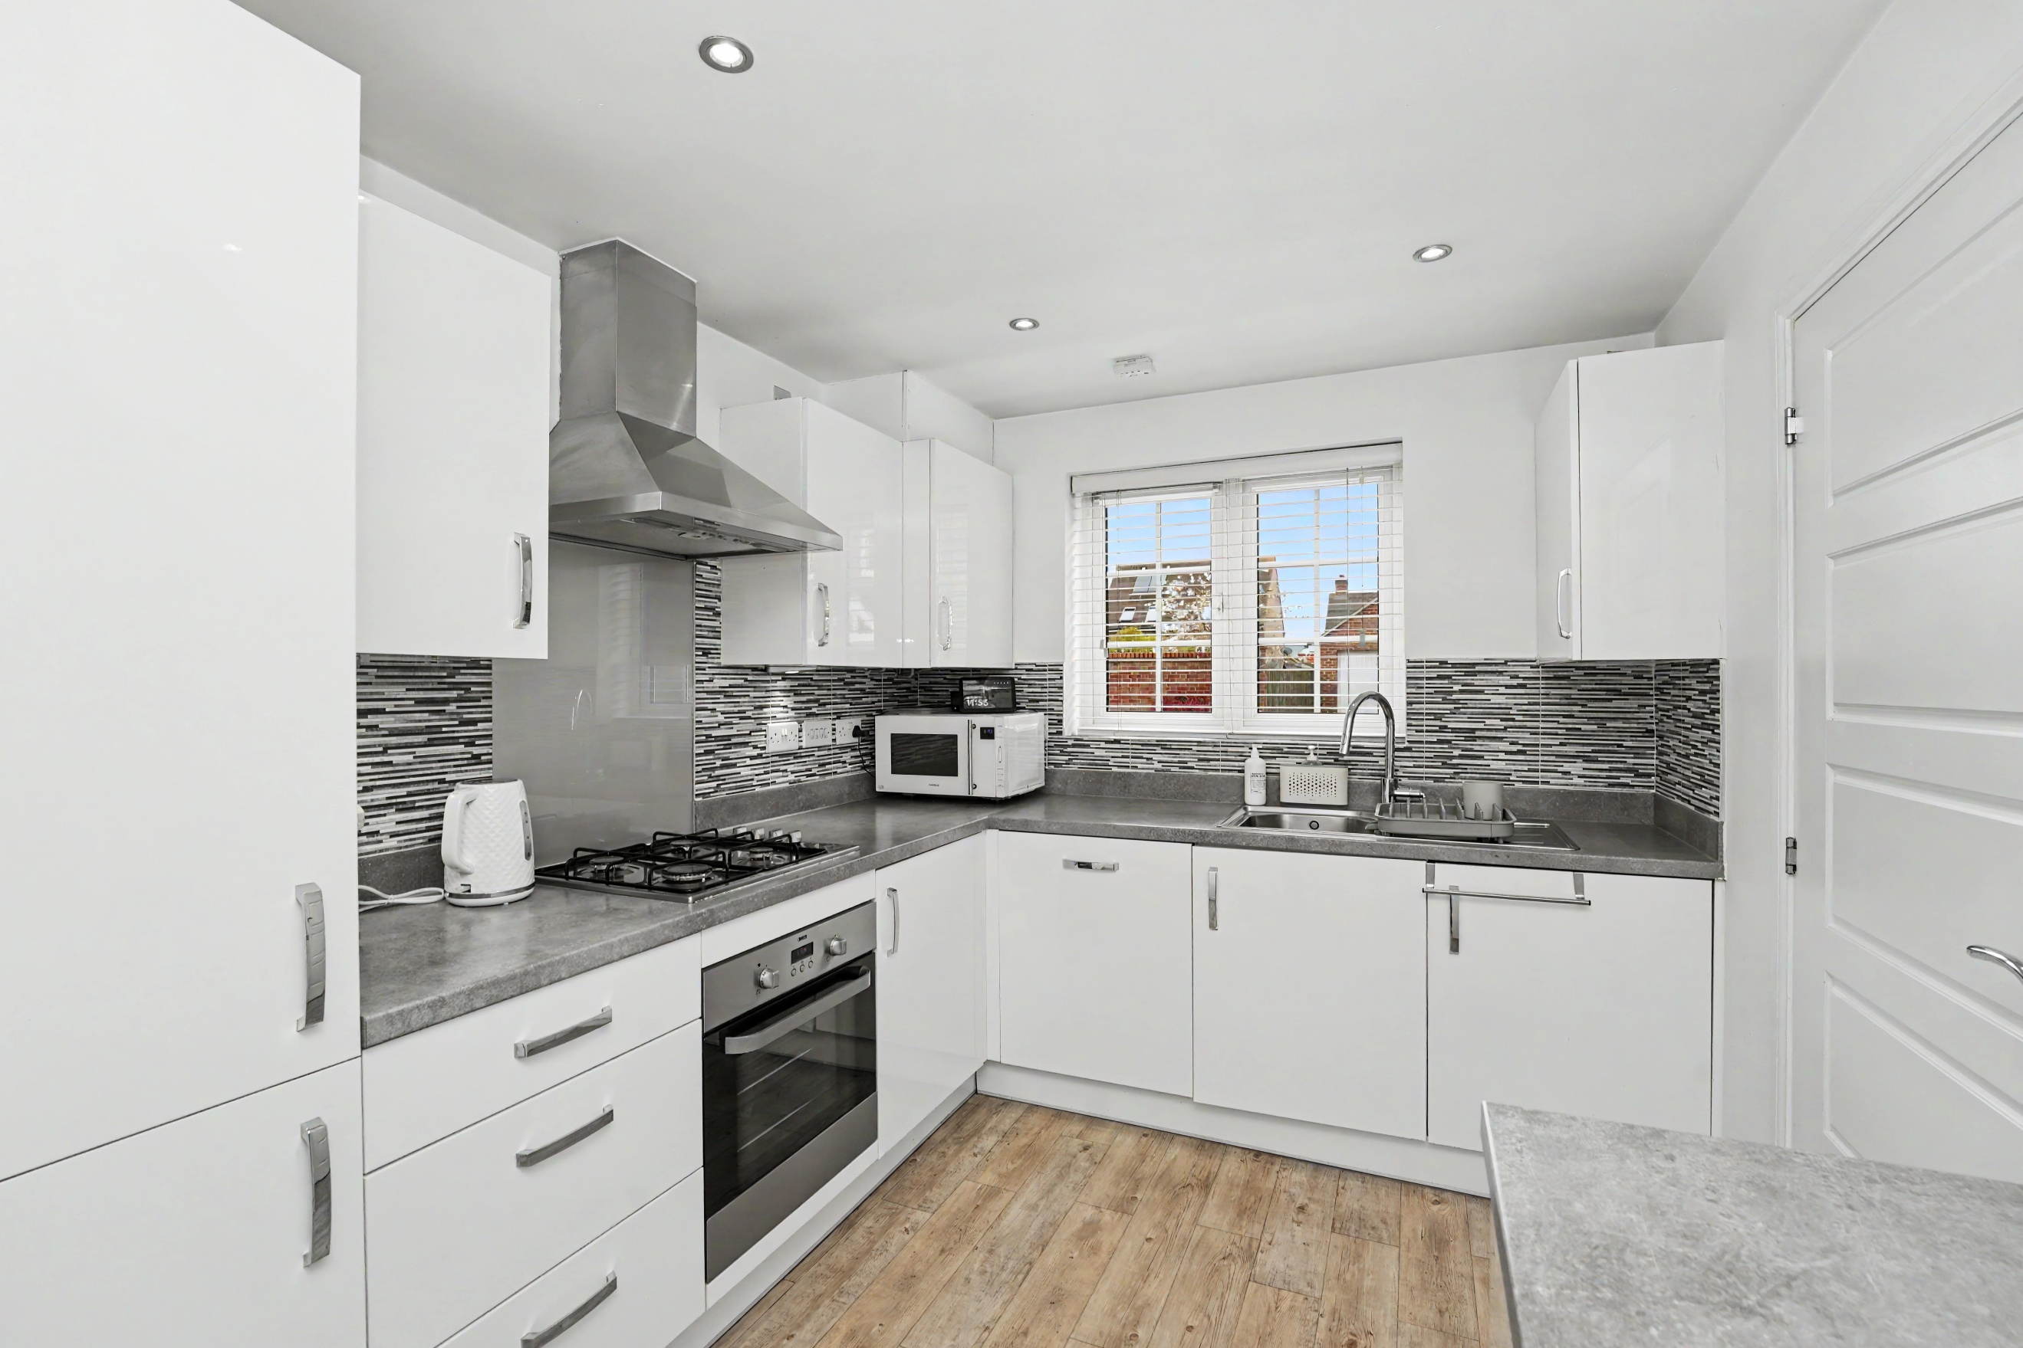
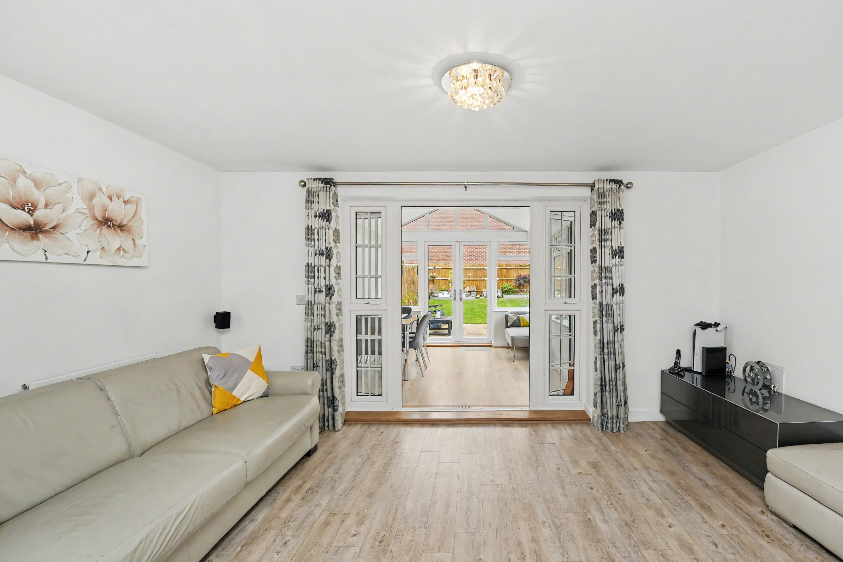
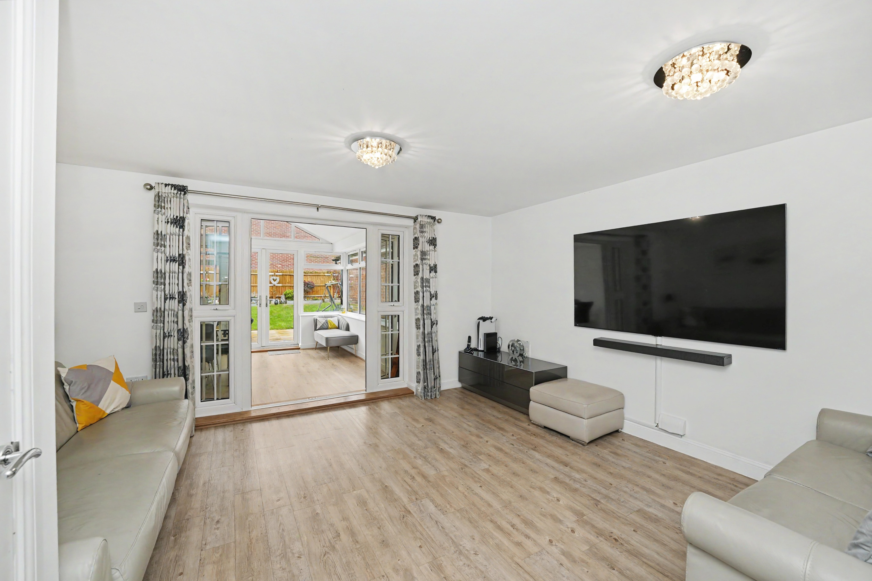
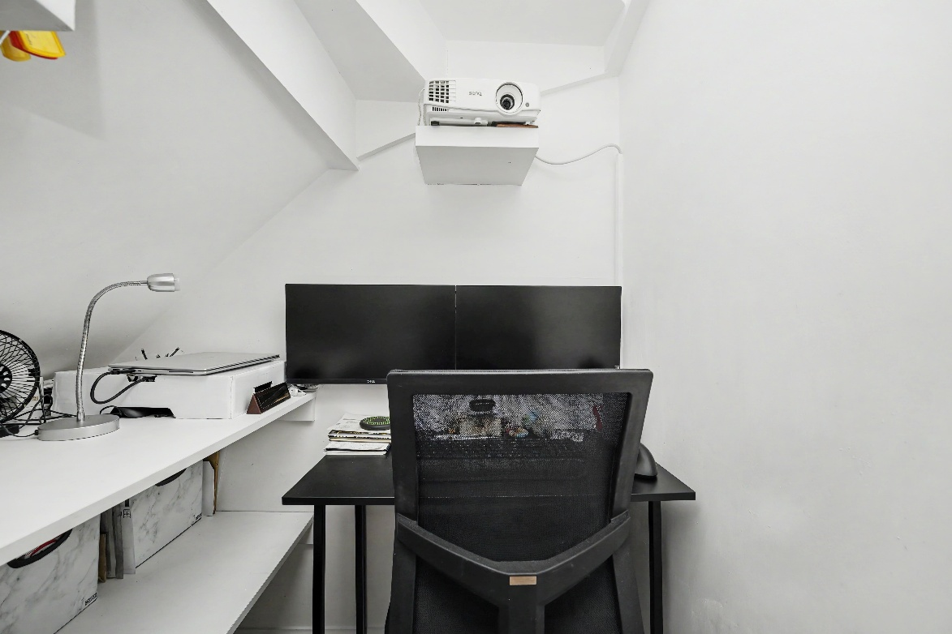
Blackwood Avenue is located within a modern residential development in Letchworth Garden City, offering a calm and family friendly environment while remaining well connected to the town’s amenities.
Letchworth Garden City is widely recognized for its thoughtful planning, combining residential areas with open green spaces to create a balanced and attractive living environment. Residents benefit from a range of everyday conveniences, including supermarkets, local shops, cafés, and leisure facilities, all within easy reach of the area.
The location is particularly appealing for families, with a selection of primary and secondary schools nearby, as well as parks and outdoor spaces that contribute to the area’s community feel. For commuters, Blackwood Avenue is well positioned, with Letchworth Garden City railway station providing regular services into London and surrounding areas. Road connections are also convenient, with access to the A1(M) offering straightforward routes to nearby towns and cities.
Overall, Blackwood Avenue offers a comfortable residential setting that blends modern living with accessibility, making it a practical choice for a wide range of buyers.
About Letchworth

Step Inside

A modern, well-presented home in a quiet residential area, featuring a stylish exterior and spacious layout. The property benefits from a private rear garden with patio and lawn, ideal for entertaining, along with a generous driveway providing ample off-street parking and access to a versatile garage with conversion potential. On the ground floor, the property features a bright and welcoming reception/dining room, ideal for both everyday living and entertaining. The contemporary kitchen is thoughtfully designed with a breakfast bar, providing a practical and sociable space for casual dining. The downstairs benefits from attractive LVT flooring throughout, offering both durability and a sleek, modern finish. To the rear, a superb conservatory with laminate flooring extends the living space and has been upgraded with a fully insulated roof, led strip lighting, spotlights and underfloor heating, ensuring year-round comfort and usability. A convenient ground floor WC and additional storage complete this level.
Upstairs, the first floor comprises three well-proportioned bedrooms, each benefiting from fitted storage units and LVT flooring. The principal bedroom also enjoys the added luxury of an ensuite, alongside a modern family bathroom featuring a contemporary three-piece suite, both with LVT flooring. Every room throughout the property is equipped with TV aerial points, offering seamless connectivity for modern living.
Further enhancing its appeal, the home is fitted with solar panels, improving energy efficiency and reducing running costs as well as a boarded loft space for extra storage.
This is a fantastic opportunity to acquire a contemporary, energy-conscious home with excellent indoor and outdoor space, ideal for modern family living.
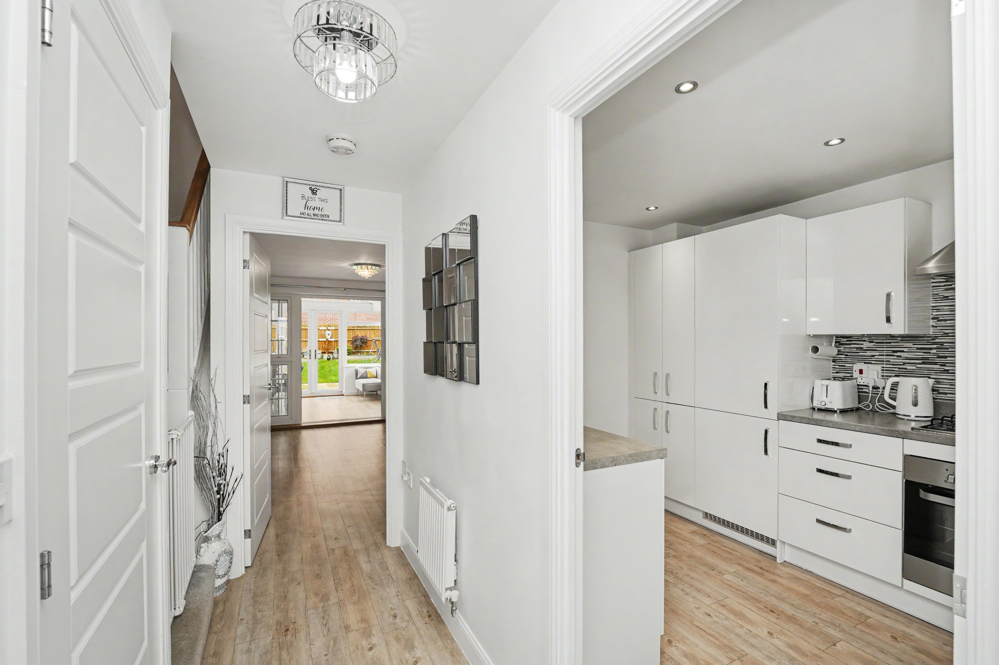
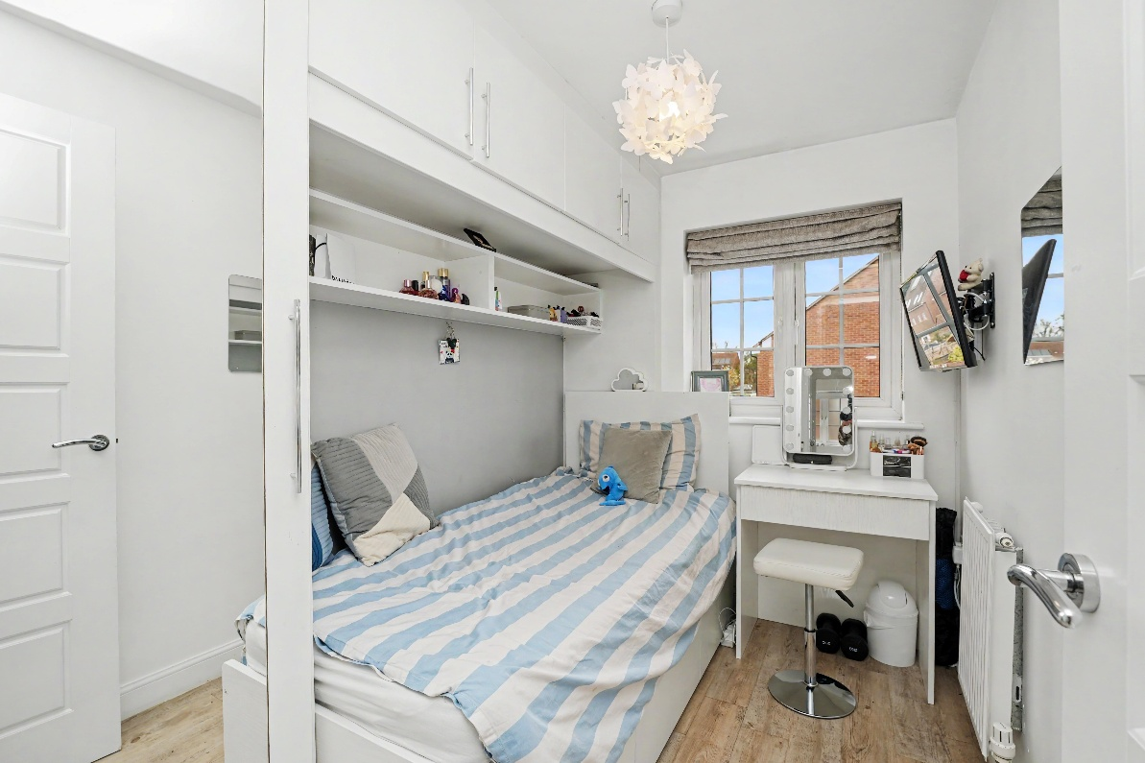
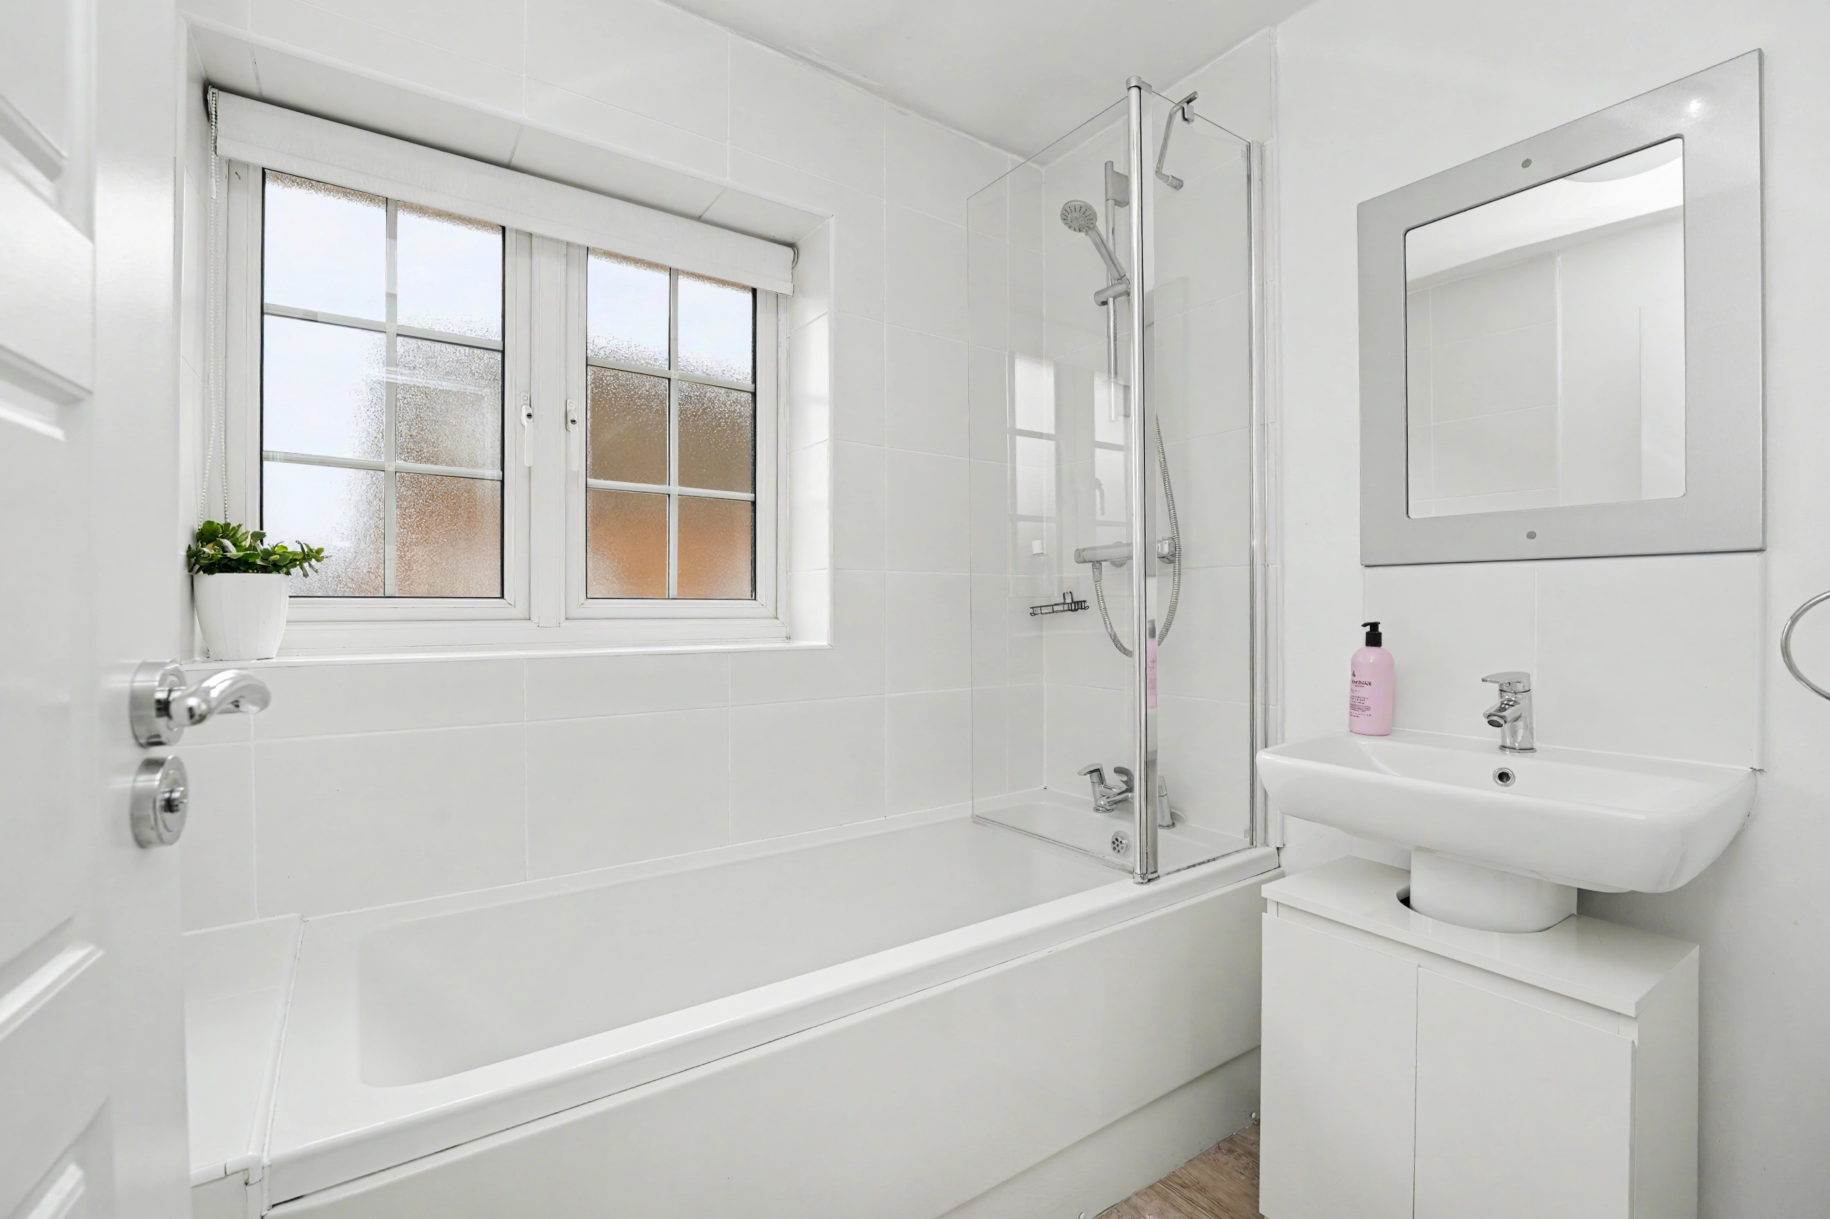
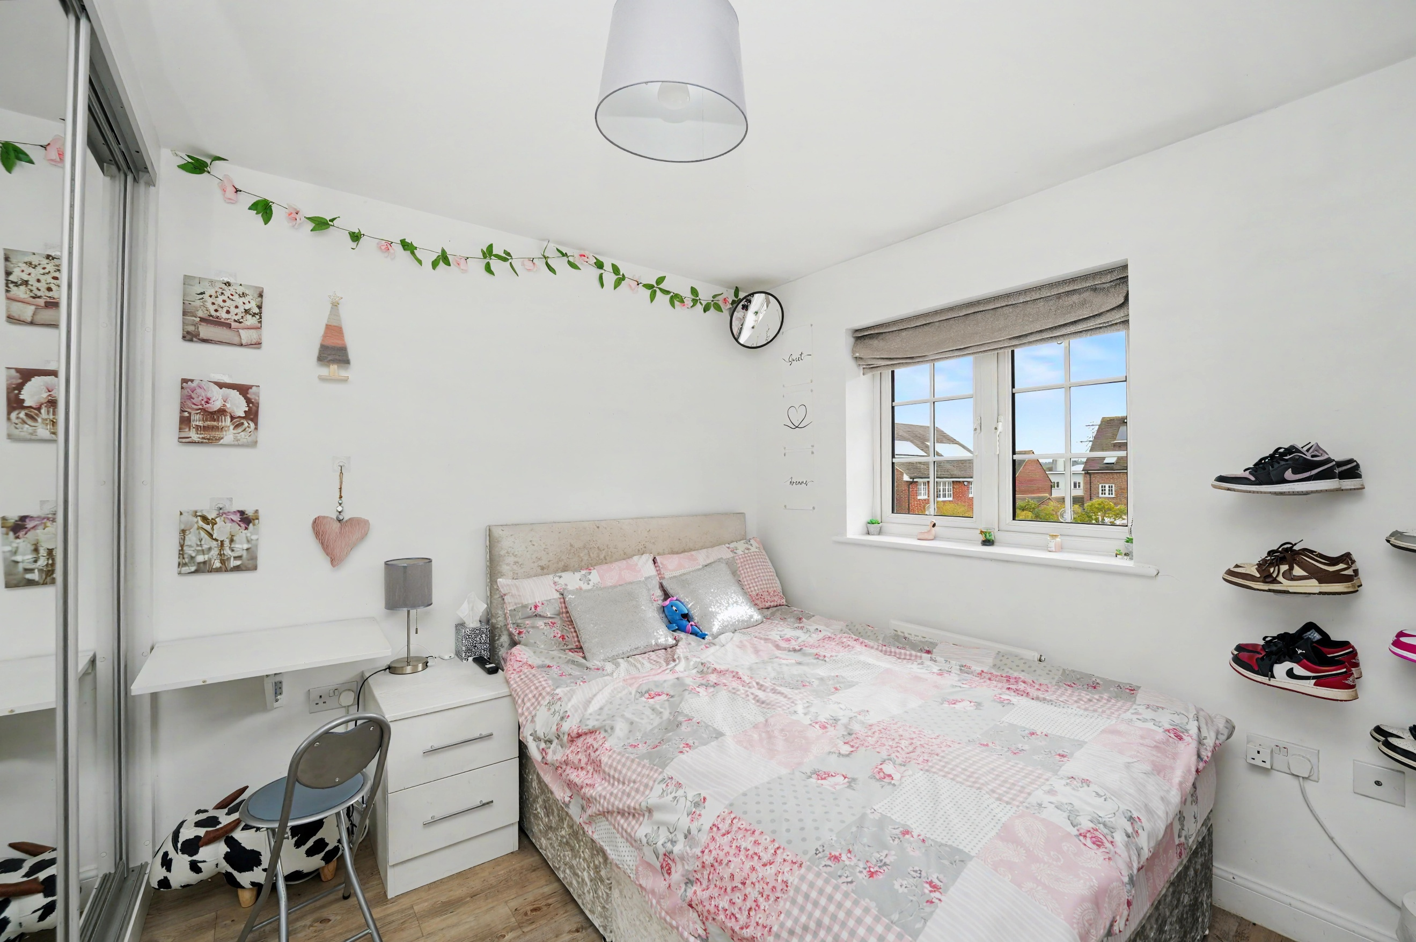
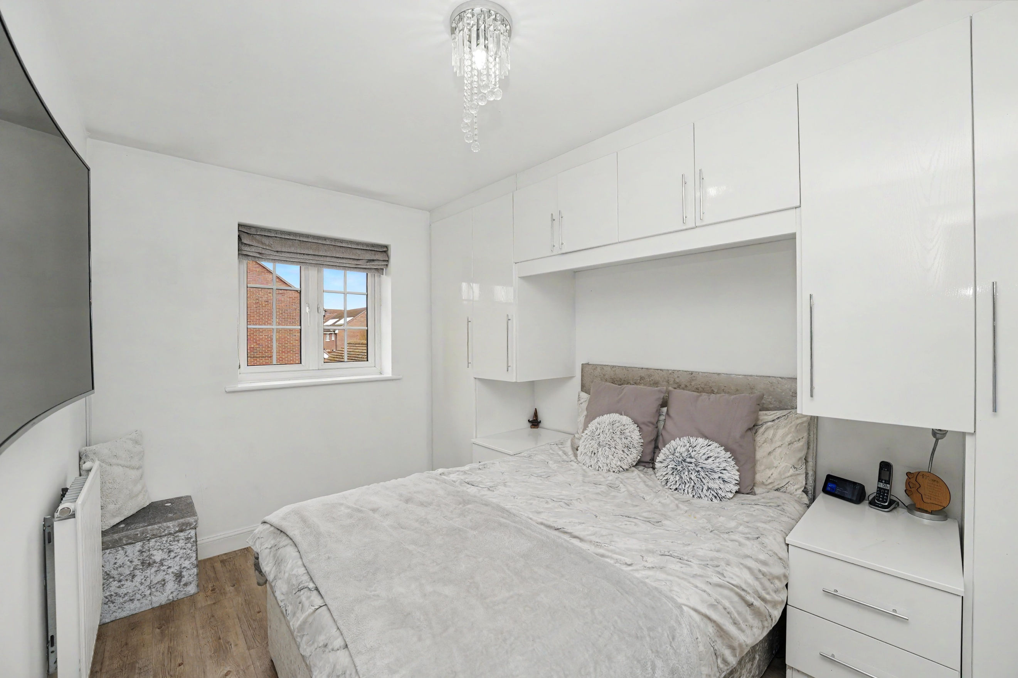
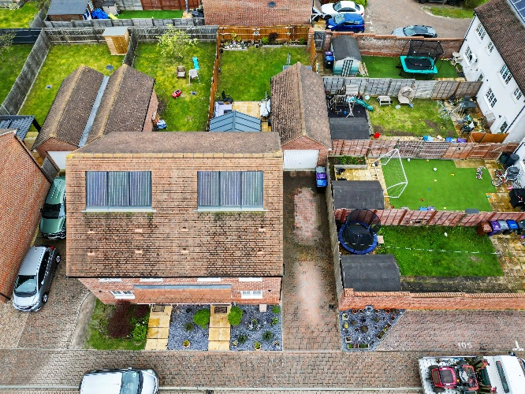
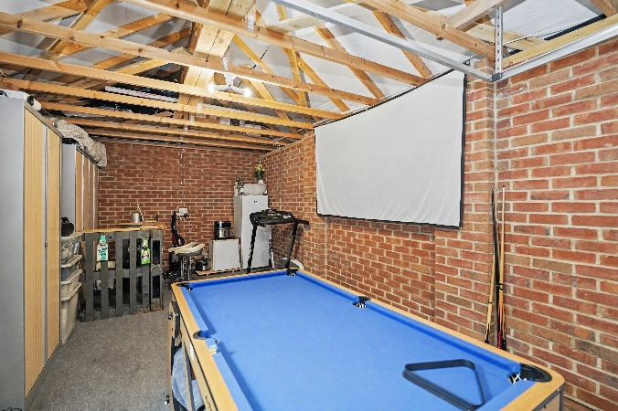
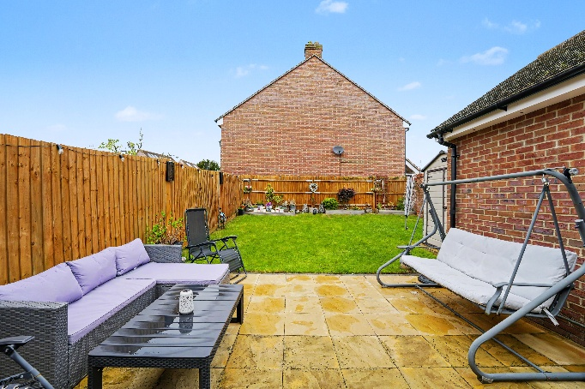
Externally, the property is equally impressive, offering a well-maintained and thoughtfully arranged outdoor space to the front and rear. To the front, a generous block-paved driveway provides ample off-street parking and leads directly to the detached garage and side gate to the garden. The frontage is neatly presented with decorative landscaping and planting, creating an attractive first impression. The good sized and non overlooked rear garden is a particularly appealing feature, designed for both relaxation and entertaining. A paved patio area adjoins the property, providing the perfect space for outdoor seating and dining, while the remainder is laid to lawn and enclosed by fencing for privacy. The garden is well kept and offers a safe and versatile space suitable for families or social gatherings. The garden also benefits from an outdoor tap, plug sockets and led lighting.
The garage benefits from having electrics installed and also offers excellent potential for conversion, subject to the necessary permissions, making it ideal for those seeking additional living space, a home office, or gym.
Overall, the outdoor areas complement the property perfectly, combining practicality with an inviting and low-maintenance finish.

Step Outside

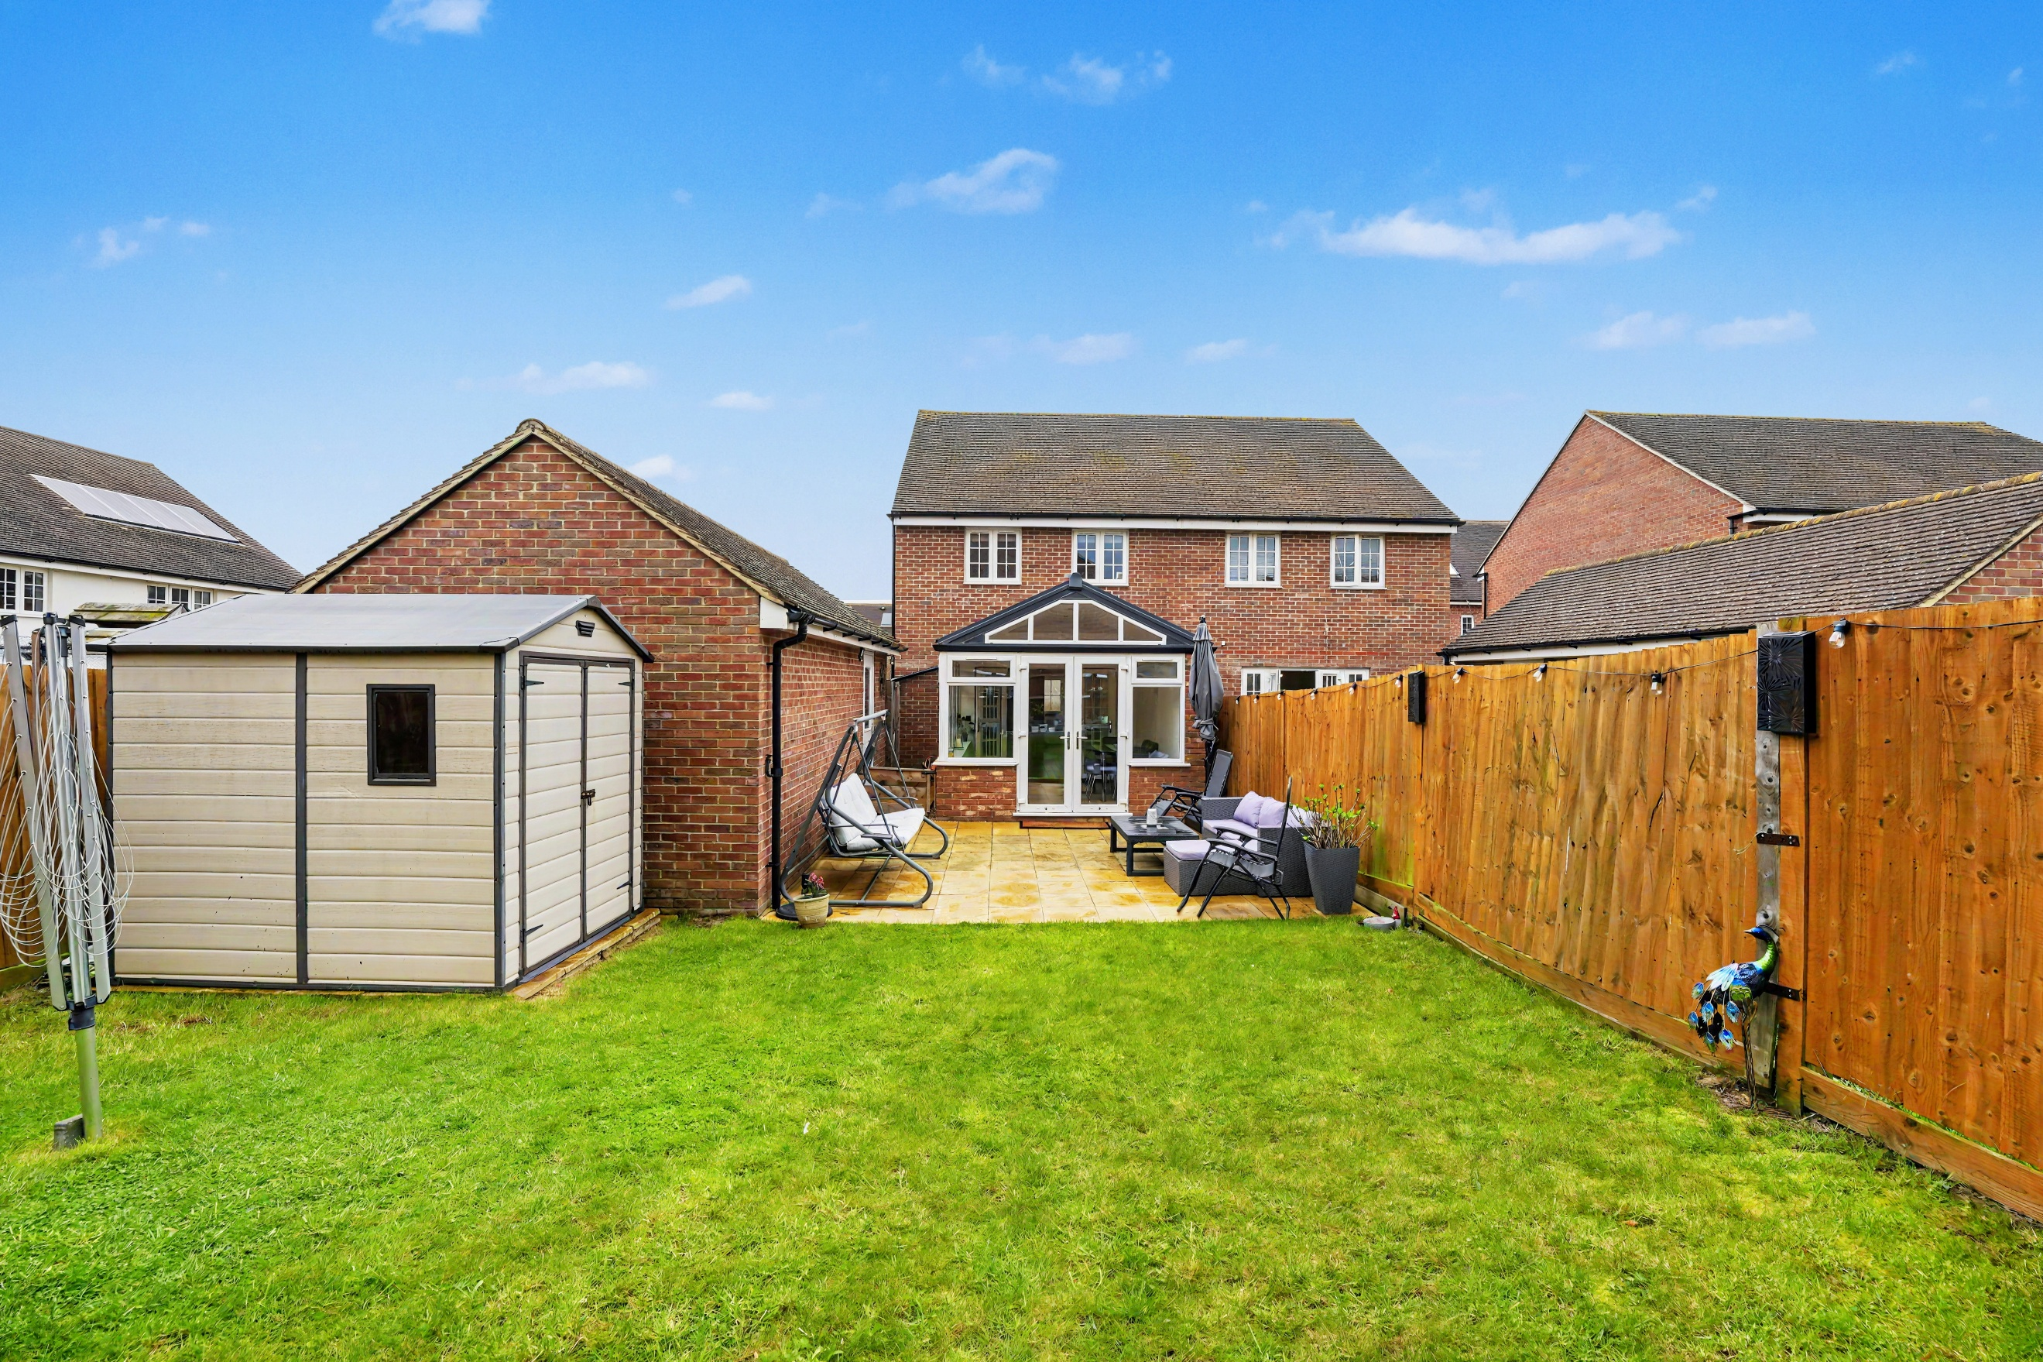

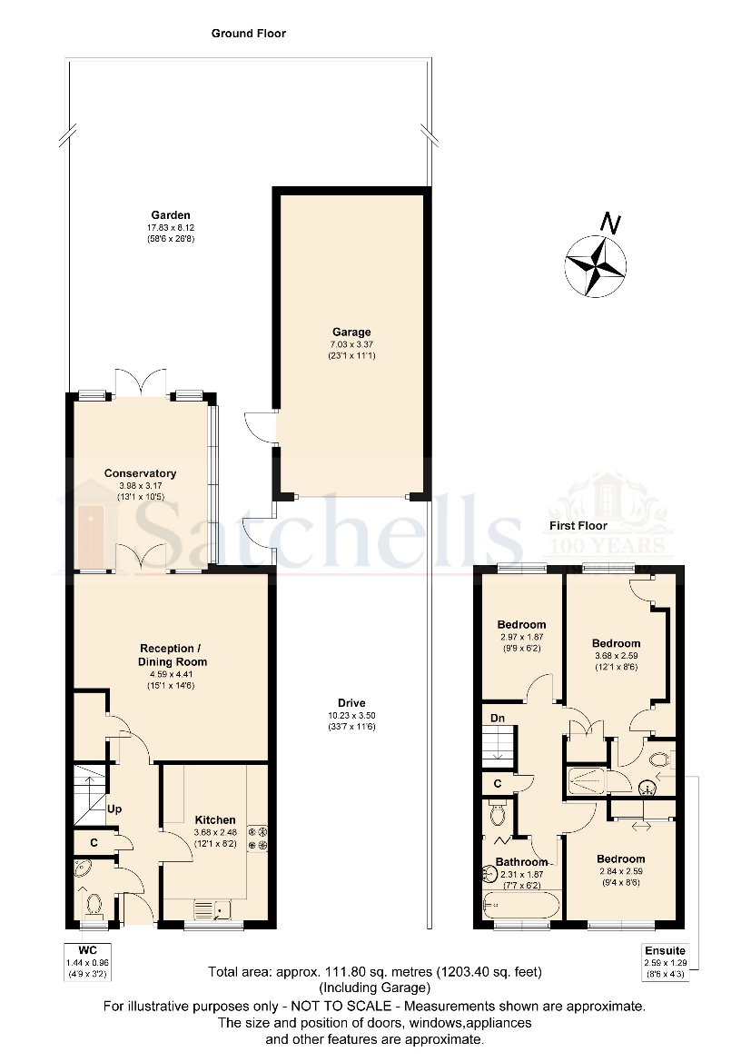

These particulars are a guide only and do not constitute an offer or a contract. The floorplan is for identification purposes only and not to scale. All measurements are approximate and should not be relied upon if ordering furniture, white goods and flooring etc. We have presented the property as we feel fairly describes it but before arranging a viewing or deciding to buy, should there be anything specific you would like to know about the property please enquire. Satchells have not tested any of the appliances or carried out any form of survey and advise you to carry out your own investigations on the state, condition, structure, services, title, tenure, and council tax band of the property. Some images may have been enhanced and the contents shown may not be included in the sale. Satchells routinely refer to 3rd party services for which we receive an income from their fee. If you would like us to refer you to one of these services, please ask one of our staff who will pass your details on. We advise you check the availability of the property on the day of your viewing.



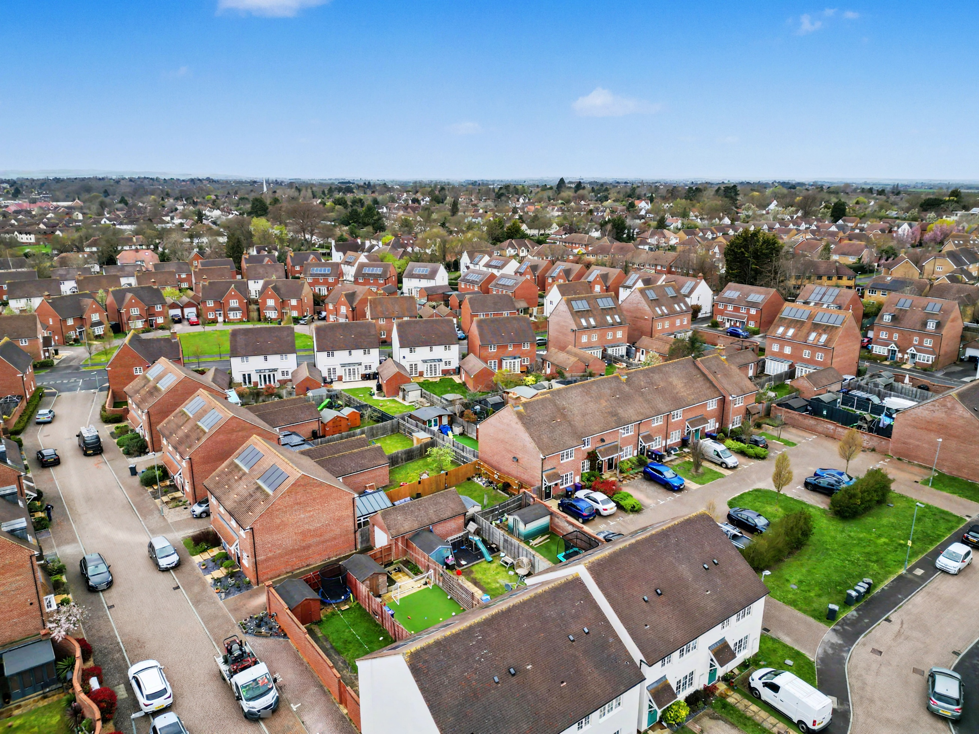
Station Place, Letchworth Garden City, Hertfordshire, SG6 3AQ.
01462 480077
letchworth@satchells.co.uk
www.satchells.com

