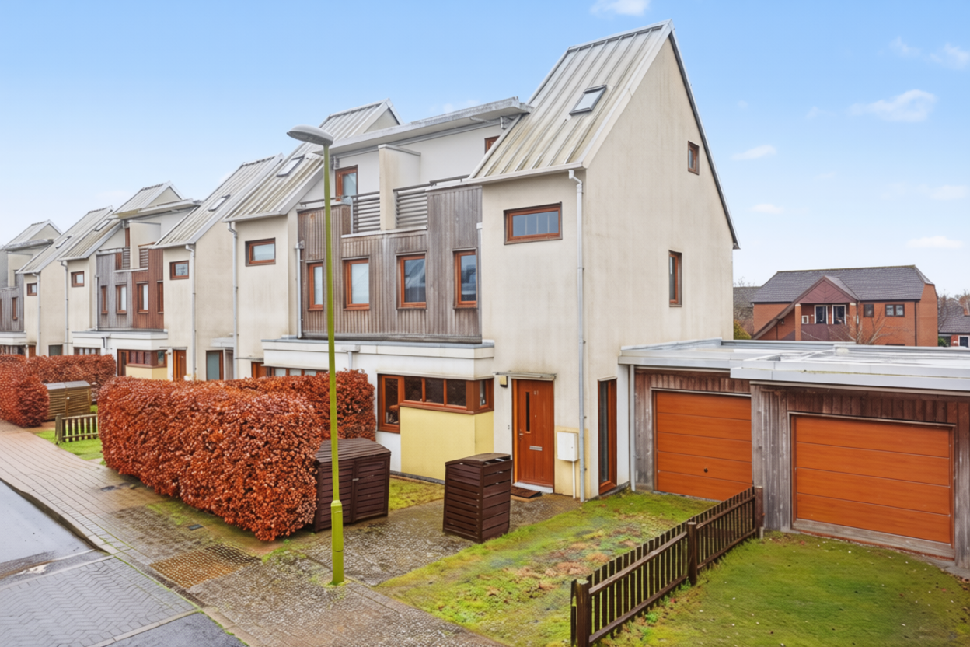
Hartington Place, Letchworth Garden City, Hertfordshire SG6 1FA
£485,000 Leasehold

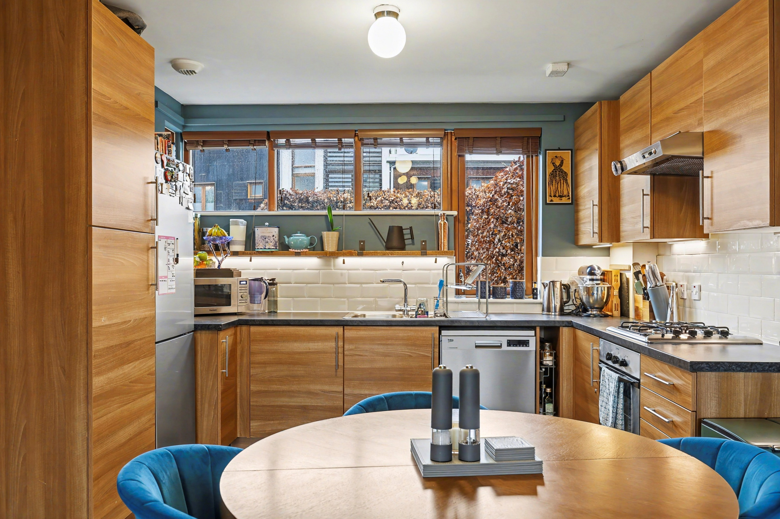
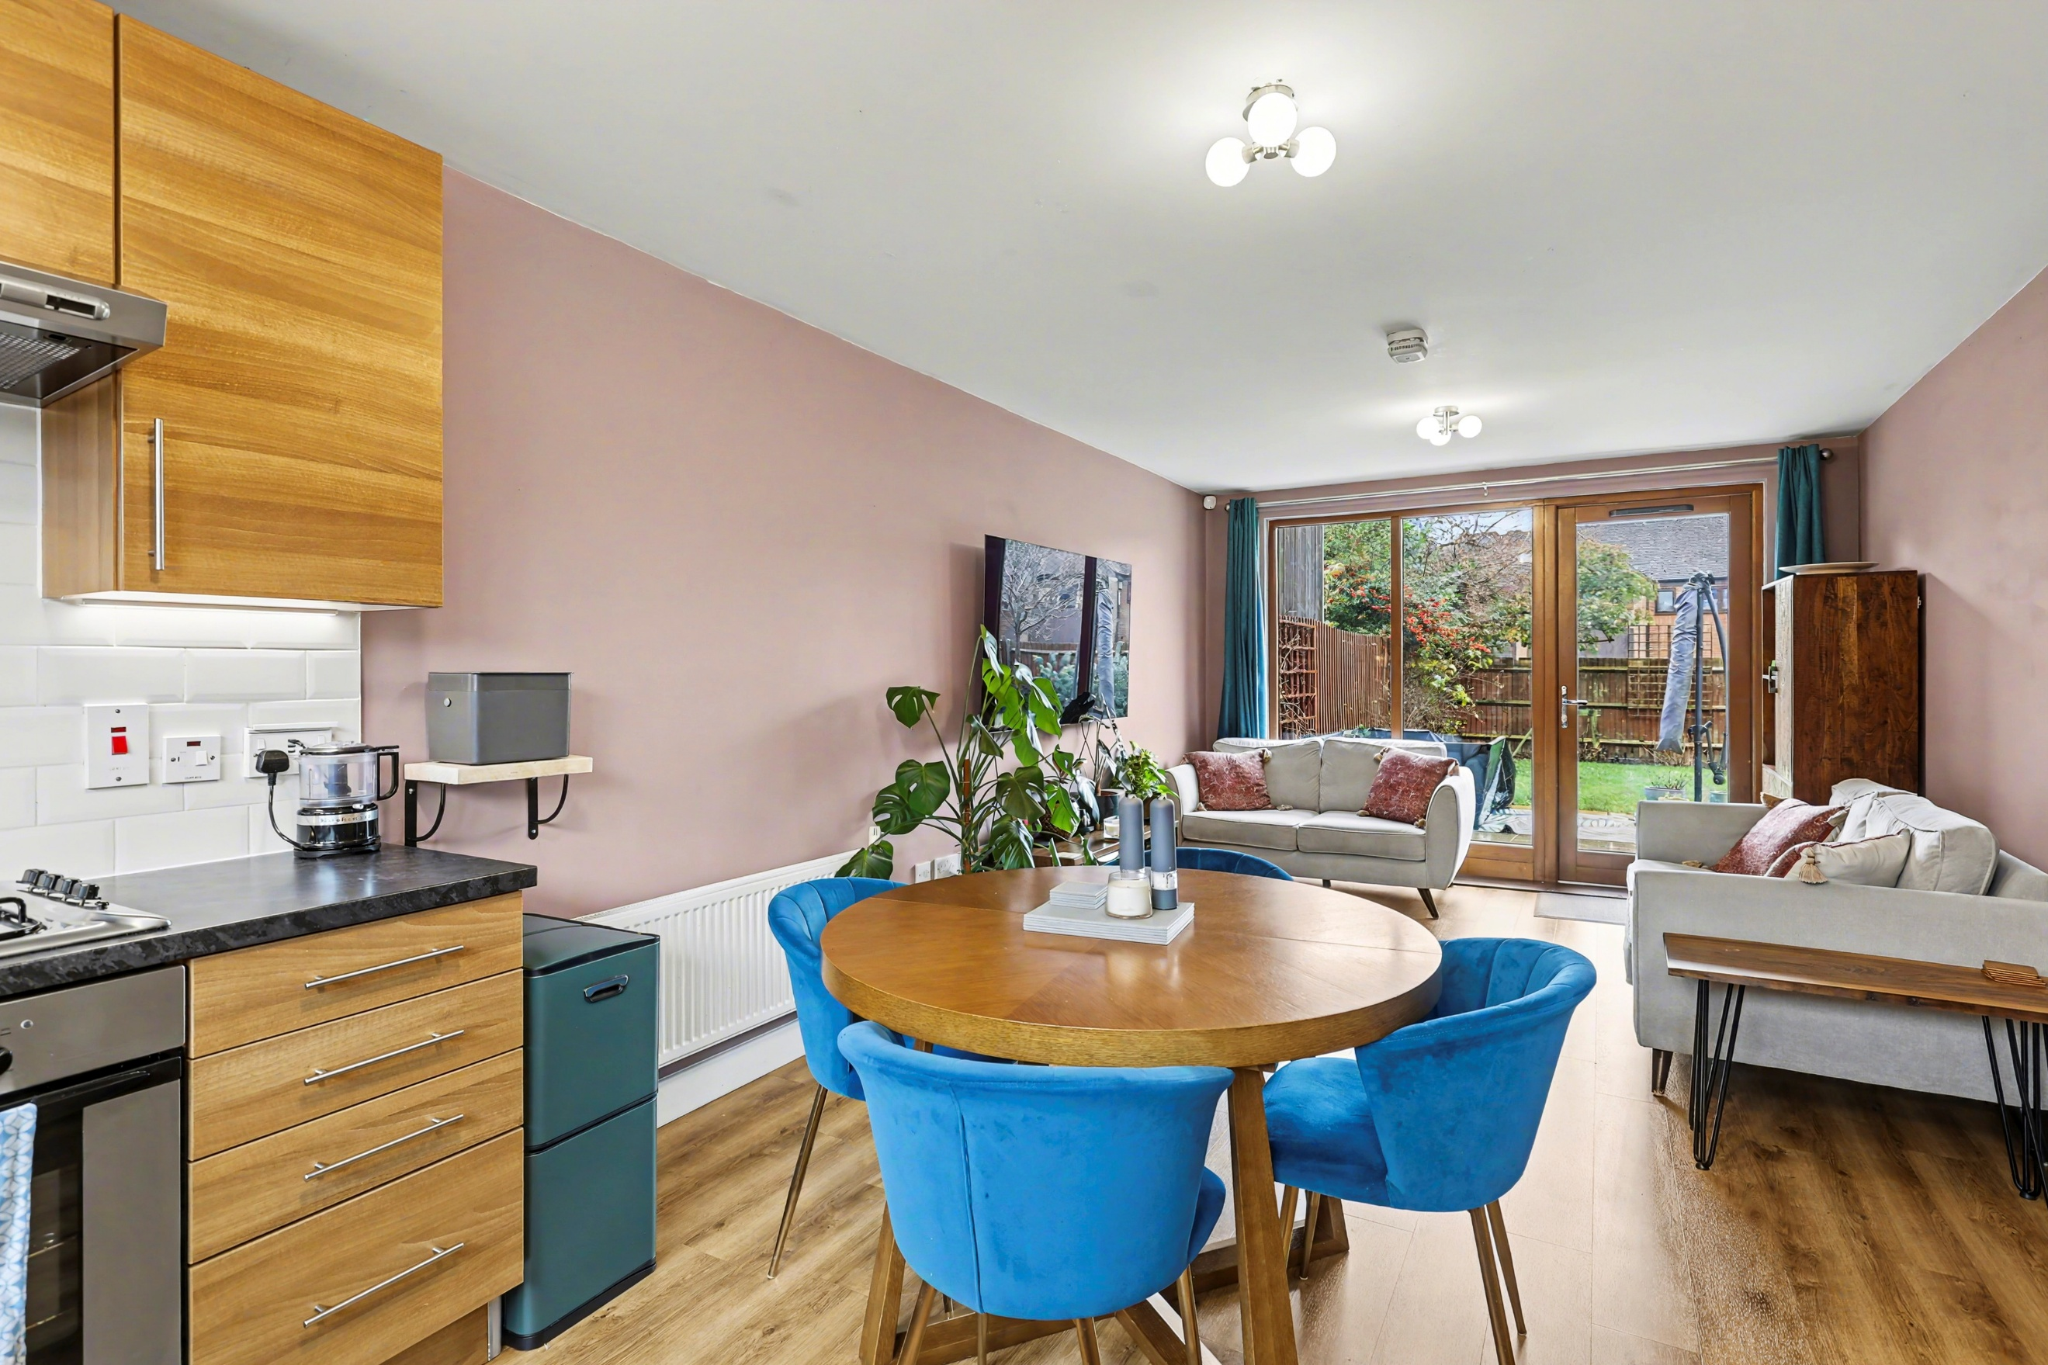
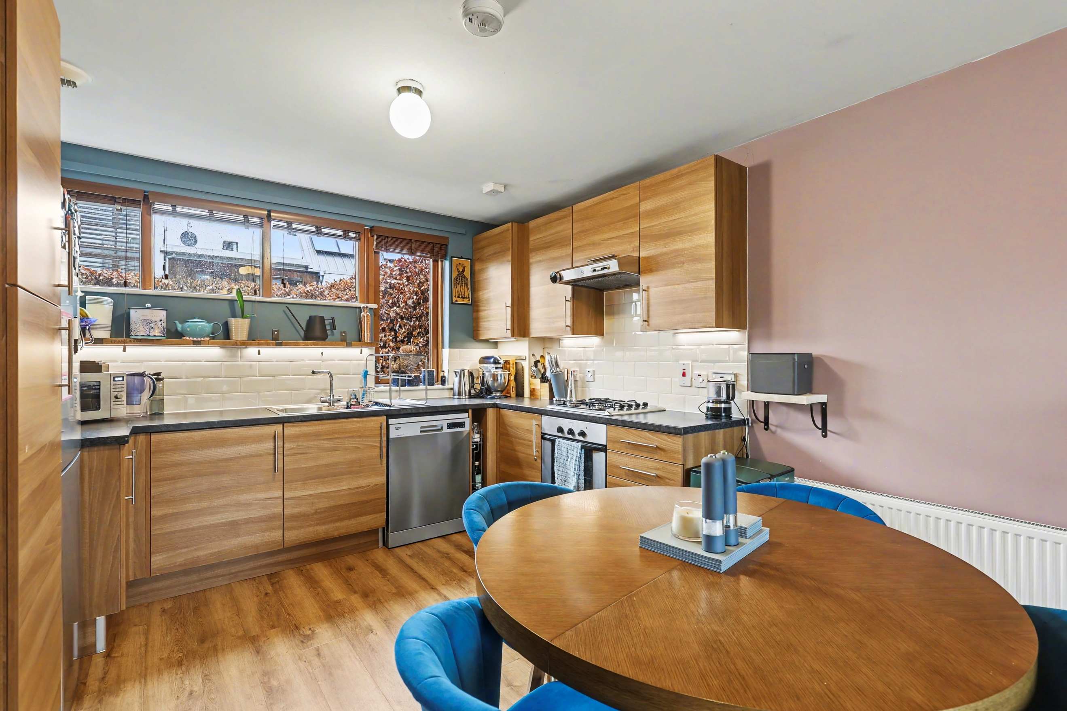
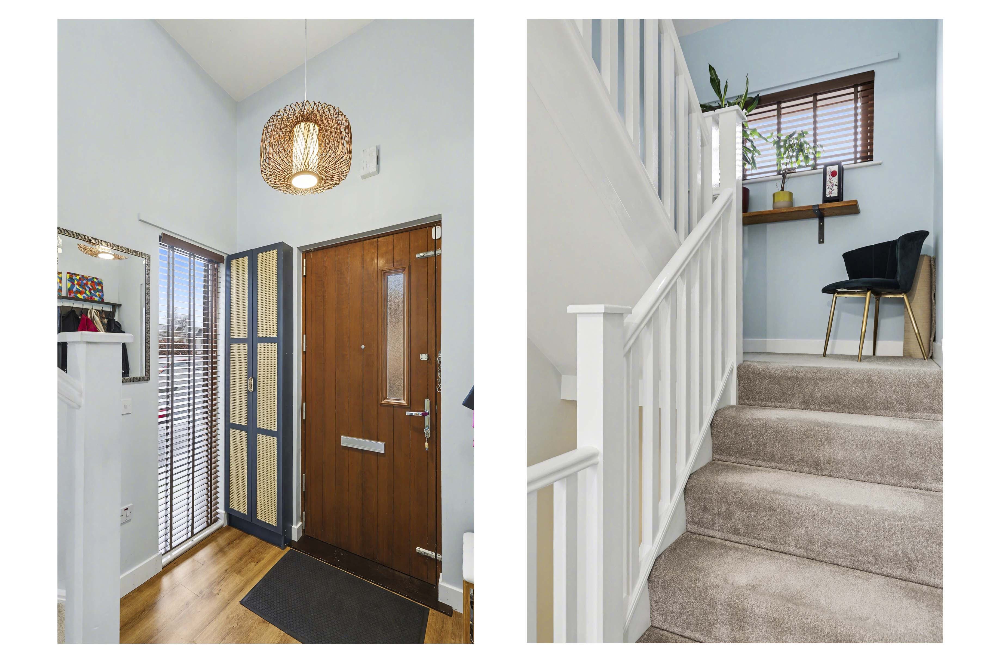
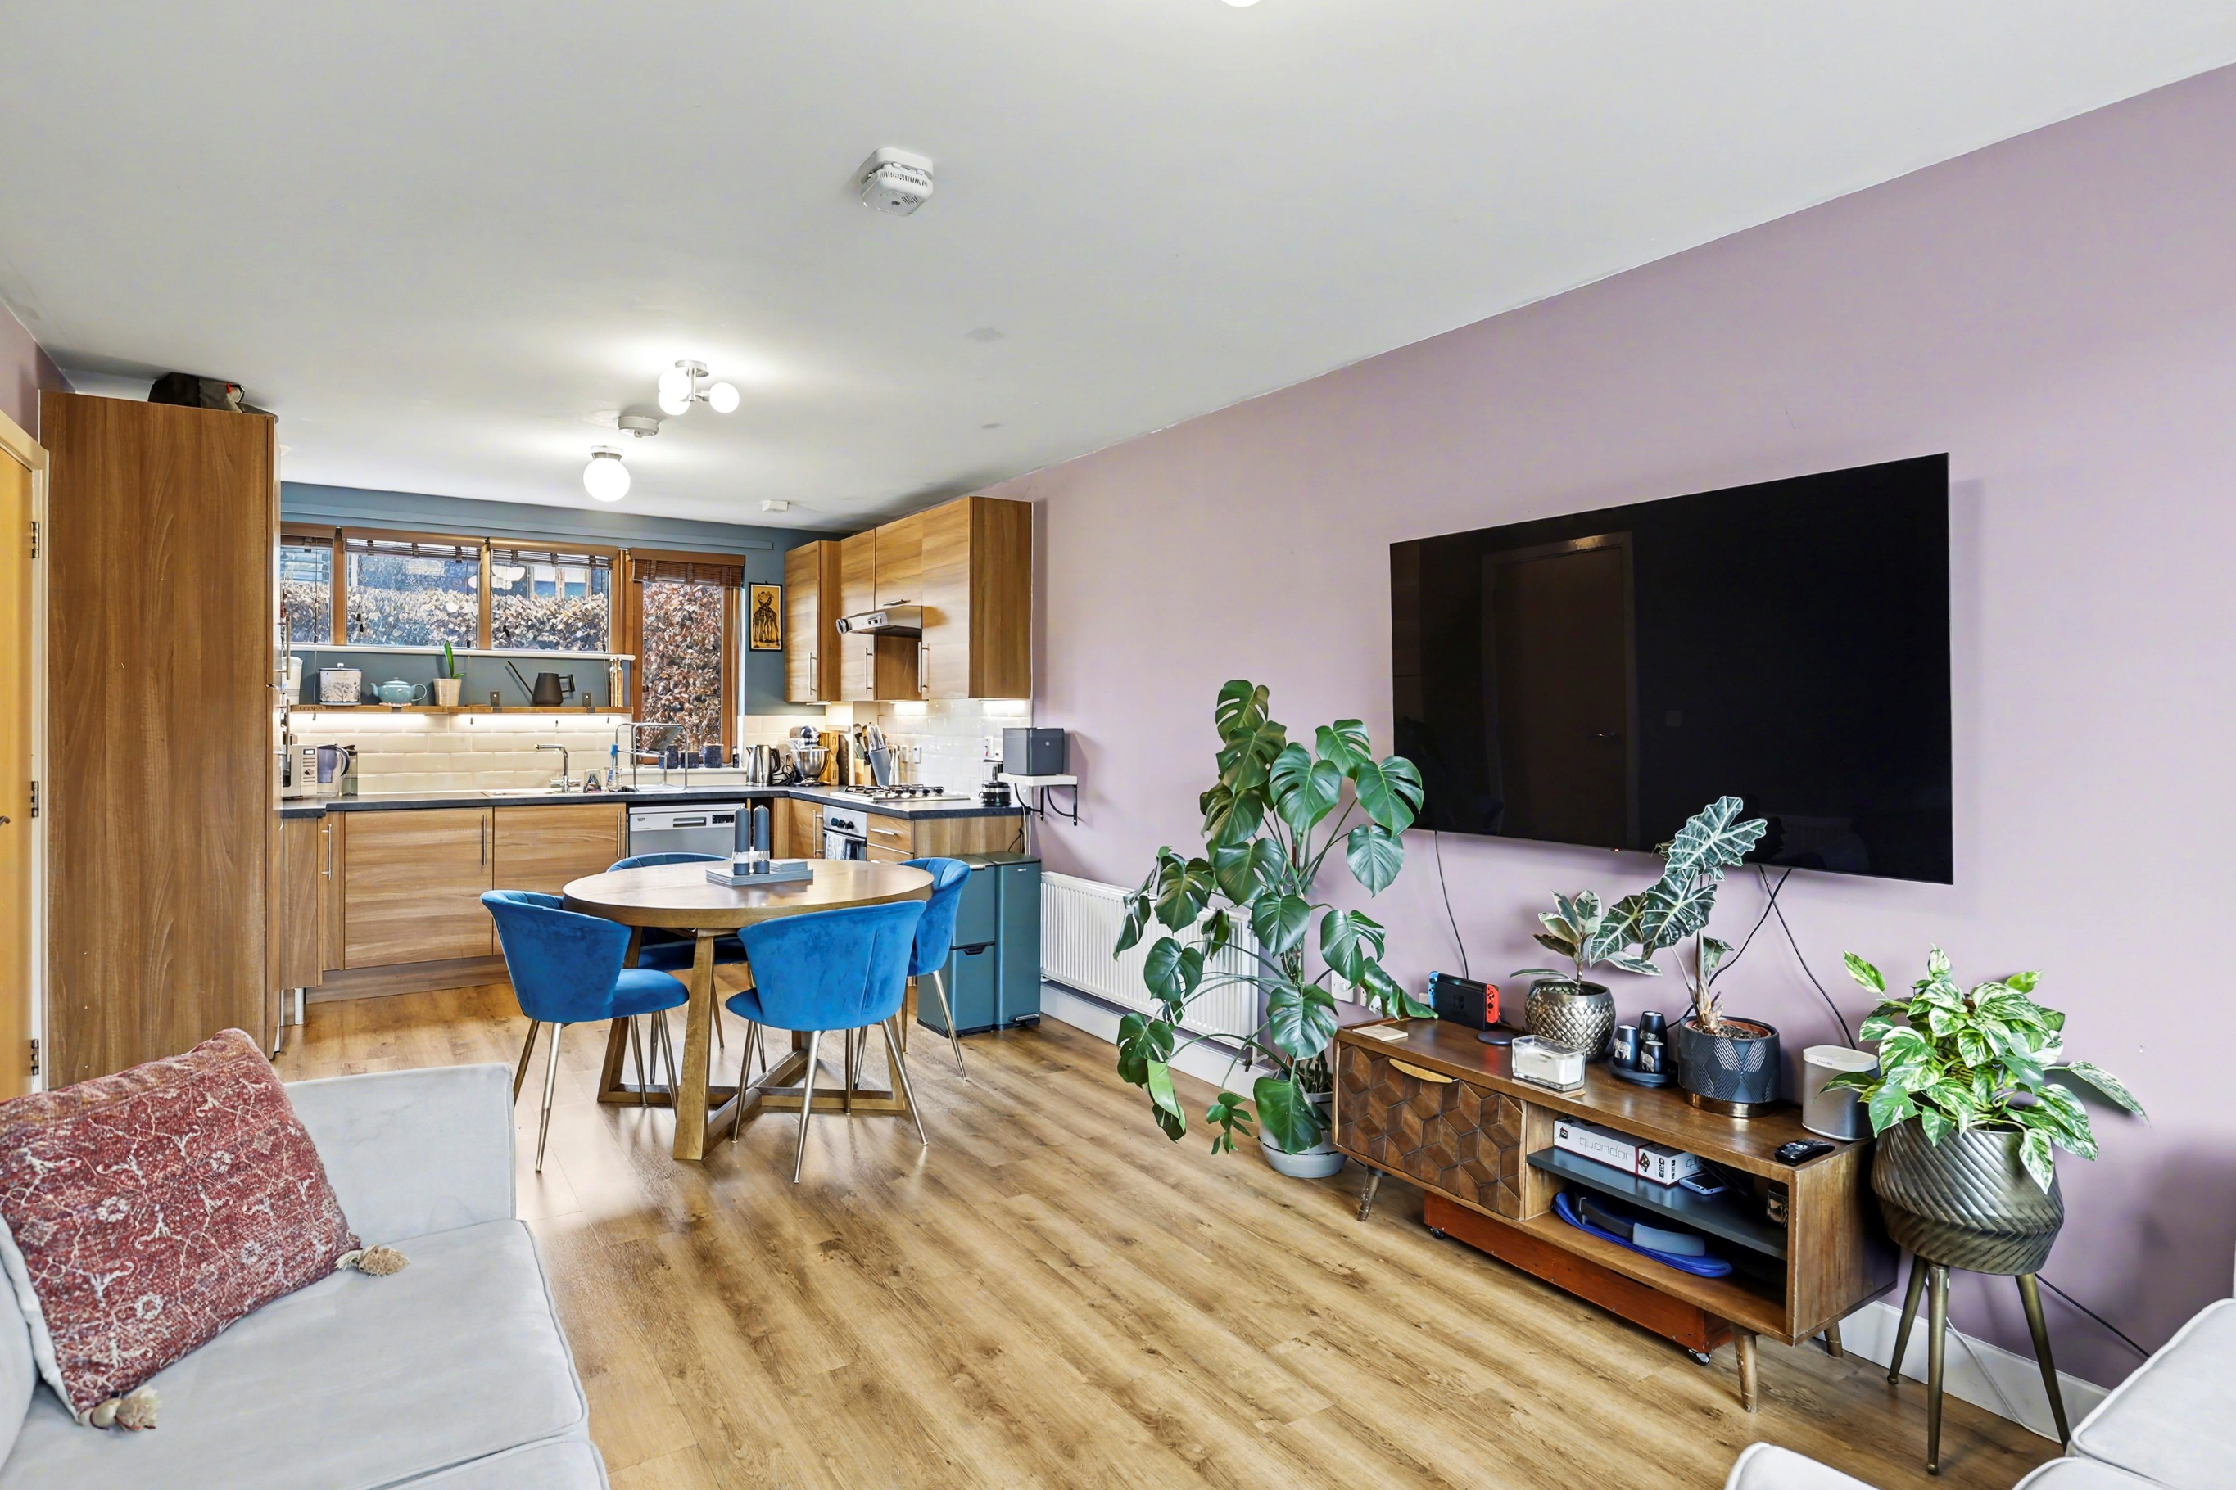
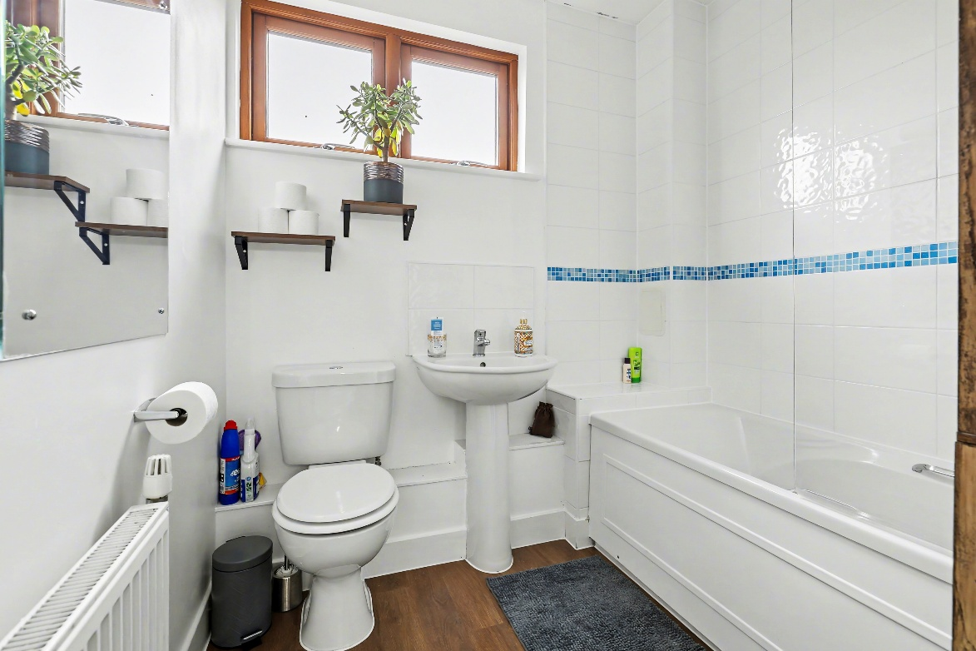
Letchworth is the world’s first ‘Garden City’, combining the best elements of town and country living according to the vision of the town’s founder, Ebenezer Howard. The area offers plenty of outdoor options including the Garden City Greenway and Norton Common’s 60 acres of grassland and woodland close to the town centre. Letchworth has treelined avenues, wide walkways, relatively uncongested roads, and a wealth of shops, coffee houses and restaurants. Letchworth train station has a regular service to King’s Cross (around 26 minutes for the fast train) and London Bridge. There are also rail services to Cambridge and the North via Peterborough. By road, Letchworth is just off the A1 Junctions 9 and 10, and approximately 22 minutes from Junction 23 of the M25. The M1 North can be accessed via the A507.
About Letchworth

Offering spacious accommodation throughout, this semi-detached eco-home has a really bright, clean feel throughout, with a practical entrance hallway that gives you space for coats and shoes before leading you into the main living areas. There’s a useful ground floor cloakroom/WC for day-to-day convenience, and the overall layout is well thought out for modern family life.
The heart of the home is the generous open plan kitchen/living/dining space. The kitchen area feels contemporary and sociable, with plenty of cupboard and worktop space and room to cook without feeling shut away from everyone else, while the living and dining zones flow nicely for everyday use and entertaining. Large windows and doors bring in lots of natural light and create a good connection to the outside, making the space feel airy and welcoming.
Up on the first floor, there are two well-proportioned bedrooms which would suit children, guests or working from home, along with a smart family bathroom finished in a modern style. One of the real highlights is the balcony on this level, a lovely spot for a morning coffee or some fresh air, and it adds that little bit of “something special” you don’t always get with a typical semi.
The top floor is set up as a more private main bedroom suite, giving you a proper retreat away from the busier parts of the house, with a sleek shower room nearby and access to additional balcony space. It’s an ideal arrangement if you like the idea of a principal bedroom that feels separate, or if you have guests staying and want everyone to have their own space.
Practicality is covered too, with an adjoining garage that’s great for storage, bikes and outdoor kit, or even for a home gym setup if you’d rather keep the car on the drive. As an eco-home, the property also benefits from improved energy efficiency and reduced running costs, while keeping the overall look and finish feeling modern and low maintenance.

Step Inside

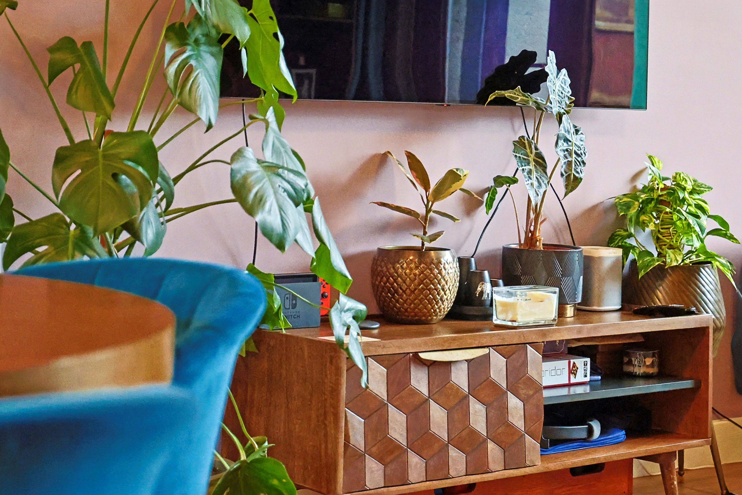
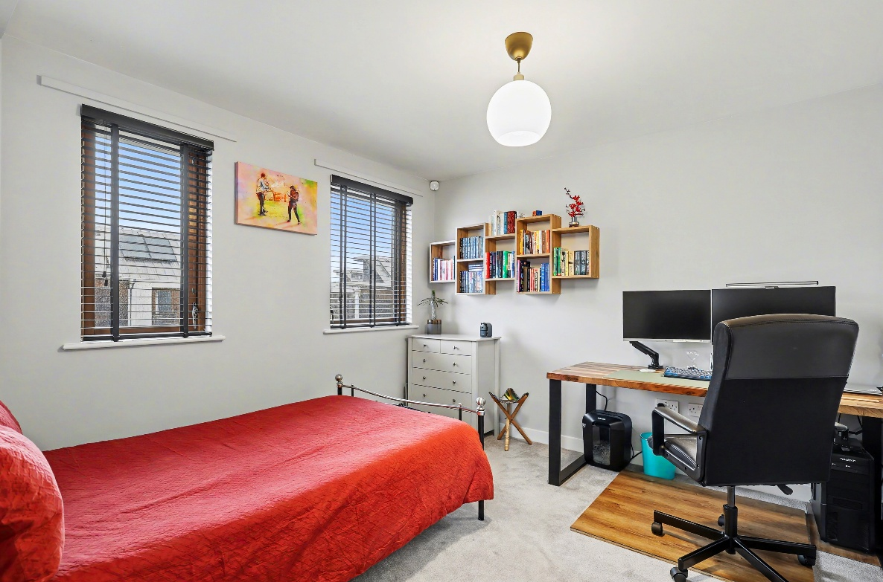
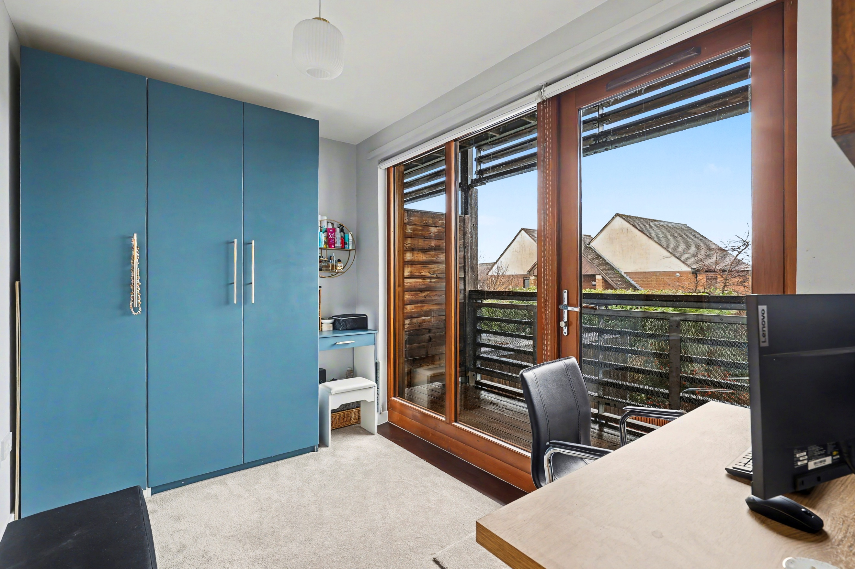
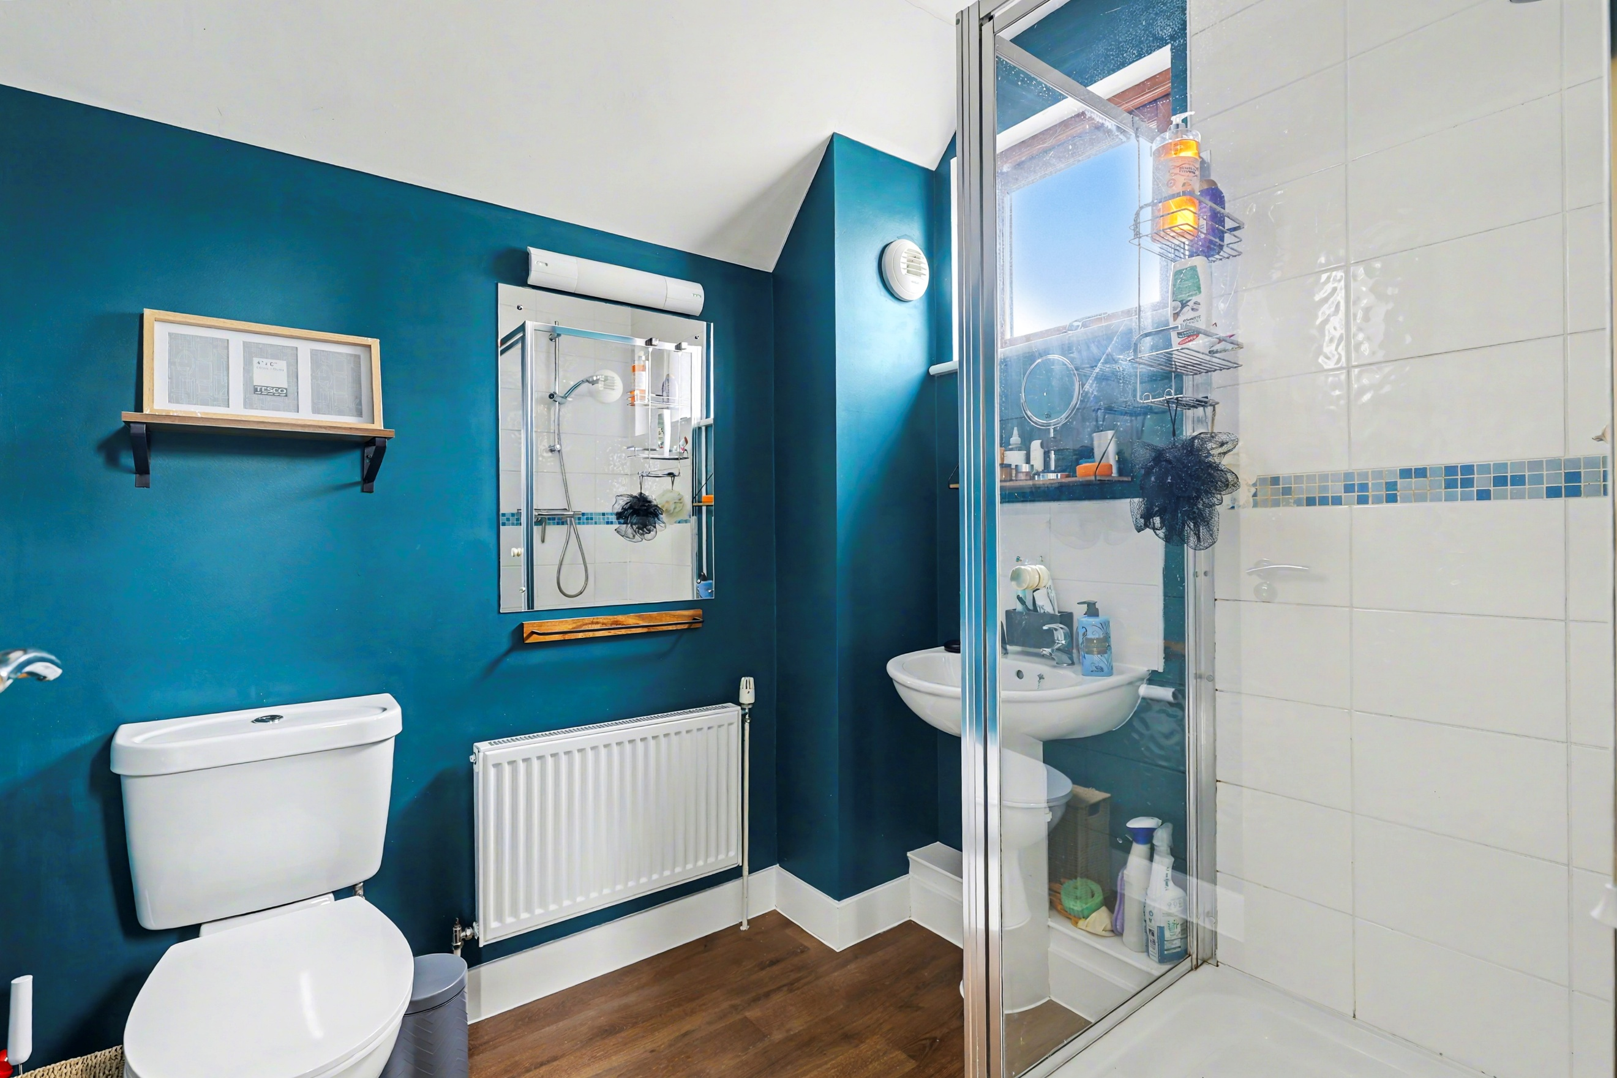
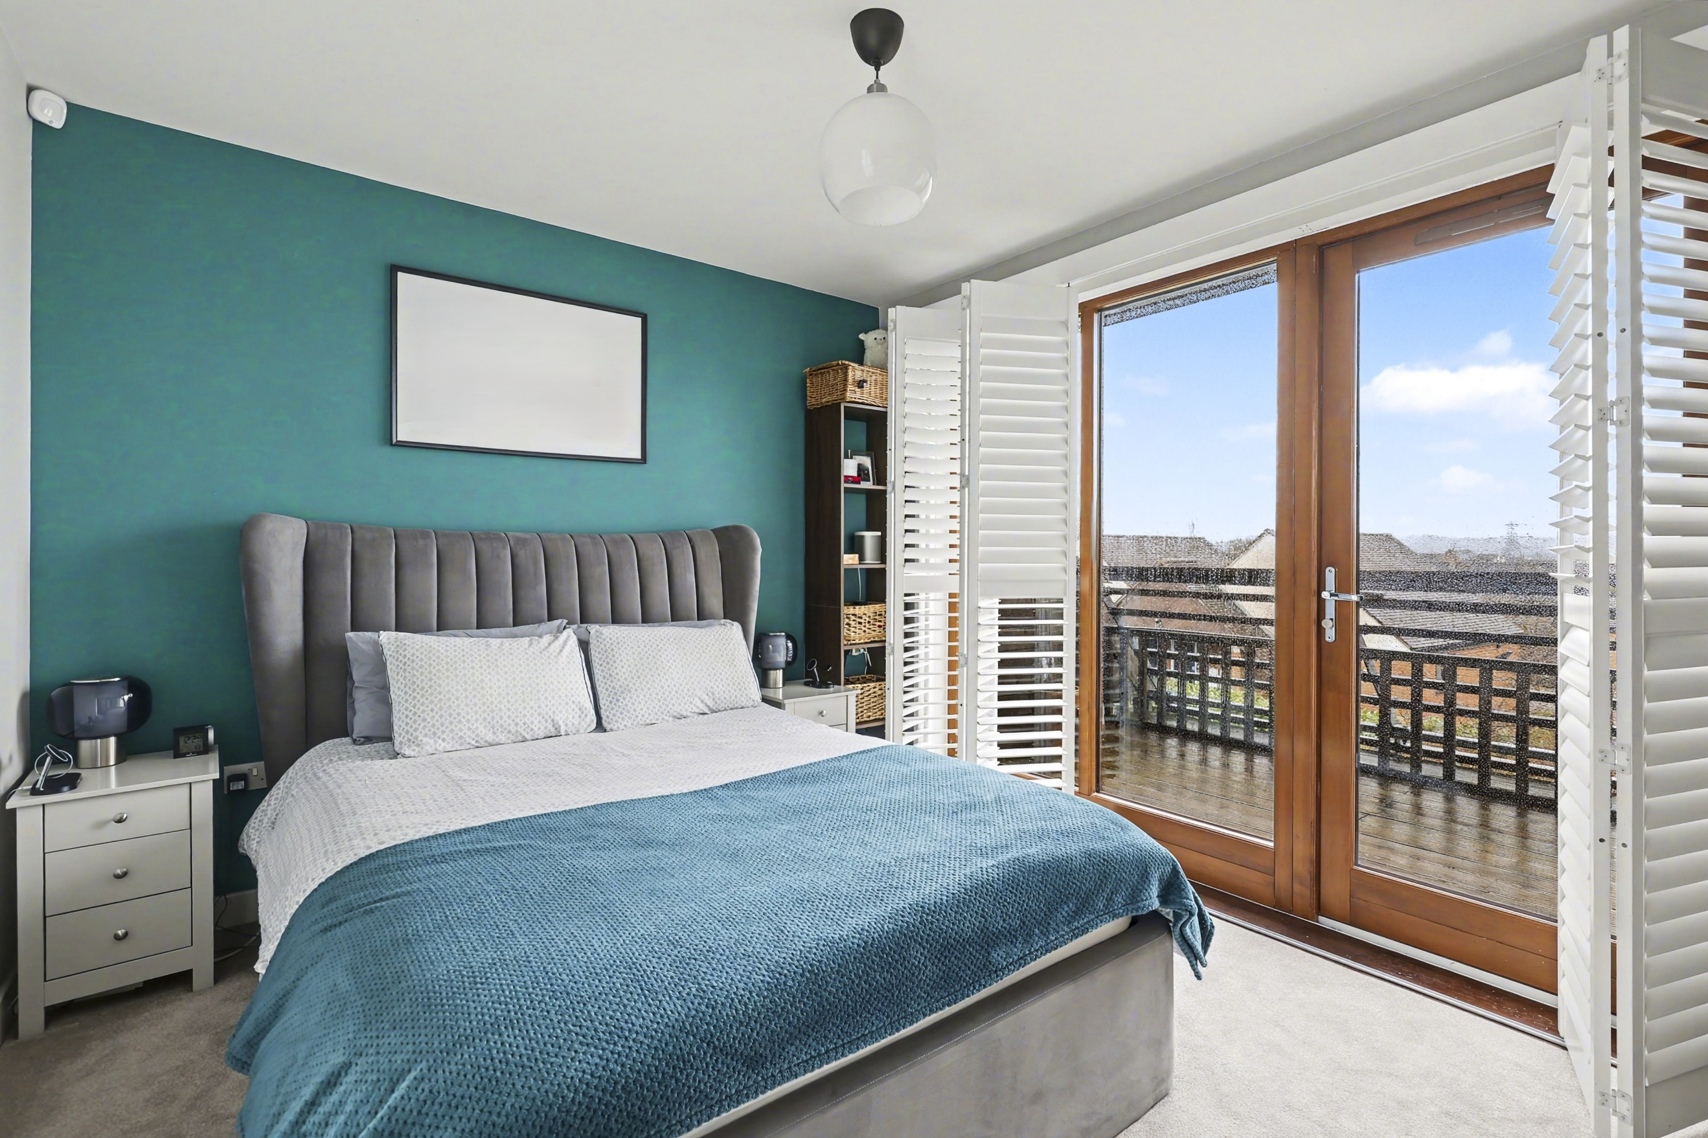
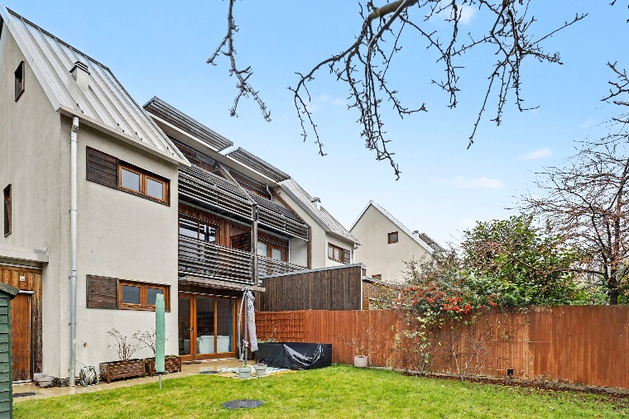
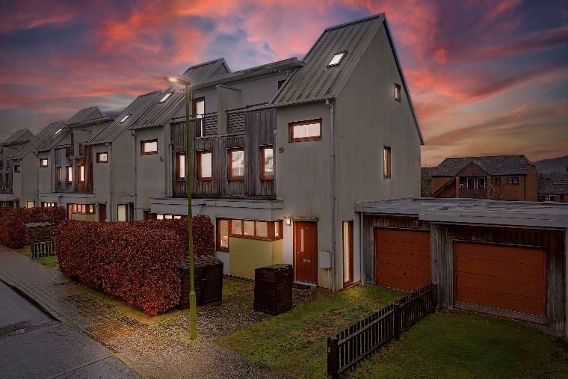
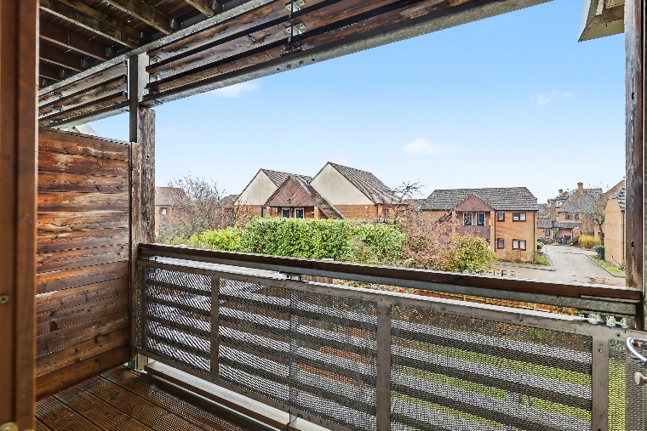
Outside, this striking modern eco-home has a really smart, contemporary look, with a mix of clean rendered elevations, timber-style detailing and a crisp metal roofline that gives the property a distinctive, architectural feel. The design makes the most of natural light too, with plenty of glazing and attractive balcony areas that add both character and usable outdoor space.
To the rear, there’s a fully enclosed garden that’s mainly laid to lawn, making it ideal for children, pets or simply keeping things low maintenance. A paved patio area sits neatly by the house, perfect for a bistro set or summer barbeques, while the established boundary fencing provides a good degree of privacy. Practical touches such as outside storage space and room for pots and planting make it easy to personalise without it feeling like a big gardening job.
At the front, the property is set back with an integral garage and a tidy approach, sitting within a modern development of similar eco-minded homes, giving a cohesive and well-kept feel from the roadside.

Step Outside

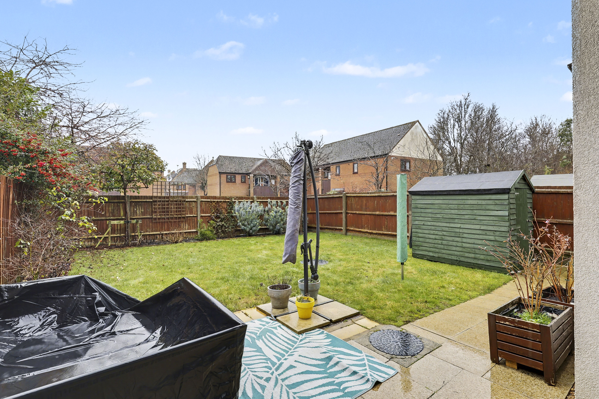

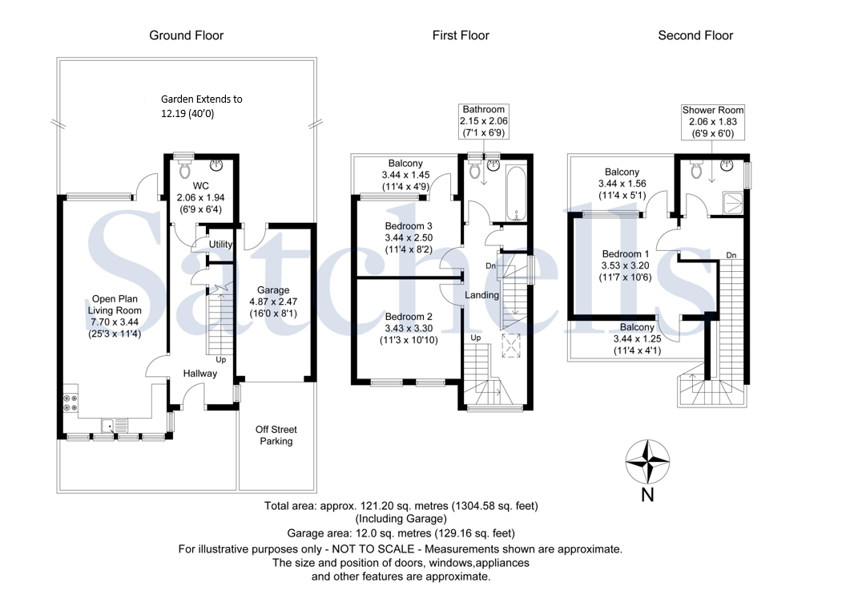

These particulars are a guide only and do not constitute an offer or a contract. The floorplan is for identification purposes only and not to scale. All measurements are approximate and should not be relied upon if ordering furniture, white goods and flooring etc. We have presented the property as we feel fairly describes it but before arranging a viewing or deciding to buy, should there be anything specific you would like to know about the property please enquire. Satchells have not tested any of the appliances or carried out any form of survey and advise you to carry out your own investigations on the state, condition, structure, services, title, tenure, and council tax band of the property. Some images may have been enhanced and the contents shown may not be included in the sale. Satchells routinely refer to 3rd party services for which we receive an income from their fee. If you would like us to refer you to one of these services, please ask one of our staff who will pass your details on. We advise you check the availability of the property on the day of your viewing.



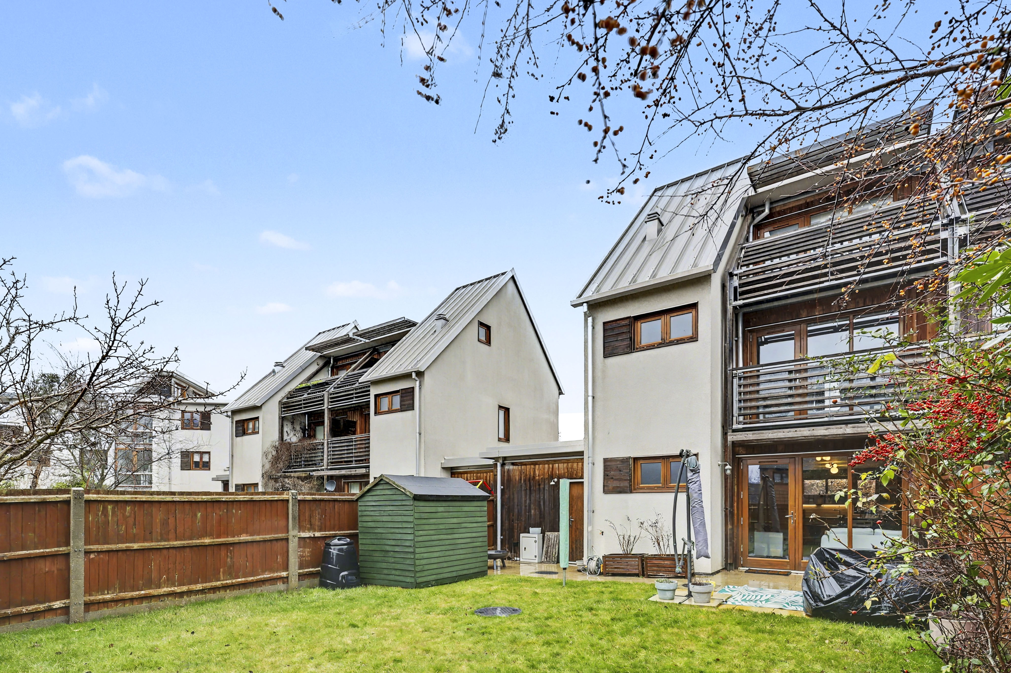
Station Place, Letchworth Garden City, Hertfordshire, SG6 3AQ.
01462 480077
letchworth@satchells.co.uk
www.satchells.com

