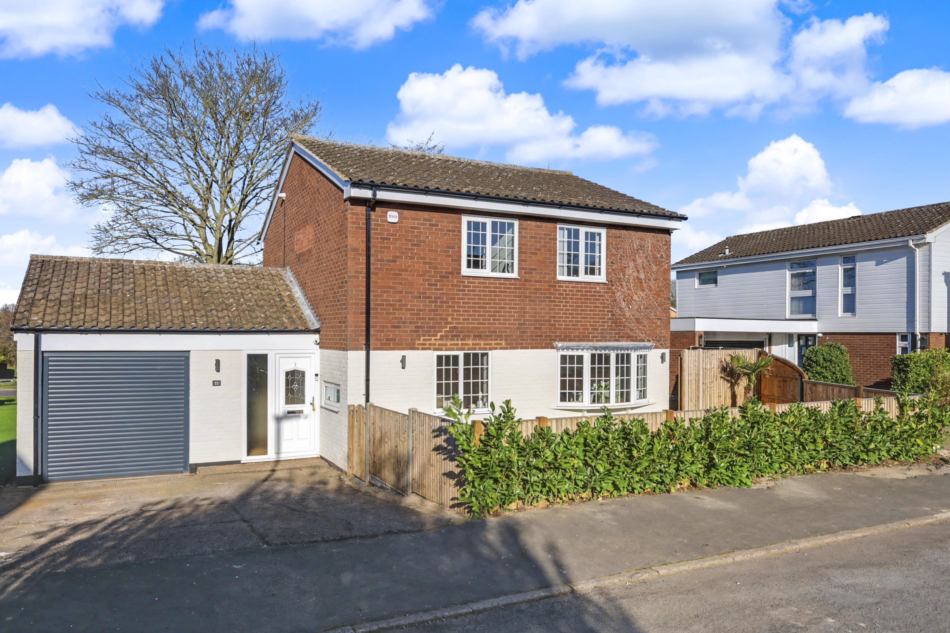
Blackmore Letchworth Garden City, Hertfordshire SG6 2SY
£699,950 Freehold

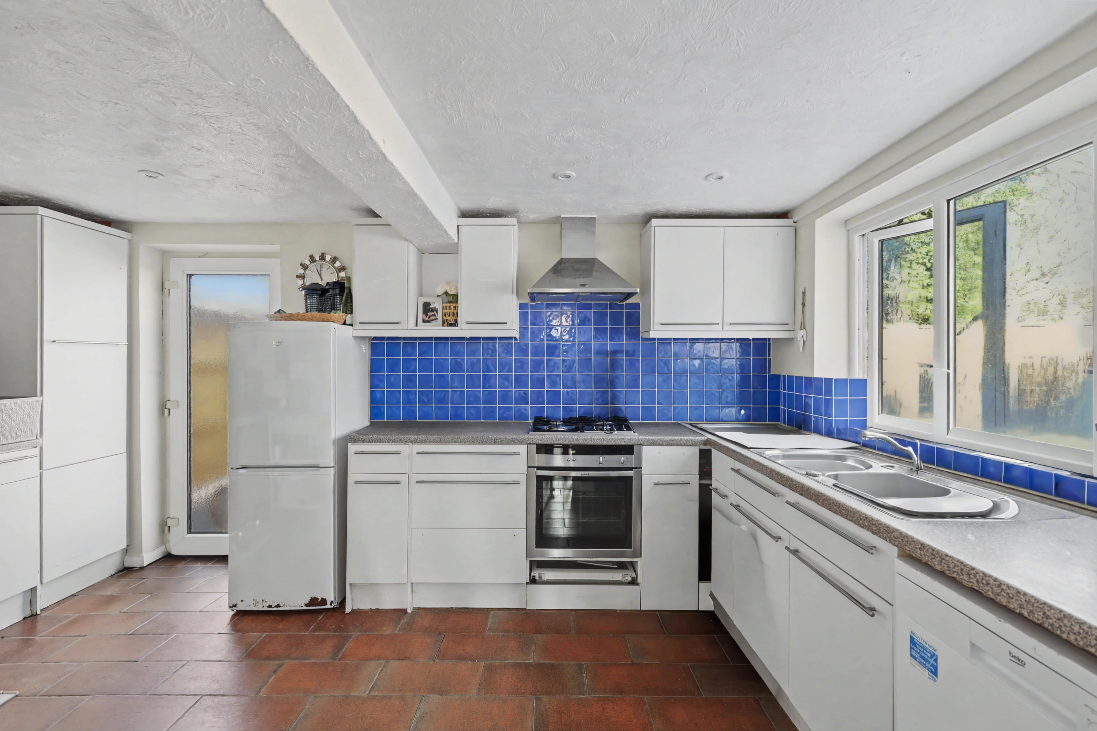
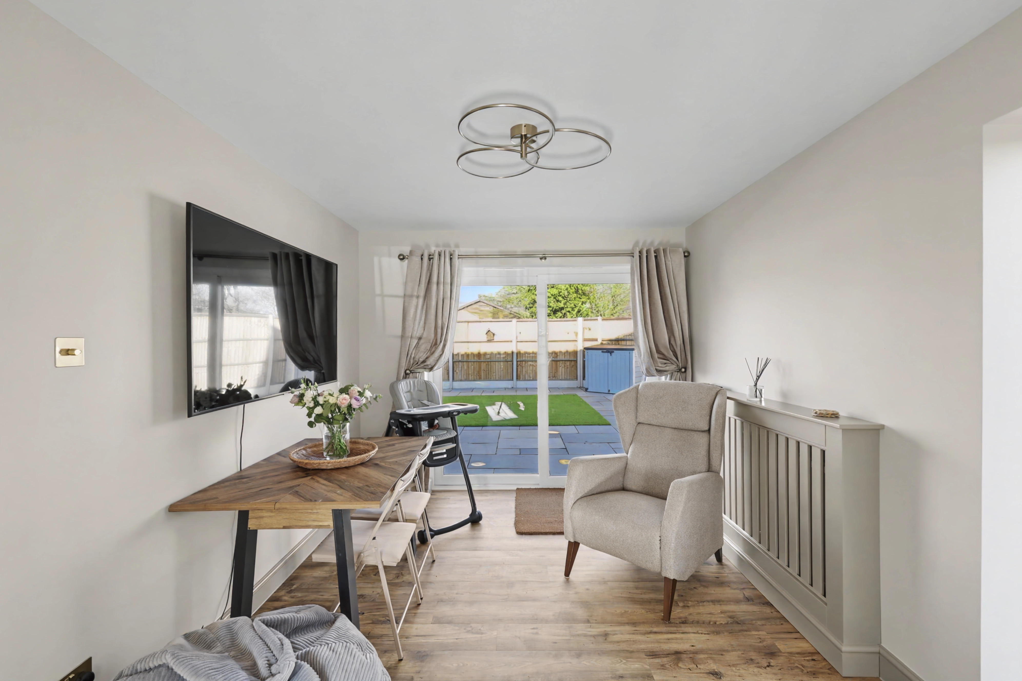
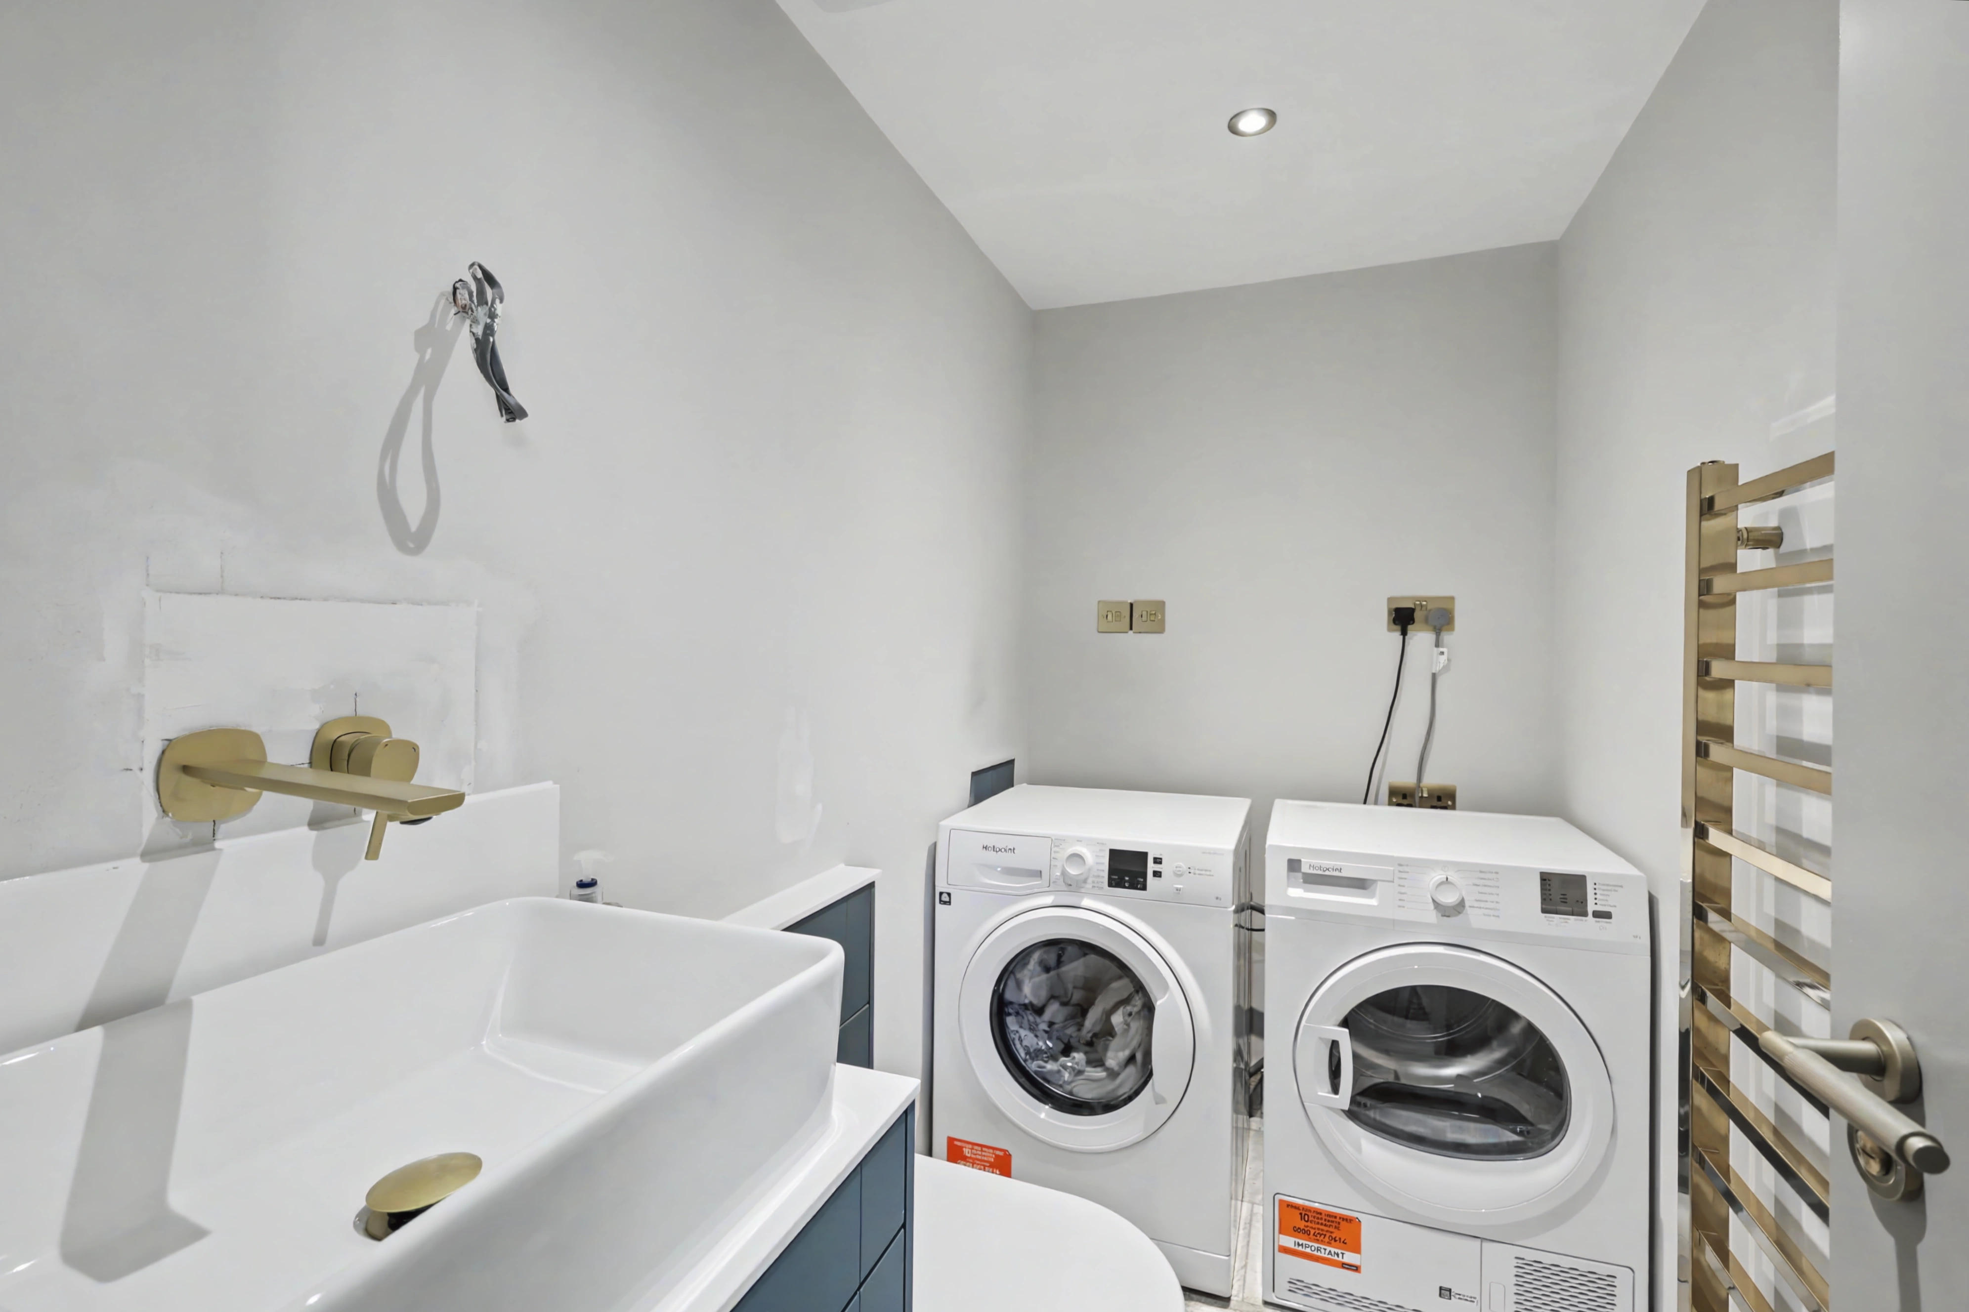
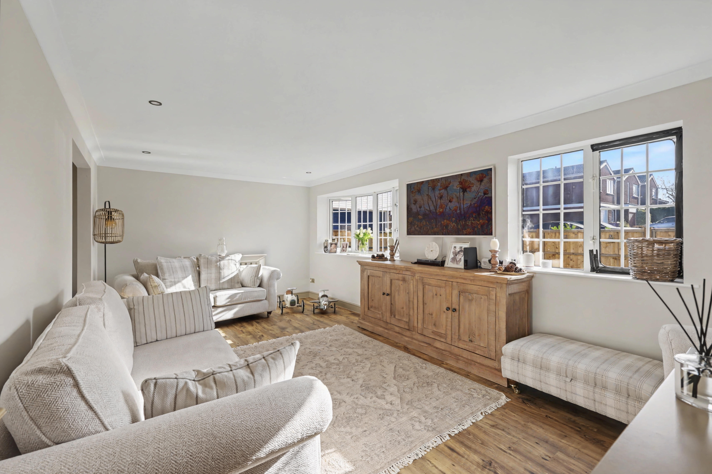
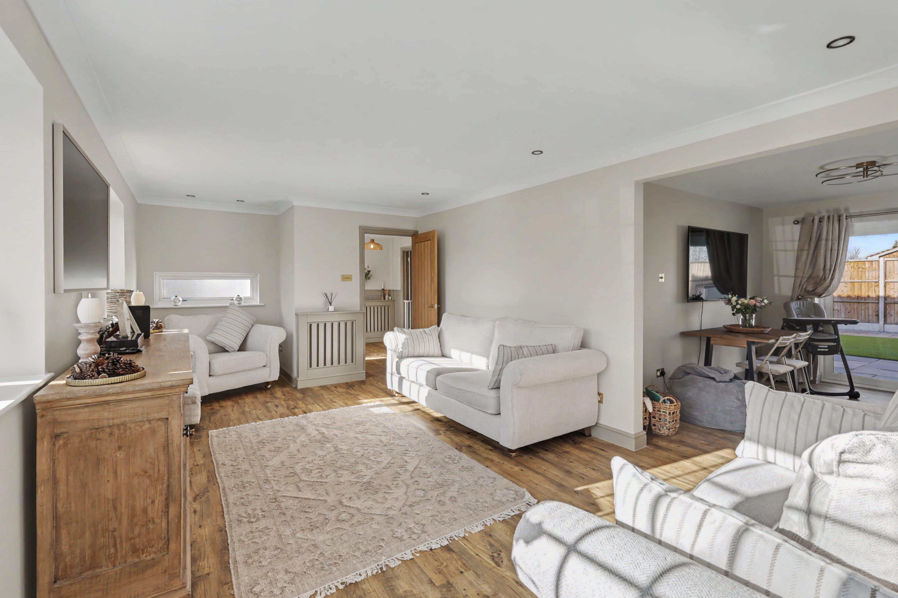
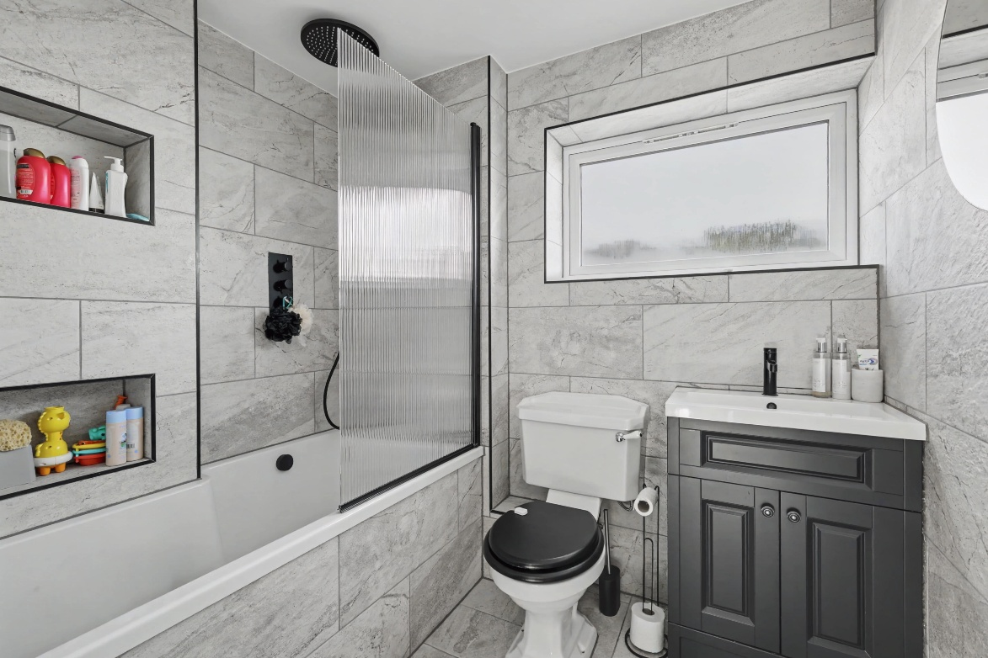
Step inside and you’re welcomed by a bright and inviting entrance hall, setting the tone for the rest of the home. The ground floor offers a spacious and well-balanced layout, with a generous lounge that provides a comfortable and modern living space, perfect for relaxing or entertaining. The separate dining room continues the contemporary feel and is ideal for both everyday meals and more formal occasions.

Much of the property has been tastefully modernised along with a re-wire, new heating and additional insulation with updated finishes that create a fresh and stylish atmosphere throughout. The hallway and cloakroom have also been improved, offering both practicality and a clean, modern look.

The kitchen/breakfast room is a good-sized space with plenty of potential, offering an excellent opportunity for a buyer to update and personalise to their own taste while the home office remains provides a flexible space that could be transformed into a study, playroom, or additional reception room depending on your needs. Further convenience is added by an internal doorway through in to the garage.

Upstairs, the property continues to impress with four well-proportioned bedrooms, all presented in a modern style. The family bathroom has also been updated, providing a sleek and functional space. The landing area connects all rooms nicely, enhancing the sense of space and flow.

Overall, this is a home that combines modern living with exciting potential in key areas, allowing a new owner to add their own stamp while enjoying the benefits of an already updated interior.

About Letchworth

The Lordship estate is one of Letchworth Garden City’s most desirable residential areas, known for its peaceful surroundings, attractive tree-lined streets, and family-friendly atmosphere. Located within easy reach of the town centre, it offers convenient access to a range of amenities including shops, the well sought after ‘Lordship Farm’ school, parks, and transport links, with Letchworth train station providing direct services to London and Cambridge.

The area is particularly popular with families and professionals alike, thanks to its blend of well-established homes, green open spaces, and a strong sense of community. Lordship strikes the perfect balance between tranquil suburban living and accessibility, making it a highly sought-after location within the town. Ideally situated, the estate is within easy reach of the charming village of Willian, a picturesque setting that offers two highly regarded pubs, a traditional village green, a beautiful church, and scenic countryside walks.

Step Inside

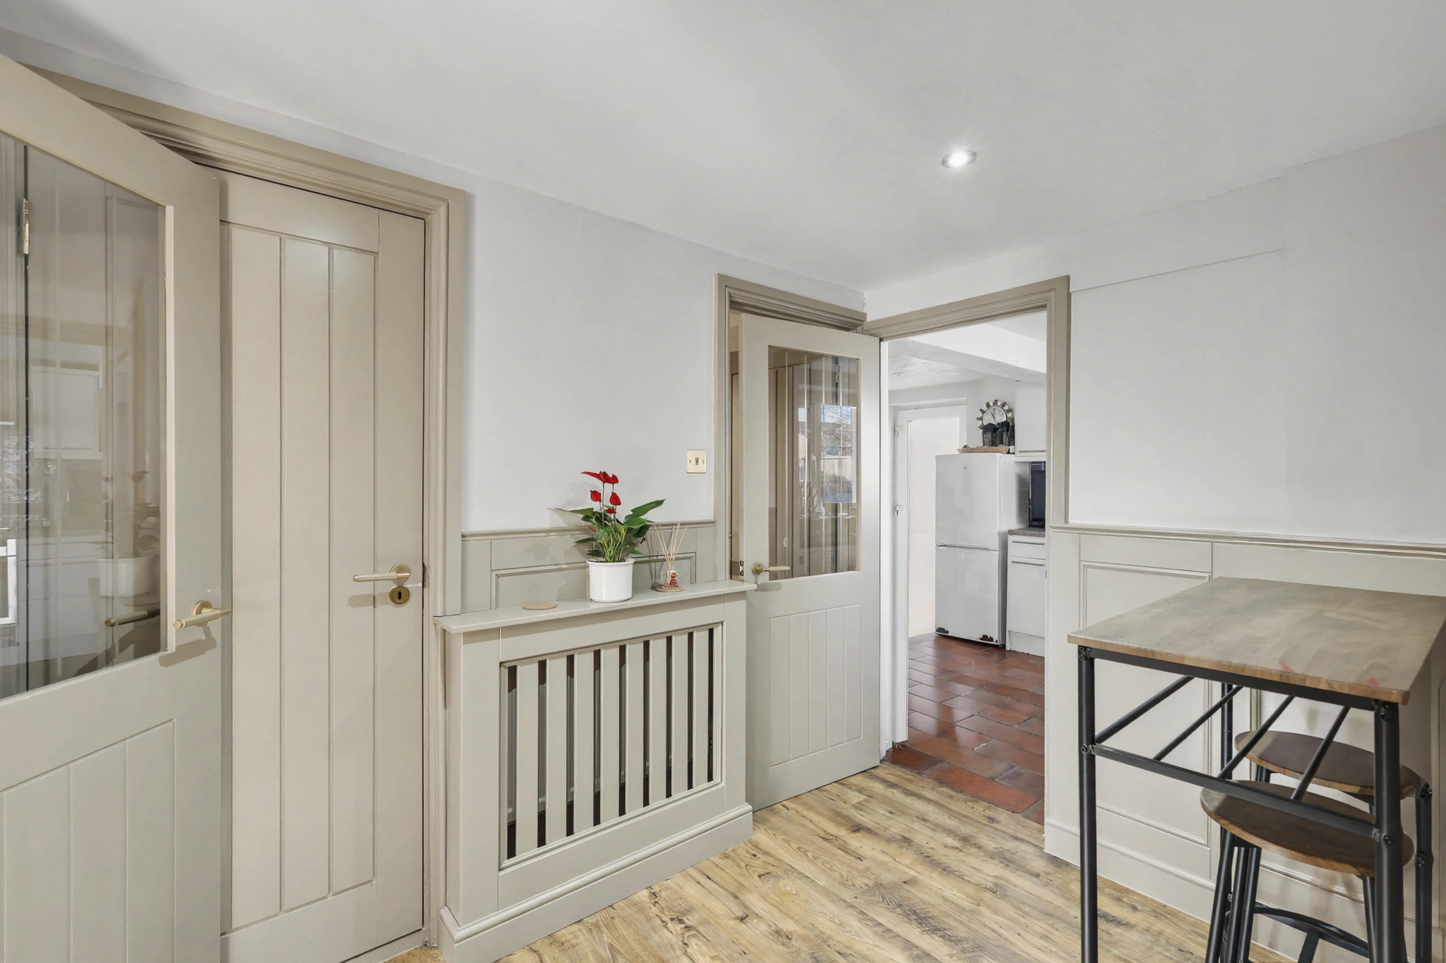
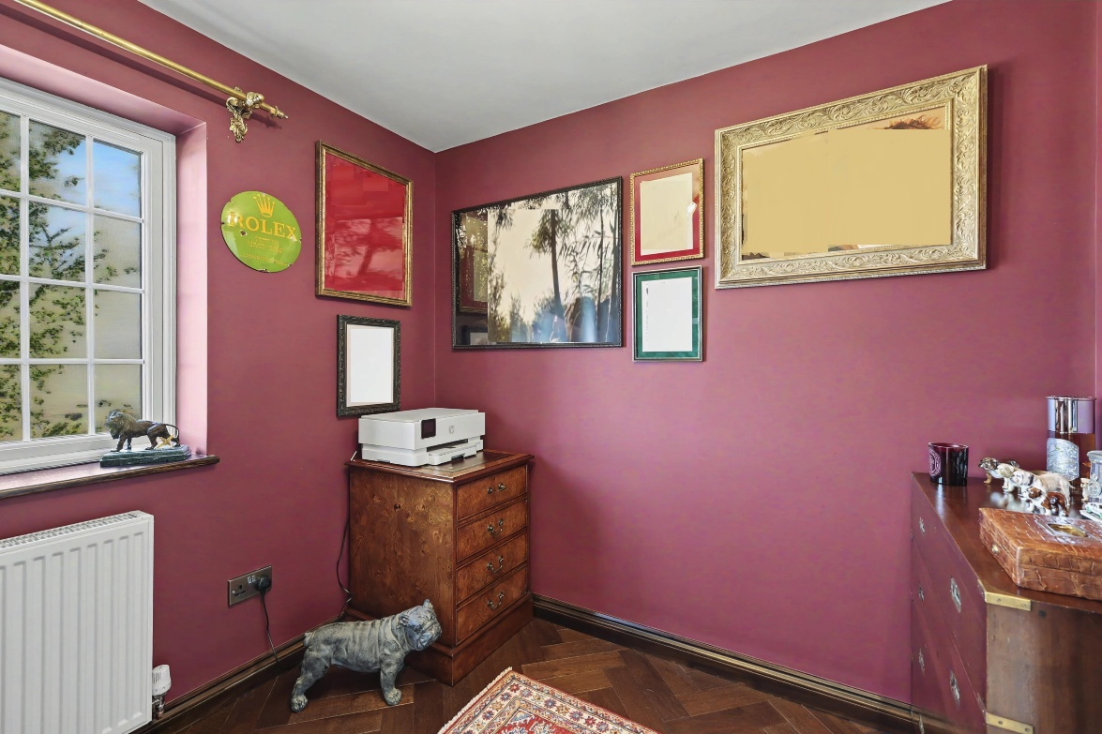
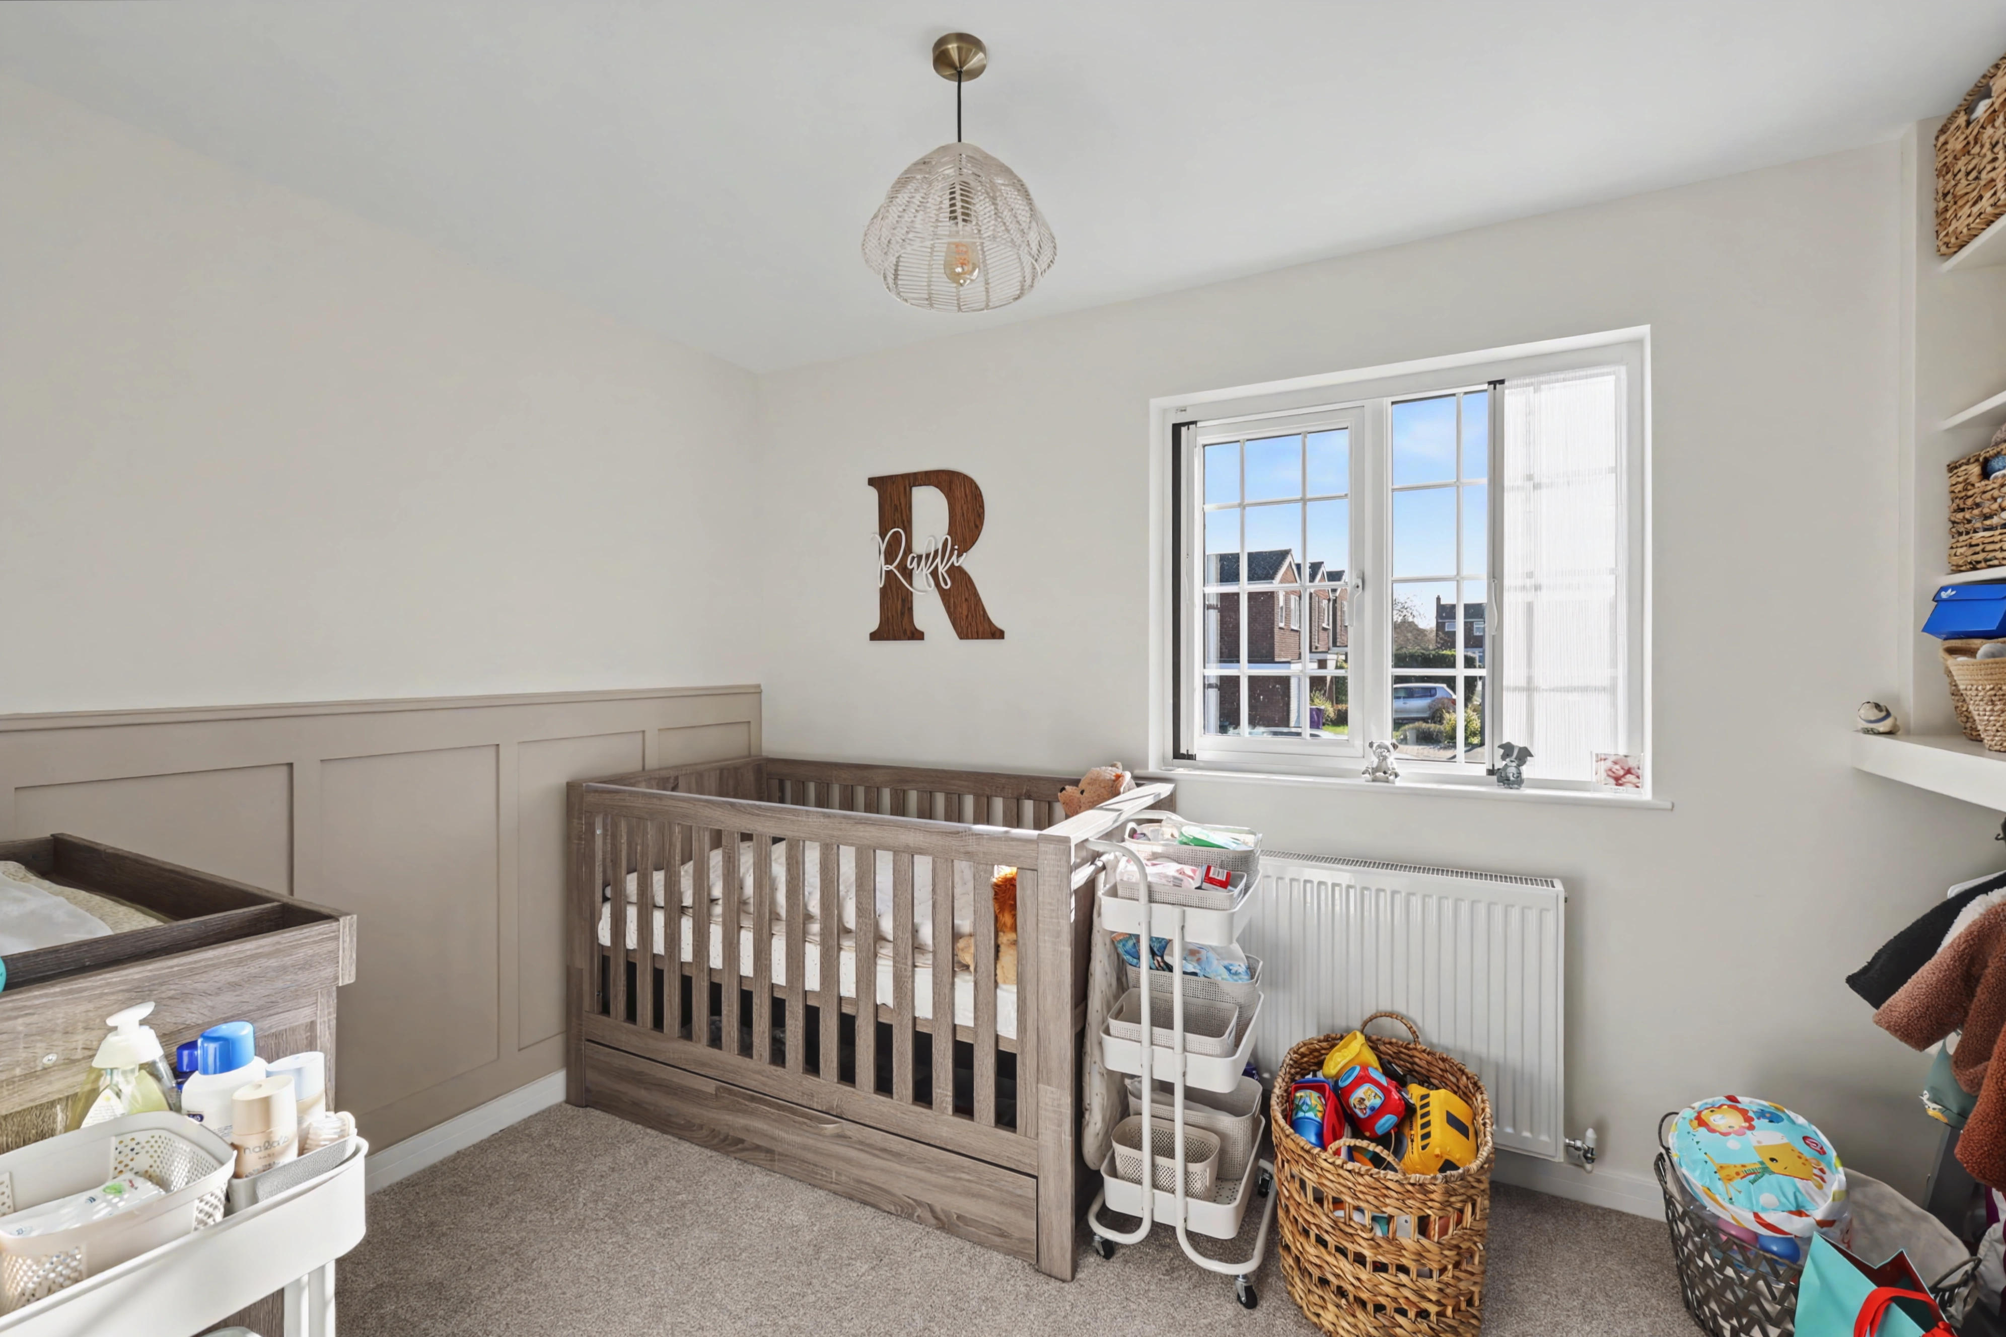
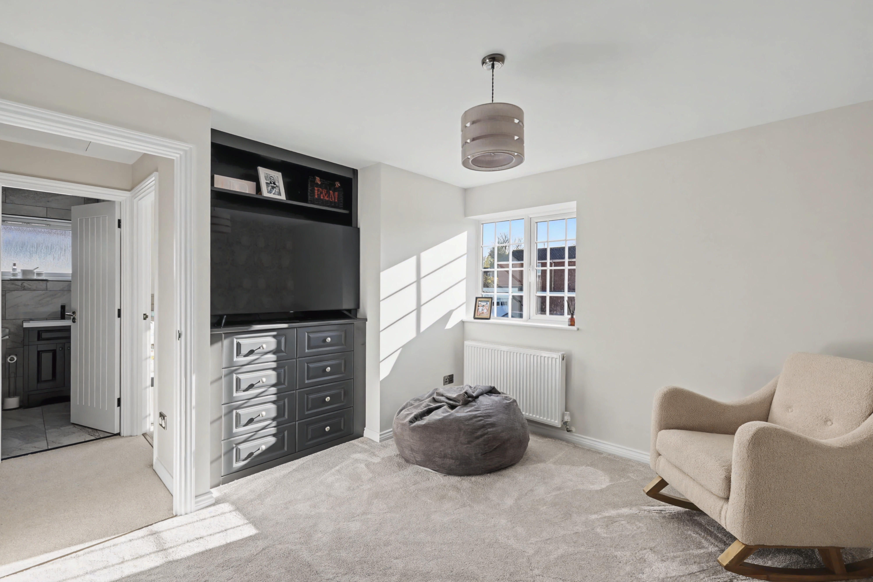
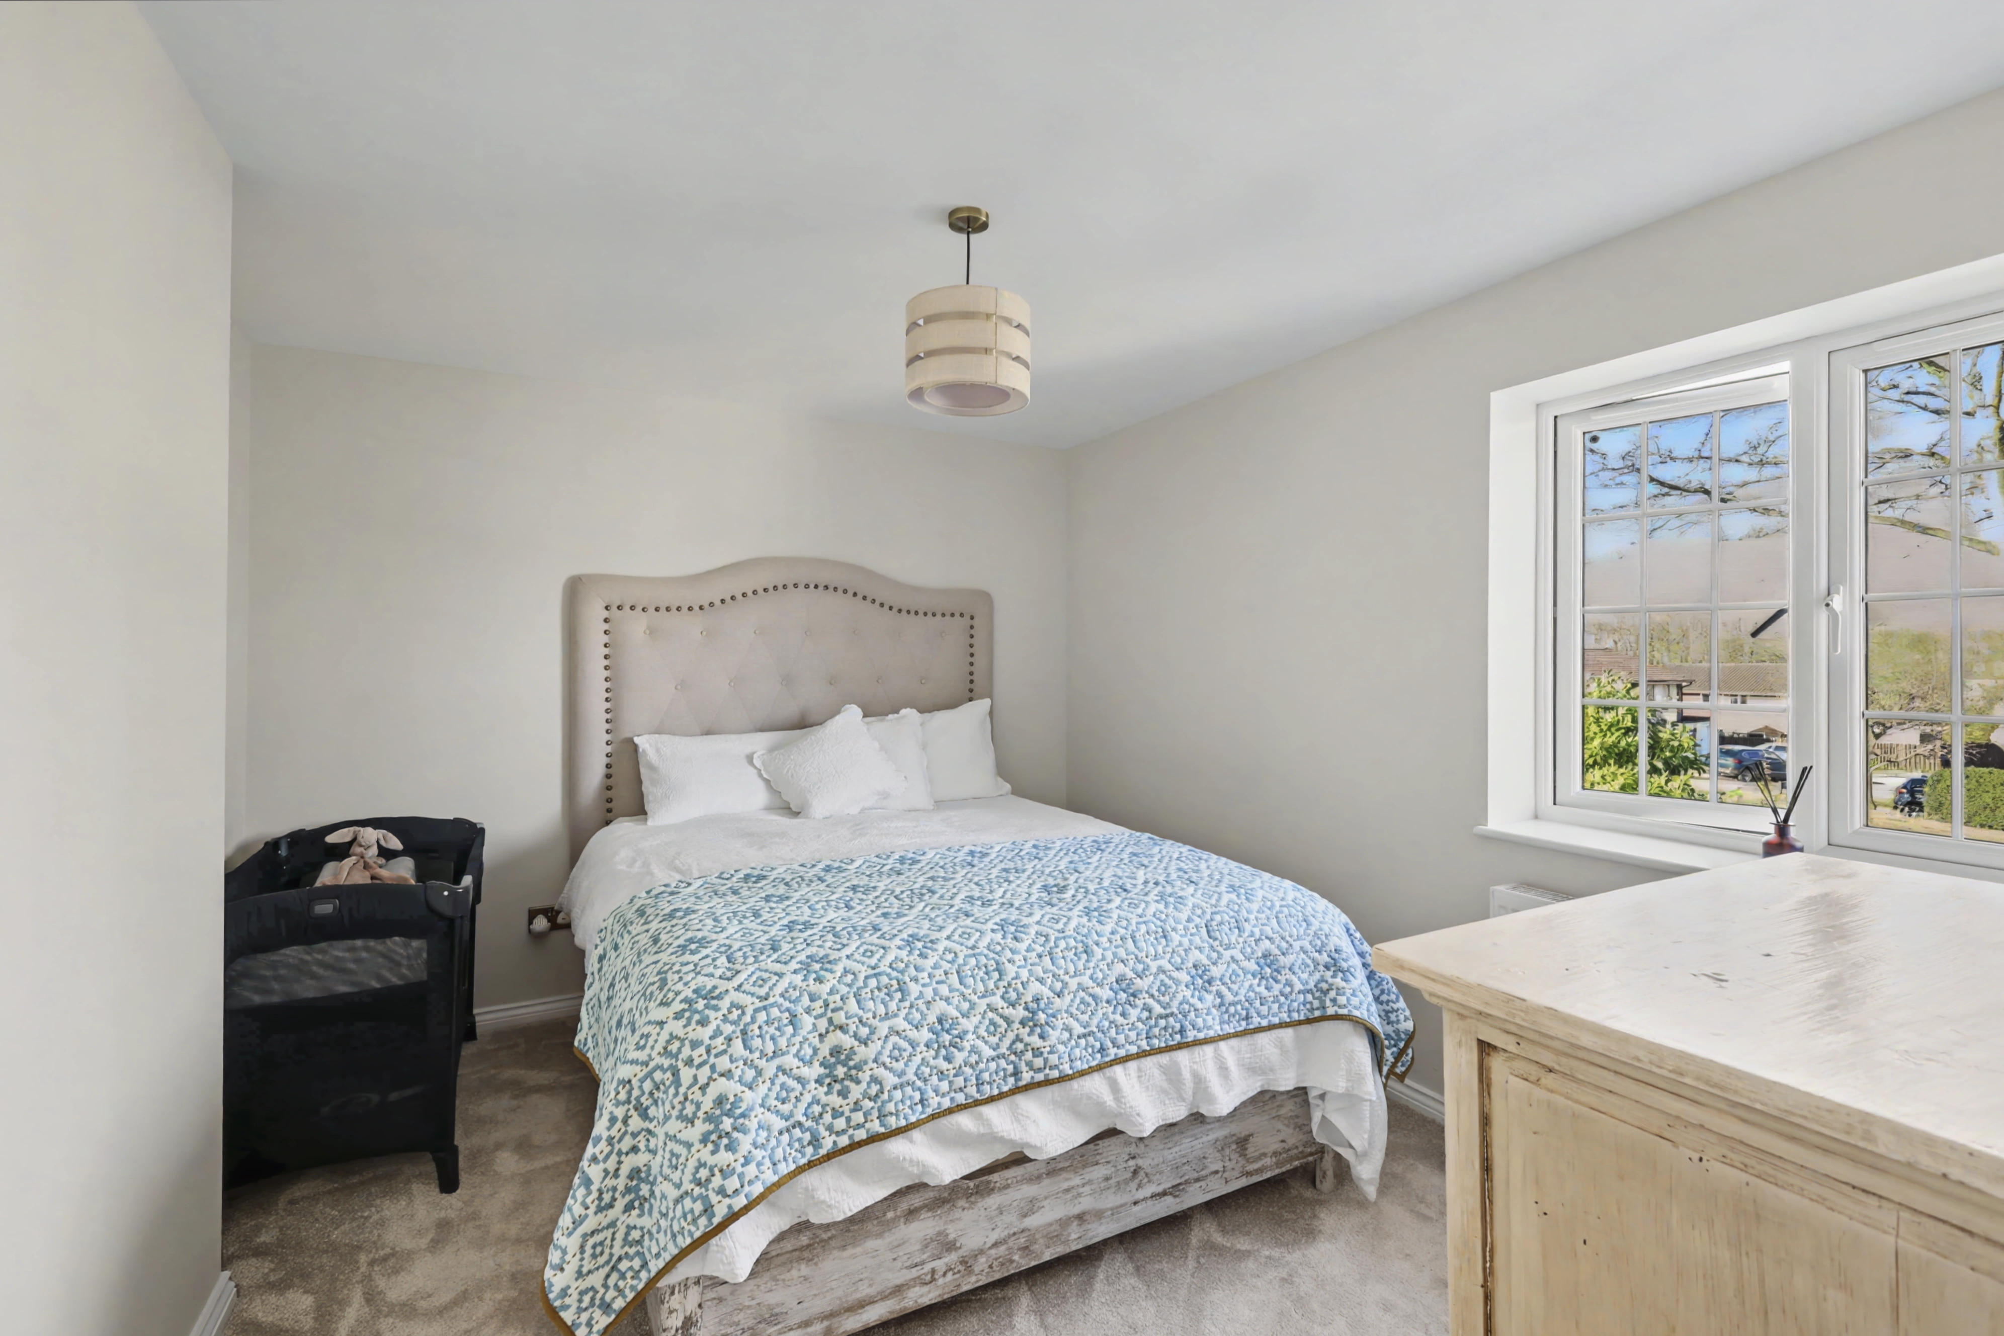
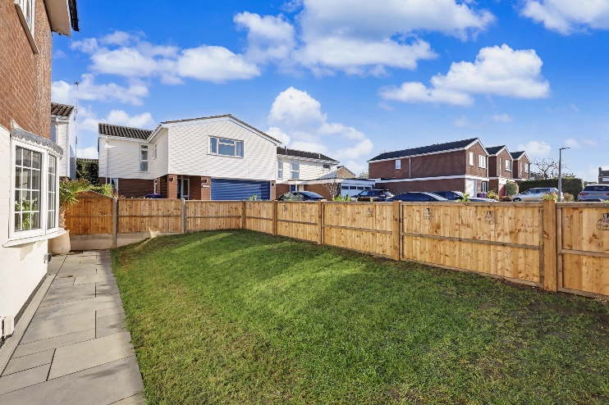
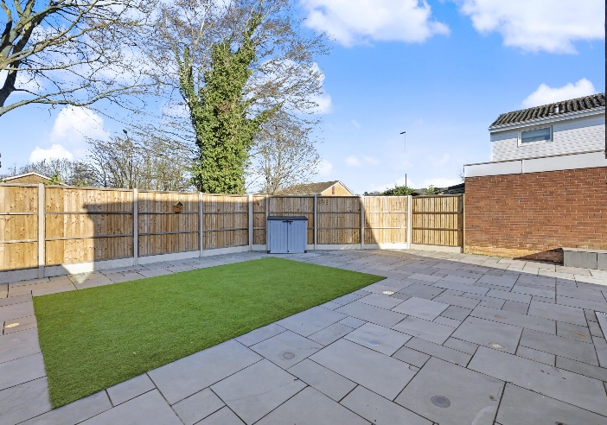
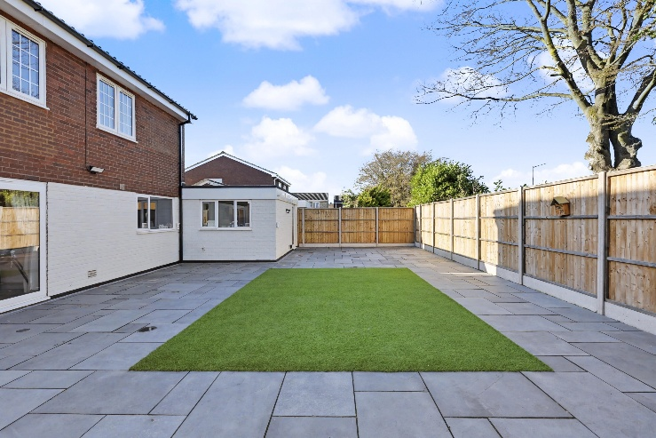
Externally, the property continues to impress with well-maintained and thoughtfully arranged outdoor space. The rear garden is fully enclosed by secure close-board fencing with durable concrete posts, creating a private and safe environment ideal for families and entertaining. Designed for low maintenance, the garden is laid to a combination of patio and artificial grass, offering a practical yet attractive space to enjoy year-round. There is also the added benefit of gated side access leading to the front of the property.

To the front, the property features a neatly presented garden laid to lawn and bordered by a low-level fence, providing an appealing first impression. A driveway offers off-road parking for two vehicles and leads directly to the garage, adding convenience and additional storage options.

Further enhancing the appeal, the property benefits from approved planning permission for an extension, presenting an exciting opportunity for future development. Full details of the approved plans are available upon request.

Step Outside

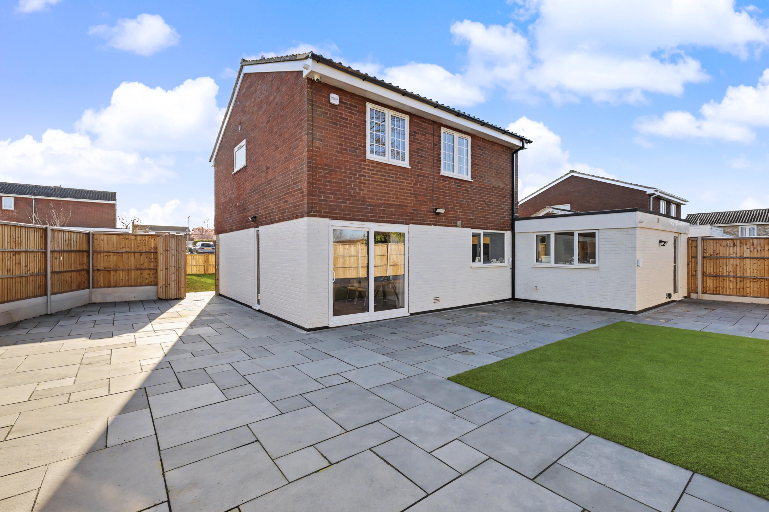

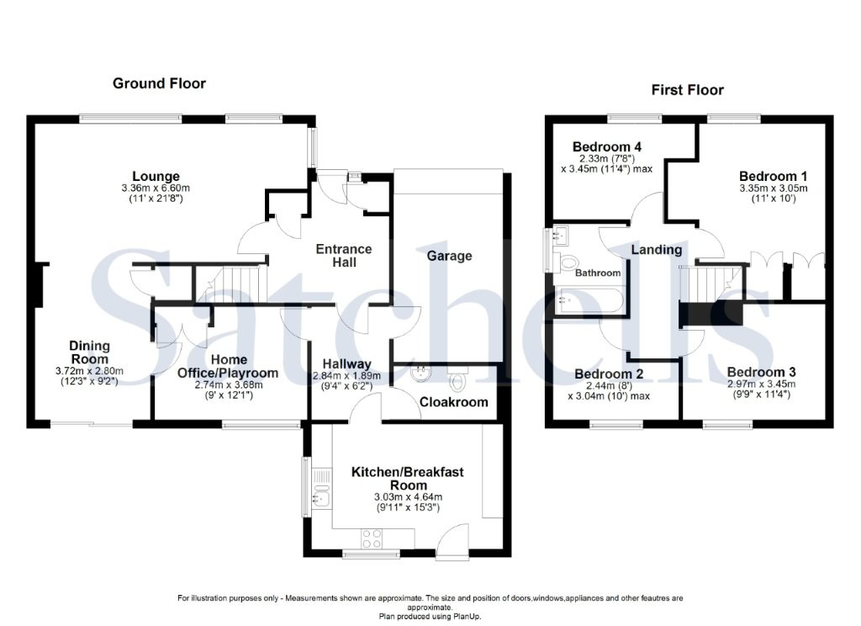

These particulars are a guide only and do not constitute an offer or a contract. The floorplan is for identification purposes only and not to scale. All measurements are approximate and should not be relied upon if ordering furniture, white goods and flooring etc. We have presented the property as we feel fairly describes it but before arranging a viewing or deciding to buy, should there be anything specific you would like to know about the property please enquire. Satchells have not tested any of the appliances or carried out any form of survey and advise you to carry out your own investigations on the state, condition, structure, services, title, tenure, and council tax band of the property. Some images may have been enhanced and the contents shown may not be included in the sale. Satchells routinely refer to 3rd party services for which we receive an income from their fee. If you would like us to refer you to one of these services, please ask one of our staff who will pass your details on. We advise you check the availability of the property on the day of your viewing.



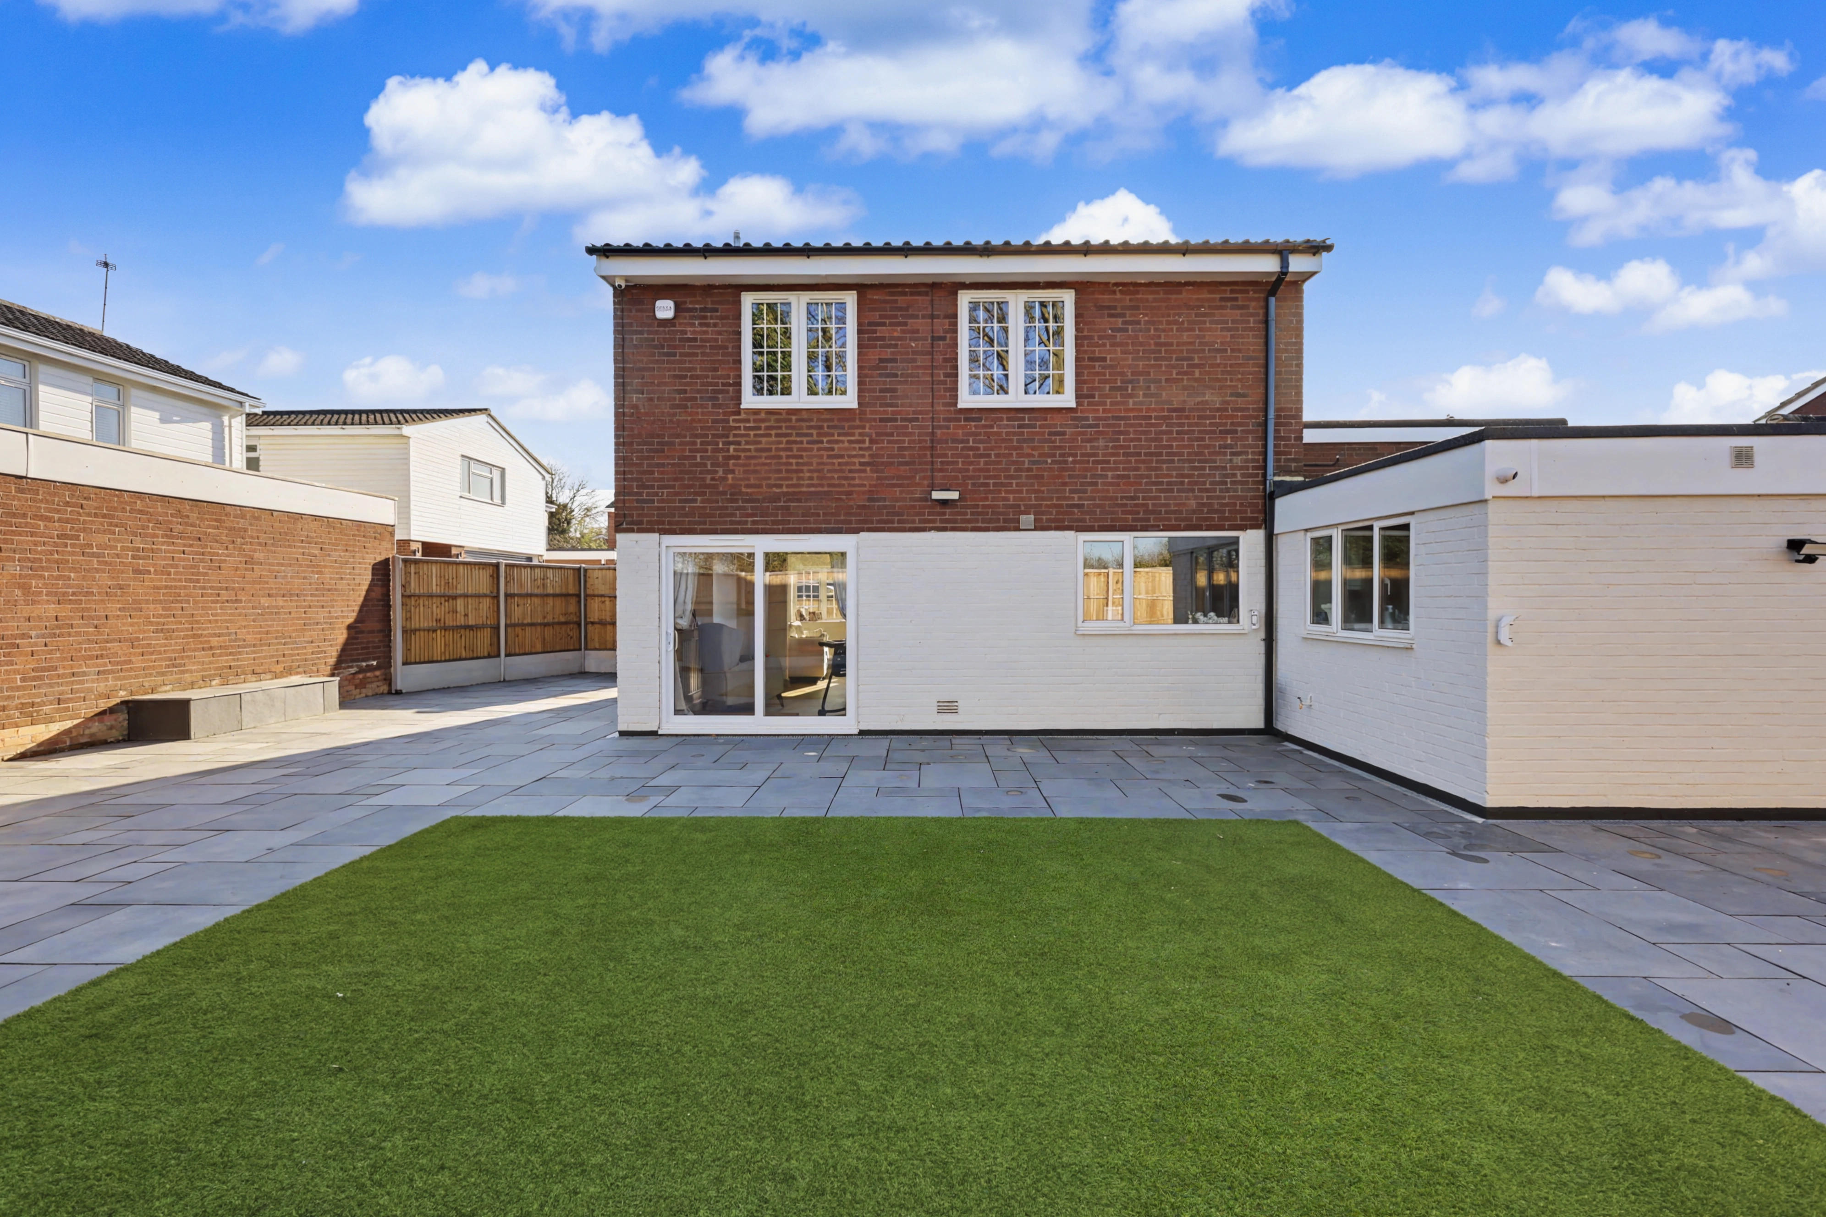
Station Place, Letchworth Garden City, Hertfordshire, SG6 3AQ.
01462 480077
letchworth@satchells.co.uk
www.satchells.com

