DRAFT

Cumbrian Properties

205 Wigton Road, Carlisle

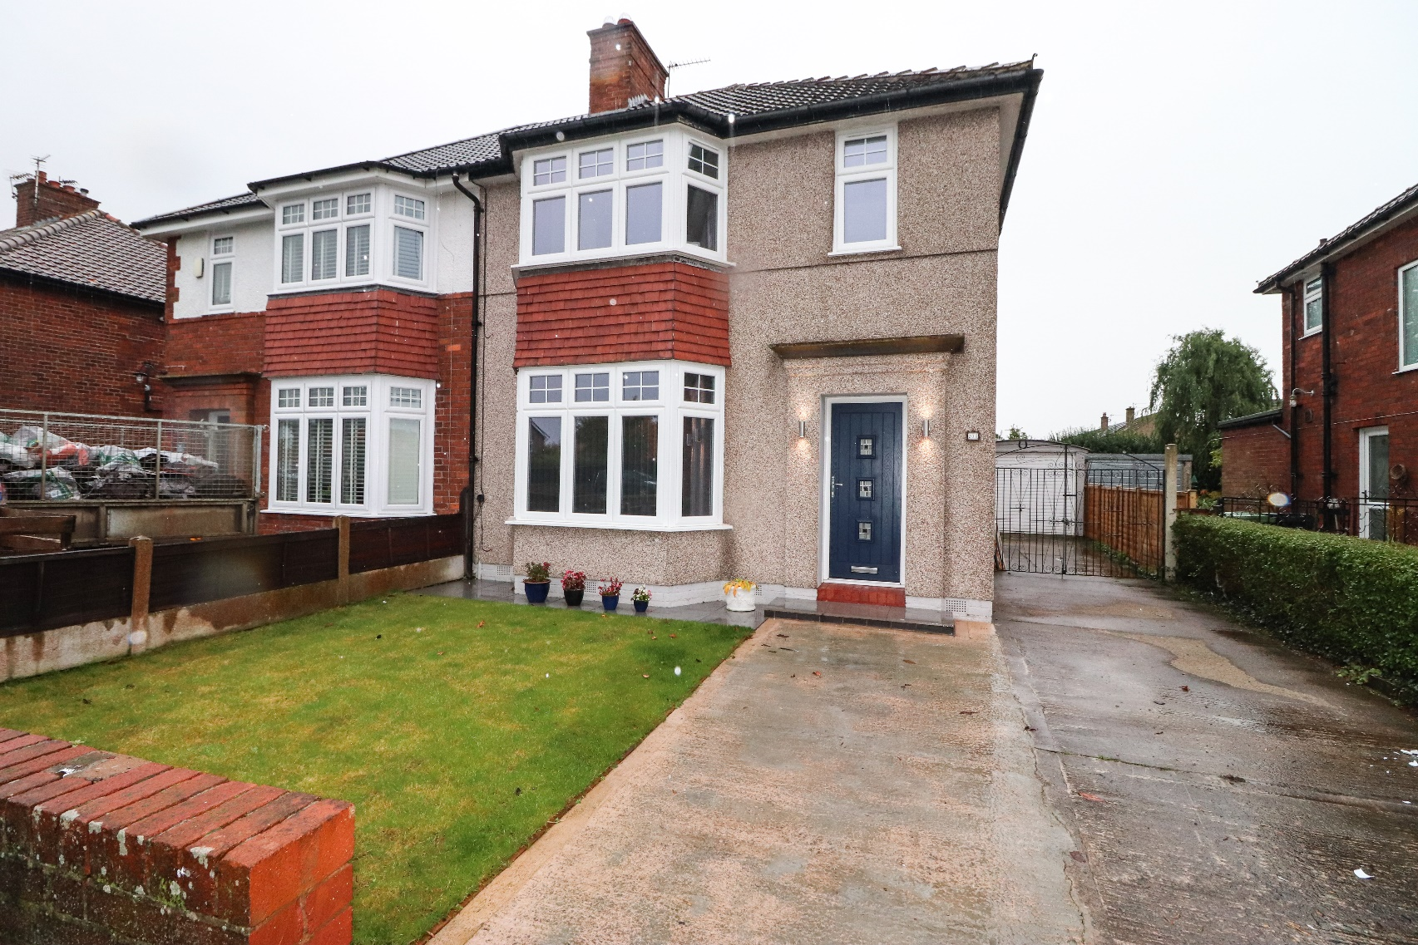
EPC-D

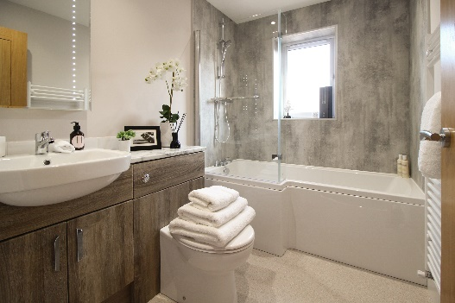
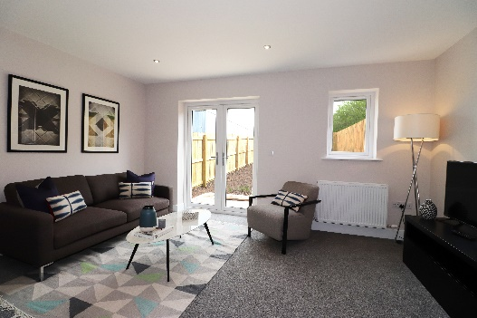
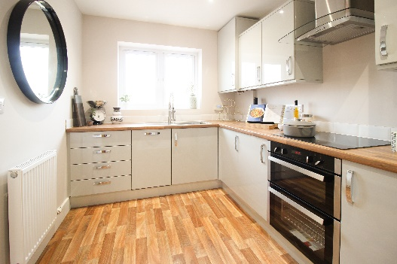

Price Region £215,000

xx | xx
reception room | bedrooms | bathroom
xx | xx

01228 599940
2 Lonsdale Street, Carlisle CA1 1DB
www.cumbrian-properties.co.uk properties@cumbrian-properties.co.uk

2/

The accommodation with approximate measurements briefly comprises:

TENURE

COUNCIL TAX

NOTE These particulars, whilst believed to be accurate, are set out for guidance only and do not constitute any part of an offer or contract - intending purchasers or tenants should not rely on them as statements or representations of fact but must satisfy themselves by inspection or otherwise as to their accuracy. No person in the employment of Cumbrian Properties has the authority to make or give any representation or warranty in relation to the property. All electrical appliances mentioned in these details have not been tested and therefore cannot be guaranteed to be in working order.
