### Hearnes New Logo 2016

**Flat 22 Maidment Court, 47 Parkstone**

**Road, Poole, Dorset, BH15 2FS**

A well presented, spacious one bedroom second floor apartment for the over 60’s, with a dual aspect lounge/kitchen/dining room, dual aspect bedroom with door out to the balcony, large built-in storage cupboard, walk in large utility cupboard, and wet room. This apartment also offers parking, video entry system, 24-hour on-site call assistance, emergency pull cords, electric heating and double glazing. The flat is vacant and sold with no forward chain. The flat benefits from brand new carpets, curtains, lights and built in wardrobes and furniture in bedroom one. Maidment Court is a luxury purpose-built retirement of 87 apartments, set over 7 floors which was completed in 2017 and offers a wealth of facilities and amenities designed to make life easier and enjoyable. This development provides a friendly, affordable alternative to retirement home living and the team can provide care and support on an hourly rate 365 days a year.

* Second floor one double bedroom apartment set within this luxury retirement development built in 2017.
* Sold vacant with no forward chain
* Brand new fitted carpets and sold with curtains and light fittings
* Fitted wardrobes and furniture in the bedroom
* Generous balcony with access from both the sitting room and bedroom and having views over the communal gardens
* Fitted kitchen with integrated appliances to include electric hob, extractor, oven, fridge/freezer, slimline dishwasher
* The flat is wheelchair friendly and benefits from a large storage cupboard and a laundry cupboard/room with Zanussi washing/drying machine
* Wet room with door from the bedroom and entrance hall
* Additional benefits include a video entry system, 24 hour onsite call assistance, pull cords, gas central heating and double glazing.
* The wellbeing service provides peace of mind for all residents and includes 24 hour staffing support on-site, help in any emergency, day or night, personally worn ‘help’ buzzers to call staff, as well as 2-way help/call intercom in the flat, and the co-ordination of an activities and events programme. If further assistance is required then extra care can be purchased. Packages/hours can include personal care package offering washing, dressing, bathing and medication assistance, daily wellbeing check which gives peace of mind to family members, domestic care with an hourly charge, maintenance service and a laundry service.

Surrounded by generous gardens and set in a premier location opposite Poole Park, Maidment Court is close to bus routes and Poole Town Centre. The apartments are linked by an impressive glass walkway that crosses across the beautiful communal gardens which residents are encouraged to tend if they so wish. There is a thriving community of friends and neighbours at Maidment Court who are supported by a dedicated on-site team, providing the care, support and personal service which Methodist Homes for the Aged (MHA) are known for. Facilities include hair and beauty salon, activities room, roof garden terrace which has a lounge and kitchen area and offers incredible views over Poole Park and down to Sandbanks, buggy store, guest suite, residents lounge, and residents bistro which supplies three meals a day and you can purchase meal packages ranging from £52 a week for 2 meals a day or up to £73 a week for three meals a day.

**Term of Lease**: 125 years from 2017 **Ground Rent:** £402.89 per annum

**Maintenance charges:** £473.19 per month to cover all communal areas, cleaning, maintenance, external window cleaning, water & sewerage, buildings insurance & estate management

**Wellbeing Service:** £302.30 per month – This covers the 24 hour staffing support on site, help with any emergency, ‘help’ buzzers to call staff, an activities and events programme

COUNCIL TAX BAND: D EPC RATING: B

**Flat 22 Maidment Court, 47 Parkstone Road, Poole, Dorset, BH15 2FS**

**Leasehold Price £250,000**

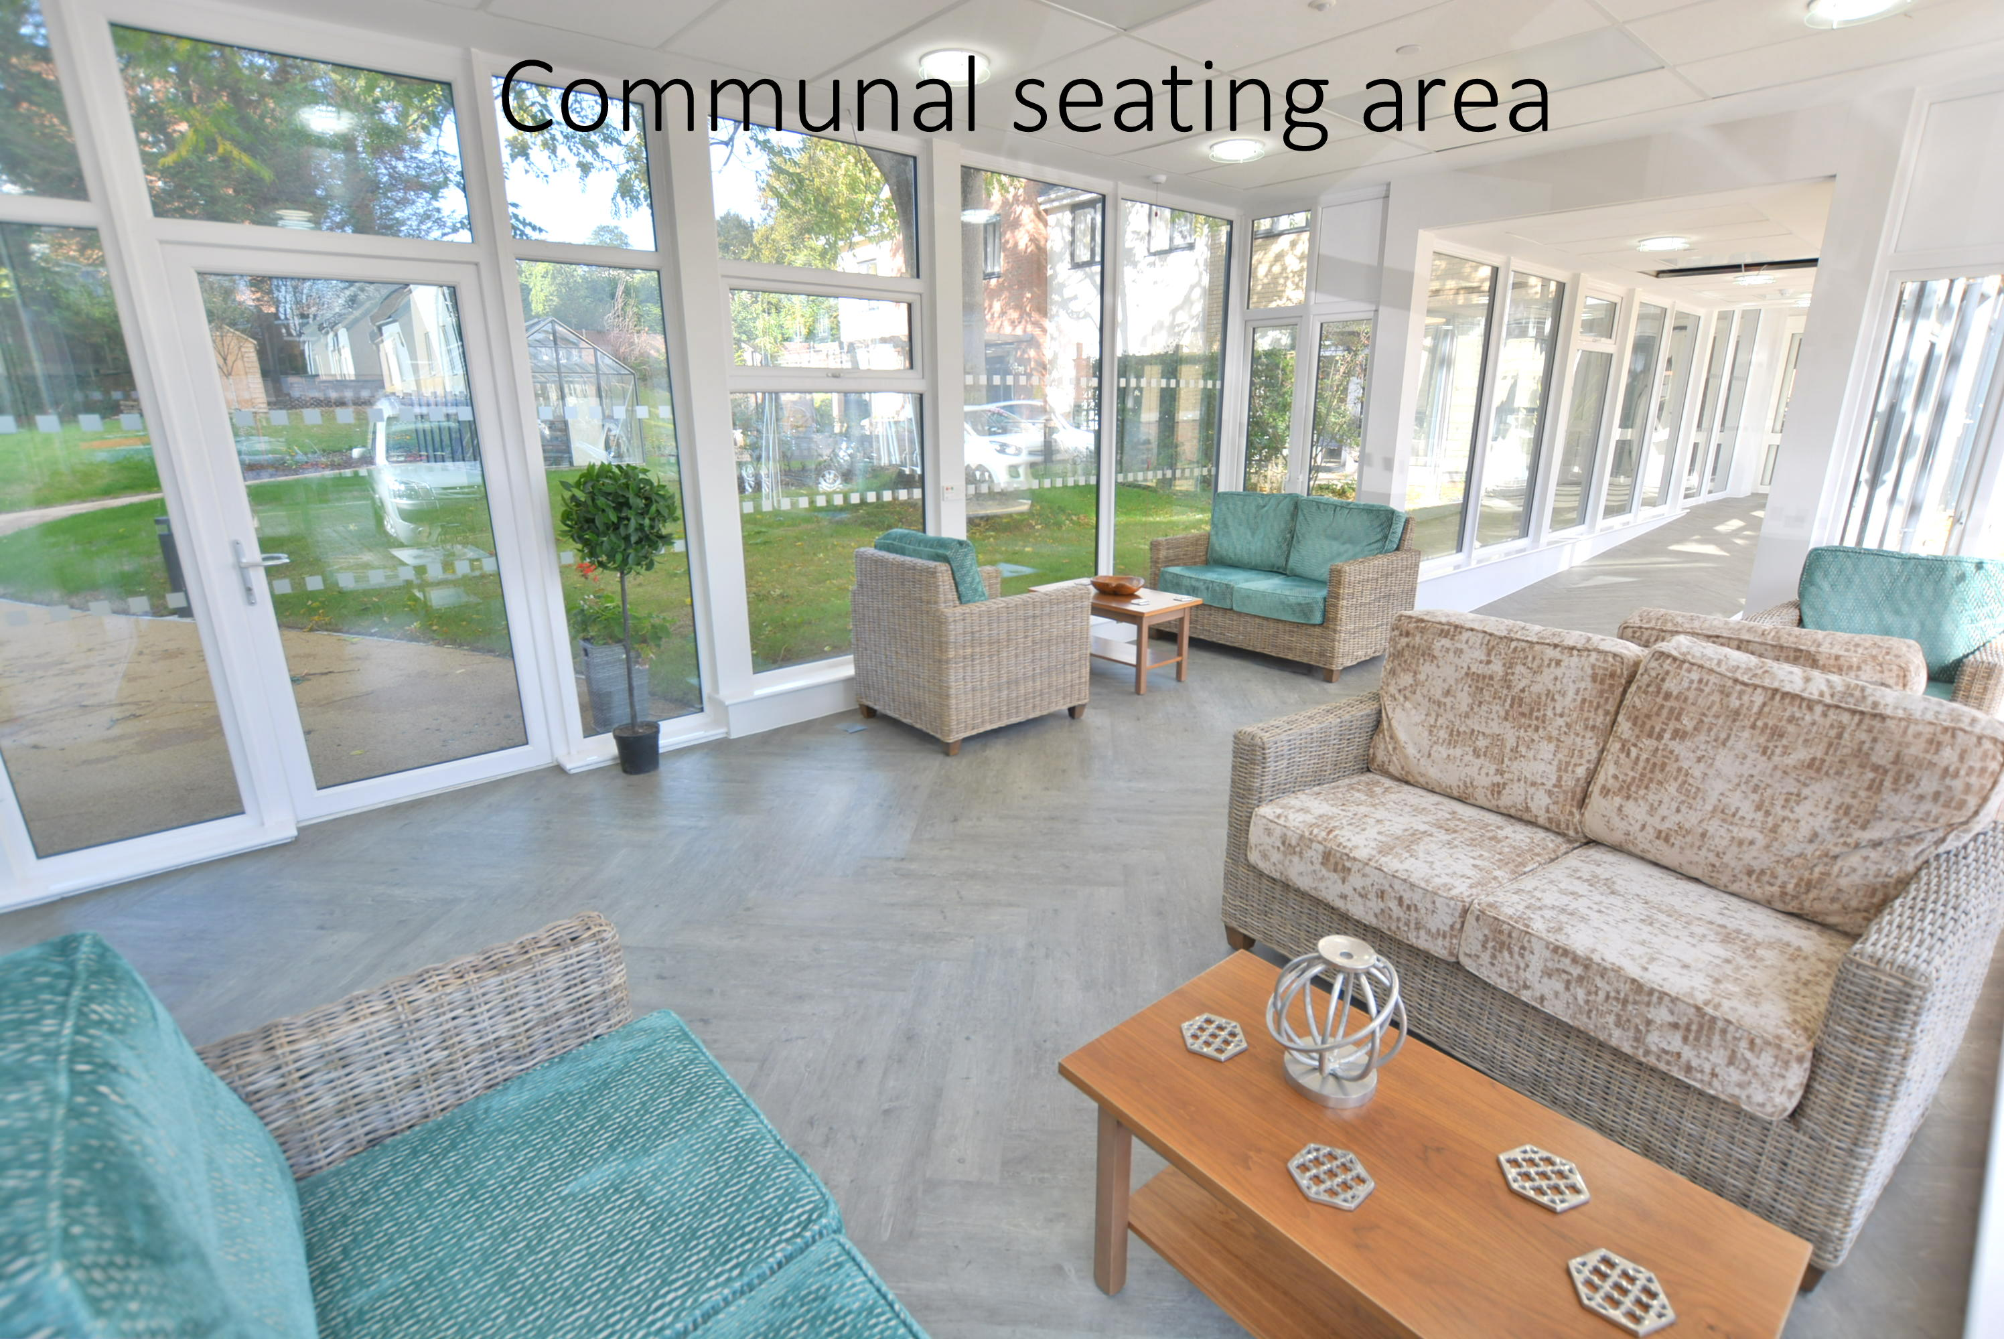

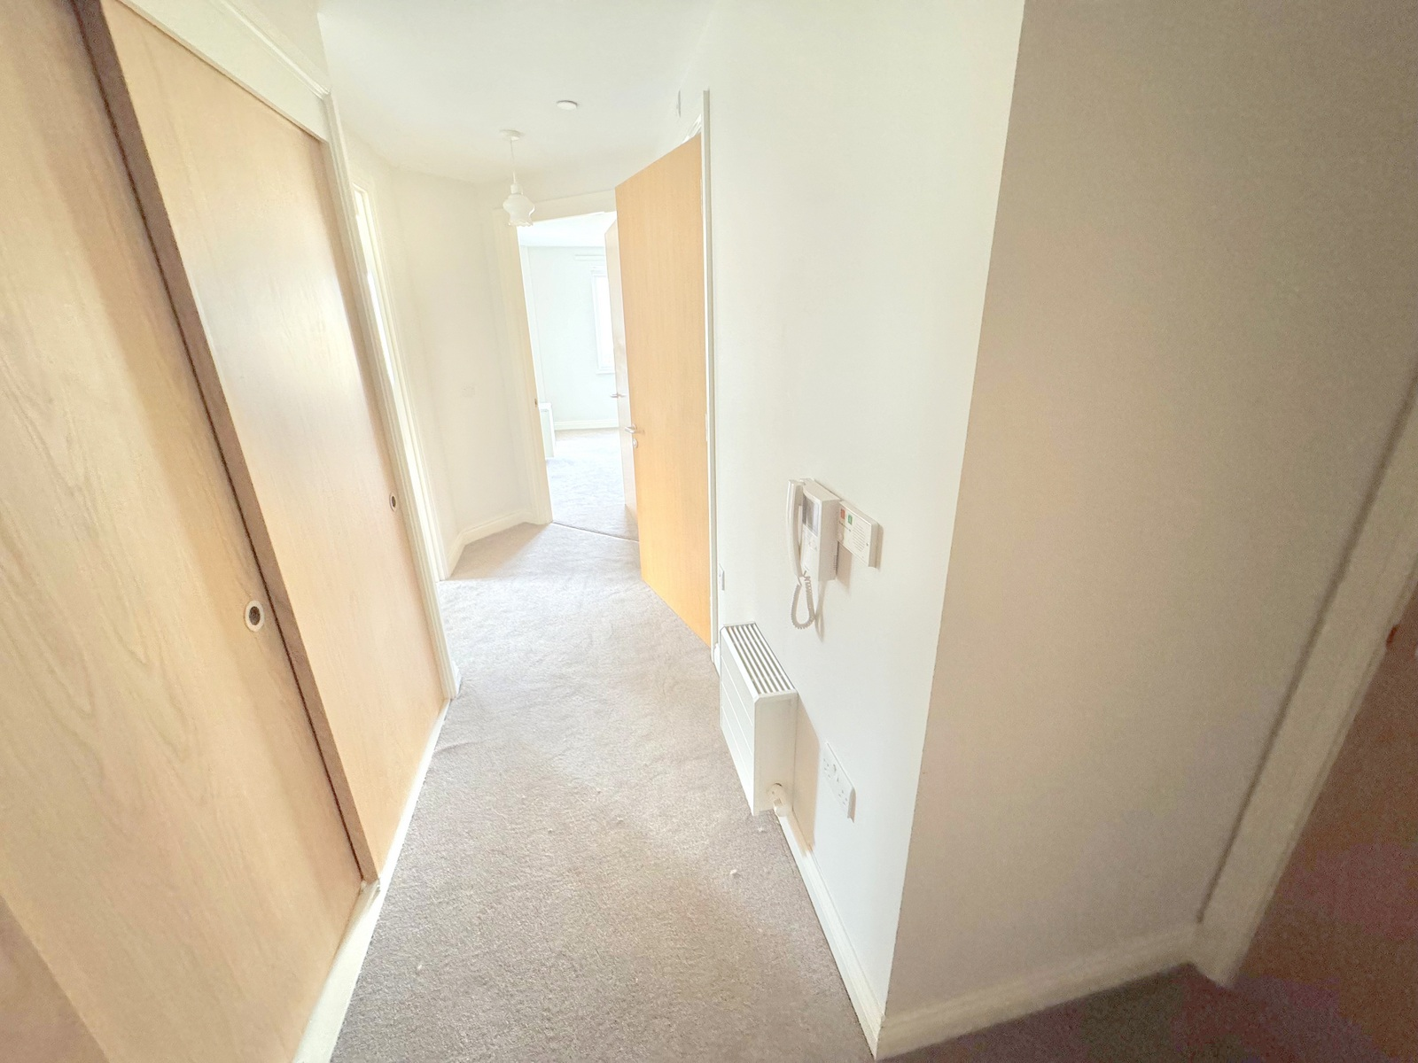

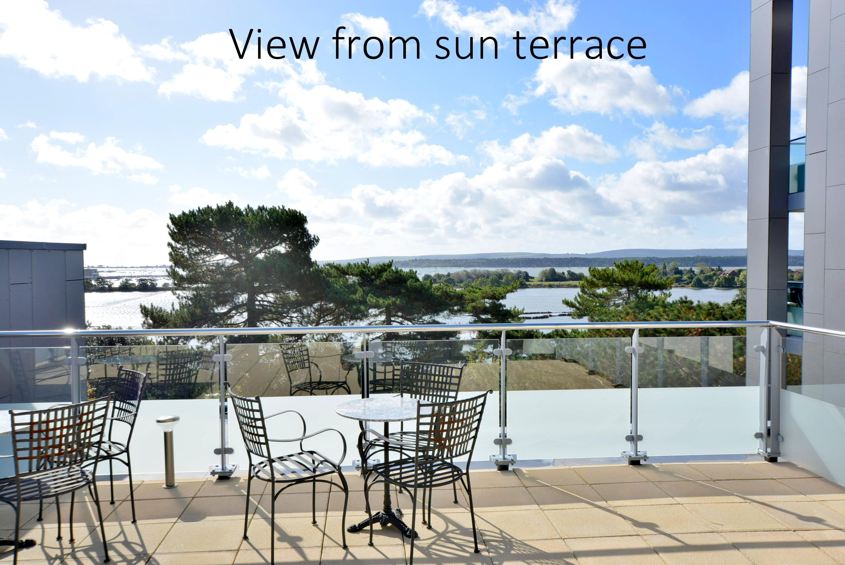

18-20 Parkstone Road, Poole, Dorset, BH15 2PG Tel: 01202 377377 Email: poole@hearnes.com www.hearnes.com

OFFICES ALSO AT: BOURNEMOUTH, FERNDOWN, RINGWOOD & WIMBORNE

